Behavior Analysis

Stabach et al. 2019 - Effects of GPS Collars

Jared Stabach, Smithsonian Conservation Biology Institute

01 March 2019

Table of Contents

# Multinomial Regression

Comments/Questions: Contact Grant Connette ([grmcco@gmail.com](mailto:grmcco@gmail.com)) and Jared Stabach ([stabachj@si.edu](mailto:stabachj@si.edu))

Script investigates behavioral changes observed in scimitar-horned oryx fit with GPS collars and described in Stabach et al. 2019. Data fit in a Bayesian framework, estimating the probability of each behavioral activity and based on a multinomial likelihood. Each animal was used as their own control to assess how each behavior changed across time periods. Our expectation was that adverse behaviors, such as headshaking, should increase during the period immediately after animals were collared (treatment) and return to normal activity during the post-treatment periods when animals become acclimated or adjust to the device.

The steps described here are aimed and recreating the figures and tables listed in Stabach et al. 2019. Importantly, this includes Figure 1.

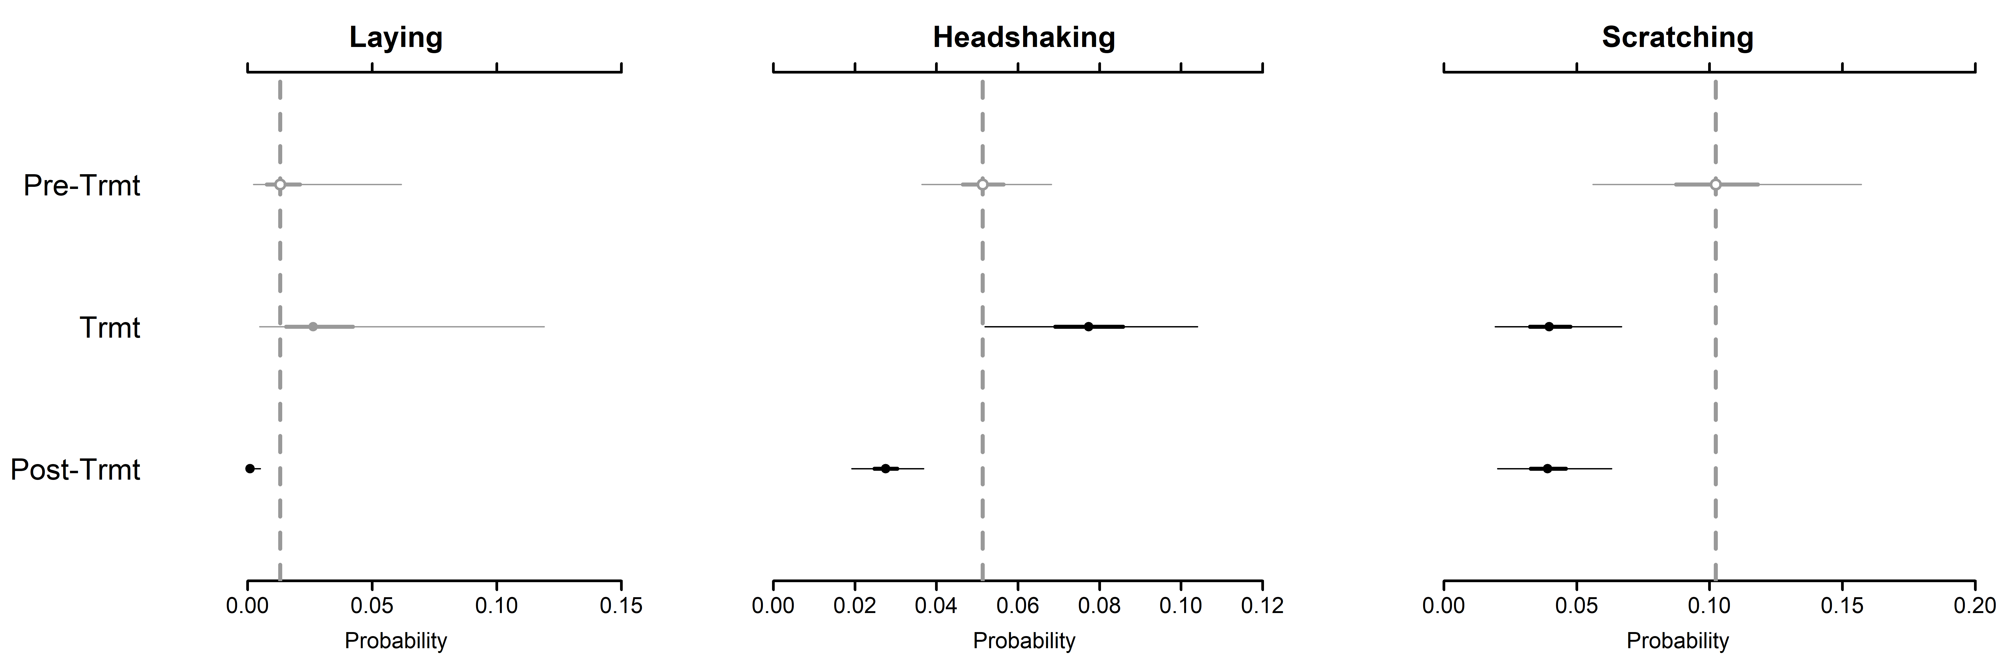

Additional details in:

Stabach, J.A., Cunningham, S.A., Connette, C., Mota, J.L., Reed, D., Byron, M., Songer, M., T. Wacher, Mertes, K., Brown, J.L., Comizzoli, P., Newby, J., S. Monfort, and P. Leimgruber. In Review. Short-term Effects of GPS Collars on Scimitar-horned Oryx. Journal of Wildilfe Management.

### Load Libraries

Load each library necessary to complete the analysis.

# Clear objects in memory  
rm(list=ls())  
  
# Load necessary libraries  
library(tidyr)  
library(reshape2)  
library(ggplot2)  
library(jagsUI)  
library(MCMCvis)  
library(HDInterval)

## Warning: package 'HDInterval' was built under R version 3.5.2

### Read/Prepare Data

Read the dataframe into [R](https://cran.r-project.org/) and correct the datatypes for some of the variables (as.POSIXct() and as.factor()). Remove the ‘Control’ animals from the dataframe since the sample size was so low from this subset. Collared animals serve as their own control, since pre-treatment information was collected.

# Read in file  
bdata <- read.csv("./Data/bdata.csv", header=T, sep=",", row.names=1)  
  
# View data  
head(bdata)

## Date TimeStart TimeEnd Elapsed Temperature  
## 1 10/8/2015 2015-10-08 10:23:00 2015-10-08 10:33:00 10 19  
## 2 10/8/2015 2015-10-08 10:23:00 2015-10-08 10:33:00 10 19  
## 3 10/8/2015 2015-10-08 10:23:00 2015-10-08 10:33:00 10 19  
## 4 10/8/2015 2015-10-08 10:23:00 2015-10-08 10:33:00 10 19  
## 5 10/9/2015 2015-10-09 08:45:00 2015-10-09 08:55:00 10 18  
## 6 10/9/2015 2015-10-09 08:45:00 2015-10-09 08:55:00 10 18  
## Weather Location Barn.in.out. Animal Sex Treatment Collard  
## 1 Sunny Meade in Loretta Female control No  
## 2 Sunny Meade in Ruby Female ATS No  
## 3 Sunny Meade in Scout Female ATS No  
## 4 Sunny Meade in Bamako Female ATS No  
## 5 Sunny Meade in Violet Female Vectronic No  
## 6 Sunny Meade in Bamako Female ATS No  
## CollarIssue RelDay AdjObTime TotalObs ModTotObs HU HD LAY HDSK LOCO  
## 1 No -14 1 40 40 38 0 0 0 2  
## 2 No -14 1 40 40 30 1 0 6 1  
## 3 No -14 1 39 40 29 1 0 0 6  
## 4 No -14 1 36 40 29 1 0 0 4  
## 5 No -13 1 36 40 9 0 18 8 1  
## 6 No -13 1 40 40 8 0 30 0 2  
## SCRATCH OOV RSums  
## 1 0 0 1  
## 2 2 0 1  
## 3 3 1 1  
## 4 2 4 1  
## 5 0 4 1  
## 6 0 0 1

# Set/Update the data/time fields  
bdata$TimeStart <- as.POSIXct(bdata$TimeStart, format="%Y-%m-%d %H:%M")  
bdata$TimeEnd <- as.POSIXct(bdata$TimeEnd, format="%Y-%m-%d %H:%M")  
  
# Code the Control and Treatment records  
# Remove the Controls, too few animals to be useful  
# Code the Control and Treatment records.  
bdata$Control <- ifelse(bdata$Treatment == "control",1,2)   
bdata.control <- bdata[which(bdata$Treatment == "control"),]  
bdata <- bdata[which(bdata$Treatment != "control"),]  
  
# Set AdjObTime as a factor   
bdata$AdjObTime <- as.factor(bdata$AdjObTime)

### Format for JAGS

Prepare data to be ingested into JAGS. Note, the number of iterations (‘n.iter’) has been reduced (e.g., 10,000) so that analyses will execute quickly. n.iter should be increased in subsequent analyses to make sure the parameter space has been thoroughly explored.

# Set-up burn-in/iterations for JAGS  
n.iter=10000 # Number of iterations.   
n.burnin=n.iter*0.20 # burn-in iterations (0.20 percent)  
n.thin = 100  
  
# Set up blank list  
data.list <- vector("list")  
  
y <- cbind(bdata$HU,bdata$HD,bdata$LAY,bdata$HDSK,bdata$LOCO,bdata$SCRATCH)   
#class(y) To make sure apended to matrix  
  
# Create matrix for inverse Wishart prior on individual random effects  
R <- matrix(0,nrow=6,ncol=6)  
for (i in 1:6){  
 R[i,i] <- 0.1  
}  
  
# Setup the data list  
data.list=list(  
 Y = y,   
 n.outcomes = ncol(y),  
 PERIOD = as.numeric(bdata$AdjObTime),  
 N = apply(y,1,sum),  
 n = nrow(y),  
 ind = as.numeric(droplevels(bdata$Animal)),  
 nind = length(unique(bdata$Animal)),  
 R = R  
)

### Model Description

Create a multinomial model to compare changes in behavior across treatment periods. Because multiple individuals are included, model parametization includes random effect. We set the first behavior (Standing head-up) as our reference behavior. Model is saved as Model_Multinomial_withREs.R and sourced in the jags function below.

model{  
   
 # SPECIFY THE PRIORS FOR GLOABAL PARAMETERS  
 # ***********************************  
 # Alphas represent the intercept for relative probabilities of each outcome at the pre-treatment period on the log scale  
 # Fix the relative probability of the reference outcome (HU) to zero on the log scale  
 alpha[1] <- 0   
   
 # Loop over response outcomes  
 for (j in 2:n.outcomes) {   
 # Assign diffuse priors to the relative probabilities of all outcomes except the reference (for period 1)  
 alpha[j] ~ dnorm(0, 0.001)   
 }  
   
 # Betas represent change from period one on the log scale  
 # Loop over response outcomes  
 for (j in 1:n.outcomes){  
 # beta[1,] are fixed to zero because there is no period-adjustment needed for period 1 since it is the reference  
 beta[1, j] <- 0   
 }  
   
 # Loop over time periods 2 (treatment) and 3 (post-treatment)  
 for (i in 2:3) {   
 # As for period 1, we have to fix the relative probabilities of the reference outcome (HU) to zero on the log scale  
 beta[i, 1] <- 0  
 # Loop over response outcomes  
 for (j in 2:n.outcomes){  
 # Assign diffuse priors to change (periods 1-2 and periods 1-3) in rel. probs. of outcomes  
 beta[i, j] ~ dnorm(0, 0.001)   
 }   
 }  
   
 # tau.j parameters represent inter-individual variation in relative probs. of outcomes  
 # Loop over response outcomes  
 for (j in 1:n.outcomes){   
 # Mean of individual random effects is 0  
 mu.re[j] <- 0   
 }  
   
 # PRIORS FOR ELEMENTS OF PRECISION MATRIX  
 # ***********************************  
 # df set to j+1  
 prec[1:6,1:6] ~ dwish(R[,],7)   
 # Convert precision to covariance matrix  
 sigma[1:6,1:6] <- inverse(prec[,])   
 # Correlation between outcome 1 and 2  
 # rho <- sigma[1,2]/sqrt(sigma[1,1]*sigma[2,2])   
   
 # DEFINE INDIVIDUAL-LEVEL PARAMETERS  
 # ***********************************  
 # Loop over individuals to define individual-level random effects  
 for (idx in 1:nind){   
 # Rel. prob. of reference outcome fixed to zero, so there is no adjustment among indiviuals  
 eps[idx,1:6] ~ dmnorm(mu.re[], prec[,])   
 }  
   
 # LIKELIHOOD   
 # ***********************************  
 # Loop over observations  
 for (i in 1:n) {   
 # Multinomial response  
 Y[i, ] ~ dmulti(p[i, ] , N[i])  
  
 # Loop through outcomes  
 for (j in 1:n.outcomes) {   
 p[i,j] <- phi[i,j] / sum(phi[i, ])  
 log(phi[i,j]) <- alpha[j] + beta[PERIOD[i], j] + eps[ind[i], j]  
 }  
 }  
   
 # DERIVED QUANTITIES  
 # ***********************************  
 for (j in 1:n.outcomes){  
 PROBS[1,j] <- PHI[1,j] / sum(PHI[1,])  
 log(PHI[1,j]) <- alpha[j] + beta[1,j]  
 PROBS[2,j] <- PHI[2,j] / sum(PHI[2,])  
 log(PHI[2,j]) <- alpha[j] + beta[2,j]  
 PROBS[3,j] <- PHI[3,j] / sum(PHI[3,])  
 log(PHI[3,j]) <- alpha[j] + beta[3,j]  
 }  
}

### Fitting JAGS Model

Here we fit the model described above, specifying the parameters estimated to save in the output.

jm2=jags(model.file = "Model_Multinomial_withREs.R",  
 data=data.list,  
 n.chains=3,n.iter=n.iter,n.burnin = n.burnin,n.thin=n.thin,parallel = F,  
 parameters.to.save = c("alpha","beta","sigma","PROBS","eps"))  
  
# You will receive an error that "At least one Rhat value could not be calculated." This is expected since these values were pre-set to zero (0) in our model above.

### Load Saved Model

Since running the model can take a lot of time, you can save the model as a .Rda file and load the model output from disk. The resulting object can then be loaded into [R](https://cran.r-project.org/) without going through all the steps to fit the model and prepare the dataframe.

# Save JAGS model  
#save(jm2, file = "Behavior_Models.Rda")  
load("Behavior_Models.Rda")  
  
# Summarize object  
jm2

## JAGS output for model 'Model_Multinomial_withREs.R', generated by jagsUI.  
## Estimates based on 3 chains of 5e+05 iterations,  
## adaptation = 600 iterations (sufficient),  
## burn-in = 1e+05 iterations and thin rate = 100,  
## yielding 12000 total samples from the joint posterior.   
## MCMC ran for 82.029 minutes at time 2018-12-16 20:51:50.  
##   
## mean sd 2.5% 50% 97.5% overlap0 f Rhat  
## alpha[1] 0.000 0.000 0.000 0.000 0.000 FALSE 1.000 NA  
## alpha[2] -0.838 0.483 -1.765 -0.856 0.199 TRUE 0.952 1.011  
## alpha[3] -3.606 0.846 -5.281 -3.586 -1.952 FALSE 0.999 1.026  
## alpha[4] -2.211 0.175 -2.555 -2.211 -1.870 FALSE 1.000 1.000  
## alpha[5] -1.215 0.202 -1.627 -1.210 -0.823 FALSE 1.000 1.003  
## alpha[6] -1.535 0.227 -2.001 -1.532 -1.084 FALSE 1.000 1.006  
## beta[1,1] 0.000 0.000 0.000 0.000 0.000 FALSE 1.000 NA  
## beta[2,1] 0.000 0.000 0.000 0.000 0.000 FALSE 1.000 NA  
## beta[3,1] 0.000 0.000 0.000 0.000 0.000 FALSE 1.000 NA  
## beta[1,2] 0.000 0.000 0.000 0.000 0.000 FALSE 1.000 NA  
## beta[2,2] 0.347 0.093 0.162 0.348 0.532 FALSE 1.000 1.000  
## beta[3,2] 0.274 0.067 0.141 0.273 0.405 FALSE 1.000 1.000  
## beta[1,3] 0.000 0.000 0.000 0.000 0.000 FALSE 1.000 NA  
## beta[2,3] 0.831 0.163 0.517 0.831 1.150 FALSE 1.000 1.000  
## beta[3,3] -2.585 0.285 -3.169 -2.575 -2.044 FALSE 1.000 1.000  
## beta[1,4] 0.000 0.000 0.000 0.000 0.000 FALSE 1.000 NA  
## beta[2,4] 0.534 0.168 0.203 0.536 0.856 FALSE 0.999 1.000  
## beta[3,4] -0.600 0.149 -0.885 -0.602 -0.306 FALSE 1.000 1.000  
## beta[1,5] 0.000 0.000 0.000 0.000 0.000 FALSE 1.000 NA  
## beta[2,5] 0.284 0.115 0.060 0.284 0.507 FALSE 0.993 1.000  
## beta[3,5] 0.359 0.086 0.192 0.361 0.527 FALSE 1.000 1.000  
## beta[1,6] 0.000 0.000 0.000 0.000 0.000 FALSE 1.000 NA  
## beta[2,6] -0.821 0.183 -1.181 -0.820 -0.466 FALSE 1.000 1.000  
## beta[3,6] -0.942 0.123 -1.181 -0.942 -0.699 FALSE 1.000 1.001  
## sigma[1,1] 0.516 0.708 0.054 0.299 2.360 FALSE 1.000 1.088  
## sigma[2,1] 0.078 0.691 -0.823 -0.043 1.779 TRUE 0.452 1.084  
## sigma[3,1] -0.646 1.191 -3.509 -0.472 1.094 TRUE 0.800 1.071  
## sigma[4,1] 0.417 0.703 -0.022 0.200 2.258 TRUE 0.938 1.107  
## sigma[5,1] 0.551 0.818 -0.048 0.311 2.687 TRUE 0.924 1.077  
## sigma[6,1] 0.393 0.710 -0.095 0.184 2.280 TRUE 0.846 1.089  
## sigma[1,2] 0.078 0.691 -0.823 -0.043 1.779 TRUE 0.452 1.084  
## sigma[2,2] 1.984 1.426 0.486 1.612 5.792 FALSE 1.000 1.010  
## sigma[3,2] -0.176 1.673 -3.372 -0.239 3.364 TRUE 0.598 1.027  
## sigma[4,2] 0.280 0.755 -0.583 0.118 2.127 TRUE 0.634 1.084  
## sigma[5,2] -0.353 0.769 -1.685 -0.397 1.389 TRUE 0.810 1.070  
## sigma[6,2] -0.331 0.705 -1.494 -0.368 1.190 TRUE 0.824 1.076  
## sigma[1,3] -0.646 1.191 -3.509 -0.472 1.094 TRUE 0.800 1.071  
## sigma[2,3] -0.176 1.673 -3.372 -0.239 3.364 TRUE 0.598 1.027  
## sigma[3,3] 4.728 4.090 0.887 3.590 15.443 FALSE 1.000 1.003  
## sigma[4,3] -0.719 1.220 -3.580 -0.539 0.992 TRUE 0.827 1.087  
## sigma[5,3] -0.913 1.357 -4.249 -0.675 0.977 TRUE 0.852 1.049  
## sigma[6,3] -0.349 1.276 -3.198 -0.239 1.717 TRUE 0.653 1.069  
## sigma[1,4] 0.417 0.703 -0.022 0.200 2.258 TRUE 0.938 1.107  
## sigma[2,4] 0.280 0.755 -0.583 0.118 2.127 TRUE 0.634 1.084  
## sigma[3,4] -0.719 1.220 -3.580 -0.539 0.992 TRUE 0.827 1.087  
## sigma[4,4] 0.496 0.734 0.039 0.273 2.384 FALSE 1.000 1.119  
## sigma[5,4] 0.444 0.805 -0.158 0.207 2.579 TRUE 0.799 1.092  
## sigma[6,4] 0.408 0.716 -0.069 0.198 2.276 TRUE 0.892 1.107  
## sigma[1,5] 0.551 0.818 -0.048 0.311 2.687 TRUE 0.924 1.077  
## sigma[2,5] -0.353 0.769 -1.685 -0.397 1.389 TRUE 0.810 1.070  
## sigma[3,5] -0.913 1.357 -4.249 -0.675 0.977 TRUE 0.852 1.049  
## sigma[4,5] 0.444 0.805 -0.158 0.207 2.579 TRUE 0.799 1.092  
## sigma[5,5] 0.962 1.004 0.129 0.668 3.588 FALSE 1.000 1.059  
## sigma[6,5] 0.561 0.848 -0.108 0.320 2.838 TRUE 0.890 1.070  
## sigma[1,6] 0.393 0.710 -0.095 0.184 2.280 TRUE 0.846 1.089  
## sigma[2,6] -0.331 0.705 -1.494 -0.368 1.190 TRUE 0.824 1.076  
## sigma[3,6] -0.349 1.276 -3.198 -0.239 1.717 TRUE 0.653 1.069  
## sigma[4,6] 0.408 0.716 -0.069 0.198 2.276 TRUE 0.892 1.107  
## sigma[5,6] 0.561 0.848 -0.108 0.320 2.838 TRUE 0.890 1.070  
## sigma[6,6] 0.689 0.789 0.102 0.466 2.831 FALSE 1.000 1.071  
## PROBS[1,1] 0.468 0.050 0.345 0.473 0.551 FALSE 1.000 1.016  
## PROBS[2,1] 0.413 0.057 0.275 0.418 0.508 FALSE 1.000 1.019  
## PROBS[3,1] 0.458 0.056 0.321 0.464 0.549 FALSE 1.000 1.012  
## PROBS[1,2] 0.217 0.085 0.090 0.202 0.433 FALSE 1.000 1.013  
## PROBS[2,2] 0.267 0.096 0.117 0.252 0.501 FALSE 1.000 1.010  
## PROBS[3,2] 0.275 0.099 0.119 0.260 0.514 FALSE 1.000 1.013  
## PROBS[1,3] 0.018 0.025 0.002 0.013 0.062 FALSE 1.000 1.210  
## PROBS[2,3] 0.036 0.042 0.005 0.026 0.119 FALSE 1.000 1.177  
## PROBS[3,3] 0.001 0.002 0.000 0.001 0.005 FALSE 1.000 1.231  
## PROBS[1,4] 0.052 0.008 0.036 0.051 0.068 FALSE 1.000 1.008  
## PROBS[2,4] 0.078 0.013 0.052 0.077 0.104 FALSE 1.000 1.014  
## PROBS[3,4] 0.028 0.004 0.019 0.028 0.037 FALSE 1.000 1.005  
## PROBS[1,5] 0.142 0.032 0.078 0.141 0.207 FALSE 1.000 1.008  
## PROBS[2,5] 0.167 0.042 0.084 0.166 0.251 FALSE 1.000 1.010  
## PROBS[3,5] 0.199 0.046 0.107 0.199 0.290 FALSE 1.000 1.009  
## PROBS[1,6] 0.103 0.025 0.056 0.102 0.157 FALSE 1.000 1.010  
## PROBS[2,6] 0.041 0.012 0.019 0.040 0.067 FALSE 1.000 1.009  
## PROBS[3,6] 0.040 0.011 0.020 0.039 0.063 FALSE 1.000 1.010  
## eps[1,1] -0.301 0.466 -1.306 -0.284 0.564 TRUE 0.745 1.010  
## eps[2,1] -0.346 0.384 -1.137 -0.344 0.432 TRUE 0.840 1.012  
## eps[3,1] 0.632 0.475 -0.141 0.566 1.770 TRUE 0.949 1.028  
## eps[4,1] -0.294 0.631 -1.637 -0.282 0.929 TRUE 0.688 1.006  
## eps[5,1] -0.398 0.312 -1.072 -0.383 0.200 TRUE 0.916 1.007  
## eps[6,1] 0.042 0.335 -0.567 0.017 0.796 TRUE 0.525 1.051  
## eps[7,1] -0.101 0.542 -0.917 -0.180 1.265 TRUE 0.680 1.149  
## eps[8,1] 0.110 0.567 -0.782 0.045 1.379 TRUE 0.545 1.099  
## eps[9,1] 1.102 0.977 -0.549 0.983 3.352 TRUE 0.905 1.038  
## eps[10,1] -0.045 0.434 -0.981 -0.028 0.772 TRUE 0.526 1.011  
## eps[1,2] 0.144 0.683 -1.284 0.152 1.504 TRUE 0.590 1.020  
## eps[2,2] 0.954 0.604 -0.324 0.967 2.142 TRUE 0.942 1.010  
## eps[3,2] 0.615 0.573 -0.440 0.575 1.837 TRUE 0.878 1.007  
## eps[4,2] -2.472 0.782 -4.220 -2.427 -1.025 FALSE 1.000 1.014  
## eps[5,2] 0.146 0.552 -1.059 0.163 1.226 TRUE 0.624 1.014  
## eps[6,2] 0.878 0.506 -0.128 0.860 1.901 TRUE 0.961 1.008  
## eps[7,2] 0.904 0.636 -0.180 0.840 2.317 TRUE 0.952 1.063  
## eps[8,2] 1.003 0.655 -0.104 0.935 2.400 TRUE 0.963 1.044  
## eps[9,2] -2.244 1.023 -4.250 -2.271 -0.082 FALSE 0.977 1.020  
## eps[10,2] 0.127 0.657 -1.244 0.135 1.442 TRUE 0.590 1.019  
## eps[1,3] 2.272 0.877 0.640 2.207 4.116 FALSE 0.992 1.030  
## eps[2,3] 1.018 0.810 -0.538 0.980 2.717 TRUE 0.908 1.018  
## eps[3,3] -1.854 1.132 -4.453 -1.721 -0.038 FALSE 0.977 1.009  
## eps[4,3] 2.036 0.962 0.130 1.991 4.000 FALSE 0.980 1.022  
## eps[5,3] 1.254 0.783 -0.186 1.196 2.917 TRUE 0.959 1.023  
## eps[6,3] -0.705 0.850 -2.484 -0.671 0.941 TRUE 0.808 1.003  
## eps[7,3] -1.574 1.223 -4.656 -1.407 0.337 TRUE 0.942 1.013  
## eps[8,3] -1.849 1.229 -4.734 -1.671 0.006 TRUE 0.974 1.010  
## eps[9,3] -2.824 2.079 -8.081 -2.471 0.250 TRUE 0.960 1.006  
## eps[10,3] 2.065 0.858 0.483 2.008 3.868 FALSE 0.990 1.030  
## eps[1,4] -0.429 0.487 -1.490 -0.409 0.480 TRUE 0.822 1.011  
## eps[2,4] -0.530 0.418 -1.392 -0.522 0.288 TRUE 0.912 1.012  
## eps[3,4] 0.250 0.482 -0.535 0.182 1.420 TRUE 0.690 1.032  
## eps[4,4] -0.288 0.646 -1.661 -0.280 0.950 TRUE 0.678 1.005  
## eps[5,4] -0.174 0.332 -0.896 -0.157 0.446 TRUE 0.709 1.010  
## eps[6,4] 0.304 0.346 -0.284 0.272 1.104 TRUE 0.838 1.057  
## eps[7,4] 0.360 0.562 -0.429 0.270 1.744 TRUE 0.785 1.153  
## eps[8,4] 0.610 0.584 -0.248 0.531 1.938 TRUE 0.919 1.107  
## eps[9,4] 0.591 0.989 -1.076 0.470 2.910 TRUE 0.732 1.036  
## eps[10,4] -0.324 0.458 -1.304 -0.304 0.533 TRUE 0.766 1.011  
## eps[1,5] -0.971 0.486 -2.010 -0.943 -0.086 FALSE 0.984 1.006  
## eps[2,5] 0.204 0.416 -0.626 0.205 1.039 TRUE 0.702 1.012  
## eps[3,5] 0.295 0.528 -0.606 0.240 1.509 TRUE 0.710 1.027  
## eps[4,5] 0.383 0.663 -0.987 0.373 1.717 TRUE 0.741 1.004  
## eps[5,5] -0.229 0.354 -0.962 -0.215 0.440 TRUE 0.754 1.004  
## eps[6,5] -0.231 0.392 -0.955 -0.247 0.602 TRUE 0.756 1.045  
## eps[7,5] 0.166 0.591 -0.762 0.091 1.647 TRUE 0.593 1.132  
## eps[8,5] -0.270 0.608 -1.255 -0.326 1.057 TRUE 0.744 1.091  
## eps[9,5] 1.991 1.023 0.273 1.884 4.376 FALSE 0.990 1.036  
## eps[10,5] -0.860 0.458 -1.844 -0.836 -0.010 FALSE 0.976 1.006  
## eps[1,6] -0.189 0.487 -1.221 -0.179 0.729 TRUE 0.652 1.006  
## eps[2,6] -0.966 0.424 -1.852 -0.947 -0.157 FALSE 0.988 1.014  
## eps[3,6] -0.080 0.515 -0.981 -0.127 1.101 TRUE 0.614 1.032  
## eps[4,6] 1.051 0.658 -0.290 1.048 2.381 TRUE 0.944 1.003  
## eps[5,6] -0.238 0.344 -0.955 -0.234 0.420 TRUE 0.764 1.008  
## eps[6,6] -0.219 0.378 -0.955 -0.231 0.553 TRUE 0.756 1.050  
## eps[7,6] 0.313 0.583 -0.613 0.241 1.736 TRUE 0.741 1.134  
## eps[8,6] 0.325 0.605 -0.646 0.266 1.581 TRUE 0.740 1.096  
## eps[9,6] 0.912 1.007 -0.808 0.802 3.220 TRUE 0.846 1.037  
## eps[10,6] -0.485 0.462 -1.463 -0.469 0.390 TRUE 0.860 1.007  
## deviance 8143.383 12.152 8121.452 8142.695 8169.146 FALSE 1.000 1.000  
## n.eff  
## alpha[1] 1  
## alpha[2] 230  
## alpha[3] 145  
## alpha[4] 6140  
## alpha[5] 732  
## alpha[6] 372  
## beta[1,1] 1  
## beta[2,1] 1  
## beta[3,1] 1  
## beta[1,2] 1  
## beta[2,2] 7000  
## beta[3,2] 12000  
## beta[1,3] 1  
## beta[2,3] 12000  
## beta[3,3] 12000  
## beta[1,4] 1  
## beta[2,4] 12000  
## beta[3,4] 12000  
## beta[1,5] 1  
## beta[2,5] 12000  
## beta[3,5] 12000  
## beta[1,6] 1  
## beta[2,6] 12000  
## beta[3,6] 7235  
## sigma[1,1] 99  
## sigma[2,1] 97  
## sigma[3,1] 104  
## sigma[4,1] 82  
## sigma[5,1] 114  
## sigma[6,1] 110  
## sigma[1,2] 97  
## sigma[2,2] 345  
## sigma[3,2] 246  
## sigma[4,2] 100  
## sigma[5,2] 98  
## sigma[6,2] 125  
## sigma[1,3] 104  
## sigma[2,3] 246  
## sigma[3,3] 1825  
## sigma[4,3] 109  
## sigma[5,3] 128  
## sigma[6,3] 109  
## sigma[1,4] 82  
## sigma[2,4] 100  
## sigma[3,4] 109  
## sigma[4,4] 76  
## sigma[5,4] 92  
## sigma[6,4] 92  
## sigma[1,5] 114  
## sigma[2,5] 98  
## sigma[3,5] 128  
## sigma[4,5] 92  
## sigma[5,5] 151  
## sigma[6,5] 131  
## sigma[1,6] 110  
## sigma[2,6] 125  
## sigma[3,6] 109  
## sigma[4,6] 92  
## sigma[5,6] 131  
## sigma[6,6] 143  
## PROBS[1,1] 241  
## PROBS[2,1] 188  
## PROBS[3,1] 322  
## PROBS[1,2] 246  
## PROBS[2,2] 281  
## PROBS[3,2] 214  
## PROBS[1,3] 91  
## PROBS[2,3] 93  
## PROBS[3,3] 104  
## PROBS[1,4] 411  
## PROBS[2,4] 235  
## PROBS[3,4] 488  
## PROBS[1,5] 271  
## PROBS[2,5] 215  
## PROBS[3,5] 259  
## PROBS[1,6] 203  
## PROBS[2,6] 225  
## PROBS[3,6] 205  
## eps[1,1] 545  
## eps[2,1] 507  
## eps[3,1] 121  
## eps[4,1] 419  
## eps[5,1] 12000  
## eps[6,1] 62  
## eps[7,1] 37  
## eps[8,1] 50  
## eps[9,1] 187  
## eps[10,1] 732  
## eps[1,2] 179  
## eps[2,2] 1551  
## eps[3,2] 552  
## eps[4,2] 168  
## eps[5,2] 369  
## eps[6,2] 873  
## eps[7,2] 89  
## eps[8,2] 124  
## eps[9,2] 358  
## eps[10,2] 203  
## eps[1,3] 98  
## eps[2,3] 153  
## eps[3,3] 225  
## eps[4,3] 108  
## eps[5,3] 118  
## eps[6,3] 607  
## eps[7,3] 244  
## eps[8,3] 394  
## eps[9,3] 360  
## eps[10,3] 99  
## eps[1,4] 609  
## eps[2,4] 529  
## eps[3,4] 114  
## eps[4,4] 429  
## eps[5,4] 10354  
## eps[6,4] 60  
## eps[7,4] 37  
## eps[8,4] 50  
## eps[9,4] 180  
## eps[10,4] 844  
## eps[1,5] 1127  
## eps[2,5] 291  
## eps[3,5] 115  
## eps[4,5] 860  
## eps[5,5] 1128  
## eps[6,5] 64  
## eps[7,5] 39  
## eps[8,5] 49  
## eps[9,5] 172  
## eps[10,5] 1158  
## eps[1,6] 1388  
## eps[2,6] 194  
## eps[3,6] 91  
## eps[4,6] 1056  
## eps[5,6] 478  
## eps[6,6] 56  
## eps[7,6] 37  
## eps[8,6] 48  
## eps[9,6] 166  
## eps[10,6] 1187  
## deviance 6698  
##   
## **WARNING** Rhat values indicate convergence failure.   
## Rhat is the potential scale reduction factor (at convergence, Rhat=1).   
## For each parameter, n.eff is a crude measure of effective sample size.   
##   
## overlap0 checks if 0 falls in the parameter's 95% credible interval.  
## f is the proportion of the posterior with the same sign as the mean;  
## i.e., our confidence that the parameter is positive or negative.  
##   
## DIC info: (pD = var(deviance)/2)   
## pD = 73.8 and DIC = 8217.208   
## DIC is an estimate of expected predictive error (lower is better).

### Summarize Results

Summarize and view the parameters estimated by the model, calculating the highest posterior density intervals. Plot the probabilities of each behavior to assess model convergence. Important in examining the results is keeping track of each parameter, as the parameters are annotated in the output matrix and dependent on the order in which they were input.

# eps are the individual random effects  
# tau.j's are the random effects for each behavior  
  
# Investigate values in output  
jm2$mean

## $alpha  
## [1] 0.0000000 -0.8383666 -3.6057551 -2.2111849 -1.2153529 -1.5345287  
##   
## $beta  
## [,1] [,2] [,3] [,4] [,5] [,6]  
## [1,] 0 0.0000000 0.0000000 0.0000000 0.0000000 0.0000000  
## [2,] 0 0.3472518 0.8308967 0.5337492 0.2839093 -0.8212494  
## [3,] 0 0.2736763 -2.5846088 -0.6000964 0.3594307 -0.9419157  
##   
## $sigma  
## [,1] [,2] [,3] [,4] [,5] [,6]  
## [1,] 0.51596268 0.07845459 -0.6464594 0.4166945 0.5508934 0.3934505  
## [2,] 0.07845459 1.98428366 -0.1761951 0.2803716 -0.3525543 -0.3305368  
## [3,] -0.64645936 -0.17619507 4.7283600 -0.7194287 -0.9130762 -0.3494501  
## [4,] 0.41669452 0.28037159 -0.7194287 0.4961227 0.4437328 0.4078545  
## [5,] 0.55089338 -0.35255432 -0.9130762 0.4437328 0.9617223 0.5613727  
## [6,] 0.39345050 -0.33053680 -0.3494501 0.4078545 0.5613727 0.6886885  
##   
## $PROBS  
## [,1] [,2] [,3] [,4] [,5] [,6]  
## [1,] 0.4681135 0.2168090 0.018326837 0.05158935 0.1418437 0.10331764  
## [2,] 0.4128297 0.2666037 0.035925363 0.07750826 0.1665949 0.04053807  
## [3,] 0.4576258 0.2751442 0.001443507 0.02763890 0.1985519 0.03959574  
##   
## $eps  
## [,1] [,2] [,3] [,4] [,5] [,6]  
## [1,] -0.30113252 0.1439376 2.2718239 -0.4293615 -0.9713507 -0.18895089  
## [2,] -0.34613870 0.9543164 1.0184830 -0.5296255 0.2043327 -0.96593344  
## [3,] 0.63206329 0.6149179 -1.8540194 0.2496119 0.2952365 -0.07967988  
## [4,] -0.29380316 -2.4715177 2.0361184 -0.2883281 0.3827409 1.05062742  
## [5,] -0.39835708 0.1456536 1.2539847 -0.1737483 -0.2293806 -0.23774199  
## [6,] 0.04163115 0.8777452 -0.7045506 0.3037302 -0.2309182 -0.21919314  
## [7,] -0.10133551 0.9036653 -1.5740339 0.3597239 0.1662376 0.31322408  
## [8,] 0.11011639 1.0029491 -1.8489093 0.6095973 -0.2698393 0.32497887  
## [9,] 1.10213881 -2.2444181 -2.8244698 0.5909258 1.9913290 0.91204110  
## [10,] -0.04504055 0.1268903 2.0652818 -0.3241115 -0.8604195 -0.48491780  
##   
## $deviance  
## [1] 8143.383

# Look at trace and density plots to assess model convergence  
MCMCtrace(jm2, params = 'PROBS', ind=TRUE, pdf=FALSE)

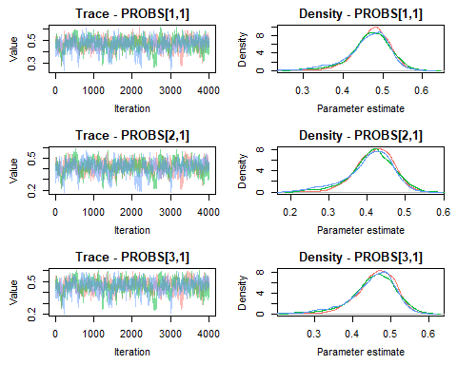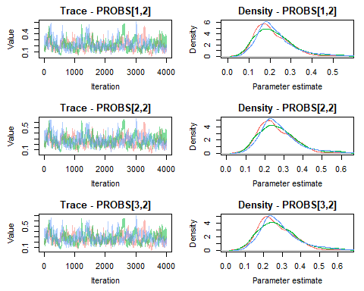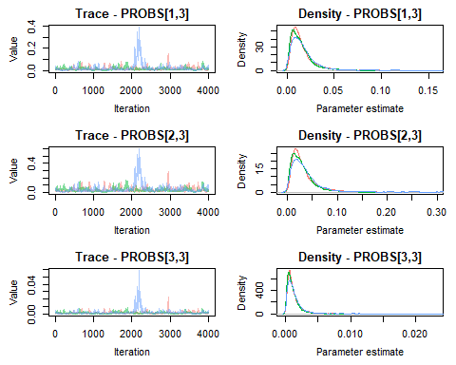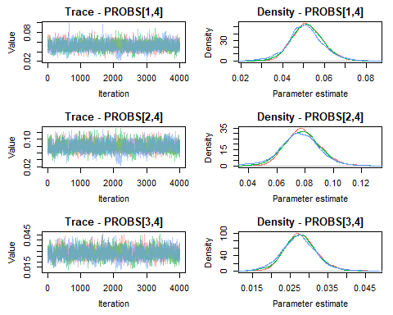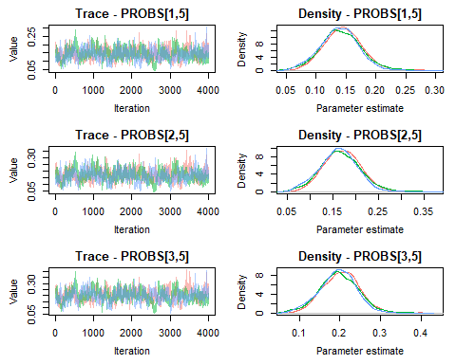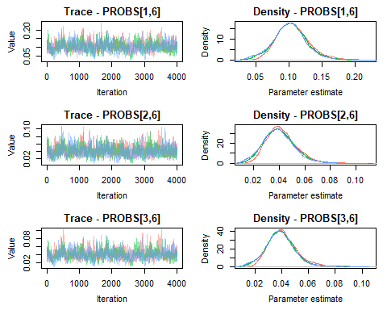

# Summarize values from the output, include median and highest posterior density intervals  
Post.Summary <- MCMCsummary(jm2,   
 params = 'PROBS',  
 Rhat = TRUE,  
 n.eff = TRUE,  
 func = function(x) c(median(x), hdi(x,credMass = 0.95)),  
 func_name = c('median','hdi_low','hdi_high'))  
  
# View  
Post.Summary

## mean sd 2.5% 50% 97.5%  
## PROBS[1,1] 0.468113507 0.050135112 0.3452597673 0.4734731573 0.550999899  
## PROBS[2,1] 0.412829706 0.056517746 0.2745183875 0.4184394258 0.508337790  
## PROBS[3,1] 0.457625815 0.055933091 0.3212907639 0.4643137082 0.549171356  
## PROBS[1,2] 0.216809019 0.085196304 0.0895645411 0.2020092299 0.432806209  
## PROBS[2,2] 0.266603657 0.095630551 0.1174171623 0.2521404296 0.501278263  
## PROBS[3,2] 0.275144186 0.098604799 0.1191237348 0.2603164587 0.514106643  
## PROBS[1,3] 0.018326837 0.024946374 0.0023479532 0.0129520502 0.061618395  
## PROBS[2,3] 0.035925363 0.042428739 0.0048273645 0.0262523740 0.118965229  
## PROBS[3,3] 0.001443507 0.002449803 0.0001620766 0.0009441542 0.005008333  
## PROBS[1,4] 0.051589352 0.007901954 0.0364024338 0.0512907991 0.068137846  
## PROBS[2,4] 0.077508261 0.013134097 0.0518954936 0.0772909189 0.103976892  
## PROBS[3,4] 0.027638896 0.004363375 0.0192060030 0.0275097856 0.036824139  
## PROBS[1,5] 0.141843650 0.032305607 0.0783893372 0.1414830557 0.207005914  
## PROBS[2,5] 0.166594943 0.042005857 0.0844023524 0.1660314484 0.251141983  
## PROBS[3,5] 0.198551854 0.046000670 0.1068223736 0.1988336212 0.289789908  
## PROBS[1,6] 0.103317636 0.024623812 0.0560820141 0.1022779477 0.157068763  
## PROBS[2,6] 0.040538070 0.011950662 0.0192955049 0.0396090680 0.066787881  
## PROBS[3,6] 0.039595742 0.010610692 0.0201969014 0.0390113913 0.063077288  
## Rhat n.eff median hdi_low hdi_high  
## PROBS[1,1] 1.01 350 0.4734731573 3.542915e-01 0.555413205  
## PROBS[2,1] 1.02 281 0.4184394258 2.952800e-01 0.521764882  
## PROBS[3,1] 1.01 280 0.4643137082 3.402847e-01 0.560328977  
## PROBS[1,2] 1.02 199 0.2020092299 6.536400e-02 0.383609795  
## PROBS[2,2] 1.02 198 0.2521404296 9.038427e-02 0.456527520  
## PROBS[3,2] 1.01 196 0.2603164587 9.965903e-02 0.477034804  
## PROBS[1,3] 1.25 206 0.0129520502 8.577084e-04 0.044343423  
## PROBS[2,3] 1.22 188 0.0262523740 1.957731e-03 0.088991221  
## PROBS[3,3] 1.26 235 0.0009441542 5.231638e-05 0.003625889  
## PROBS[1,4] 1.01 2045 0.0512907991 3.562382e-02 0.067180779  
## PROBS[2,4] 1.02 1255 0.0772909189 5.141142e-02 0.103370081  
## PROBS[3,4] 1.00 1566 0.0275097856 1.902358e-02 0.036545012  
## PROBS[1,5] 1.01 330 0.1414830557 7.404103e-02 0.201555545  
## PROBS[2,5] 1.01 270 0.1660314484 8.249655e-02 0.248447807  
## PROBS[3,5] 1.01 267 0.1988336212 1.027117e-01 0.284509023  
## PROBS[1,6] 1.01 428 0.1022779477 5.459032e-02 0.154456761  
## PROBS[2,6] 1.01 452 0.0396090680 1.752259e-02 0.064017782  
## PROBS[3,6] 1.01 368 0.0390113913 1.781983e-02 0.060169798

### Export Summary

Output Post.Summary to re-create Appendix A.

# Export file  
write.csv(Post.Summary, "./Output/jm2_Output_Summary.csv")

### Plot Results

Using the MCMCplot function, plot the probabilities of the behaviors with significant effects from the pre-treatment period. Again, here, it is important to keep track of the parameters output from the model. Note that the reference category (pre-treatment period) has been set to ‘0’. Thus, treatment and post-treatment periods are the probability of behavior in reference to this pre-treatment period. This allowed us to evaluate the general effect of each behavior. The code could be easily modified to plot all variables estimated. To save this plot to a directory, the command png() and dev.off() can be activated in the code.

# Plot the caterpillar plots from the MCMC output  
#MCMCplot(jm2, params = 'PROBS')  
  
# Set all the Labels  
main.label <- c("Head-Up", "Head-Down", "Laying", "Headshaking", "Locomotion", "Scratching")  
  
# Display only the graphs where a significant change occurred  
#png(file = "./Output/PROBS_variables.png",width=15, height=5, units = 'in', res=500)  
layout(matrix(c(1,2,3), 1, 3, byrow = FALSE), widths=1, heights=1)  
  
MCMCplot(jm2, params = c('PROBS\\[1,3\\]', 'PROBS\\[2,3\\]', 'PROBS\\[3,3\\]'), ref = Post.Summary[7,8],   
 ref_ovl = TRUE, ISB=FALSE,   
 main=main.label[3],  
 med_sz=1.5, thin_sz = 1, thick_sz = 3, ax_sz=2, main_text_sz=2,axis_text_sz=1.5,tick_text_sz = 1.5,   
 labels_sz = 2,  
 labels=c('Pre-Trmt','Trmt','Post-Trmt'), xlab="Probability",  
 mar = c(5.1, 6.1, 4.1, 2.1))  
MCMCplot(jm2, params = c('PROBS\\[1,4\\]', 'PROBS\\[2,4\\]', 'PROBS\\[3,4\\]'), ref = Post.Summary[10,8],   
 ref_ovl = TRUE, ISB=FALSE,   
 main=main.label[4],  
 med_sz=1.5, thin_sz = 1, thick_sz = 3, ax_sz=2, main_text_sz=2,axis_text_sz=1.5,tick_text_sz = 1.5,   
 labels=NULL, xlab="Probability",  
 mar = c(5.1, 6.1, 4.1, 2.1))  
MCMCplot(jm2, params = c('PROBS\\[1,6\\]', 'PROBS\\[2,6\\]', 'PROBS\\[3,6\\]'), ref = Post.Summary[16,8],   
 ref_ovl = TRUE, ISB=FALSE,   
 main=main.label[6],  
 med_sz=1.5, thin_sz = 1, thick_sz = 3, ax_sz=2, main_text_sz=2,axis_text_sz=1.5,tick_text_sz = 1.5,   
 labels=NULL, xlab="Probability")

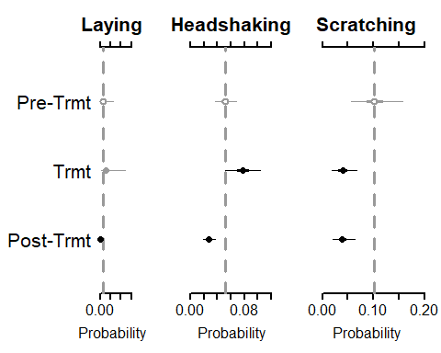

#dev.off()