
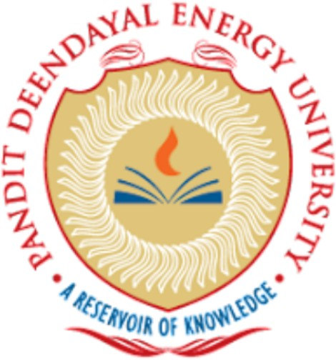
Smit Patel +91-9016974353
Roll No.: 23BCP115 smitptl5806@gmail.com
B. Tech 23bcp115@sot.pdpu.ac.in

Computer Science and Engineering GitHub Profile
Pandit Deendayal Energy University, Gandhinagar LinkedIn Profile

EDUCATION
- Pandit Deendayal Energy University, Gujarat 2023-2027
B. Tech in Computer Science and Engineering CGPA: 8.64
- A B School Chikhli , Gujarat 2023
- Higher Secondary (12th), Gujarat Board Percentage:76.62
- A B School Chikhli , Gujarat 2021
Secondary School (10th), Gujarat Board Percentage: 91.00

PERSONAL PROJECTS
- Job Portal Web Application
Technologies: Java, Spring Boot, React.js, MySQL, REST APIs
  - Developed a full-stack Job Portal web application using Spring Boot and React.js.
  - Designed RESTful APIs for user authentication and job management.
  - Implemented CRUD operations for posting and managing job listings.
  - Integrated MySQL database for persistent data storage.
  - Applied MVC architecture to structure backend services.

- Library Management System
Technologies: Core Java, OOP, Collections, File Handling
  - Developed a console-based Library Management System using Core Java.
  - Implemented Object-Oriented Programming concepts such as encapsulation and abstraction.
  - Utilized ArrayList to manage book records.
  - Implemented file handling for persistent storage of data
  - Designed menu-driven system for issuing and returning books

- React Quiz Application
Technologies: React.js, JavaScript, HTML, CSS
  - Developed an interactive quiz application using React.js.
  - Implemented dynamic question rendering using React hooks (useState).
  - Designed reusable components for quiz topic selection and question display.
  - Added progress tracking with a dynamic progress bar.
  - Implemented score calculation and result feedback system.

TECHNICAL SKILLS AND INTERESTS
Programming Languages: Java, JavaScript, SQL
Frameworks & Libraries: Spring Boot, React.js
Developer Tools: Git, GitHub, VS Code, Postman , Eclipse, Spring Tool Suite
Soft Skills: Problem Solving, Time Management, Attention to Detail
Areas of Interest: Backend Development, Full-Stack Web Development, Algorithms ,Generative AI

certificates
- Generative AI Internship – Prodigy InfoTech Jul 2024
- Understanding Incubation and Entrepreneurship – NPTEL (IIT Bombay) Oct 2025
- Amazon DynamoDB: Building a Serverless Web Application – AWS Jan 2026
- Create a Static Website with Amazon S3 – AWS Feb 2026

