Currency Converter Web Application
Project Report
Project Group: 27
Project No: 107
Class: SE_COMP_D
Division: D
Roll Numbers: 68, 69
Students:
Smit Patil
Shirin Shaikh
1. Introduction
A Currency Converter is a web application that converts one currency into another using the latest exchange rates. It is commonly used for financial transactions, international trade, and travel planning.
This project implements a Currency Converter using Java Servlets, JSP, and MySQL. The application retrieves exchange rate data from an external API and stores it in a database. The stored exchange rates are then used to perform currency conversions efficiently.
The system also allows exporting stored exchange rate data in CSV format for analysis and record keeping.
2. Objective
The objective of this project is to develop a web-based currency conversion system that can:
- Convert currencies using exchange rate data
- Store exchange rate data in a database
- Provide a user-friendly interface
- Export stored exchange rate data in CSV format
3. Technologies Used
The following technologies were used in this project:
- Java (Servlets)
- JSP (Java Server Pages)
- MySQL Database
- Apache Tomcat Server
- Frankfurter Exchange Rate API
- HTML and CSS
4. System Architecture
The system follows a client-server architecture.
- The user opens the currency converter web application.
- The user enters the amount and selects the currencies.
- The request is sent to the Java Servlet.
- The servlet retrieves exchange rates from the database.
- If required, the system fetches data from the exchange rate API.
- The conversion is calculated and the result is displayed.
- Users can download stored exchange rate data as a CSV file.
5. Use Case
Actor
User
Steps
- User opens the Currency Converter application.
- User enters the amount to convert.
- User selects the source currency.
- User selects the target currency.
- System retrieves exchange rate data.
- System calculates the converted amount.
- Result is displayed to the user.
- User can export stored exchange rate data as a CSV file.
6. API Used
This project uses the Frankfurter Exchange Rate API.
API Website
https://www.frankfurter.app/
Example API endpoints:
Latest exchange rates
https://api.frankfurter.app/latest
Latest exchange rates for a specific currency
https://api.frankfurter.app/latest?from=USD
Historical exchange rate data
https://api.frankfurter.app/2026-01-01..2026-03-09?from=USD
The API is used to retrieve exchange rate data which is stored in the MySQL database.
7. Application Screenshots
Currency Conversion
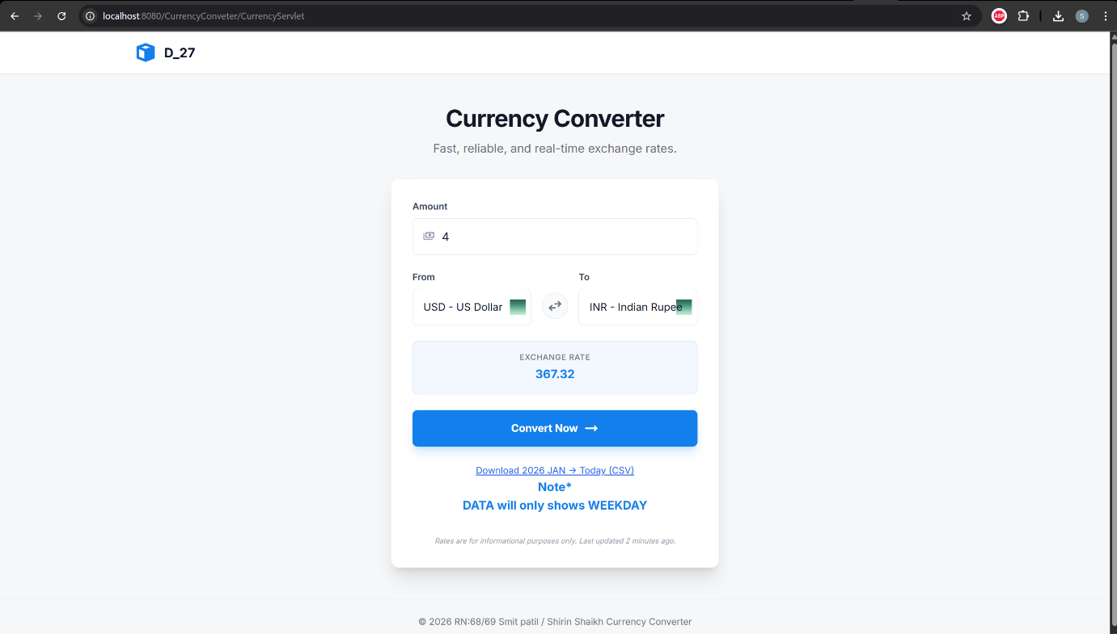
CSV Export
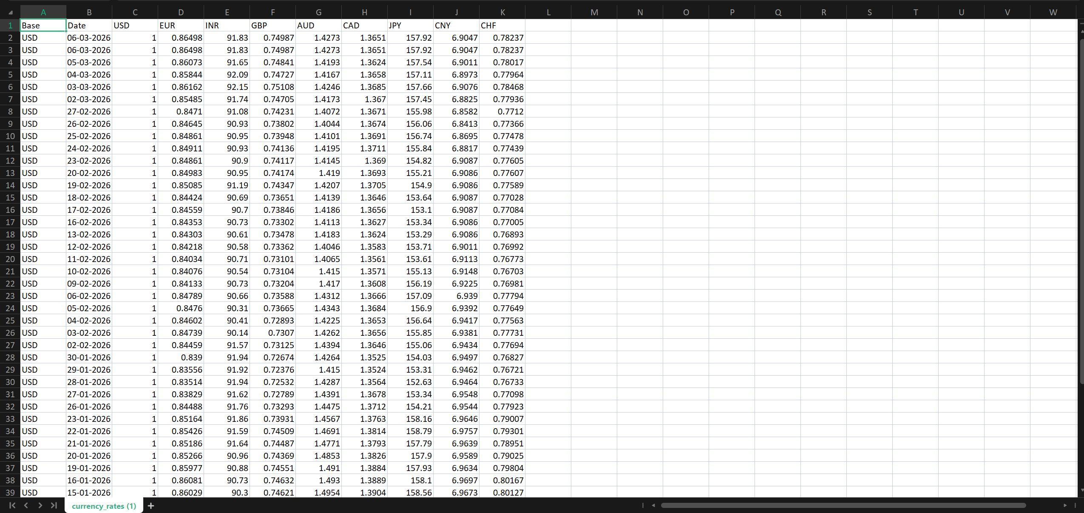
MySQL Database Table
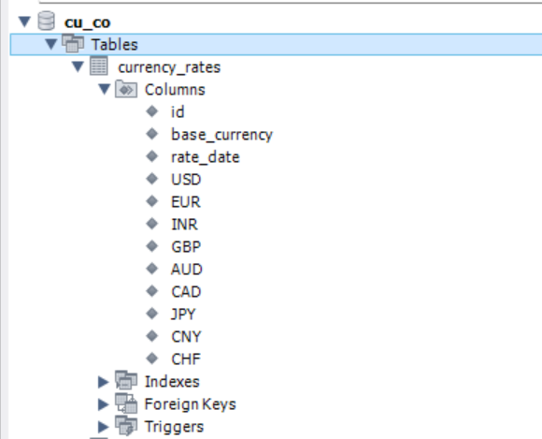

MySQL Database Records
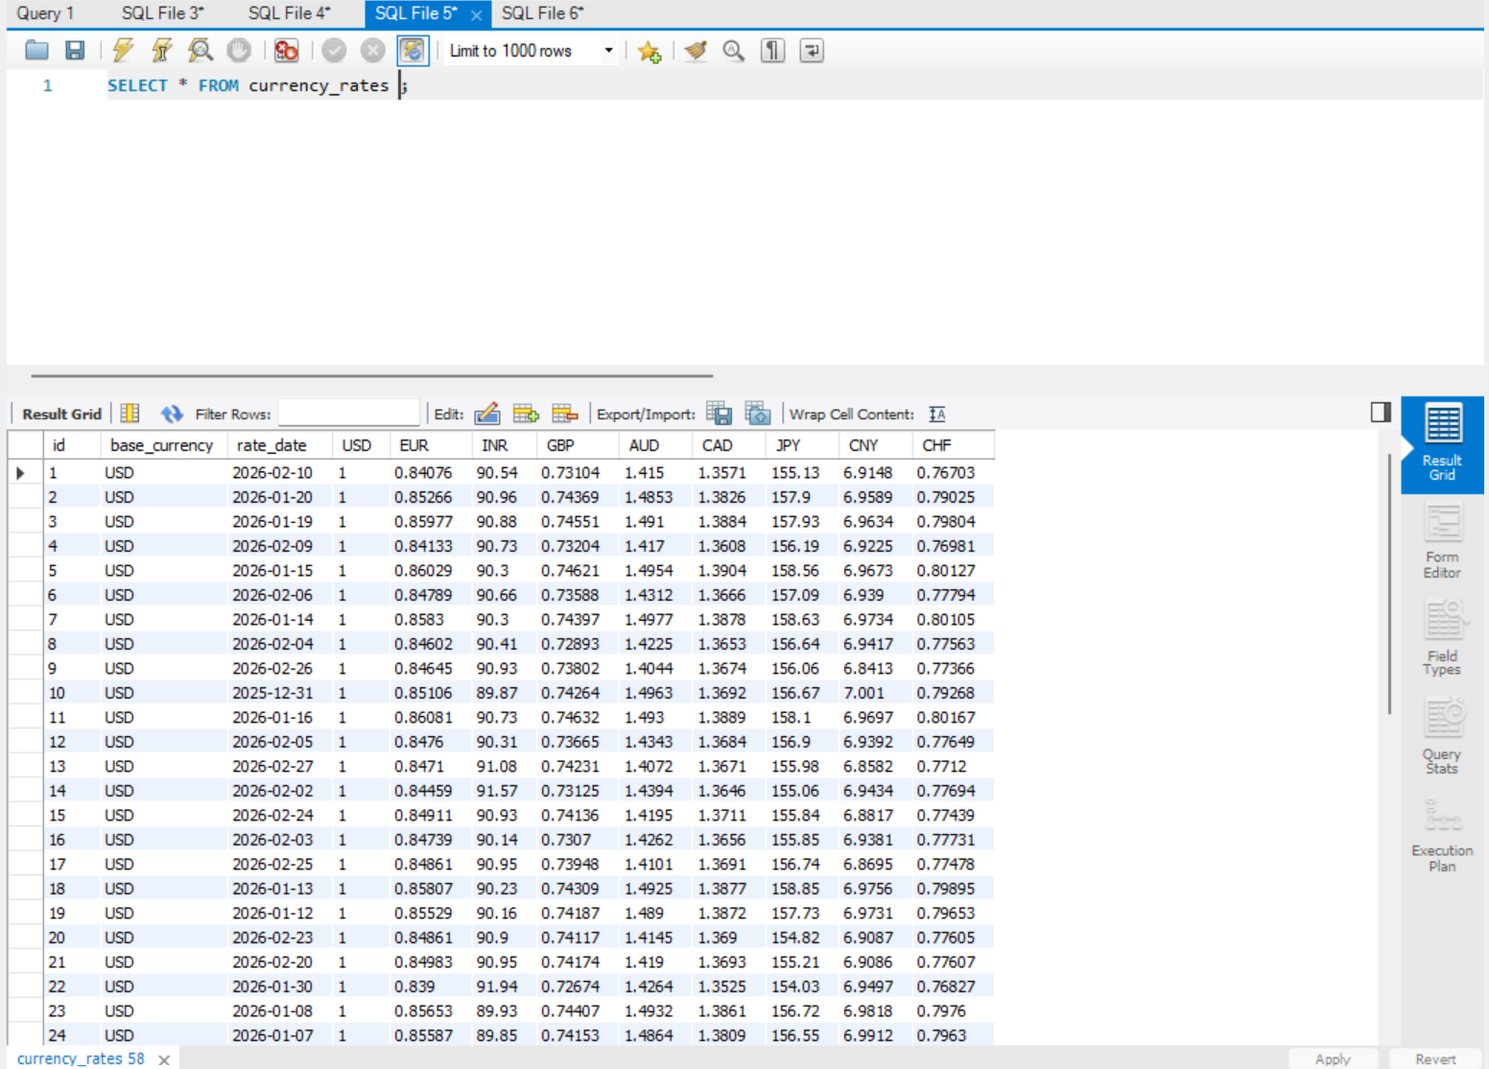
8. Test Cases
Test Case ID | Input | Expected Result | Actual Result | Status
TC1 | 100 USD → INR | Converted value displayed | Correct conversion shown | Pass
TC2 | Empty amount | Error message displayed | Error message shown | Pass
TC3 | CSV export | CSV file downloaded | File downloaded successfully | Pass
TC4 | Database storage | Exchange rate data stored | Data stored correctly | Pass

9. Conclusion
The Currency Converter web application successfully performs currency conversion using stored exchange rate data and external API integration. The system also allows exporting stored exchange rate data in CSV format.
This project demonstrates the integration of web technologies, databases, and external APIs to develop a functional web-based application.

10. Source Code Repository
GitHub Repository Link
https://github.com/SmitsPatil/CurrencyConvertor

