# CS 255 System Design Document Template

David Smith

Department of Computer Science, Southern New Hampshire University

CS 255: System Analysis and Design

Professor K. Foss

June 20, 2021

## UML Diagrams

### UML Use Case Diagram

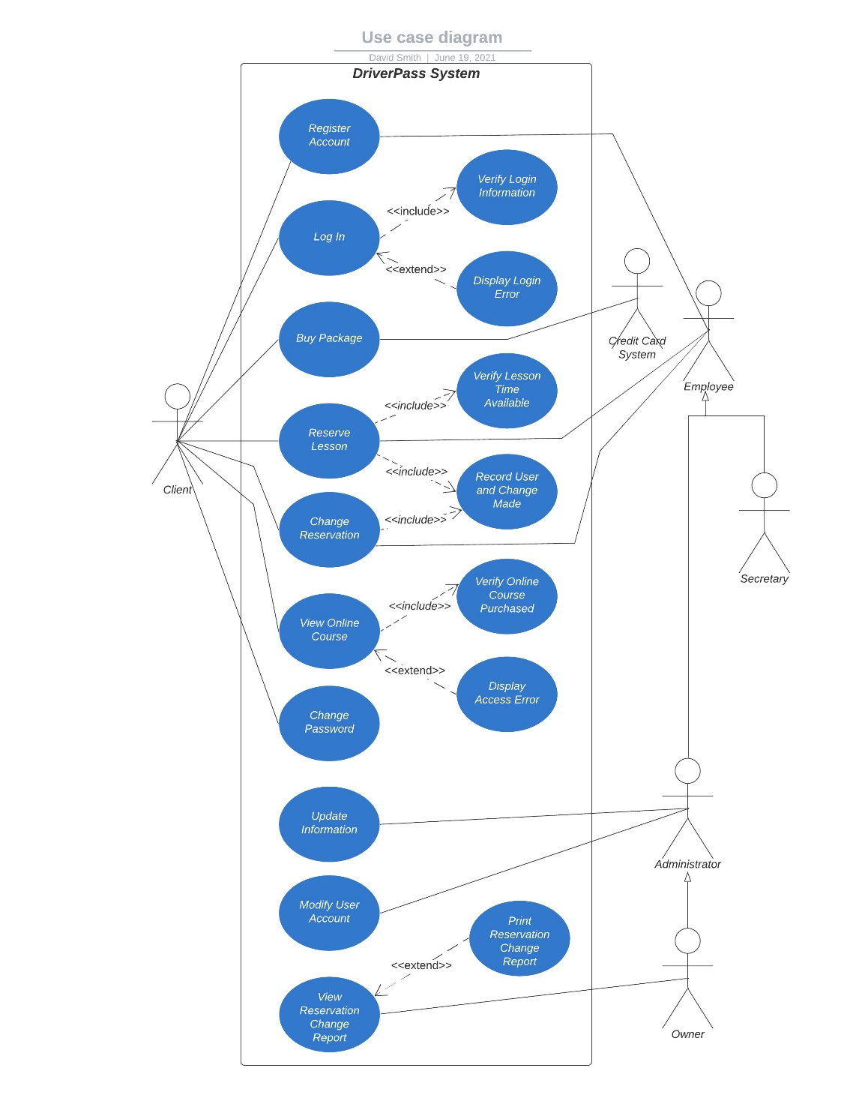

### UML Activity Diagrams

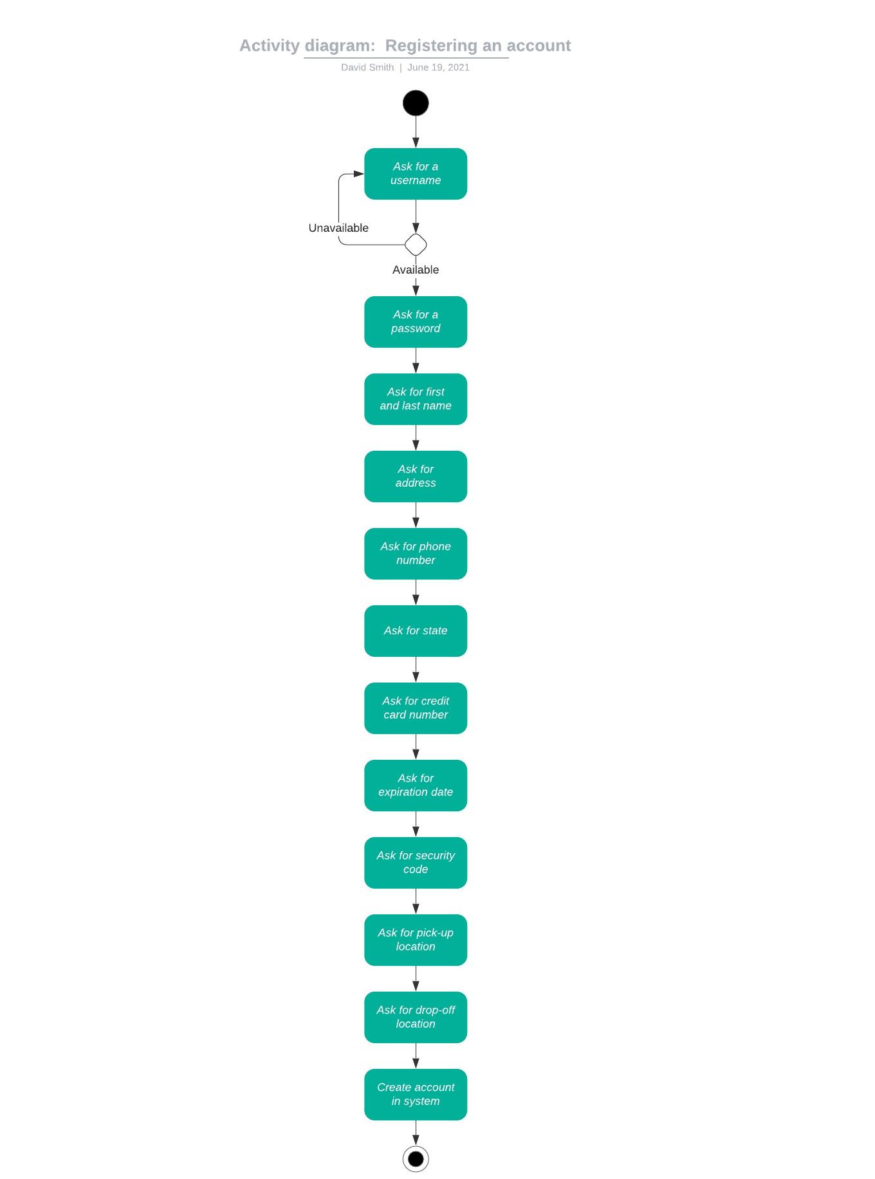

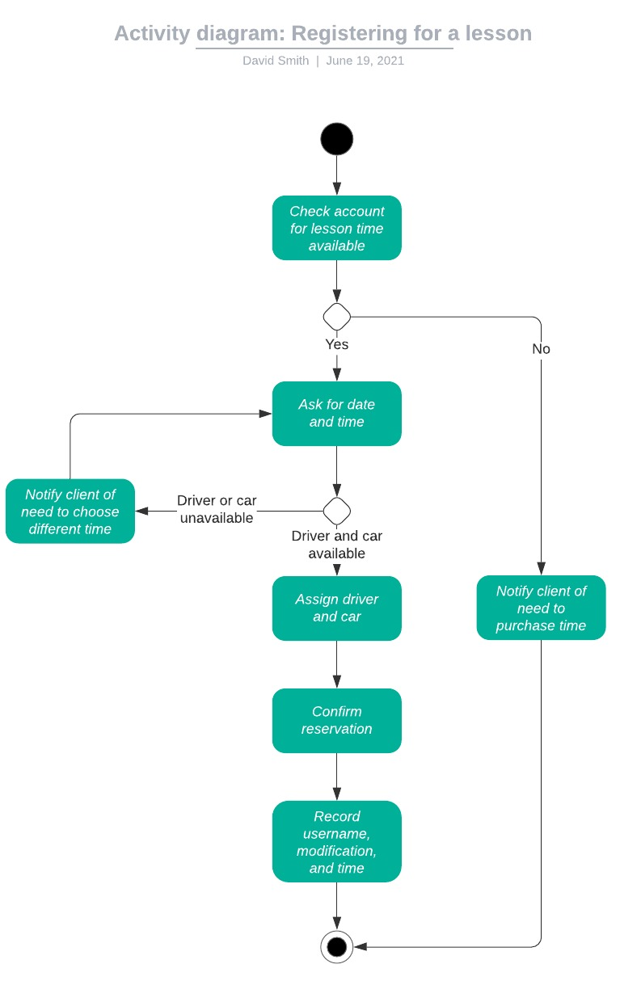

### UML Sequence Diagram

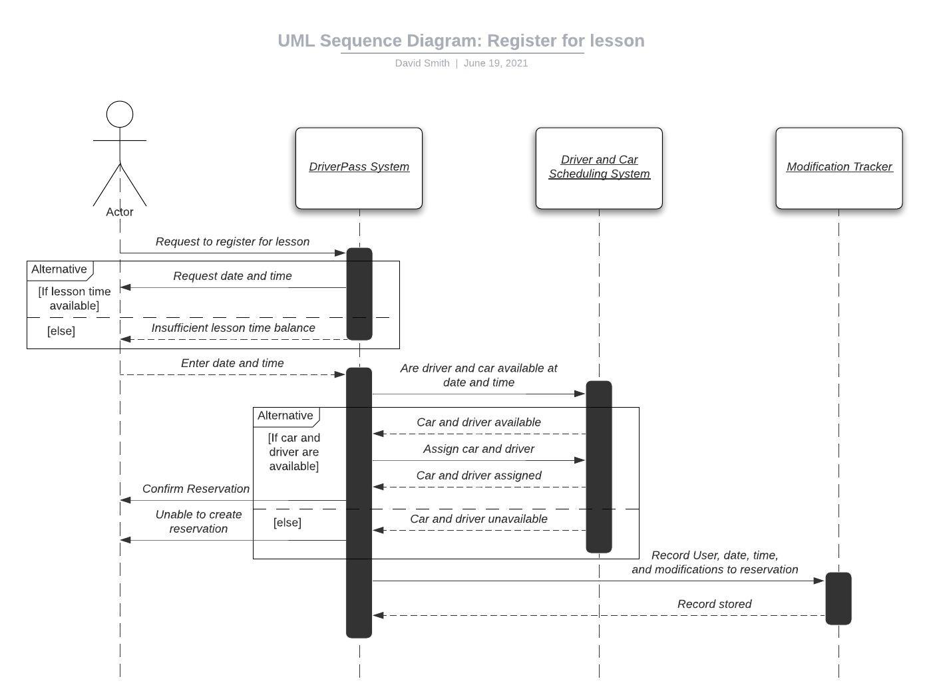

### UML Class Diagram

## Technical Requirements

* A cloud-based service to serve the application to users.
* The cloud-based service must handle platform security, backup, and restore operations.
* The cloud-based service must maintain system availability at all times.
* A database to store user, course, and scheduling information.
* An encryption algorithm to secure the information in the database.
* The system must be available to users on all computer and mobile device platforms if they have an internet connection.
* XLReporter will be used to export reservation data change reports as an Excel spreadsheet.
* The driver availability and reservation system is an external system in this model.
* The system must run with a valid SSL certificate to enable HTTPS secure communication. This is especially important as we are collecting payment information.