**Evaluating Bitcoin Investment Strategies: Leveraging the Fear Greed Index for Optimal ROI**

# Abstract

With the growing popularity of cryptocurrencies, increasingly more investment strategies and methods are coming about, looking to maximise ROI for investors. During this time, indices within the cryptocurrency space have also grown in popularity such as the Bitcoin Fear/Greed Index (FGI) developed by Alternative.me. This study looked to explore the relationship between Bitcoin and the FGI and following this, established it’s potential as a valuable tool within investment strategies. The correlation between the FGI and Bitcoin price was examined over a 6-year period, providing a wide range of market conditions. It was determined that the FGI effectively tracks Bitcoin price trends, however only in certain conditions. After establishing the correlation, four different strategies were evaluated including traditional Dollar-Cost Averaging (DCA) and HODL approaches, alongside additional strategies incorporating the FGI. Results showed that strategies incorporating the FGI, such as the HODL with FGI and pairs strategy, significantly outperformed traditional approaches, leading to substantially higher ROI. This study highlights the positive impact of using the FGI within investment strategies, providing valuable information for retail investors to capitalise on market conditions and improve their overall profitability in the cryptocurrency landscape.

# 1. Introduction

Amidst the surging popularity of cryptocurrencies, an increasing number of individuals are seeking ways to maximise ROI. In the United Kingdom, approximately 10% of the public currently owns at least one form of cryptocurrency, a figure expected to rise as more governments, businesses, and individuals venture into this domain [1]. Notably, even the Bank of England is considering the creation of its own cryptocurrency, known as the "Digital Pound" [2]. Among cryptocurrencies, Bitcoin has emerged as the poster child, boasting over 190 million users and 250,000 daily transactions [3]. Its popularity stems from the digitalisation of society and prevailing distrust in traditional banking systems, forged in the aftermath of the 2008 financial crisis [4]. Originally released as an open-source project by the pseudonymous Satoshi Nakamoto, Bitcoin operates without a centralised controlling authority, establishing itself as a decentralised currency for the people, by the people [5].

Bitcoin's widespread adoption has catapulted its overall market value beyond 326 billion USD, peaking at 1.28 trillion USD in November 2021 [6]. During this, the price of Bitcoin reached 69,044.77 USD, accounting for 48.14% of all cryptocurrencies at the time [7-9]. Bitcoin's exponential growth has been underpinned by its increasing scarcity, mainstream adoption, and halving events that periodically reduce mining rewards, introducing further scarcity and driving price increases [10,11]. The rise of cryptocurrency exchanges has also made Bitcoin more accessible to the masses, particularly attracting younger adults aged 18-40 who constitute 94% of cryptocurrency holders [12]. Many of these investors are keen on automating and maximising their investments, and for this purpose, long-term strategies such as Dollar-Cost Averaging (DCA) and the HODL approach have become prevalent [13,14].

The HODL strategy, inspired by its stock market equivalent, involves holding an asset with the expectation of long-term price appreciation, irrespective of short-term market fluctuations [15]. This term originated from a misspelling of "hold" in a 2013 Bitcoin forum post and has since become a mainstream investment term [15,16]. Whilst this has typically been known to generate strong profits, this strategy requires considerable mental discipline. This is especially important within Bitcoin where historical short-term price swings are prevalent [9]. Some examples include significant drops during the COVID-19 pandemic, 2022 war in Ukraine and ensuing economic recession [8].

Dollar-Cost Averaging (DCA) has also gained popularity due to its ease of use and potential for respectable profit margins, especially for retail investors [17,18]. DCA suggests investing small amounts of capital regularly, allowing investors to buy during market highs and lows, effectively averaging out their ROI [17,18]. For retail investors, DCA is particularly enticing as it enables them to invest continuously while maintaining full-time employment. Additionally, automated DCA through cryptocurrency exchanges provides convenience and further simplifies the investment process [14]. With Bitcoin's exponential growth, DCA has become a favoured strategy for its reliability in generating long-term profits [18].

In addition to these traditional strategies, some investors have explored the use of financial indices as tools to enhance their investment strategies [19]. Financial indices look at the soundness, stability and performance of a specific economy and have traditionally been used in stock markets [20]. Despite this, a growing number of indices focusing on cryptocurrencies have emerged. Among these is the Bitcoin Fear/Greed Index (FGI) developed by Alternative.me's cryptocurrency division [21]. The FGI combines multiple factors, including social media sentiment, market volatility, search trends, market dominance, and trading volume, into a single sentiment value, providing insight into the overall market conditions for Bitcoin [21]. With a substantial following on Twitter and prevalence within the cryptocurrency community, the FGI has gained popularity as a valuable sentiment index [22]. Due to this, the FGI was used for the basis of a novel investment strategy in this study. Furthermore, the detailed construction of the index available also validates it for this usage.

As the popularity of cryptocurrencies continues to rise, the question of whether financial indices can be adapted for retail investment gains significance. This study aims to explore the potential of the FGI as a valuable tool for optimising Bitcoin investment strategies, whilst mitigating issues discovered from existing literature. Correlation between the FGI and Bitcoin price is calculated throughout a number of years and Bitcoin market conditions; these parameters were not accounted for in previous studies; thus, their inclusion creates for a robust methodology. A novel Bitcoin investment strategy was devised, utilising FGI values at its core. By examining the performance of this alongside other investment strategies such as DCA and HODL, it is determined whether the FGI can yield greater ROI. This research should empower retail investors to make informed decisions, capitalise on market conditions, and enhance their overall profitability in the ever-evolving cryptocurrency landscape.

# 2. Background

Limited research is available surrounding the use of financial indices, specifically the FGI, for cryptocurrency investment purposes. A previous study using complex classification models based on technical indicators, similar to a financial index, yields promising ROI but falls short when compared to the HODL strategy [19]. This study fails to account for key issues when trading with Bitcoin, such as transaction fees and Bitcoin volatility, which are essential to consider [23]. Furthermore, only an evaluation of the win to loss ratio of days are examined, regardless of their return values [19]. Whilst no primary literature was found surround the use of the FGI, one grey literature study was discovered. Johnson [24] establishes that the FGI is not effective within investment decisions when trying to predict future prices, but again contained a number of errors. The main limitation is the consideration of using FGI for future predictions, which it does not contain the ability to do [24]. The FGI simply provides an overview of current market conditions, so to suggest that it could be used to predict future prices bears no meaning [21]. This study also contained other issues such as using the Bitcoin FGI for other cryptocurrencies for which it is not relevant, and only utilising a limited time frame[21,24]. Furthermore, the time frame chosen is where Bitcoin hit the highest price in its history. This is not typical market conditions and would drastically have altered the results (Figure 1)[9,24]. This study considers these issues and applies methods to mitigate and nullify the effects. This includes utilising the maximum length of data to ensure accuracy, and evaluating ROI which is the main factor for retail investors.

**Figure 1. Logarithmic Price History of Bitcoin [9]**

Due to the exponential increase of Bitcoin price, a logarithmic y axis has been used to better visualise trends.

# 3. Experimental Dataset

To develop an evaluation of FGI performance regarding Bitcoin investment, two datasets were required. The first of these was the daily values of the FGI. This has two official sources, Alternative’s website, and their related Twitter account [21,22]. While the Twitter account has large set of FGI values, the web API that can be accessed via their website contains a larger period of data, containing an additional 515 days' worth of values. This data, however, has missing values between 14/04/2018 and 16/04/2018 with no known cause. During this time frame, the FGI increased by 3 and the price of Bitcoin increased by 0.55% [21]. This suggests that no significant changes are likely to have occurred and following this; no attempt was made to estimate the values during this time. The data that was obtained from Alternative’s web API was also copied locally. This ensured that the values could not be altered or added to, which may have affected the project as it progressed. Due to this, the FGI values end on the date 08/04/2023. Overall, 1890 FGI values were able to be obtained, with an overall range between 5-95. This data should provide enough insight to be able to establish trends and performance statistics when compared to Bitcoin price.

The second dataset to be obtained was a list of the historical prices of Bitcoin. This was acquired from Kaggle and contains Bitcoin price data from 17/09/2014 onwards [25]. This date range successfully overlaps with the FGI data, allowing it to be used in the evaluation. The dataset includes daily price observations with the relative date, however, only the open price and date will be used for each day. This is because cryptocurrency trading occurs constantly, contrary to traditional stock trading which has specific market hours. Following this, the Bitcoin close price for one day will always equate to the open price of the next, which in this dataset, occurs at 0:00 UTC. With the daily FGI value being released at 01:00 AM UTC, the market open price is the closest price value that can be used to evaluate the FGI. Examining this dataset over the FGI data time frame, a Bitcoin price range between 3,236.27 - 67,539.70 USD can be observed.

Following the datasets being acquired these were then combined using the time frame of the FGI dataset. Using this, the opening date within the data contains a price of 10,237.30 USD with a FGI value of 30. Likewise, the closing date contains a price of 27,920.50 USD with a FGI value of 61.

# 4. Methods

## 4.1 Correlation

To understand whether the FGI could be used as an investment tool, the Pearson Correlation Coefficients between the FGI and Bitcoin price were calculated. The correlation was calculated for each of the years independently and was applied across the whole FGI data. Despite this, 2018 and 2023 are split years and thus, don’t include an entire years’ worth of data. This was calculated by first importing the datasets to dataframes within Python. The Pearson correlation values could then be calculated using the Pandas “corr” function. These values help to understand how close the FGI tracks the price of Bitcoin, if at all. Table 1 details what these outcomes show.

**Table 1. Pearson Correlation Results [26]**

|  |  |
| --- | --- |
| **Pearson Correlation (r)** | **Interpretation** |
| *r*=1 | Perfect positive linear correlation |
| 1>*r*≥0.8 | Strong positive linear correlation |
| 0.8>*r*≥0.4 | Moderate positive linear correlation |
| 0.4>*r*>0 | Weak positive linear correlation |
| *r*=0 | No correlation |

The FGI and Bitcoin price were also plotted together over each year to visualise similarities and differences between the two values. This also establishes any base trends and potentially reinforces the correlation results.

## 4.2 Profit Testing

Three different investment strategies were tested for their profit-making ability. These were HODL, DCA and a novel “pairs” strategy using the FGI. These strategies were tested with an original investment of 1000 USD to ensure that profits remained consistent. Additionally, these tests cover the entire FGI date range and assume that on the most recent date, the Bitcoin holdings were sold. This provides a monetary input and output value for each method, which can be used to calculate overall profits. The methods tested also account for any additional trading fees. These typically range from 0.1% to 1.0% per transaction [27]. To keep these consistent the fees from the most popular exchange, Coinbase, were used which was 1.0% [28]. After the profits of each strategy have been established, these can be compared to establish the effectiveness of each for retail investors.

### 4.2.1 DCA

DCA can be executed using several different time frames. Monthly DCA was chosen due it providing a good balance between transaction fees and overall price breadth. 62 months were present in the FGI dataset, resulting in the 1000 USD investment being separated into 62 equal amounts. This totalled 15.96774194 USD per month after accounting for fees. To test the profitability of DCA, this amount of Bitcoin was acquired on the first day of each month, between 2018 and 2023. Furthermore, information regarding the transaction was recorded, including the Bitcoin price and amount spent. After processing all 62 months, the overall Bitcoin amount was converted to USD to provide a profit value. With the DCA strategy utilising a fixed timeframe-based method, it isn’t possible to integrate the FGI within this. Therefore, only the profit monthly DCA will be calculated.

### 4.2.2 HODL

Two separate methods were used to calculate profits generated from the HODL strategy. The first method followed the traditional strategy of purchasing a large amount (1000 USD) and holding it over the entire FGI data duration. The second method followed a similar approach whilst also integrating the FGI values. To execute this method, 100 separate tests were established, one for each possible FGI values between 0-99. For each test, Bitcoin was purchased once the daily FGI value was beneath the FGI value given to the test. For example, if test 50 was initiated, each day of the FGI dataset would be iterated through until an FGI value of 50 or lower was present. Once this value had been reached, Bitcoin would be bought for the open price of that day with the maximum amount. Both methods follow the same fundamentals and the overall Bitcoin amount accumulated was sold on the final day to provide an overall profit value.

### 4.2.3 Fear/Greed Index Pairs

The final method performed used the FGI values to determine the buying and selling times. This required the creation of 4,950 “pairs” of values. These values ranged between 0-99 and corresponded to when Bitcoin should be bought or sold based upon the FGI value for that day. The pairs are displayed as “X-Y”, where X is the value to sell at and Y is the value to buy at. When these pairs were created, the buy value always had to be beneath the sell value. This ensured that a recurring loop could not be formed, whereby the method bought and sold every single day of the test. This also explains why the number of pairs is 4,950, rather than 10,000 as seen in Table 2.

**Table 2. FGI Pairs Data Structure**

|  |  |  |  |  |  |  |  |  |
| --- | --- | --- | --- | --- | --- | --- | --- | --- |
|  |  | **Sell FGI Value** | | | | | | |
|  |  | **1** | **2** | **3** | **4** | **5** | **6** | **…** |
| **Buy FGI Value** | **0** | 1-0 | 2-0 | 3-0 | 4-0 | 5-0 | 6-0 | … |
| **1** |  | 2-1 | 3-1 | 4-1 | 5-1 | 6-1 | … |
| **2** |  |  | 3-2 | 4-2 | 5-2 | 6-2 | … |
| **3** |  |  |  | 4-3 | 5-3 | 6-3 | … |
| **4** |  |  |  |  | 5-4 | 6-4 | … |
| **5** |  |  |  |  |  | 6-5 | … |
| **…** | … | … | … | … | … | … | … |

As the buy value cannot be equal to or above the sell value, any pair where this occurs is removed and not processed. This is shown as a blank value in the table. Only 6 values have been shown, however the ranges 0-99 were calculated for both values.

The number of pairs can also be calculated using the sum of natural numbers formula.

$$Sn = n/2 [a + I]$$

Sum of natural numbers formula used to calculate the number of pairs where n = 100, a = 0 and I = 99.

The same 1000 USD investment amount was used to remain consistent with other tests. This required a hypothetical bank to ensure that Bitcoin could not be bought if no money was present, and similarly, no Bitcoin could be sold if none had been bought. Furthermore, each transaction executed would always use the maximum amount available. For instance, if Bitcoin was to be bought and 1500 USD was stored in the bank, 1500 USD of Bitcoin would be acquired. This allows profit to accumulate over time and further highlights pairs that consistently create profit.

Once the data structure (Table 2) had been made, the pairs were iterated through each day in the FGI dataset. For each day, it was determined whether Bitcoin was being held or not. If no Bitcoin was held, then consequently no Bitcoin could be sold for that day. Similarly, if Bitcoin was held, no additional Bitcoin could be purchased on that day. Following this rule, the appropriate buy or sell function was checked. If the current FGI value was equal to or below the buy value, then the maximum amount of Bitcoin was bought with the banked USD. Likewise, If the current FGI value was equal to or above the sell value, all held Bitcoin was sold at the open price for that day to USD. When the current FGI value was between the buy and sell values no actions occurred, and the day was skipped. In the case of a transaction occurring, various values were stored. This included the date, whether Bitcoin was bought or sold, the current Bitcoin price and monetary value gained/lost. These rules were iteratively applied to each day in the FGI dataset until the final day was reached.

Once the end of the data had been reached, any remaining Bitcoin was sold for USD at the final Bitcoin price. If no Bitcoin was held at this time, then no further actions were taken. Following this, the profits were totaled along with the relevant pair designation. Figure 2 displays the main processes that occur when executing this strategy.

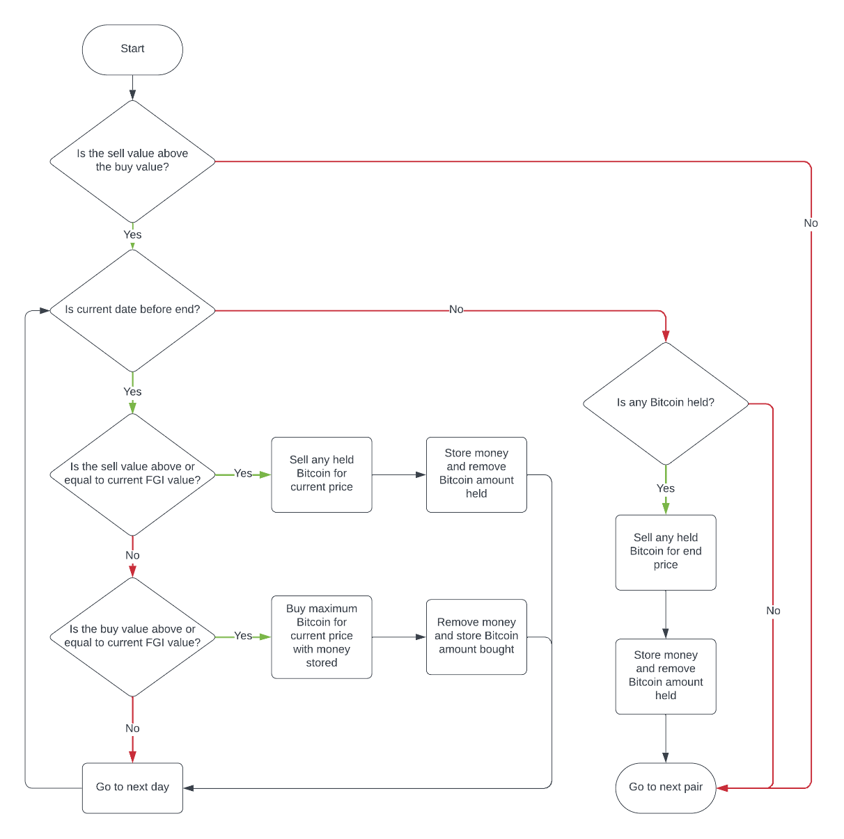**Figure 2. FGI Pair Investment Strategy**

Flowchart containing the main elements of the FGI pair investment strategy. This does not include variable specific and transaction fee information, both of which are accounted for within the strategy.

# 5. Results

### 5.1 Correlation

The Pearson Correlation Coefficients were calculated for each year of FGI data available (Table 3). The lowest value can be seen in 2019 at 0.125747, whilst the highest was in 2023 at 0.913808. Using the values provided by NCL, 2008 we can establish the correlation between Bitcoin and the FGI for each year. For years 2019 and 2022, only a weak positive linear correlation can be seen, with 2022 having a moderately higher correlation. Following this, 2018 and 2021 display a moderate positive linear correlation. 2020 and 2023 are the only years in which a strong positive linear correlation can be seen, demonstrating that the FGI followed the Bitcoin price more accurately for these years. Despite this large variance in correlation, the average weighted correlation across all 6 years is 0.487029 which displays a moderate positive linear correlation.

**Table 3. FGI Bitcoin Correlation**

|  |  |
| --- | --- |
| **Year** | **Correlation** |
| **2018** | 0.644096 |
| **2019** | 0.125747 |
| **2020** | 0.844289 |
| **2021** | 0.423489 |
| **2022** | 0.296590 |
| **2023** | 0.913808 |
| **Weighted Mean (2018-2023)** | 0.487029 |

The weighted mean accounts for 2020 containing 366 days due to the occurrence of a leap year. This also negates the effects of 2018 and 2023 containing less than a year’s worth of data.

Figure 3 shows the FGI and Bitcoin price plotted together from 2018-2023. These are separated by year and consequently the Bitcoin price axis fluctuates significantly. Throughout these charts, the price of Bitcoin is shown in blue and the FGI index value is shown in red. As the FGI data for 2018 and 2023 is limited, the time frames of these differ to other years.

**Figure 3. FGI and Bitcoin Price Correlation**

All 6 years of Bitcoin price and FGI values plotted together by year. These are in order top-left to bottom-right.

Throughout all 6 years, similarities between the Bitcoin price and FGI can be observed (Figure 3). This is especially apparent in 2018 and 2023, where the shorter time frames accentuates the pattern between the two values. For instance, at the end of February 2023 the FGI tracks the drop in Bitcoin price almost exactly, increasing similarly afterwards. This can also be seen in 2018 where the FGI accurately follows each dropping peak and lowering trough in price to a similar degree. As well as the shorter time frames, patterns can also be noticed in the full years. In 2021 the FGI accurately follows many of the Bitcoin price changes successfully, dropping significantly in May and increasing by a comparable amount in July and October. Despite these patterns, there are also places where both values show no discernable relationship. The most noticable of these is the large price increase at the end of 2020 that displays marginal difference in the FGI, despite the price of Bitcoin increasing by a further 200%. Similarly, between March and July of 2019, the FGI only increased by 20% whilst the Bitcoin price increased by 200%. Instances in which subsequent lower prices did not create a lower FGI value can also be distinguished. In August 2019 the marginal drop in Bitcoin price in caused the FGI to drop to 5, the lowest over the entire 6 year duration. However in November of the same year the price had dropped by a further 50%. In spite of this the FGI only reached 17, 12 higher than it was 3 months prior despite a lower Bitcoin price being reached.

### 5.2 DCA

Executing the DCA strategy over the 62-month period generated an overall profit of 1,530.35 USD (Table 4). Furthermore, before the end of the time period a total of 0.09154182 Bitcoin was accumulated.

**Table 4. Monthly DCA Strategy Profit**

|  |  |  |
| --- | --- | --- |
| **Investment Strategy** | **Bitcoin Accumulated** | **Profit (USD)** |
| **DCA** | 0.09154182 | 1,530.35 |

Bitcoin accumulated over the 62 months was sold on 08/04/2023 when the Bitcoin price was 27920.50 USD.

### 5.3 HODL

The traditional HODL strategy generated an overall profit of 1673.05 USD over the 6-year period (Table 5). This method purchased 0.09670518 Bitcoin on 01/02/2018 and subsequently sold 100% of this on 08/04/2022.

**Table 5. Traditional HODL Strategy Profit**

|  |  |  |
| --- | --- | --- |
| **Investment Strategy** | **Bitcoin Accumulated** | **Profit (USD)** |
| **HODL** | 0.09670518 | 1,673.05 |

Bitcoin price at the start and end dates was 10237.30 and 27920.50 USD respectively.

Figure 4 shows the profit generated by using the HODL strategy whilst utilising the FGI values. The lowest profit generated was 1,673.05 USD, which was achieved by using the 30-95 FGI values. In contrast, the maximum profit was 2,880.58 USD achieved when utilising the FGI values 8-10. The profits generated with the FGI values 5-7 are slightly higher than the values from 30 upwards, with a profit of 1,698.03 USD.

**Figure 4. HODL FGI Strategy Profit**

The FGI value axis ranges from 5-95 as the values outside this range do not occur in the FGI dataset.

### 5.4 FGI Pairs

The FGI pairs profit were calculated across all 4950 pairs and have been visualised as a heatmap (Figure 5). In the middle of the heatmap, several substantial profit points can be observed. The highest profit generated was by the pair 44-37 which had an overall profit of 9,843.16 USD and accumulated 0.33432987 Bitcoin (Table 5). The lowest profit generated was by the pair 94-91 which had an overall profit of -119.33 USD. Examining the upper sell value levels, a large dark patch can be seen. This is due to the FGI dataset not including a value above 95, which meant Bitcoin was never bought. Similarly, in the low buy value levels there are many pairs with 1,673.05 USD profit due to the FGI dataset not including a value below 5. This caused Bitcoin to be immediately bought on the first day and only sold on the last. Consequently, these pairs contain identical transactions and profit as the traditional HODL strategy.

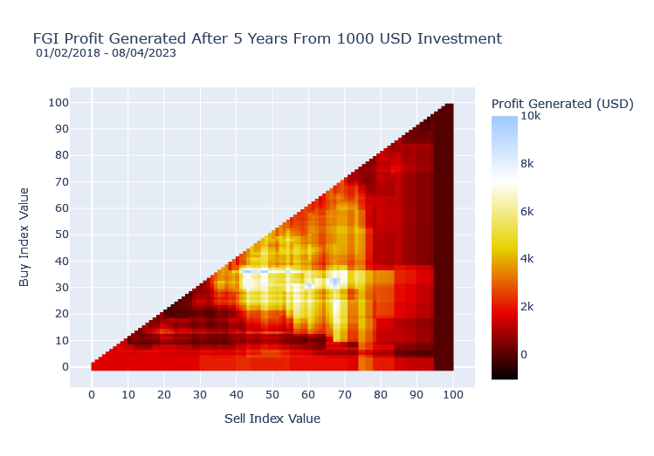**Figure 5. FGI Pairs Strategy Profit**

As the buy value for each pair had to be below the sell value, these were not calculated and therefore not shown within the figure.

**Table 6. Highest FGI Pair Profit (44-37)**

|  |  |  |  |  |
| --- | --- | --- | --- | --- |
| **Investment Strategy** | **Buy Value** | **Sell Value** | **Bitcoin Accumulated** | **Profit (USD)** |
| **FGI Pairs** | 44 | 37 | 0.33432987 | 9,843.16 |

As Bitcoin was continuously bought and sold, Bitcoin accumulated is the last value available before the final day concluded.

Figure 6 visualises the highest profit pairs from Figure 5, this helps to establish trends and patterns between those generating significant ROI. This contains the pairs with the sell value between 35-75 and buy value between 20-45. Here, the highest profit pair can be seen more clearly at 44-37 with other clusters showing similar profit levels. Following this, a high profit range can be established ranging between buy values 31-37 and sell values 42-71 with all pairs within this generating over 4000 USD profit. Furthermore, profit lines can be observed stemming from the major profit points, both horizontally and vertically.

**Figure 6. Concentrated FGI Pairs Strategy Profit**

Concentrated FGI profit heatmap focussing on buy values 20-45 and sell values 35-75.

Displaying the distribution of profits between the pairs also shows some interesting trends (Figure 7). A gradual increase can be seen between the 0-4,000 USD profit range, accounting for roughly 80% of the data. Following this, a sharp exponential increase can be seen for the 500 most profitable pairs. The profit for these rose from 5,000 to almost 10,000 USD, with 19 of those generating a profit over 8000 USD. 91.84% of the pairs produced a profit over the specified time range, compared to 8.16% that created 0 or less profit. Overall, only 14 pairs lost money with the rest breaking even or creating profit.

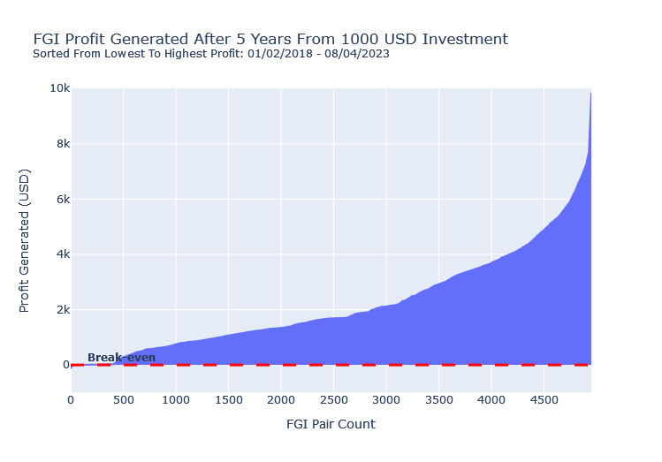**Figure 7. FGI Pairs Strategy Profit Distribution**

Pairs were sorted from lowest to highest profit for visualisation.

Each FGI sell value’s profit can be visualised to better understand the main profit levels (Figure 8). Here, a profit section can be seen between the sell values of 4-80. The highest average profit was achieved by the buy value 68, with an average profit of 4,520.64 USD. In contrast, the lowest average profit was achieved by the buy value 95 with an average profit of 659.87 USD. There is also a flat trend at the beginning of the graph which can be attributed to pairs that had identical transactions and profit to the HODL strategy. A slight decrease can be seen in the profits starting at sell value 10, reaching an average of 885.00 USD before increasing to the peak. Similarly, there is a 35% decrease in profits between sell value 61-65 which then increases to the highest average profit.

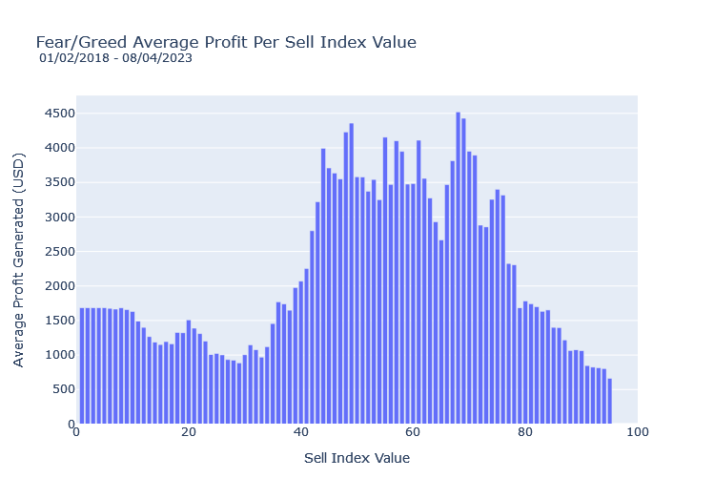**Figure 8. FGI Pairs Strategy Average Sell Value Profit**

Average profit generated for each sell value within the pairs. This covers all 4950 pairs.

As well as the sell value profits, the average buy value profits also provide valuable insight (Figure 9). Within these, there is a discernible peak with a slow decrease in profits over the remaining values. The highest average profit was 4,985.82 USD achieved by the buy value 37. However despite this, the average profit had subsequently dropped 51.4% by the buy value 40. The lowest of those containing data was 91 with an average profit of 11.04 USD. This also displays a slight dip in average profits starting at the buy value 4, before increasing to the peak.

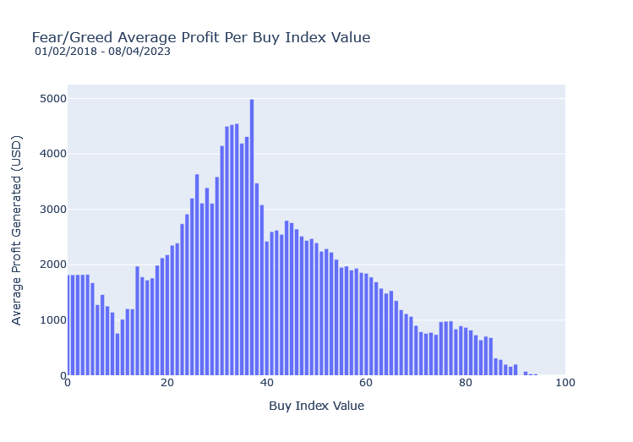**Figure 9. FGI Pairs Strategy Average Buy Value Profit**

Average profit generated for each buy value within the pairs. This covers all 4950 pairs.

# 6. Discussion

In the sphere of cryptocurrency investments, retail investors are continuously seeking more accessible and secure ways in which to allocate their portfolios. For this purpose, the present study attempts to assess the correlation between the FGI and the price fluctuations of Bitcoin, determining its practical utility. Additionally, this paper explores the potential integration of the FGI into novel and established Bitcoin investment approaches to gauge its potential impact in ROI.

Observing the FGI Bitcoin price correlation values and plots, in the majority of cases the FGI follows the trend of Bitcoin price effectively. However, this correlation appears to be entirely dependent on the timeframe, as well as the current market cycle. This is due to the exponential nature of Bitcoin price progression and the massive volatility that it displays. As Bitcoin reaches its previous all-time high (ATH), the FGI reaches the highest values within its range. However, following this, the Bitcoin price continues to increase whereas the FGI cannot move any higher, being limited within its 0-100 range. This break in correlation arises from notable shifts in the Bitcoin price range, leading to an alteration in the overall market depth. Consequently, the FGI’s ability to offer insights into Bitcoin market conditions is only effective over a macro time frame, providing valuable short-term tracking of Bitcoin’s price. Nevertheless, this does not imply that the FGI lacks utility. During periods of low Bitcoin volatility, the FGI correlation increases significantly, as demonstrated in the first three quarters of 2020 and final three quarters of 2021. This cements the FGI as a relatively effective tool within the Bitcoin space, empowering investors with valuable information to make informed decisions regarding their investments.

The profits from four distinct different retail investment strategies were calculated over a 6-year period. These strategies encompassed traditional DCA and HODL approaches as well as HODL and pair strategies which incorporated the utilisation of the FGI. Across these four strategies, each of them generated positive returns from the initial 1000 USD investment. This was to be expected given the 173% increase in Bitcoin price during the same time frame. Consequently, the rise in Bitcoin price can be recognised as a benchmark for overall profitability. Beginning with the HODL strategy it achieved an overall ROI of 167.3% (Table 5). Since this approach involved minimal trading activity, limited to a single buy and sell, its ROI closely mirrors the increase in Bitcoin price. However, the ROI was slightly reduced, primarily due to the incurred transaction fees amounting to 37.00 USD. On the other hand, the DCA strategy yielded an ROI of 153.0%, which was 14.3% lower than the HODL strategy’s overall ROI (Table 4). The DCA strategy also demands more effort to execute compared to the HODL strategy, rendering it less viable in this particular case. The decrease in profit can be attributed to the Bitcoins high prices throughout 2021 and 2022, followed by subsequent lower prices in 2023. Consequently, the DCA strategy purchased a significant amount of Bitcoin at prices considerably higher than the final Bitcoin price, leading to diminished profits. Future studies may benefit from considering different DCA time frames to potentially achieve a better average buy price; however, this may entail accumulating additional transaction fees.

While both traditional investment strategies yielded positive profits, they were significantly lower compared to those utilising the FGI. Examining the HODL with FGI strategy, the highest ROI generated was 288.0%, a substantial 82.1% increase compared to the traditional HODL strategy (Figure 4). Notably, all the HODL FGI values below 30 produced higher profits, whereas those above 30 generated the same profit as the traditional strategy. However, utilising the highest profit values resulted significantly greater gains with minimal additional effort required.

Similarly, the pairs strategy also outperformed traditional investment approaches, with the most profitable pair being 44-37, generating an overall ROI of 984.4% (Table 6). This monumental profit stands as the highest across all four investment strategies, surpassing the HODL strategy by 484.8% and the DCA strategy by 522.3%. This is despite incurring significantly higher transaction fees due to increased trading, with the most profitable pair totalling 3303.12 USD. The pairs strategy was able to facilitate consistent profit-taking throughout the entire time frame, leading to the substantial increase in ROI. Consequently, the pairs strategy better capitalised on the significant increases and drops in Bitcoins price. Despite this, while this pair generated significant profit in this instance, that is not to say that it would perform just as well during a different timeframe. Furthermore, these findings use an investment amount of 1000 USD, however if this amount were to change the ROI would remain at 984.4% due to the linear nature of the strategy. Whilst this wouldn’t increase the ROI, utilising a cryptocurrency exchange which has lower transaction fees would substantially increase the ROI generated. When lowering the transaction fees by 0.5% the total fees accumulated decrease by 38.1%. This causes the ROI to increase by a further 277.4% whilst utilising the same pair.

Both the HODL with FGI and pairs strategies highlight the positive impact of utilizing the FGI within investment strategies. Comparing all four investment approaches, those incorporating the FGI resulted in an average ROI that was 297.3% higher. Furthermore, the pairs strategy exhibited a considerable 514.7% increase over the average traditional strategy ROI. These findings imply the significant advantage that FGI can offer in enhancing investment outcomes. Despite this, it is essential to consider the time-limited nature of the FGI data available in this study, which allowed calculations for only a 6-year period. As more data becomes available in the future, the effectiveness of the FGI in investment strategies may evolve. Additionally, further studies will shed more light on the utility of the FGI in differing market conditions, potentially showing additional use cases for the index. Moreover, since news and information regarding the internal mechanisms of the FGI is limited, it is likely that the algorithm has changed and will continue to change in the coming years. Such changes could impact the FGI efficacy as an investment tool, making it imperative for investors to remain vigilant about its potential fluctuations in effectiveness.

Considering the significant ROI generated from strategies utilising the FGI, retail investors may benefit greatly from an automated system in which the FGI can be used to directly invest into Bitcoin[29]. This could revolutionise how Bitcoin investors look at their portfolios, establishing techniques which require less time to utilise and learn as well as significantly increasing ROI [29-31]. Future research may benefit from examining the FGI and additional cryptocurrency indices as well as their composition to establish the most effective index for both trading and information purposes. The findings of these should help to influence how retail and institutional investors alike can shape best practices in the relatively new cryptocurrency era.

# 7. Conclusion

This study aimed to determine whether financial indices such as the FGI could be utilised for Bitcoin investment purposes. The research conducted looked to compare existing investment strategies within Bitcoin to new novel strategies using the FGI, comparing the ROI to establish the success. Following the results, it can be established that there is a clear relationship between the FGI and the price of Bitcoin, however, only during certain timeframes and market cycles. Furthermore, strategies which utilised the FGI created a significantly higher ROI than those which did not with a novel pairs strategy performing substantially better than those already being utilised within cryptocurrency. Regarding these findings, this study looks to encourage the possible integration of financial indices, notably the FGI, into investment strategies for retail investors either independently or alongside other techniques. This use of this can potentially lead to more informed and profitable decision making.

# References

1. Financial Conduct Authority. FCA introduces tough new rules for marketing cryptoassets Available online: <https://www.fca.org.uk/news/press-releases/fca-introduces-tough-new-rules-marketing-cryptoassets> (accessed on 17 July 2023).

2. Bank of England. The digital pound: A new form of money for households and businesses? Available online: <https://www.bankofengland.co.uk/paper/2023/the-digital-pound-consultation-paper> (accessed on 27 February 2023).

3. Howarth, J. How Many People Own Bitcoin? 95 Blockchain Statistics. Available online: <https://explodingtopics.com/blog/blockchain-stats> (accessed on 26 February 2023).

4. Kostakis, V.; Giotitsas, C. The (A)Political Economy of Bitcoin. *tripleC: Communication, Capitalism & Critique* **2014**, *12*, doi:10.31269/triplec.v12i2.606.

5. Lemieux, P. *Who Is Satoshi Nakamoto?*; 2013.

6. GlobalData. Bitcoin’s Market Capitalization History (2013 – 2023). Available online: <https://www.globaldata.com/data-insights/financial-services/bitcoins-market-capitalization-history/> (accessed on 27 February 2023).

7. CoinGecko. Global Cryptocurrency Market Cap Charts. Available online: <https://www.coingecko.com/en/global-charts> (accessed on 17 July 2023).

8. CoinGecko. Bitcoin Price Statistics. Available online: <https://www.coingecko.com/en/coins/bitcoin> (accessed on 17 July 2023).

9. CoinCodex. Bitcoin (BTC) Historical Data. Available online: <https://coincodex.com/crypto/bitcoin/historical-data/> (accessed on 19 July 2023).

10. Wang, M. Bitcoin and its impact on the economy. **2020**, doi:10.48550/arXiv.2010.01337.

11. Meynkhard, A. Fair market value of bitcoin: halving effect. *Investment Management and Financial Innovations* **2019**, *16*, 72-85.

12. Gogol, F. Study: 94% of Crypto Buyers are Gen Z/Millennial, but Gen X is Outspending Them. Available online: <https://www.stilt.com/blog/2021/03/vast-majority-crypto-buyers-millennials-gen-z/> (accessed on 27 February 2023).

13. Waksman, A. Antitrust and Crypto Exchanges: Time to HODL. **2022**.

14. Maldini, A. Comparative Analysis Cryptocurrency Of Bitcoin, Stock, and Gold Return and Risks as Alternative Investments (2015-2020) *Financial Management Studies* **2022**, *2*, 34-48, doi:10.24036/jkmk.v2i2.76

15. Hubrich, S. 'Know When to Hodl 'Em, Know When to Fodl 'Em': An Investigation of Factor Based Investing in the Cryptocurrency Space. **2017**.

16. Yogarajah, Y. ‘Hodling’ on: Memetic storytelling and digital folklore within a cryptocurrency world. *Economy and Society* **2022**, *51*, doi:10.1080/03085147.2022.2091316

17. Luci, F.; Bernaschi, M. Algorithmic Trading Systems in Blockchain Era. **2022**, 26.

18. Wójcik-Czerniawska, A. Cryptocurrencies as a capital investment during the COVID-19 pandemic. *Zeszyty Naukowe WSB w Poznaniu* **2020**, *89*, 23–30.

19. Huang, J.-Z.; Huang, W.; Ni, J. Predicting bitcoin returns using high-dimensional technical indicators. *The Journal of Finance and Data Science* **2019**, *5*, 140-155, doi:10.1016/j.jfds.2018.10.001.

20. Canada, S. *Financial indicators from the National Balance Sheet Accounts: Update*; 2018.

21. Alternative.me. Crypto Fear & Greed Index. Available online: <https://alternative.me/crypto/fear-and-greed-index/> (accessed on 27 February 2023).

22. Twitter. Bitcoin Fear and Greed Index (@BitcoinFear). Available online: <https://twitter.com/BitcoinFear> (accessed on 17 July 2023).

23. Bukovina, J.; Martiček, M. Sentiment and Bitcoin Volatility. *MENDELU Working Papers in Business and Economics* **2016**, *58*.

24. Johnson, J. How Useful is the Crypto Fear and Greed Index When Making Cryptocurrency Investment Decisions. **2023**, doi:10.2139/ssrn.4407405

25. Samir, M. Bitcoin Historical Data. Available online: <https://www.kaggle.com/datasets/mixmore/bitcoin-historical-data> (accessed on 1 March 2023).

26. Newcastle University. Strength of Correlation. Available online: <https://www.ncl.ac.uk/webtemplate/ask-assets/external/maths-resources/statistics/regression-and-correlation/strength-of-correlation.html> (accessed on 17 July 2023).

27. Lodha, C. 2022 Crypto-Exchange Fee Comparison. Available online: <https://www.cointracker.io/blog/2019-crypto-exchange-fee-comparison> (accessed on 02 March 2023).

28. Coinbase. Coinbase Commerce Fees. Available online: <https://help.coinbase.com/en/commerce/getting-started/fees> (accessed on 26 February 2023).

29. Huang, B.; Huan, Y.; Xu, L.D.; Zheng, L.; Zou, Z. Automated trading systems statistical and machine learning methods and hardware implementation: a survey. *Enterprise Information Systems* **2019**, *13*, 132-144, doi:10.1080/17517575.2018.1493145.

30. Fang, F.; Ventre, C.; Basios, M.; Kanthan, L.; Martinez-Rego, D.; Wu, F.; Li, L. Cryptocurrency trading: a comprehensive survey. *Financial Innovation* **2022**, *8*, doi:10.1186/s40854-021-00321-6.

31. Mahayana, D.; Shan, E.; Fadhl'Abbas, M. Deep Reinforcement Learning to Automate Cryptocurrency Trading. *12th International Conference on System Engineering and Technology (ICSET)* **2022**, 36-41, doi:10.1109/ICSET57543.2022.10010940.