**Client Side:**

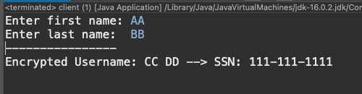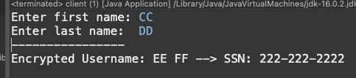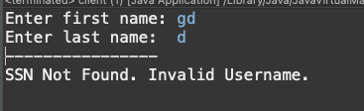

Client IP Address:

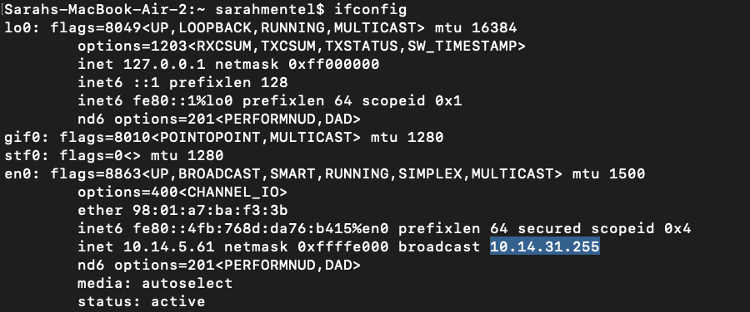

**Server Side:**

**WireShark:**

