CS401- Group Project completed by Sarah Mentel
The TCP Server is the main server that the client interacts with. The TCP Server will first ask the user for credentials and verifies them by accessing its login.txt file which has registered username and password details.
For a valid user, TCP Server then provides a menu to the client. The user, through the client program, then orders from the menu. The TCP Server then generates a receipt and returns it to the client.
The client will then send the user's credit card details in encrypted format to the TCP Server. TCP Server forwards it to UDP Server.
UDP Server validates the credit card info, notifies TCP Server of payment, and TCP Server confirms it to the client.

My code running with everything entered correctly
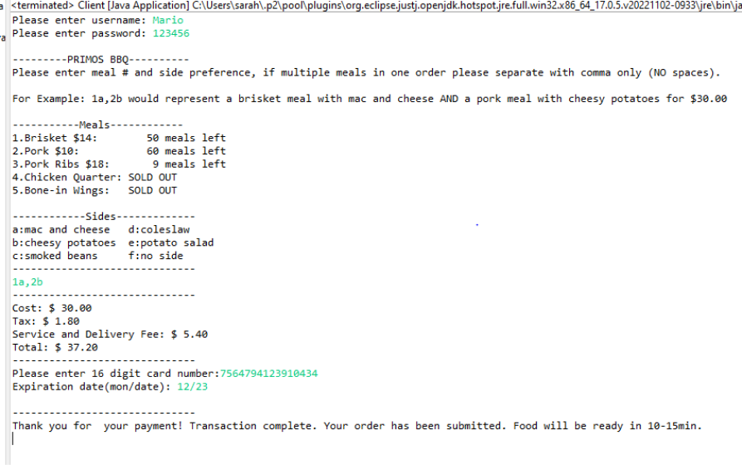
Invalid username/password
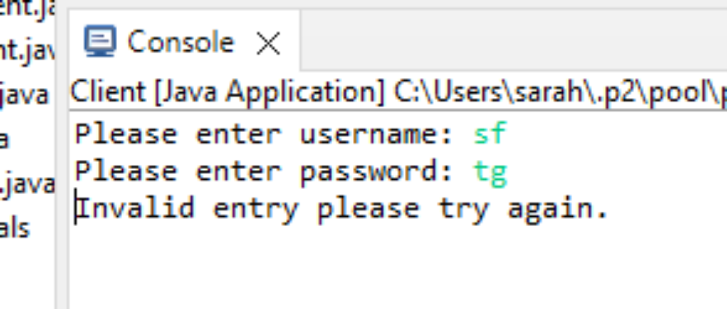
Invalid card input
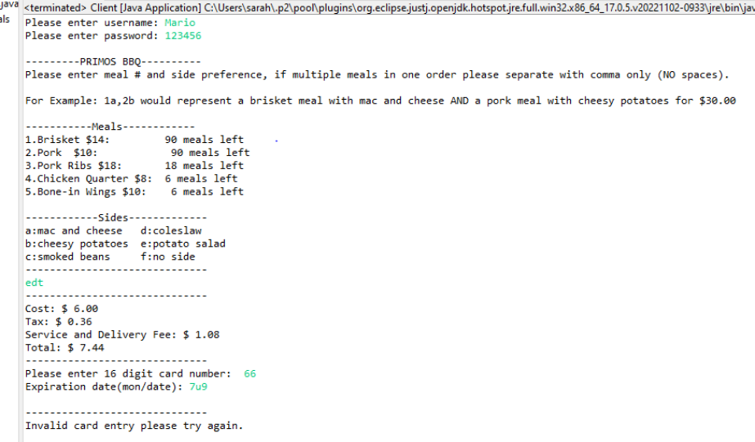

My issues/bugs with this code would be when user provides input for their order, I have no way to check if it is a valid string. I would argue that my limitations are using only java language, if i was able to have HTML and JavaScript I would be able to create a GUI for the user this would eliminate the possibility of ambiguity in placing an order.

