FlockTrax-Mobile iOS & Android initial beta release testing and version/build control documentation. Any fix that touches a build that has already been released will be included in a subsequent build release to that platform. Platforms are not required to be identical in their respective builds.

Version/Build States: iOS v1.1.0 (Build 7) 4/25/26 Android: v1.1.0 (open)
Submitted not Submitted

Document: BetaReleaseTesting,docx 4/27/26 kls
Method : The purpose of this document is to catalog and create detailed descriptions of issues discovered while testing. This document will also develop details about how the fix might be designed and user-facing changes that should be implemented.

Location: This section attempts to identify the source causing the issue. The info given here is from an educated user’s perspective.

Solution: From a UI perspective. A proposal of what might be a solution. Notwithstanding that proposal, more robust solutions should and can be discussed/developed. The driving factor is that the whatever solution is chosen…that it results in a premium user experience and/or a more secure database model.

Contents: (Detail explanations on following pages)

- Mobile* Mortality Display Popup feature on dashboard to display mortality history
- Mobile* Permissions Doesn’t appear permissions are implemented in mobile
- Admin Outbox New Function to manually change state of a sync line item
- Admin Outbox New Initial display filtered by date incremented by date.
- Admin Outbox Remove redundant column “Farm” Add “Username”
- Admin Sidebar When “…” was limited by Role, Super-Admin needs access/visibility
- Admin Placement Edit On edit form drop the “Female Start” to same line as “Male Start”
- Admin 7-day Popups Rename the field labels to “Roo / Hen” to avoid wrapping lines

- - Fixes will require new builds in released version
- Mobile* Mortality Display Popup feature on dashboard to display mortality history
Control: iOS – Next Build/Release Android – Implement now included in initial

Location: Mobile App
Dashboard Card List of Active, In-Barn Placements by Barn Code

Solution: New Feature to be added to the placement card for each displayed Barn / flock

Like the Admin Dashboard, add a button or icon button that will display a similar modal popup screen that displays the previous 8 days (inclusive of today) mortality as a reference for the user. The first day on the left should be (today – 8) incrementing by day and ending with the current date shown on the right most column. Modal popup should be titled “Recent Mortality History”

Future: a nice, enhanced feature of this popup could be the option with an (icon button) to email the output to the current user; of which the system already has his destination email address as his user identification reference. This would be applied to all popup displays. When executed this option should require no input or acknowledgement from the user. Success or Failure could simply be stated on the status bar output line.

- Mobile* Permissions Doesn’t appear permissions are implemented in mobile
Control: iOS – Next Build/Release Android – Implement now included in initial

Location: Mobile App
Throughout??

Solution: Initial test of the userid issued to Apple for Build Review was set to READONLY
Userid: reviewme@mothercluckershenhouse.com
Pswd: FlockTrax500
Enter in a placement daily record and type a couple of field entries. Was expecting that when I pressed SAVE LOG that I would get a msg that my permissions did not permit me to save entries to the database or msg that I was not authorized. Instead, the system saved the log daily record. The permissions model needs to be examined and applied to the mobile app.

- Admin Outbox New Function to manually change state of a sync line item
Control: iOS – Not effected Android – not effected
Location: Admin Console
Sync Outbox Queue
Solution: Need surfaced when I mistakenly added a log_entry date for a flock that was only set to Active but had not been checked into the barn yet (in-Barn = False) so that when the sync attempted to add the entry to the spreadsheet, the spreadsheet worksheet did not exist in the target. This was an original business rule that was assumed that the worksheet would exist before access was attempted. So now the outbox queue has 2 lines that show as “Failed” and will continue to increment the “attempts” counter (“Failed" rollup counter remains at 2). I noted the issue before thew first attempt was made and could have prevented the “Failed” condition if had the ability to set the task “Status” to “Suspended” and maybe the ability to change it back to “Pending” if a condition was fixed or simply left at “Suspended” forever. Implementation could be with a double+click action on the line and be presented with the ability to alter the “Status” I think only to “Suspended” or from “Suspended” to “Pending” and then to execute the sync for that single line only. That would allow an admin user the ability to work through a failed outbox line. So, with this new feature you would have option to change status:
Current --- New
Pending - Suspend
Suspend -Pending
Failed - Pending
Rejected - Pending

After allowing the user to alter the status present the user with ability to “Process this transaction now? "Y/N" or [CANCEL, NO & YES]: CANCEL stops all actions without changing status; NO updates the status but does not complete the transaction. While YES changes the status and processes that single line item.

- Admin Outbox New Initial display filtered by date incremented by date.
Control: iOS – Not effected Android – not effected
Location: Admin Console
Outbox Queue (New Feature)
More: The outbox listing is going to grow substantially with multiple users entering updates, I think a logical pathway to reduce the feel of the length is to only display the current date as a default filter and that one filter is available at the top of the listing maybe show the date being displayed as a locked field with a [+ & -] icon button to increment the listing forward by a day or backward. Should the user need to explore a wider range of days etc. if he was looking for a particular transaction, then he could access the advance filter inputs at the bottom of the list; which really should be truncated at a reasonable number of lines them pagination added.

- Admin Outbox Remove redundant column “Farm” Add “Username”
Control: iOS – Not effected Android – not effected
Location: Admin Console
Outbox Queue Listing
More: The current list shows COLUMN 2 is “Farm” and COLUMN 3 is “Endpoint” both have the exact same entry data. Change the COLUMN 2 Label & data to display “Username” of the user that caused the task to be placed into the queue.

- Admin Sidebar When “…” was limited by Role, Super-Admin needs
access/visibility

Control: iOS – Not effected Android – not effected
Location: Admin Console
Sidebar (Upper left corner)
“…” action item
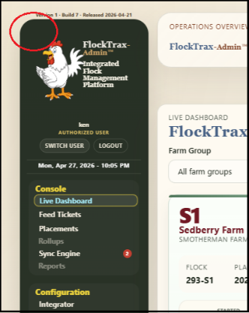
Solution: A change was applied immediately before committing build #7 for iOS where this access action was made invisible to everyone except those with a Role of Admin or Super-Admin. The “…” option would be available to both on the sidebar menu to access the sub-screen and the Super-Admin Role would also have visibility of the Platform settings on the lower portion of the sub-screen; while the Admin Role would only see the publc.app_settings and the configurable task reminders. Both need the sidebar “…” visible to access the sub screen.

I did just discover that the “…” does show on the main splash page, but when select an option from the sidebar…it disappears

- Admin Placement Edit On edit form drop the “Female Start” to same line as
“Male Start”
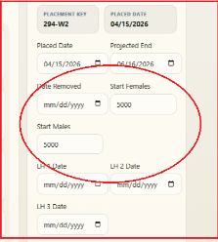
Control: iOS – Not effected Android – not effected
Location: Admin Console
Placements and Placement Wizard
Placement Edit form
Solution: When a flock is selected to be edited from the calendar control or from the placement list on the righthand mini-calendar sidebar, the START FEMALES Head Placed field is shown to the right of DATE REMOVED with the START MALES on the line below.

The START FEMALES needs to be displayed on the line below to the right of the START MALES. Should the length of the new MALE – FEMALE together line cause wrapping. It would be acceptable to change the labels to “Start: Males ______ Females _______”

- Admin 7-day Popups Rename the field labels to “Roo / Hen” to avoid wrapping
Lines

Control: iOS – Not effected Android – not effected
Location: Admin Console
Buttons on Placement Cards
[First 7-Day] & [Last 7-Days]
This is also listed in Option #1 of this document for Mobile App
Solution: The popup display has each day’s label listed as “Males/Females” this causes the narrow blocks for each of the 7 days to wrap and display the label as :
Males /
Females
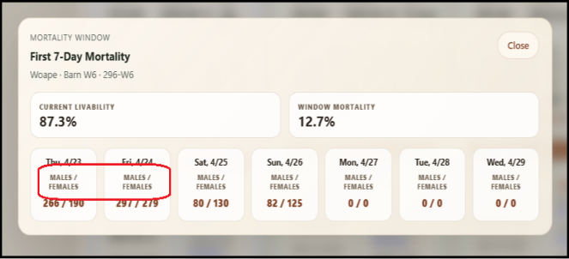
This makes the height of the modal popup window to be taller than is actually necessary and slightly less intuitive to the users, especially to a less tech savvy user. It would be more obvious and intuitive to have the labels look identical to the data being displayed if they appeared like the data (on a single line)

Change the label to “Roo / Hen”. It would also make the data a little clearer, if the data field that were EMPTY or NULL (meaning that there was not ever data initialized into those fields) that those days could be left with a “Blank Display” rather than a “0/0” as it currently written. Once values have been written by the mobile app for any of the fields, I believe the function writes zeros into the field if no value is given. In this case, display the “0/0”.

