Assignment – HTML

1. Create a Signup Page:

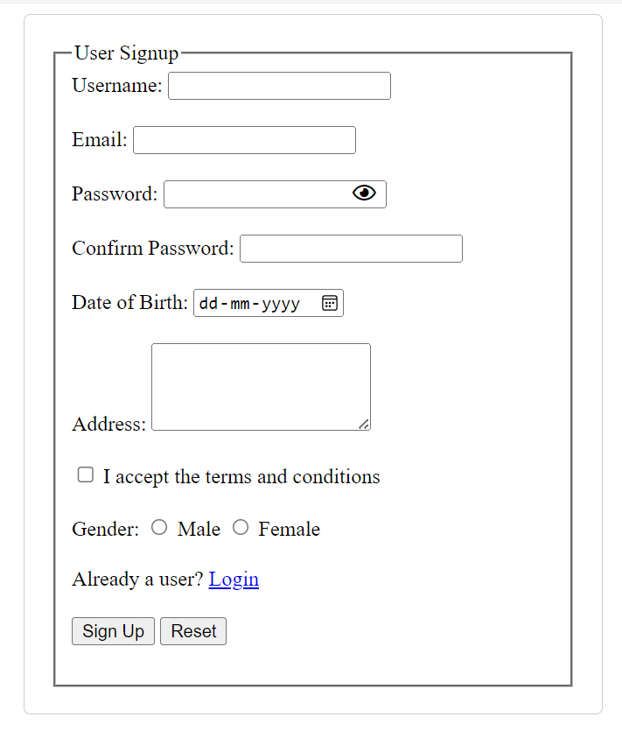

1. Apply CSS on the above form:

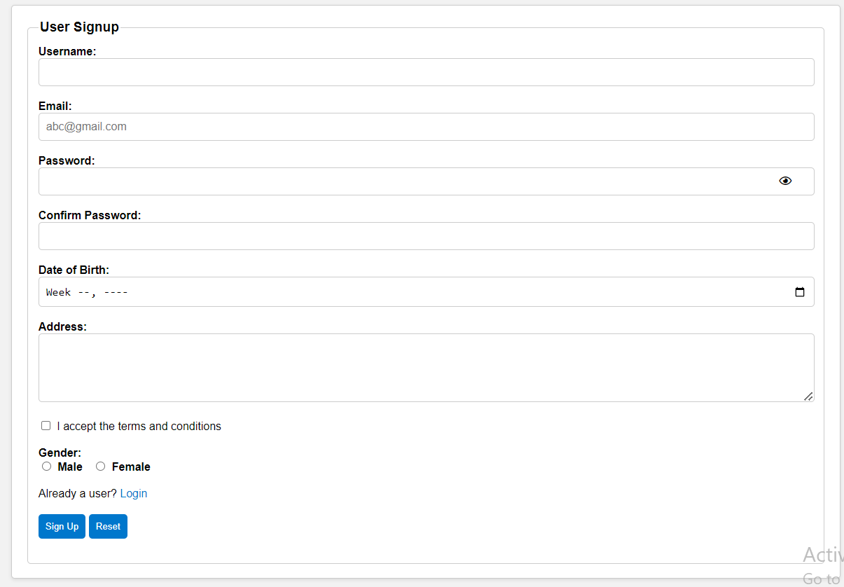

1. Create a page Layout

