The following text is an excerpt from John Belton’s book *American Cinema/American Culture*, pages 46-52.

**MISE-EN-SCÈNE**

Not every Hollywood film is so meticulous in its use of decor and mise-en-scène; *Citizen Kane,* for example, overwhelms the spectator with detail, much of which never finds its way into the narrative except as atmosphere. But films like *Shadow of a Doubt* reflect the general principles of narrative economy that informs the majority of Hollywood films and sets a standard for efficiency that a surprising number of narratives meet. Elements of fi lm style are not merely ornamental. They are not the superficial coating of a story that could be told in a thousand different ways. Classical Hollywood style becomes *the means by which* narratives are realized; it provides the formal system that enables them to be told. Elements of style serve to shape the narrative. They function to read it for the audiences. They draw attention to, underline, and point out what it is that the audience needs to see or hear in order to read or understand the scene.

I n presenting stories on the screen, the cinema relies on actors and actresses to stage events, much as they are staged in the theater. The term “mise-en-scène” describes this activity. Mise-en-scène encompasses a variety of categories related to the staging of action. These range from purely theatrical areas of expression such as set design, costume design, the blocking of actors, performance, and lighting to purely filmic techniques such as camera movement, camera angle, camera distance, and composition. Strictly speaking, mise-en-scène (or “put on the stage”) includes the relation of everything in the shot to everything else in the shot—of actors to the decor; of decor and actors to the lighting; of actors, decor, and lighting to the camera position; and so forth.

I n the theater, mise-en-scène serves as a reading of the action. Set design, costume, lighting, and the movement of actors are designed by the stage director (or producer) to present the ideas in the script to the audience in a more or less predigested way. That is, these elements of stagecraft, which are used to organize the drama, process the action for the audience. Mise-en-scène translates the contents of a scene into the language of the theater, producing a reading of the action that guides the audience’s attention in specific ways.

**THE CAMERA**

In the cinema, theatrical mise-en-scène provides a primary interpretation of the drama. Costume and set design become a reflection of character, as we saw in the introduction of Uncle Charlie lying fully dressed on a bed at midday in *Shadow of a Doubt.* Lighting becomes an extension of the character’s psychological makeup into the surrounding space. The shadow of the blind that falls over Charlie’s face becomes the “shadow” of his doubt, conveying the concern that creeps over him about the two men waiting outside for him in the street. The mise-en-scène’s theatrical reading of the action is driven home, in turn, by means of a variety of uniquely cinematic techniques such as camera position (which includes the camera’s angle on and distance from the action) and camera movement (which includes pans, tracks, zooms, and combinations of all three).

Thus, the low-angle shot of Uncle Charlie from below as he looks out of the window, coupled with the high-angle shot from above of what he sees (the two men outside), communicates ideas. The shots function in terms of both their narrative context and their relation to one another in a system of other shots to convey a sense of conflict or opposition between his view and physical position in space and theirs. These two seemingly insignificant shots help to set up the tense confrontation that follows, when Charlie walks directly toward, then past, the two men.

#### **Meaning through Context: Camera Angle and Distance**

Camera angle and distance become expressive devices as a result of their participation in systems of difference. They possess no absolute meaning but derive their meaning through a relative process that depends on the specific dramatic context in which they are used and their relation to other possible angles and distances. Thus, a low-angle shot, in which the camera looks up at the action, might acquire meaning through a process of association, becoming identified with a specific character or situation that it is repeatedly used to film.

At the same time, the particular meaning of a low-angle shot derives not only from the content of the shot but also from the relation of that particular angle to the other angles used in the fi lm, that is, from its place in a system of differences. Thus, a particular low-angle shot differs not only from other low-angle shots (which look up at different angles), but also from eye-level and high-angle shots, in which the camera looks at the action straight on or from above, respectively.

It is often tempting to view low- or high-angle shots in somewhat literal terms as descriptive of the relative power of a character; thus, when the camera looks up at a character, it (and we) occupy an inferior position in relation to that character. As a result, our impression of that character’s power or stature is thereby magnified. Similarly, high-angle shots automatically position viewers above the action, giving them a quasi-omniscient, quasi-omnipotent, god’s eye view of the action, indicating the relative weakness or inferiority of any onscreen character. However, this literal interpretation of camera angle proves to be rather limited, especially when it ignores the context in which the shot occurs.

Thus the low-angle shot of Charles Foster Kane (Orson Welles) in *Citizen Kane* (1941) as he stands in his deserted campaign headquarters and talks to his friend Jed Leland (Joseph Cotten) after his defeat in the race for state governor conveys contradictory ideas. Kane’s power and mystery are suggested in the camera angle—yet in losing the election he has just proven how vulnerable he is. The extremity of the low angle actually captures his powerful powerlessness, making it appear as if the character is about to topple over.

Something similar takes place at the end of *Ace in the Hole* (1951). The film’s central character, a newspaper reporter named Chuck Tatum

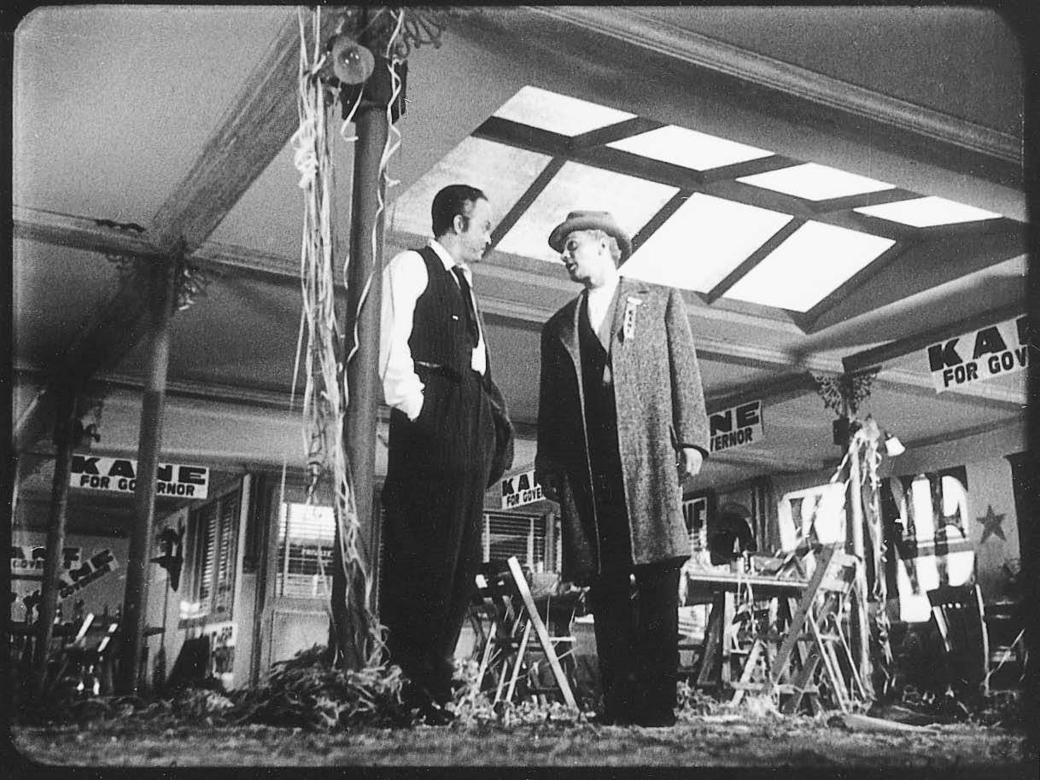

Frame enlargement by Kristin Thompson

A low-angle shot of Kane (Orson

Welles) and his friend Leland (Joseph Cotten) after Kane’s defeat at the polls.

(Kirk Douglas), turns the simple rescue of a man trapped in a cave accident into a sensational front-page story, then delays the rescue process in order to further his own career as a journalist.

After the man dies, Tatum is fatally wounded by the man’s wife. Back at his newspaper office, he renounces the fame he has won through his coverage of the story. As he does so, director Billy Wilder films him in an extreme low-angle shot. The exaggeration of the angle serves to caricature his excessive abuse of the power of the press and to look askance at his greed and self-interest; the shot concludes as Tatum drops dead on the floor, falling right into the camera. This particular low-angle shot can hardly be understood as a signifier of his power; rather, it dramatizes the terrible consequences of too much power.

#### **Systematic Meaning: Some Definitions**

At the same time, camera angle and distance determine meaning systematically. They participate in a system of differences that varies from fi lm to fi lm. Thus the extreme camera angles and distances employed in a Welles fi lm, such as *Citizen Kane,* differ significantly from the more moderate angles and distances found in a fi lm directed by Howard Hawks, such as *Bringing Up Baby* (1938) or *His Girl Friday* (1940). In *Kane,* the extreme close-up of Kane’s lips as he utters the word “rosebud” and then dies *underlines* the importance of that moment and that word in a way that would be unthinkable in a Hawks fi lm. In other words, the Welles system depends on exaggeration for effect, while the Hawks system employs a more subtle variation from shot to shot to drive home the meaning of its scenes.

Although camera distance is clearly a relative phenomenon, the terms used to describe it are more or less fixed. The scale on which the terms rely is that of the human body (though the content of shots, of course, is not restricted to human or even animate forms). Thus an extreme close-up presents only a portion of the face—Kane’s mouth in *Kane* or the gunfighters’ eyes as they face off against one another in *Forty Guns* (1957). A close-up frames the entire head, hand, foot, or other object, such as the shot of the wad of money on the floor in *Shadow of a Doubt* or the close-up of Kane’s hand as he drops the glass ball to the floor in his death scene in *Kane.*

Medium close-ups give a chest-up view of individuals, as seen in most sequences in which two characters converse with one another, while medium shots tend to show the body from the waist up. Shots of characters that frame them from the knees up are referred to as medium long shots, while long shots range from full-figure images of characters as well as a bit of the surrounding space immediately above and below them (such as the first image of Uncle Charlie lying on the bed), to shots in which the human figure is only a small part of the overall scene (as in the point-of-view shot in which the two men are seen waiting in the street below for Charlie). In extreme long shots, the human body is overwhelmed by the setting in which it is placed, as in countless Westerns in which distant figures are seen as specks in a larger landscape.

#### **Camera Movement**

Camera movement emerges as a powerful element of mise-en-scène that (in most classical Hollywood films) serves the interests of narrative exposition. The term “camera movement” encompasses a variety of different formal devices, including one—the zoom—in which the camera makes no movement whatsoever. A zoom involves the use of a special lens that possesses a variety of different focal lengths ranging from wide-angle to telephoto. Manipulation of the lens produces the impression of movement toward or away from objects by shifting from wide-angle to telephoto focal lengths or vice versa. These shifts simply enlarge or decrease the apparent size of the image.

Since the camera does not literally move during a zoom shot (unless it is combined with other camera movements), its sense of movement is illusory. The famous vertigo effect in *Vertigo,* when the acrophobic central character, Scottie, looks down from a height, is achieved by the combined

effects of zooming in and tracking out. This makes the space appear to expand and to contract at the same time. Zooms, which are frequently used to designate a character’s subjective point of view or reaction to something, function as a kind of consciousness that surveys, studies, or scrutinizes the drama unfolding before it.

Actual camera movements consist of pans, tracks, and dolly or crane shots. In a pan, the camera rotates horizontally and/or vertically on its axis. Typically, it presents a panoramic view of a space by rotating from right to left

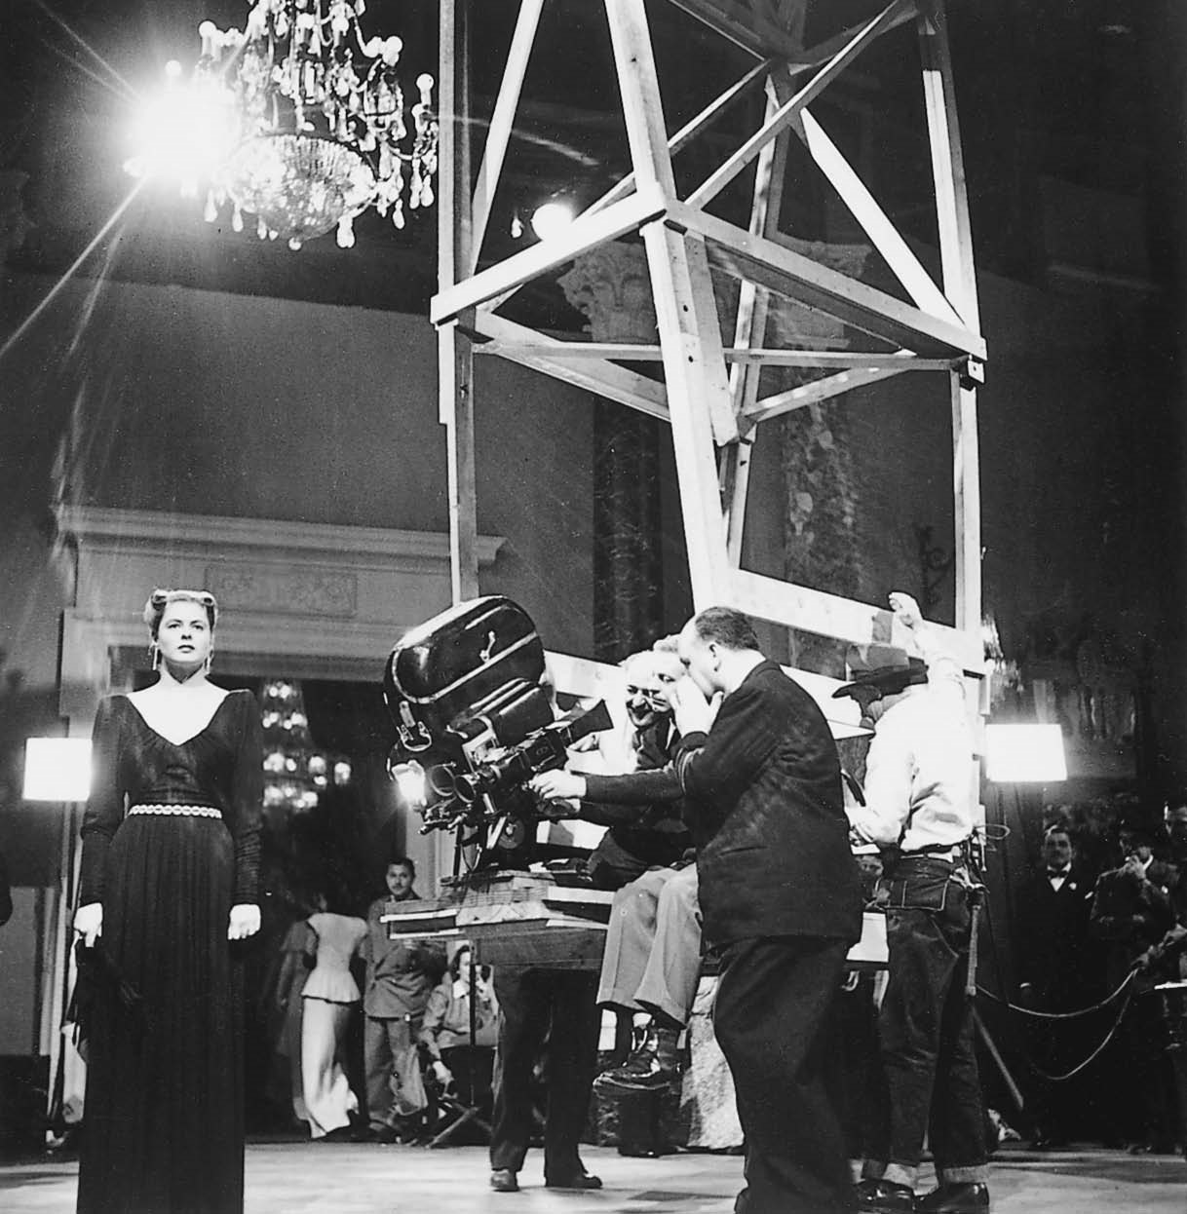

Author’s collection

The camera, mounted on a makeshift crane (*center*), descends to photograph the key in Ingrid Bergman’s hand in *Notorious,* as director Alfred Hitchcock looks on.

(or from left to right) a certain number of degrees to reveal what lies before the camera on either side. At the start of the cattle drive in *Red River* (1948), the camera pans 180 degrees as the owner of the herd (John Wayne) surveys his cattle and the men (including his adopted son, Montgomery Clift) who will drive them to market. The pan not only conveys the enormous size of the herd, but also sets up the conflict between Wayne and Clift that will dominate the rest of the narrative.

In tracking shots, the camera moves bodily through space in any of a variety of directions parallel to the floor. To facilitate smooth movement, the camera is either mounted on tracks fixed to the ceiling (as in the long tracking shot of the man’s rendezvous with the woman from the city in the swamp in *Sunrise,* 1927) or to the floor. In the majority of instances, however, it is affixed to a movable camera support, such as a dolly, as seen in the continuous camera movements in *Rope* (1948). If mounted on a dolly, the camera can track in a variety of different directions. It can move laterally, either to follow the movements of a character walking parallel to it or to explore space in one direction or the other. It can move circularly, tracking around a central subject or observing a scene that is taking place around it from the center of a circle. The camera is also capable of moving circuitously in, out, and around the scene.

Most typically, the camera tracks in or out on an axis, moving at an angle to or perpendicularly to the dramatic action. In a crane shot, the camera can not only move forward, backward, or circuitously on the ground, as in any dolly shot, but can also rise or descend. The party sequence in *Notorious* (1946) begins with a crane shot that descends from an overhead long shot of the ballroom floor and surrounding staircase to an extreme close-up of an important key clutched in the hand of the heroine (played by Ingrid Bergman). Like other camera movements, this crane shot reads the action for the spectator, singling out a crucial detail that might otherwise have gone unnoticed.