**Git Assignment 1**

**Git basic commands**

git init(initialise git repo)

git status (to check status)

git log (to check history)

git checkout -b branchname(to create branch)

git add file_name (to add file )

git commit -m "first commit" (to add save changes to local)

git commit --amend(to add multiple line commit)

git checkout -b branchname (to create branch)

git branch -d branch_name (to delete branch)

git reset --soft HEAD~(to undo last commit)

git reset --hard HEAD~(to undo latest staging)

git stash(to store local in form of stack)

git stash pop(to retrieve)

git show(show last commit)

git remote add origin url (to connect github)

git push origin branch_name (to push in remote)

Q1. How to commit multiple line

Ans :- git commit -m “commit 1” -m “commit 2”

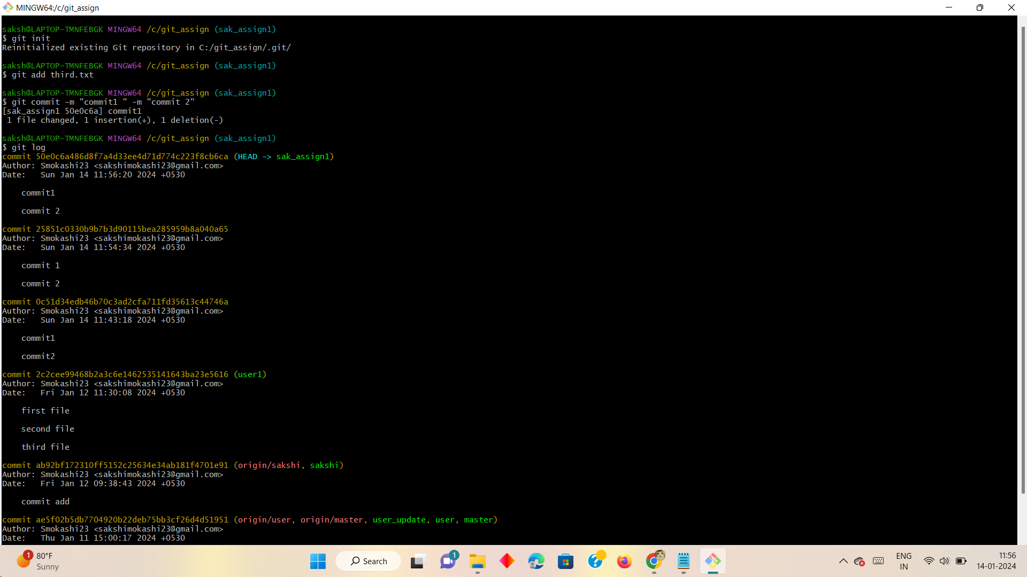

Q2 How to change commit message

Ans :-

Step 1- Write command git – amend

Step 2 - Edit the commit message by entering ESC+I key

Step 3- press ESC Shift ++ZZ

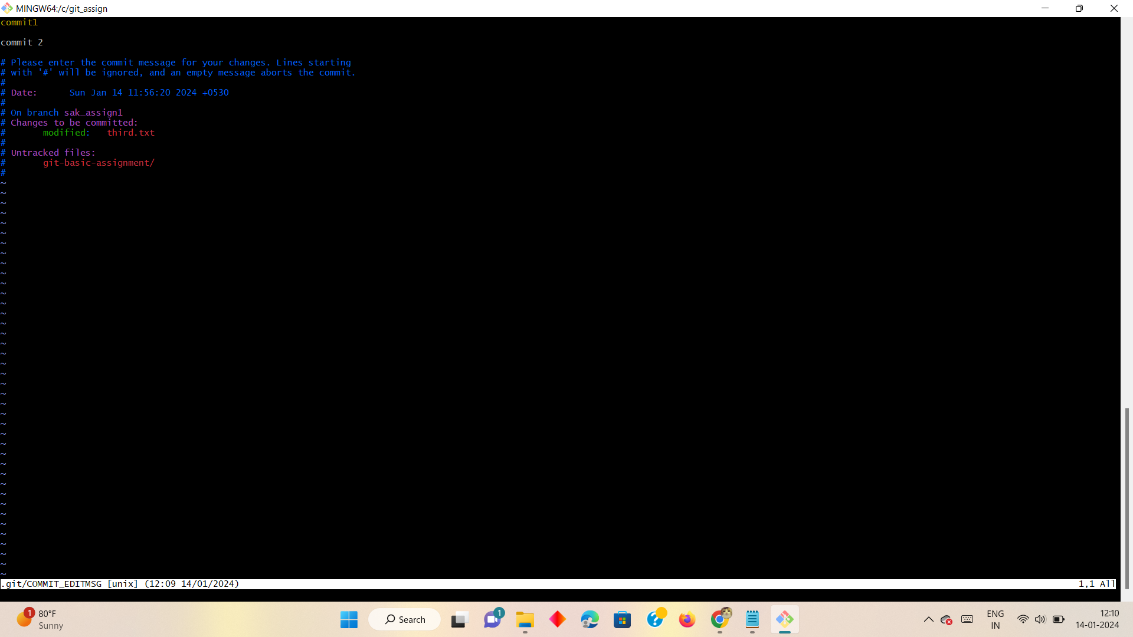

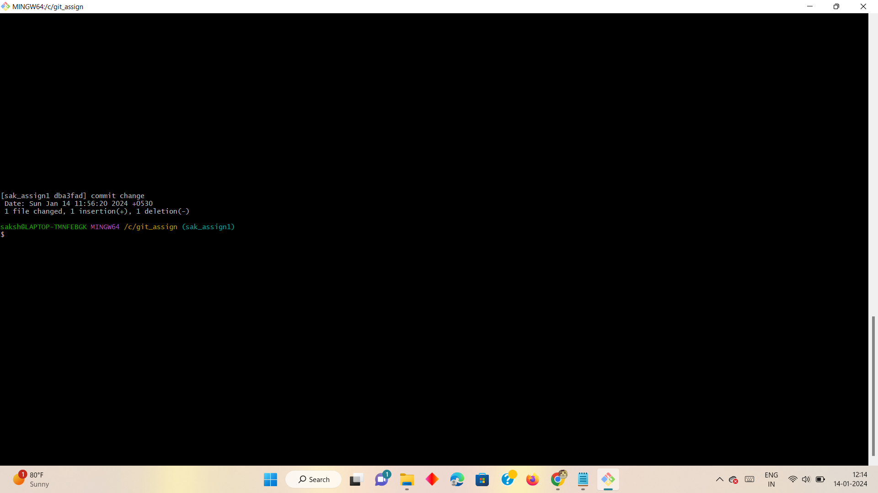

Q3 How to get my code back if i do git stash

Ans ;-

Git stash is used to save changes temporarily

Steps - make changes use command

Git stash

Step2 - to see the list

Git stash list

Step3 - to apply apply changes

Git stash apply

Or

Git stash pop

