VCC_BAT

5

D1 VS-10BQ060-M3/5BT U1

1 2 3

IN

LM317D2TG ONS

4

OUT

ADJ

LM317D2TG R1

1

*0603*

1 2

D2 1N5819HW

5V3

4

U2 NCP5501DT33RKG ONS

1 3

Vout

Vin

GND

NCP5501DT33RKG

4

+3V3

PDM_RRV_1

# 3 2 1

VCC_BAT

0603 C1

0603 C2

510F

0603 C3 0603 10uF C5

0603 C6 0603 10uF C8

CS20_[1..8]

OutCH20_1 OutCH20_2 OutCH20_3

OutCH20_1 OutCH20_2 OutCH20_3 OutCH20_4

0.1uF

VCC_BAT

0.1uF

R2

1K5F

*0603*

0603 10uF C9

0.1uF C4

47uF/10V

0.1uF C7

47uF/10V

Cs_Dis20_[1..8]

InCH20_[1..8]

OutCH20_4

OutCH20_5 OutCH20_6

OutCH20_5 OutCH20_6 OutCH20_7

EXT_Din[1..12]

D OutCH20_7

GND

OutCH20_8 D

OutCH20_8

V_AIN1 V_AIN2 V_AIN3 V_AIN4

CANH CANL

VUSB

USB_Dm_eXt

USB_Dp_Ext

PDM_MCU1

V_AIN1 V_AIN2 V_AIN3 V_AIN4

CANH CANL

Din[1..12] VUSB

USB_Dm_eXt

CS20_[1..8]

Cs_Dis20_[1..8] InCH20_[1..8]

5V3

+3V3 GND

InCH8_[9..20]

CS8_[9..20]

Cs_Dis8_9_10 Cs_Dis8_11_12 Cs_Dis8_13_14 Cs_Dis8_15_16

5V3

+3V3

Cs_Dis8_9_10 Cs_Dis8_11_12 Cs_Dis8_13_14 Cs_Dis8_15_16 Cs_Dis8_17_18

CS20_[1..8]

Cs_Dis20_[1..8] InCH20_[1..8]

InCH8_[9..20]

CS8_[9..20]

PDM_RRV_20

VCC_BAT

GND

VCC_BAT

VCC_BAT

JP1

1

OutCH20_1 OutCH8_17 OutCH20_2 OutCH8_18 OutCH20_3 OutCH8_16

OutCH20_4 OutCH20_4

OutCH8_15 OutCH20_5

OutCH8_11 VUSB

OutCH8_12

OutCH20_6 OutCH20_6

1A

2A

11A

3A

4A

13A

5A

6A

15A

7A

16A

8A

17A

1B

8B

2B

9B

3B

10B

J1-1

26A

18A

OutCH20_1 10A

27A

19A

28A

20A

OutCH20_2 12A

29A

21A

30A

22A

OutCH20_3 14A

31A

23A

32A

24A

33A

25A

34A

OutCH20_5 9A

20B

14B

21B

15B

22B

16B

OutCH8_13 OutCH8_14

EXT_Din7 EXT_Din6

EXT_Din5 EXT_Din4 EXT_Din3

EXT_Din2

EXT_Din1

EXT_Din8

EXT_Din9

OutCH8_9 OutCH8_10

CANH

CANL

USB_Dp_Ext USB_Dm_eXt

EXT_Din12

C USB_Dp_Ext

Cs_Dis8_17_18

Cs_Dis8_19_20

OutCH8_19 4B

23B

EXT_Din11 C

PDM_MCU

Cs_Dis8_19_20

PDM_DRV_1

InCH8_[9..20]

CS8_[9..20]

OutCH8_9 OutCH8_10 OutCH8_11 OutCH8_12 OutCH8_13

OutCH8_9 OutCH8_10 OutCH8_11 OutCH8_12 OutCH8_13 OutCH8_14

VCC_BAT

OutCH20_7 OutCH20_7

OutCH8_20 OutCH20_8 OutCH20_8

11B

5B

12B

6B

13B

7B

17B

24B

18B

25B

19B

26B

EXT_Din10

V_AIN2

V_AIN4

V_AIN1

V_AIN3

R3 4K7F

*0603*

R4 *0603*

1 0KF EXT_Din1

Cs_Dis8_9_10 Cs_Dis8_11_12 Cs_Dis8_13_14 Cs_Dis8_15_16 Cs_Dis8_17_18

OutCH8_14

OutCH8_15 OutCH8_16 OutCH8_17 OutCH8_18 OutCH8_19 OutCH8_20

GND

OutCH8_15 OutCH8_16 OutCH8_17 OutCH8_18 OutCH8_19 OutCH8_20

6437288-5 TE AMP/1.0MM/60P/26p/34p

1 2

Din1

Cs_Dis8_19_20

D3 BZT52C3V6S-7-F

R5 4K7F

*0603*

1 2

R6 *0603*

10KF

Din2

EXT_Din2

PDM_DRV_8

D4 BZT52C3V6S-7-F

R7 4K7F

*0603*

1 2

R8 *0603*

10KF

Din3

EXT_Din3

D5 BZT52C3V6S-7-F

R9 4K7F

*0603*

R10

*0603*

10KF

EXT_Din4

S1 S7

B 1 2

D6 BZT52C3V6S-7-F

Din4

` 1 ` 1 B

R11 4K7F

*0603*

R12

*0603*

dirca3.2m

dirca3.2m

10KF

EXT_Din5

S2 S8

1 2

Din5

` 1 ` 1

D7 BZT52C3V6S-7-F

dirca3.2m

dirca3.2m

R13 4K7F

*0603*

R14

*0603*

10KF

EXT_Din6

S3 S9

1 2

Din6

` 1 ` 1

D8 BZT52C3V6S-7-F

dirca3.2m

dirca3.2m

R15 4K7F

*0603*

R16

*0603*

10KF

EXT_Din7

S4 S10

1 2

Din7

` 1 ` 1

D9 BZT52C3V6S-7-F

dirca3.2m

dirca3.2m

R17 4K7F

*0603*

R18

*0603*

10KF

EXT_Din8

S5 S11

D10 1 2

R20

Din8

` 1 ` 1

BZT52C3V6S-7-F

R19 4K7F

*0603*

*0603*

EXT_Din9

dirca3.2m S6

dirca3.2m S12

D11 1 2

10KF

Din9

` 1 ` 1

BZT52C3V6S-7-F

dirca3.2m

dirca3.2m

R21

*0603*

D12 1

4K7F

2

R22

*0603*

10KF

Din10

EXT_Din10

BZT52C3V6S-7-F

R23

*0603*

D13 1

4K7F

2

R24

*0603*

10KF

Din11

EXT_Din11

BZT52C3V6S-7-F

A R25 4K7F R26

*0603*

*0603*

10KF

EXT_Din12 A

D14 1

2

BZT52C3V6S-7-F

Din12

Din[1..12]

Tiiitllle

PDM

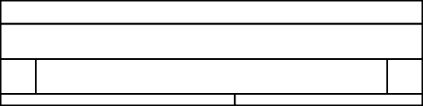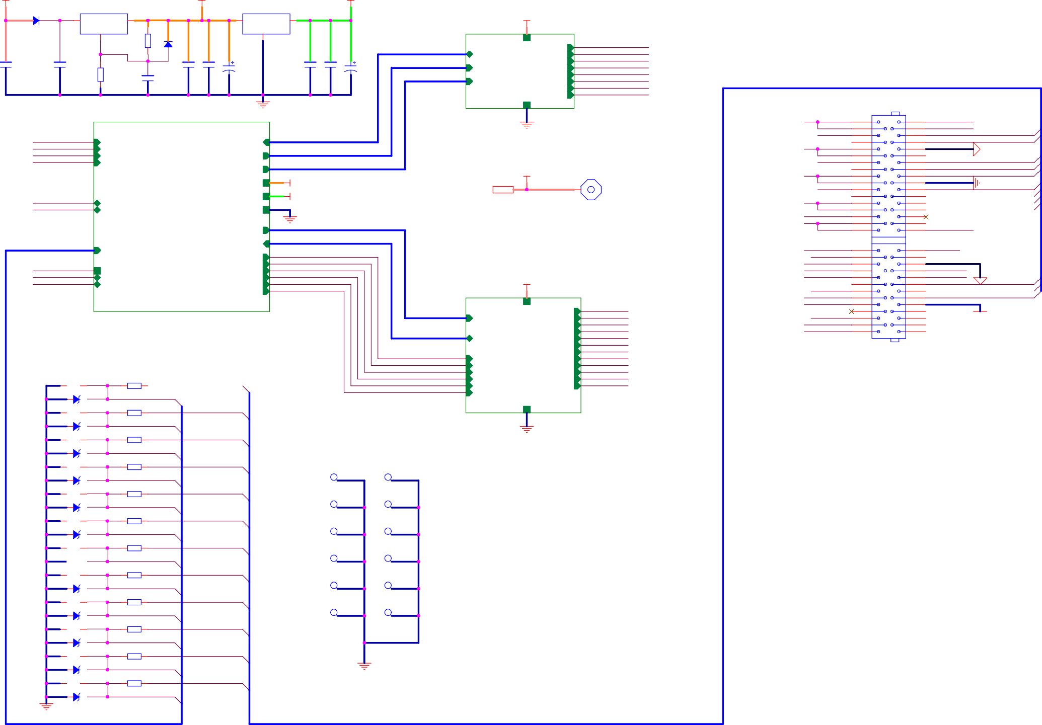

Siiize

A3

Date:

Document Number

1...0

Sattturday,,, May 07,,, 2022

Sheet

1 of

Rev 1.0

4

# 5 4 3 2 1

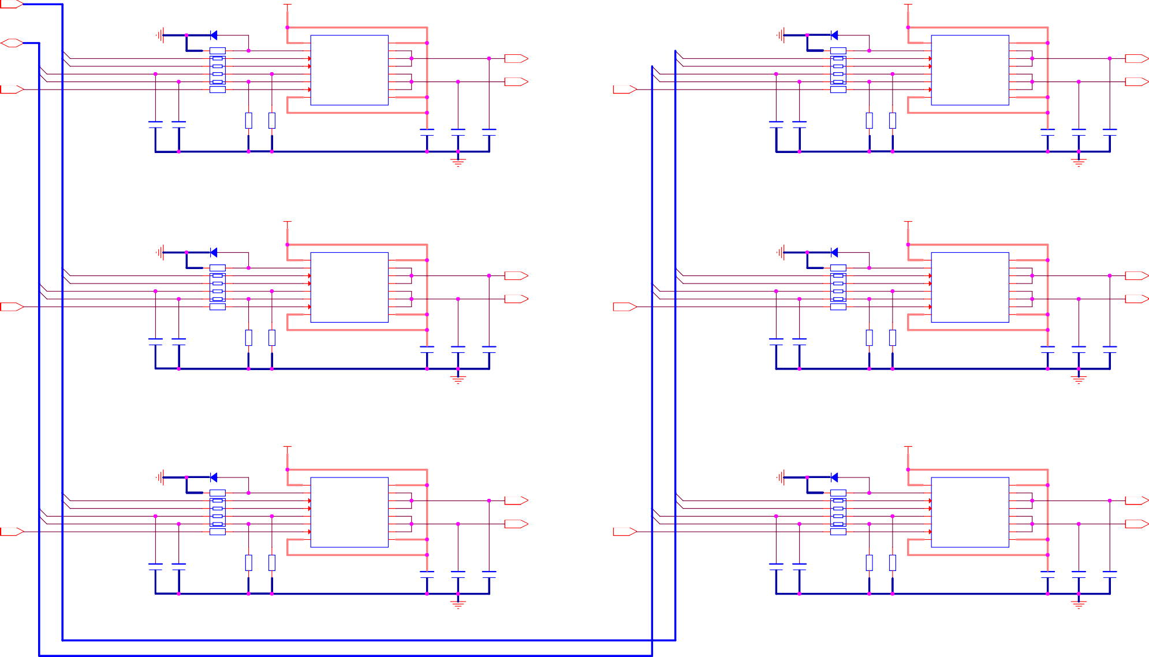InCH8_[9..20]

VCC_BAT VCC_BAT

D15 1N5819HW D16 1N5819HW

2 1 U4 2 1 U3

D CS8_[9..20]

2

15

2

15

1 Vcc

Vcc1 16

1. Vcc

Vcc1 16 D

Cs_Dis8_9_10

InCH8_10 InCH8_9 CS8_9 CS8_10

Cs_Dis8_9_10

C10

0603

10K

C13

0603

5

6

R27 1KF

7

8

R37

*0603*

*0603*

4 PR10

3

2

1

10K

R40 1KF

*0603*

R39 1KF

*0603*

GND IN2 IN1

C_SENSE1 C_SENSE2 CS_DIS

3

4

5

6

7

8

Vcc2

VND5E025ASTR-E

OUT22 OUT21 OUT20 OUT12 OUT11 OUT10

Vcc3

14

13

12

11

10

9

C14

C15

C16

OutCH8_10 OutCH8_9

Cs_Dis8_11_12

InCH8_12 InCH8_11 CS8_11 CS8_12

Cs_Dis8_11_12

C11

0603

10K

C12

0603

5

6

R29 1KF

7

8

R38

*0603*

*0603*

4 PR11

3

2

1

10K

R41 1KF

*0603*

R42 1KF

*0603*

GND IN2 IN1

C_SENSE1 C_SENSE2 CS_DIS

3

4

5

6

7

8

Vcc2

VND5E025ASTR-E

OUT22 OUT21 OUT20 OUT12 OUT11 OUT10

Vcc3

14

13

12

11

10

9

C17

C18

C19

OutCH8_12 OutCH8_11

10nF

10nF

0.1uF 0603 0.1uF 0603 0.1uF 0603

10nF

10nF

0.1uF 0603 0.1uF 0603 0.1uF 0603

VCC_BAT VCC_BAT

D17 1N5819HW D18 1N5819HW

2 1 U5

1 Vcc

Vcc1 16

2 1 U6

1 Vcc

Vcc1 16

C InCH8_14

R43

*0603* 1KF

1. GND

OUT22 15

InCH8_15

R44

*0603* 1KF

2 GND

OUT22 15 C

Cs_Dis8_13_14

InCH8_13 CS8_13 CS8_14

Cs_Dis8_13_14

C20

0603

10K

C21

0603

5

6

7

8

R53

*0603*

4 PR12

3

2

1

10K

R55 1KF

*0603*

R56 1KF

*0603*

1. IN2
2. IN1
3. C_SENSE1
4. C_SENSE2
5. CS_DIS
6. Vcc2

VND5E025ASTR-E

OUT21 OUT20 OUT12 OUT11 OUT10

Vcc3

14

13

12

11

10

9

C24

C25

C26

OutCH8_14 OutCH8_13

Cs_Dis8_15_16

InCH8_16 CS8_16 CS8_15

Cs_Dis8_15_16

C22

0603

10K

C23

0603

5

6

7

8

R54

*0603*

4 PR13

3

2

1

10K

R57 1KF

*0603*

R58 1KF

*0603*

1. IN2
2. IN1
3. C_SENSE1
4. C_SENSE2
5. CS_DIS
6. Vcc2

VND5E025ASTR-E

OUT21 OUT20 OUT12 OUT11 OUT10

Vcc3

14

13

12

11

10

9

C27

C28

C29

OutCH8_15 OutCH8_16

10nF

10nF

0.1uF 0603 0.1uF 0603 0.1uF 0603

10nF

10nF

0.1uF 0603 0.1uF 0603 0.1uF 0603

VCC_BAT VCC_BAT

D19 1N5819HW D20 1N5819HW

2 1 U7

1 Vcc

Vcc1 16

2 1 U8

1 Vcc

Vcc1 16

B InCH8_18

R59

*0603* 1KF

2 GND

OUT22 15

InCH8_20

R60

*0603* 1KF

2 GND

OUT22 15 B

Cs_Dis8_17_18

InCH8_17 CS8_17 CS8_18

Cs_Dis8_17_18

C31

0603

10K

C32

0603

5

6

7

8

R69

*0603*

4 PR14

3

2

1

10K

R71 1KF

*0603*

R72 1KF

*0603*

1. IN2
2. IN1
3. C_SENSE1
4. C_SENSE2
5. CS_DIS
6. Vcc2

VND5E025ASTR-E

OUT21 OUT20 OUT12 OUT11 OUT10

Vcc3

14

13

12

11

10

9

C34

C35

C36

OutCH8_18 OutCH8_17

Cs_Dis8_19_20

InCH8_19 CS8_19 CS8_20

Cs_Dis8_19_20

C33

0603

10K

C30

0603

5

6

7

8

R70

*0603*

4 PR15

3

2

1

10K

R73 1KF

*0603*

R74 1KF

*0603*

1. IN2
2. IN1
3. C_SENSE1
4. C_SENSE2
5. CS_DIS
6. Vcc2

VND5E025ASTR-E

OUT21 OUT20 OUT12 OUT11 OUT10

Vcc3

14

13

12

11

10

9

C37

C38

C39

OutCH8_20 OutCH8_19

10nF

10nF

0.1uF 0603 0.1uF 0603 0.1uF 0603

10nF

10nF

0.1uF 0603 0.1uF 0603 0.1uF 0603

InCH8_[9..20]

CS8_[9..20]

VCC_BAT

VCC_BAT

# A A

GND



Tiiitllle

PDM_DRV8

Siiize

A3

Document Number

1...0

Rev 1.0

Date:

Sattturday,,, May 07,,, 2022

Sheet

2

of 4

# 5 4 3 2 1

U9

8 13

Vin1 Vin2 GND1 GND2

+Vo

0V2

0V1

14

BLM15AG121SN1D

FP1

5V3

5V3

C44 0.1uF

InCH20_[1..8]

InCH20_[1..8]

InCH20_1 TIM4_CH3

0.1uF

0.1uF

TIM8_CH1 4 5PR1 1K

0603 C40

10uF

C45 10uF

10uF

10uF

0603 C41

0.1uF

7

6

B0505MT-1WR4

1

U10

2

0603 C42

0603 C43

0.1uF

*0603*

C46

C47

C48

C49

InCH20_2 TIM4_CH4

InCH20_3 TIM2_CH1

InCH20_4 TIM3_CH2 InCH20_5 TIM1_CH3

InCH20_6 TIM1_CH4

InCH20_7 TIM12_CH1

10uF

+3V3

STM_NC

1KF

R75

TIM8_CH2 3

TIM8_CH3 2

TIM8_CH4 1

TIM4_CH4 1

TIM4_CH3 2

TIM4_CH2 3

6

7

8

8PR2 1K

7

6

CAN_Vcc 8

1

CAN_RX

2

Vcc1 RxD TxD Gnd1

Vcc2 CANH CANL

Gnd2

+3V3

InCH20_8 TIM4_CH2

TIM4_CH1 4 5

D CANH

CANH 7

CANL

6

CAN_TX

3

InCH8_[9..20] D

CANL 5

BLM15AG121SN1D

FP2

4

InCH8_[9..20]

InCH8_9 TIM1_CH1

TIM1_CH1 4 5PR3 1K

ISO1050DUBR

B0505MT-1WR4 MORNSUN ISO1050DUBR TI

0603 C50

10uF

0603 C51

0.1uF

GND

J3

+3V3

+3V3

SWCLK

USART2_RX 1

TIM3_CH2 TIM3_CH1 TIM2_CH2

GND

Cs_Dis8_15_16

USART2_RX

GND

USART2_TX

CAN_TX CAN_RX

TIM2_CH1

USART2_TX 2

127

126 Cs_Dis20_4

125 Cs_Dis20_3

3

InCH8_10 TIM1_CH2

InCH8_11 TIM2_CH4

InCH8_12 TIM2_CH3

InCH8_13 TIM8_CH1 InCH8_14 TIM8_CH2

InCH8_17 TIM8_CH3

InCH8_18 TIM8_CH4

*0603*

TIM1_CH2 3

TIM1_CH3 2

TIM1_CH4 1

TIM2_CH1 4

TIM2_CH2 3

TIM3_CH1 2

TIM3_CH2 1

6

7

8

5PR4 1K

6

7

8

PLS3

144

143

142

141

140

139

138

137

136

135

134

133

132

131

130

129

128

R76

Din2 Din1 Din8 Din9

124

123

122

121

120

119

118

117

116

115

114

113

112

111

110

109

InCH8_15 TIM3_CH1

TIM2_CH3 4 5PR5 1K

+3V3

J2

+3V3

+3V3

Vdd RFU PE1 PE0 PB9 PB8 BOOT0 PB7 PB6 PB5 PB4 PB3 PG15

Vdd Vss PG14 PG13 PG12 PG11 PG10 PG9 PD7 PD6

Vdd Vss PD5 PD4 PD3 PD2 PD1 PD0 PC12 PC11 PC10 PA15 PA14

R77

*0603* 100F

D21

1 2

1N5819HW

C54 0.1uF

0603

0603 C52

10uF

+3V3

Din3 Din4 Din5 Din6 Din7

U12

1. PE2
2. PE3
3. PE4
4. PE5
5. PE6
6. Vbat

Vdd 108

Vss 107

Vcap_2 106

PA13 105

PA12 104

PA11 103

C55 2.2uF

TMS USB_DP USB_DM

0603

GND

+3V3

0603 0603

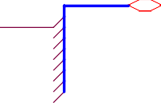

CS20_[1..8]

CS20_1

CS20_2

CS20_3

CS20_4

CS20_5

CS20_6

CS20_7

CS20_8

C53 10uF

C56

0.1uF

InCH8_16 TIM2_CH2

InCH8_19 TIM12_CH2 InCH8_20 TIM4_CH1

TIM2_CH4 3 6

TIM12_CH1 2 7

TIM12_CH2 1 8

1

2 SWCLK

3

4 TMS

5

U11

1. NC
2. NC
3. NC

Vcc 8

WC 7

SCL 6

R80 4K7

R78 4K7

I2C2_SDA I2C2_SCL

*0603*

*0603*

1. PC13-RTC_AF1
2. PC14-OSC32_IN
3. PC15-OSC32_OUT
4. PF0
5. PF1

PA10 PA9 PA8 PC9 PC8

102

101

100

99

98

USB_ID

USB_VBUS

TIM8_CH4 TIM8_CH3 TIM8_CH2

C59 0.1uF

R79

*0603* 10KF

CS20_[1..8]

C 4 Vss

SDA 5

12

CS20_2

PF2

PC7 97

TIM8_CH1 C

PLS5

R81 10KF

M24C16-WMN6P

*0603*

C57 10uF

0603

0603

GND

+3V3

13

CS20_1 14

CS8_14 15

16

17

CS8_13

PF3 PF4 PF5

Vss Vdd

PC6 96

Vdd 95

Vss 94

PG8 93

PG7 92

GND

Vbus_Det USB_Disc

+3V3

0603 0603

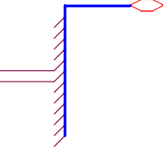

CS8_[9..20]

CS8_9

CS8_10

CS8_11

CS8_12 CS8_13 CS8_14

CS8_15

CS8_16

CS8_17

CS8_18

CS8_19

CS8_20

C58 10uF

C61 0603

NRST

C60

0.1uF

18

CS8_18 19

CS8_17 20

CS20_3 21

CS8_15

PF6

PF7 PF8 PF9

PG6

PG5 PG4 PG3

91

90 Cs_Dis8_17_18

89 Cs_Dis8_13_14

88 Cs_Dis20_1 Cs_Dis20_2

CS8_[9..20]

0.1uF

X1 KX-13T-8Mhz

NRST

1. PF10
2. PH0-OSC_IN
3. PH1-OSC_OUT
4. NRST

PG2 87

PD15 86

PD14 85

Vdd 84

TIM4_CH4 TIM4_CH3

+3V3

10uF

0.1uF

1

C64

3

C65

2

4

CS8_16 26

CS20_4 27

CS8_10 28

PC0 PC1 PC2

Vss 83

PD13 82

PD12 81

GND TIM4_CH2 TIM4_CH1

0603 0603

C62

C63

CS8_9 29

PC3

PD11

80 Cs_Dis20_8

16pF NPO

16pF NPO

+3V3 GND

1. Vdd
2. Vssa
3. Vref+

PD10 PD9 PD8

79 Cs_Dis8_19_20

78 Cs_Dis20_7

77 Cs_Dis8_11_12

+3V3

FP3

BLM15AG121SN1D

33

CS20_5 34

CS20_6 35

CS8_12 36

C68

0.1uF

Vdda

PA0-WKUP PA1

PA2

PB15 76

PB14 75

PB13 74

PB12 73

TIM12_CH2

TIM12_CH1

0603 0603 0603 0603

C66

C67

0.1uF

C69

PA3

Vss Vdd PA4 PA5 PA6 PA7 PC4 PC5 PB0 PB1 PB2 PF11 PF12

Vss Vdd PF13 PF14 PF15 PG0 PG1 PE7 PE8 PE9

Vss Vdd PE10 PE11 PE12 PE13 PE14 PE15 PB10 PB11

Vcap_1 Vdd

B GD32F405Zx B

10uF

10uF

37

38

39

40

41

42

43

44

45

46

47

48

49

50

51

52

53

54

55

56

57

58

59

60

61

62

63

64

65

66

67

68

69

70

71

72

Cs_Dis20_[1..8]

CS8_11

CS20_7 CS8_20 CS8_19

CS20_8 ADC1_4 ADC1_5 ADC1_8 ADC1_9

Din10 Din11 Din12

Cs_Dis20_[1..8]

Cs_Dis20_1

+3V3

Cs_Dis20_2

4 5PR6 1K

C70 10nF

0603

C71

GND

+3V3

GND

+3V3

Cs_Dis20_5 Cs_Dis20_6 Cs_Dis8_9_10

TIM1_CH1

GND

+3V3

TIM1_CH2

TIM1_CH3 TIM1_CH4

TIM2_CH3 TIM2_CH4

0603

Cs_Dis20_2 Cs_Dis20_3 Cs_Dis20_4 Cs_Dis20_5

Cs_Dis20_1 3

Cs_Dis8_13_14 2

Cs_Dis8_17_18 1

Cs_Dis8_11_12 4

6

7

8

5PR7 1K

V_AIN1

V_AIN1

R82

*0603*

140KF ADC1_4

R83

*0603*

2

10KF

1

2.2uF

Cs_Dis20_6 Cs_Dis20_7 Cs_Dis20_8

Cs_Dis20_7 3 6

Cs_Dis8_19_20 2 7

Cs_Dis20_8 1 8

BZT52C3V6S-7-F

0603

10uF

0.1uF

10uF

0.1uF

10uF

0.1uF

D22

PR8 1

8 1K

V_AIN2

ADC1_5

C72

10nF

0603 0603

0603 0603

0603 0603

0603 0603

Cs_Dis8_9_10 Cs_Dis8_11_12

Cs_Dis8_9_10

Cs_Dis8_11_12

Cs_Dis20_4 2 7

Cs_Dis20_3 3 6

V_AIN2

R85

*0603*

140KF

R84

*0603*

10KF

Cs_Dis8_13_14 Cs_Dis8_15_16

Cs_Dis8_13_14

Cs_Dis8_15_16

C73 10uF

C74 0.1uF

C75

C76

C77

C80

C78

C79

Cs_Dis8_15_16 4

Cs_Dis8_9_10 PR91

5

8 1K

2 1

BZT52C3V6S-7-F

D23

Cs_Dis8_17_18 Cs_Dis8_19_20

Cs_Dis8_17_18

Cs_Dis8_19_20

Cs_Dis20_6 2 7

Cs_Dis20_5 3 6

4 5

C81 10nF

0603

V_AIN3

V_AIN3

R86

*0603*

140KF ADC1_8

R87

*0603*

10KF

Din1

Din2

Vbus_5V

VS-10BQ060-M3/5BT

2 1

BZT52C3V6S-7-F

D24

Din3

Din4

D251

2 5V3

C82 10nF

0603

Din5

Din6

PA9 USB_VBUS

BLM15AG121SN1D

R88

*0603* 430K

R89

*0603* 620K

V_AIN4

ADC1_9

Din7

VUSB

VUSB

FP4

Vbus_Det

A V_AIN4

R90

*0603* 140KF

R91

*0603*

10KF

Din8

USB_Dm_eXt

USB_Dm_eXt R92

*0603* 24R9

USB_DM A

2 1

BZT52C3V6S-7-F

D26

Din9

Din10

Din11

Din12

USB_Dp_Ext

USB_Dp_Ext R93

*0603* 24R9

U13

1. I/O1
2. GND
3. I/O2

I/O4 6

Vbus 5

I/O3 4

R94

USB_DP

*0603* 1K5F USB_Disc

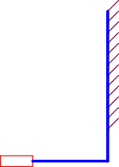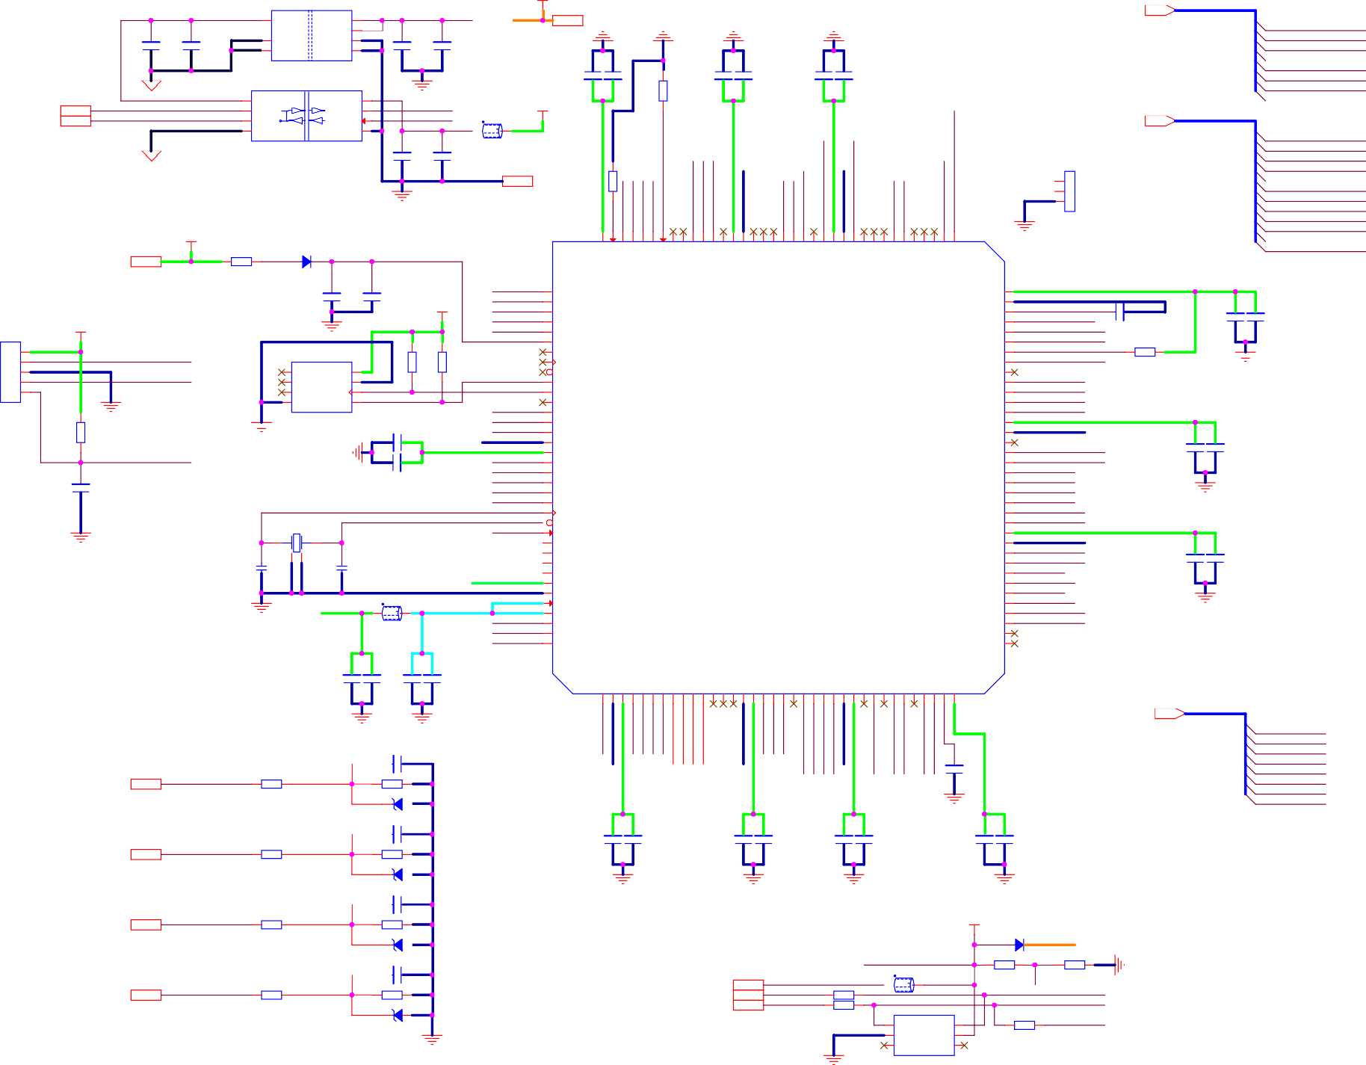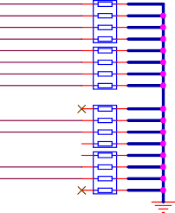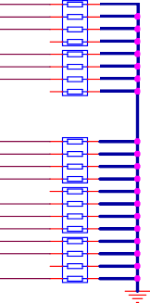

Din[1..12]

Din[1..12]

USBLC6-4SC6

Tiiitllle

Siiize

A3

Date:

PDM_MCU

Document Number

1...0

Sattturday,,, May 07,,, 2022

Sheet

3 of

Rev 1.0

4

# 5 4 3 2 1

VCC_BAT VCC_BAT

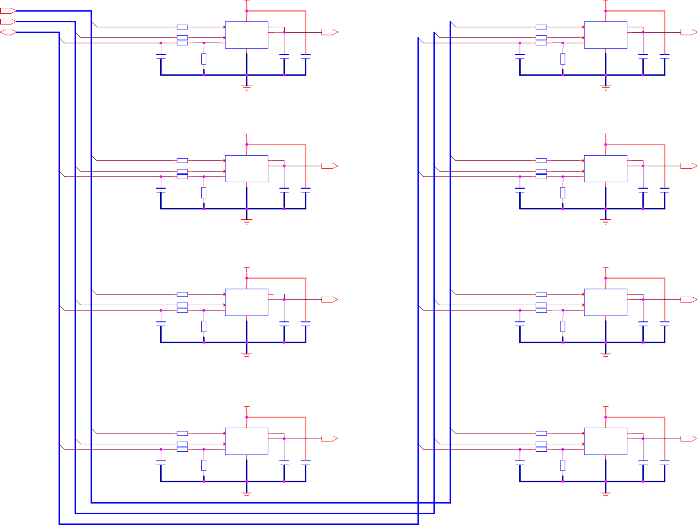

InCH20_[1..8]

Cs_Dis20_[1..8]

CS20_[1..8]

InCH20_[1..8]

Cs_Dis20_[1..8] CS20_[1..8]

InCH20_1

4

4

Cs_Dis20_1

R95 *0603* 10K

R97 10K

U14

3 IN

6

GND

5

OUT 1

OUT1 7

Vcc

OutCH20_1

InCH20_2

Cs_Dis20_2

R96 *0603* 10K

R98 10K

U15

3 IN

6

GND

5

OUT 1

OUT1 7

Vcc

OutCH20_2

CS20_1

R99

*0603* 10K

*0603*

CS_DIS

CS

2

CS20_2

R100 *0603* 10K

*0603*

CS_DIS

CS

2

C83

*0603*

VN5E010MH-E

C84

C85

C86

VN5E010MH-E

C87

C88

0603

R101

0.1uF 0603 0.1uF 0603

0603

R102

0.1uF 0603 0.1uF 0603

D 10nF

*0603*

1KF

10nF

1KF D

VCC_BAT

VCC_BAT

VCC_BAT

VCC_BAT

GND

InCH20_3

4

4

Cs_Dis20_3

R103 *0603* 10K R105 10K

U16

3 IN

6

GND

5

OUT 1

OUT1 7

Vcc

OutCH20_3

InCH20_4

Cs_Dis20_4

R104 *0603* 10K R106 10K

U17

3 IN

6

GND

5

OUT 1

OUT1 7

Vcc

OutCH20_4

CS20_3

R107 *0603* 10K

*0603*

CS_DIS

CS

2

CS20_4

R108 *0603* 10K

*0603*

CS_DIS

CS

2

C89

*0603*

*0603*

VN5E010MH-E

C90

C91

C92

VN5E010MH-E

C93

C94

0603

10nF

R109 1KF

0.1uF 0603 0.1uF 0603

0603

10nF

R110 1KF

0.1uF 0603 0.1uF 0603

# C C

VCC_BAT VCC_BAT

InCH20_5

4

4

Cs_Dis20_5

R111 *0603* 10K R113 10K

U18

3 IN

6

GND

5

OUT 1

OUT1 7

Vcc

OutCH20_5

InCH20_6

Cs_Dis20_6

R112 *0603* 10K R114 10K

U19

3 IN

6

GND

5

OUT 1

OUT1 7

Vcc

OutCH20_6

CS20_5

R115 *0603* 10K

*0603*

CS_DIS

CS

2

CS20_6

R116 *0603* 10K

*0603*

CS_DIS

CS

2

C95

*0603*

*0603*

VN5E010MH-E

C96

C97

C98

VN5E010MH-E

C99

C100

0603

10nF

R117 1KF

0.1uF 0603 0.1uF 0603

0603

10nF

R118 1KF

0.1uF 0603 0.1uF 0603

# B B

VCC_BAT VCC_BAT

InCH20_7

4

4

Cs_Dis20_7

R119 *0603* 10K R121 10K

U20

3 IN

6

GND

5

OUT 1

OUT1 7

Vcc

OutCH20_7

InCH20_8

Cs_Dis20_8

R120 *0603* 10K R122 10K

U21

3 IN

6

GND

5

OUT 1

OUT1 7

Vcc

OutCH20_8

CS20_7

R123 *0603* 10K

*0603*

CS_DIS

CS

2

CS20_8

R124 *0603* 10K

*0603*

CS_DIS

CS

2

C101

*0603*

*0603*

VN5E010MH-E

C102

C103

C104

VN5E010MH-E

C105

C106

0603

10nF

R125 1KF

0.1uF 0603 0.1uF 0603

0603

10nF

R126 1KF

0.1uF 0603 0.1uF 0603

InCH20_[1..8]

Cs_Dis20_[1..8] CS20_[1..8]

# A A



Tiiitllle

PDM_DRV20

Siiize

A3

Document Number

1...0

Rev 1.0

Date:

Sattturday,,, May 07,,, 2022

Sheet

4

of 4