SHRMS — IWR
Intelligent Workflow Routing
System Documentation & Code Explanation

A thesis project implementing a two-layer hybrid AI system
for routing HR documents in a Philippine civil service (LGU) context.
March 2026

1. System Overview
The IWR (Intelligent Workflow Routing) is a Python-based decision engine that routes two types of HR documents: IPCR performance evaluation forms and leave applications. It does not store data — it receives a form snapshot and returns a routing instruction.

1.1 The Three-Layer Pipeline
Every form submission flows through three layers in sequence:
- Caller (Smart-HRMS web app) — sends the form as a JSON request
- Layer 1: Rule Engine — checks civil service compliance rules
- Layer 2: Decision Tree — ML model predicts the routing action

1.2 File Structure
File | Purpose
org_and_rules.py | Knowledge Base — employees, leave rules, ML encodings
rule_engine.py | Layer 1 — CSC compliance checker (Rete algorithm)
decision_tree.py | Layer 2 — ML Decision Tree classifiers
workflow_router.py | Main orchestrator — runs Layer 1 then Layer 2
api/schemas.py | Pydantic request models for the REST API
api/auth.py | API key authentication
api/data_loader.py | Fetches live employee data from Smart-HRMS
api/main.py | FastAPI app — exposes IWR as HTTP endpoints

1.3 Document Types Handled
Document | Routing Classes
IPCR Form | route_to_evaluator | return_for_remarks | save_data
Leave Application | route_to_department_head | route_to_hr | require_rejection_reason | completed

1.4 How the Two Layers Work Together
The Rule Engine (Layer 1) acts as a gatekeeper. If any civil service rule is violated, the document is returned immediately and Layer 2 never runs. Only documents that pass all compliance checks reach the Decision Tree (Layer 2), which predicts the next routing action using a trained ML model.

2. org_and_rules.py — Knowledge Base
This is the single source of truth for the entire system. It contains only data — no logic, no conditions, no functions. Every other file imports from here.

2.1 What This File Contains
- EMPLOYEES — the org chart (21 employees + PMT-001 external evaluator)
- LEAVE_RULES — CSC Omnibus Rules on Leave (9 leave types)
- IPCR_PASSING_SCORE — CSC minimum passing threshold (2.5)
- IPCR_EVALUATOR_ID — override switch for evaluator assignment
- ROLE_ENCODING / LEAVE_TYPE_ENCODING — integer mappings for the ML model
- LEAVE_DT_ACTIONS / IPCR_DT_ACTIONS — maps ML output integers to readable labels
- LEAVE_FEATURES / IPCR_FEATURES — feature column names for the Decision Tree

2.2 EMPLOYEES Dictionary
Each entry in EMPLOYEES maps an employee ID to three fields:
Field | Explanation
name | Full name of the employee
role | Official position title — must match a key in ROLE_ENCODING
supervisor_id | Employee ID of their direct superior. None = top of hierarchy
Example entry:
"EMP-005": {
"name": "Patricia Garcia",
"role": "Administrative Aide I",
"supervisor_id": "EMP-001",
}
EMP-001 (John Reyes, Department Head) has supervisor_id pointing to PMT-001, an external Performance Management Team. PMT-001 exists in EMPLOYEES so the Rule Engine can look them up as evaluator, but they are not a regular employee in the system.

2.3 LEAVE_RULES Dictionary
Key | Meaning
max_days_per_year | Maximum days allowed per year (balance-limited types)
max_days | Fixed entitlement cap (e.g. 105 days maternity)
min_days_advance_notice | How many days before start date the form must be filed
medical_cert_required_after | Sick leave threshold requiring a medical certificate
requires_marriage_certificate | Paternity leave requires this document
requires_solo_parent_id_card | Solo parent leave requires this document
requires_medical_certificate | Special sick leave always requires this

2.4 IPCR_PASSING_SCORE
IPCR_PASSING_SCORE = 2.5
Per CSC Performance Evaluation Guidelines, a rating of 2.5 (Satisfactory) is the minimum passing mark. Ratings below 2.5 are considered failing and require evaluator remarks.

2.5 IPCR_EVALUATOR_ID Override
IPCR_EVALUATOR_ID = None
None = each employee is evaluated by their own immediate supervisor (standard CSC rule). Setting this to 'EMP-001' routes all IPCR evaluations to the Department Head.

2.6 ML Encodings
The Decision Tree only understands numbers, not text. These dictionaries convert text values to integers:
LEAVE_TYPE_ENCODING = {
"vacation_leave": 0,
"sick_leave": 1,
"maternity_leave": 2,
"paternity_leave": 3,
"solo_parent_leave": 4,
"force_leave": 5,
"special_privilege_leave": 6,
"wellness_leave": 7,
"special_sick_leave_for_women": 8,
}

ROLE_ENCODING = {
"Administrative Aide I": 0,
"Administrative Officer II": 1,
"Department Head": 2,
}
IMPORTANT: These encodings must match what was used when training the model. If you add a new role or leave type, you must update these AND retrain.

3. rule_engine.py — Layer 1 Rule Engine
This is the first layer of the routing pipeline. It validates documents against Civil Service Commission rules before allowing them to proceed to the Decision Tree. It uses the durable-rules library, which implements the Rete algorithm — a formal pattern-matching algorithm used in expert systems.

3.1 How the Rete Algorithm Works
- A fact (the form fields) is asserted into the network
- The network evaluates all rule conditions simultaneously
- Every rule whose conditions are met fires automatically
- A fired rule writes its violation reason into a result container
- If no violation fires, the document is compliant
This is called forward chaining — starting from known facts and reasoning toward a conclusion.

3.2 Ruleset Name Generator
_leave_counter = _counter(1)
_ipcr_counter = _counter(1)

def _next_leave_name():
return f"leave_check_{next(_leave_counter)}"
The durable-rules library requires every ruleset to have a unique name per session. The auto-incrementing counter ensures every call creates a fresh ruleset (leave_check_1, leave_check_2, ...).

3.3 check_leave() — The 10 Leave Rules
Rule | What It Checks
Rule 1 | Employee ID must exist in the org chart
Rule 2 | Leave type must be a recognized CSC category
Rule 3 | Days requested must be at least 1
Rule 4 | Vacation/sick/force leave cannot exceed remaining balance
Rule 5 | Fixed-entitlement leaves cannot exceed annual cap
Rule 6 | Advance notice requirement (varies by leave type)
Rule 7 | Sick leave > 6 days requires a medical certificate
Rule 8 | Solo Parent Leave requires a Solo Parent ID card
Rule 9 | Paternity Leave requires a Marriage Certificate
Rule 10 | Special Sick Leave for Women always requires a medical certificate

Rule 6 — Advance Notice Example
min_notice = rule.get('min_days_advance_notice')
if min_notice is not None:
days_until_start = (start_date - date.today()).days
if days_until_start < min_notice:
return False, f'{leave_type_label} must be filed at least {min_notice} day(s) in advance.'
Reads the notice period from LEAVE_RULES (e.g. vacation_leave requires 5 days). Subtracts today from the planned start date. If the employee is filing too late, the application is rejected.

3.4 check_ipcr() — The 5 IPCR Rules
Rule | Condition Checked
Rule 1 | employee_valid == False — employee ID not found
Rule 2 | has_supervisor == False — employee has no supervisor
Rule 3 | supervisor_valid == False — supervisor not found in system
Rule 4a | rating_missing == True — returning form has no rating
Rule 4b | rating_invalid == True — rating is outside 1.0–5.0 range

4. decision_tree.py — Layer 2 Decision Tree
This is the second layer of the pipeline. It contains two sklearn DecisionTreeClassifier models — one for IPCR forms and one for leave applications. Models are trained once by setup.py and saved as .pkl files. At runtime, WorkflowRouter loads them from disk and reuses them for every request.

4.1 Key Terminology
Term | Meaning
Root node | The very first split/question the tree asks
Decision node | An internal node representing one condition (e.g. 'is_first_submission <= 0.5?')
Leaf node | A terminal node — the final predicted routing action
Splitting | Dividing training records at a node using a feature condition
Pruning | max_depth limits tree depth to prevent memorizing training data
Entropy | Splitting criterion — Information Gain measures how much a split reduces uncertainty

4.2 Four Layers of Overfitting Prevention

Layer 1 — Structural Pruning (max_depth=4)
DecisionTreeClassifier(criterion='entropy', max_depth=4, min_samples_leaf=5, random_state=42)
max_depth=4 caps the tree at 4 decision levels. Without this, the tree grows until every training record is its own leaf — 100% training accuracy but useless on new data.

Layer 2 — Leaf Sample Guard (min_samples_leaf=5)
A leaf node is only created if it is supported by at least 5 training samples. Prevents routing decisions based on tiny, unrepresentative pockets of data.

Layer 3 — Train-Validation Gap Check
gap = train_accuracy - val_accuracy
if gap > 0.05:
print('Warning: possible overfitting.')
A gap greater than 5% signals overfitting. Near 0% confirms the model generalises to unseen data.

Layer 4 — k-Fold Cross-Validation (k=5)
cv_scores = cross_val_score(self.model, X_train, y_train, cv=5, scoring='accuracy')
The training set is divided into 5 equal folds. The model is trained 5 times, rotating which fold is the test set. A low standard deviation (≤ 0.03) confirms stability — not just a lucky split.

4.3 Training Data Split (70/20/10)
Split | Size (IPCR: 900 records)
Training set (70%) | 630 rows — used to fit/train the Decision Tree
Validation set (10%) | 90 rows — checks generalisation before final test
Test set (20%) | 180 rows — held back completely, final evaluation only

4.4 IPCR Decision Tree

Input Features
Feature | Description
role_encoded | Employee role as integer (0=Aide I, 1=Officer II, 2=Dept Head)
performance_rating | IPCR score 1.0–5.0 (0.0 if first submission)
is_first_submission | 1 = fresh form with no rating yet, 0 = returning form

Output Classes (Leaf Nodes)
Class | Routing Action
0 | route_to_evaluator — fresh form, send to assigned evaluator
1 | return_for_remarks — rating < 2.5, evaluator must add remarks
2 | save_data — rating >= 2.5, passed, save directly

Trained IPCR Decision Tree Diagram
The diagram below shows the actual trained tree structure. Each internal node shows a feature condition. Each leaf node (coloured box) shows the predicted routing action and the training samples that reached it.
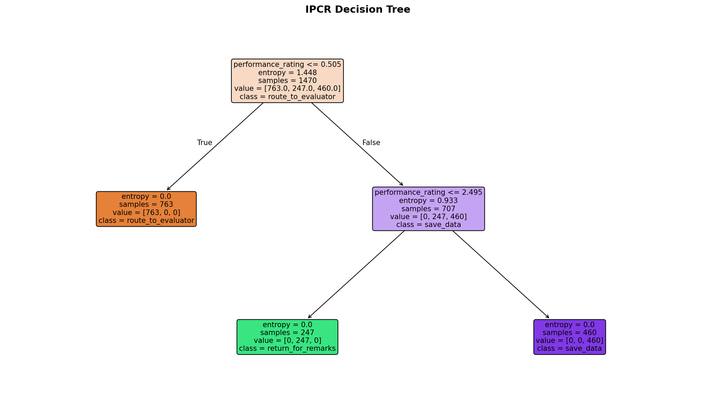
Figure 1: IPCR Decision Tree — trained structure

4.5 Leave Application Decision Tree

Input Features
Feature | Description
leave_type_encoded | Leave type as integer (0–8)
days_requested | Number of days filed
days_balance | Remaining leave credits
has_required_attachment | 1 if required document is attached, 0 if not
dh_decision | Department Head's decision: 0=pending, 1=approved, 2=rejected
hr_decision | HR Officer's decision: 0=pending, 1=approved, 2=rejected
has_rejection_reason | 1 if a rejection reason was recorded, 0 if not

Output Classes (Leaf Nodes)
Class | Routing Action
0 | route_to_department_head — fresh application, DH has not decided
1 | route_to_hr — DH approved, HR has not decided
2 | require_rejection_reason — DH or HR rejected, no reason given yet
3 | completed — HR approved OR rejection reason recorded

Trained Leave Application Decision Tree Diagram
The diagram below shows the trained Leave Decision Tree. The 7 input features are used at decision nodes to determine which routing class to predict.
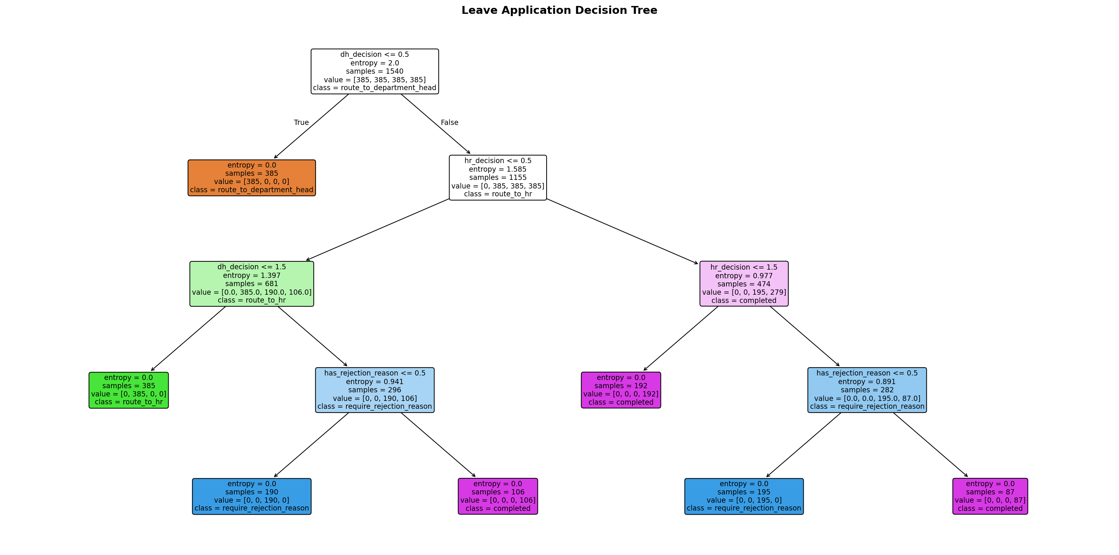
Figure 2: Leave Application Decision Tree — trained structure

4.6 predict() Method — How a Prediction Is Made
def predict(self, features: dict) -> dict:
row = pd.DataFrame([{col: features[col] for col in IPCR_FEATURES}])
prediction = self.model.predict(row)[0]
probabilities = self.model.predict_proba(row)[0]
confidence = round(float(max(probabilities)) * 100, 2)
return {
'routing_action_code': int(prediction),
'routing_action_label': IPCR_DT_ACTIONS[int(prediction)],
'confidence_pct': confidence,
}
Line | Explanation
row = pd.DataFrame(...) | Converts the feature dict to a one-row DataFrame — the format sklearn expects
model.predict(row)[0] | The tree traverses its nodes and returns the predicted class integer
model.predict_proba(row)[0] | Returns the probability of each class at the reached leaf node
max(probabilities) * 100 | The highest probability = confidence percentage
IPCR_DT_ACTIONS[int(prediction)] | Looks up the human-readable label for the predicted class integer

5. workflow_router.py — Main Orchestrator
This is the only file that Smart-HRMS (or any caller) interacts with. It instantiates and coordinates both layers. Every call to route_ipcr() or route_leave() runs the full two-layer pipeline and returns a routing decision.

5.1 Imports
import logging
import json
from datetime import datetime, timezone

from org_and_rules import EMPLOYEES, ROLE_ENCODING, LEAVE_TYPE_ENCODING
from rule_engine import RuleEngine
from decision_tree import IPCRDecisionTree, LeaveDecisionTree

logger = logging.getLogger(__name__)
Import | Why It Is Needed
logging, json | Structured audit logging — emits one JSON line per routing decision
datetime, timezone | Adds UTC timestamp to each audit log entry
EMPLOYEES, ROLE_ENCODING, LEAVE_TYPE_ENCODING | Used to look up employee data and encode features
RuleEngine | Layer 1 — compliance checker
IPCRDecisionTree, LeaveDecisionTree | Layer 2 — ML routing classifiers
logger = logging.getLogger(__name__) | Creates a named logger configured by api/main.py at startup

5.2 __init__() — Constructor
def __init__(self):
self.rules = RuleEngine()
self.ipcr_dt = IPCRDecisionTree()
self.leave_dt = LeaveDecisionTree()
try:
self.ipcr_dt.load()
except FileNotFoundError as e:
print(f'[ERROR] {e}')
WorkflowRouter is instantiated once at startup. The constructor loads both trained Decision Tree models from disk. If setup.py has not been run yet, a clear error message is printed.

5.3 _log_decision() — Audit Trail
def _log_decision(self, result: dict, document_type: str) -> None:
entry = {
"timestamp": datetime.now(timezone.utc).isoformat(),
"employee_id": result.get("employee_id"),
"document_type": document_type,
"routing_action": result.get("routing_action") or result.get("action", "unknown"),
"confidence_pct": result.get("confidence_pct"),
"compliance_passed": result.get("stage") != "compliance_check",
}
logger.info(json.dumps(entry))
Field | What It Records
timestamp | UTC date-time when the decision was made
employee_id | Who filed the form
document_type | 'ipcr' or 'leave'
routing_action | What the system decided
confidence_pct | ML model confidence. Null for compliance failures (Layer 2 never ran)
compliance_passed | False if Layer 1 rejected the form, True if it passed

5.4 Public Entry Points
def route_ipcr(self, form: dict) -> dict:
result = self._route_ipcr(form)
self._log_decision(result, 'ipcr')
return result
Thin wrappers that call the private routing method, log the result, and return it unchanged. All callers (tests and API endpoints) use these public methods.

5.5 _route_ipcr() — IPCR Routing Logic

Stage 1 — Layer 1: Rule Engine
passed, reason, evaluator = self.rules.check_ipcr(form)
if not passed:
return { 'status': 'returned', 'stage': 'compliance_check', 'reason': reason }
If any rule fails, returns immediately. Layer 2 never runs.

Stage 2 — Layer 2: Decision Tree
role_enc = ROLE_ENCODING[employee['role']]
features = { 'role_encoded': role_enc, 'performance_rating': rating or 0.0, 'is_first_submission': 1 if is_first else 0 }
dt_result = self.ipcr_dt.predict(features)
action = dt_result['routing_action_label']

Stage 3 — Branch on Predicted Action
Predicted Action | What Happens
route_to_evaluator | Returns routing info pointing to the assigned evaluator
save_data | Returns completed — rating >= 2.5 passed
return_for_remarks (no remarks yet) | Routes back to evaluator to add remarks
return_for_remarks (remarks given) | Returns completed — remarks recorded, data saved

5.6 _route_leave() — Leave Routing Logic

Feature Vector Construction
features = {
'leave_type_encoded': LEAVE_TYPE_ENCODING.get(leave_type, 0),
'days_requested': application.get('days_requested', 1),
'days_balance': application.get('days_remaining_balance', 0),
'has_required_attachment': has_attachment,
'dh_decision': int(application.get('dh_decision', 0)),
'hr_decision': int(application.get('hr_decision', 0)),
'has_rejection_reason': int(application.get('has_rejection_reason', 0)),
}

Department Head Special Case
if action == 'route_to_department_head':
if employee_id == 'EMP-001': # DH is the applicant
# Skip DH approval — escalate directly to HR
When the Department Head submits a leave application, his applications skip the DH-approval stage and go directly to the HR Officer per CSC guidelines.

The 4 Leave Branches
Branch | Trigger Condition
route_to_department_head | dh_decision == 0 (fresh application)
route_to_hr | dh_decision == 1 (DH approved), hr_decision == 0
require_rejection_reason | DH or HR rejected, has_rejection_reason == 0
completed | hr_decision == 1 (HR approved) OR rejection reason recorded

6. API Layer — FastAPI REST Interface
The API layer wraps the Python routing engine in HTTP endpoints so that Smart-HRMS can call it over the network. Built with FastAPI and served by uvicorn.

6.1 api/schemas.py — Request Validation
Pydantic models that define the exact shape of every incoming HTTP request. FastAPI validates and parses the JSON body before calling the endpoint function.
class IPCRRequest(BaseModel):
employee_id: str
performance_rating: float | None = None
is_first_submission: bool
evaluator_gave_remarks: bool
class LeaveRequest(BaseModel):
employee_id: str
leave_type: str
days_requested: int
days_remaining_balance: int
start_date: date
has_medical_certificate: bool
has_solo_parent_id: bool
has_marriage_certificate: bool
dh_decision: int
hr_decision: int
has_rejection_reason: int

6.2 api/auth.py — API Key Authentication
load_dotenv()
_API_KEY_HEADER = APIKeyHeader(name='X-API-Key', auto_error=False)

def require_api_key(api_key: str = Security(_API_KEY_HEADER)) -> str:
expected = os.getenv('IWR_API_KEY')
if not expected:
raise RuntimeError('IWR_API_KEY is not set')
if not api_key or api_key != expected:
raise HTTPException(status_code=403, detail='Invalid or missing API key')
return api_key
Line | Explanation
load_dotenv() | Loads the .env file so IWR_API_KEY is available as an environment variable
APIKeyHeader(auto_error=False) | Suppresses FastAPI's default error so we can return a custom 403
os.getenv('IWR_API_KEY') | Reads the expected key from the environment
api_key != expected | Both missing and wrong keys return HTTP 403 Forbidden

6.3 api/data_loader.py — Dynamic Data Loading
Fetches latest employee and leave-rule data from Smart-HRMS at server startup. Falls back to hardcoded data if HRMS is unreachable.
EMPLOYEES.clear()
EMPLOYEES.update(employees)
LEAVE_RULES.clear()
LEAVE_RULES.update(leave_rules)
Why .clear() + .update() instead of reassignment? Because rule_engine.py and workflow_router.py import EMPLOYEES directly. Python binds the name to the dict object at import time. Reassigning would only update the local reference — the imported references in other files would still point to the old dict. Mutating the existing object in-place ensures all files see the new data.

6.4 api/main.py — FastAPI Application
@asynccontextmanager
async def lifespan(app: FastAPI):
_audit = logging.getLogger('workflow_router')
if not _audit.handlers:
_h = logging.StreamHandler()
_h.setFormatter(logging.Formatter('%(message)s'))
_audit.addHandler(_h)
_audit.setLevel(logging.INFO)
_audit.propagate = False
load_from_hrms() # fetch live data from Smart-HRMS
yield
Line | Explanation
@asynccontextmanager | Code before yield = startup actions. Code after yield = shutdown
logging.getLogger('workflow_router') | Gets the same logger workflow_router.py uses
_audit.propagate = False | Prevents audit logs from being filtered by uvicorn's WARNING-level root logger
load_from_hrms() | Fetches employee/rule data before the first request is served
_router = WorkflowRouter()

@app.get('/api/health')
def health(): return {'status': 'ok', 'models_loaded': True}

@app.post('/api/ipcr/route', dependencies=[Depends(require_api_key)])
def route_ipcr(req: IPCRRequest): return _router.route_ipcr(req.model_dump())

@app.post('/api/leave/route', dependencies=[Depends(require_api_key)])
def route_leave(req: LeaveRequest):
form = req.model_dump()
form['start_date'] = req.start_date
return _router.route_leave(form)
Line | Explanation
_router = WorkflowRouter() | Singleton — one instance at startup, reused for every request
/api/health (no Depends) | Public endpoint — no API key required. For health monitoring
dependencies=[Depends(require_api_key)] | FastAPI calls require_api_key before the function runs. Returns 403 if key is wrong
req.model_dump() | Converts the Pydantic model to a plain Python dict
form['start_date'] = req.start_date | Keeps start_date as a Python date object (not a string) for the Rule Engine

7. API Endpoints Reference

7.1 GET /api/health
Public — no API key required.
Response: { 'status': 'ok', 'models_loaded': true }

7.2 POST /api/ipcr/route
Protected — requires X-API-Key header. Request body:
{ "employee_id": "EMP-007", "performance_rating": null,
"is_first_submission": true, "evaluator_gave_remarks": false }
Example response (fresh submission):
{ "status": "routed", "stage": "sent_to_evaluator",
"routing_action": "route_to_evaluator",
"evaluator_id": "EMP-001", "evaluator_name": "John Reyes",
"confidence_pct": 100.0,
"notification": "IPCR form for Lorraine Flores has been sent to John Reyes for evaluation." }

7.3 POST /api/leave/route
Protected — requires X-API-Key header. Request body:
{ "employee_id": "EMP-005", "leave_type": "vacation_leave",
"days_requested": 3, "days_remaining_balance": 10,
"start_date": "2026-04-01",
"has_medical_certificate": false, "has_solo_parent_id": false,
"has_marriage_certificate": false,
"dh_decision": 0, "hr_decision": 0, "has_rejection_reason": 0 }
Example response (fresh application):
{ "status": "routed", "stage": "sent_to_department_head",
"routing_action": "route_to_department_head",
"approver_id": "EMP-001", "approver_name": "John Reyes",
"confidence_pct": 95.0,
"notification": "Leave application for Patricia Garcia has been sent to John Reyes for review." }

8. Environment Configuration
Variable | Purpose
IWR_API_KEY | Secret key Smart-HRMS must include as X-API-Key header. Required.
HRMS_API_URL | Base URL of Smart-HRMS (e.g. http://localhost:4000). Leave blank to use hardcoded data.
HRMS_API_KEY | API key for IWR to authenticate when calling Smart-HRMS. Leave blank if not needed.

8.1 Running the Server
# One-time setup (generate training data, train models)
python setup.py

# Run all tests (76 test cases)
python -X utf8 tests.py

# Start the API server
.venv/Scripts/python -m uvicorn api.main:app --reload --port 8000

9. Smart-HRMS Integration Guide

9.1 What Smart-HRMS Must Build
Endpoint / Task | Details
GET /api/iwr-config | Returns employees and leave_rules JSON for IWR to load at startup
Call POST /api/ipcr/route | After employee submits IPCR form, and again when evaluator acts
Call POST /api/leave/route | After employee submits leave, and again after each approver acts
Save IWR response to DB | Store routing_action, approver_id, status in the relevant table
Notify approvers | Use approver_id from IWR response to know who to notify next

9.2 The /api/iwr-config Response Shape
{ "employees": {
"EMP-001": { "name": "John Reyes", "role": "Department Head", "supervisor_id": null },
"EMP-005": { "name": "Patricia Garcia", "role": "Administrative Aide I", "supervisor_id": "EMP-001" }
},
"leave_rules": {
"vacation_leave": { "max_days_per_year": 15, "min_days_advance_notice": 5 }
}
}

9.3 Leave Application Workflow — Re-calling IWR
State | dh / hr / reason → IWR returns
Employee submits | 0 / 0 / 0 → route_to_department_head
DH approves | 1 / 0 / 0 → route_to_hr
HR approves | 1 / 1 / 0 → completed
DH rejects | 2 / 0 / 0 → require_rejection_reason
Rejection reason recorded | 2 / 0 / 1 → completed

