Project Patience

By Nathaniel Gonzales

# Revision History

|  |  |  |  |
| --- | --- | --- | --- |
| Version | Date | Author/s | Revision |
| 0.1 | 07/08/2021 | NaGon | * Created copy of original Project-Patience GDD * Updated Project Milestone Dates * Updated Scope and Limitations   + Original: Game will be developed on Unity **2020**   + Updated: Game will be developed on Unity **2021** |

Table of Contents

Revision History 1

**Game Overview** 2

Game Description 2

Genre 2

Target Audience 2

Target hardware 2

Scope & Limitations 4

- Technical Limitations 4

- Design Limitations 4

**Gameplay** 4

**Game Flow**  4

Initial Screen 4

Change Skin 4

Settings 4

Profile 4

Create Game 5

Game Rules 5

Game End Screen 5

**Game Mechanics** 5

Setup 5

Progression of play 5

Resolution 5

**Audio** **Breakdown** 5

**Technical Requirements** 5

**Art Bible** 5

**About the Dev** 6

# **Game Overview**

|  |  |
| --- | --- |
|  |  |
| **Game Description** | Experience Solitaire in a new light by being able to customize your cards, decks and even backgrounds. Make different rule sets and make your own game of Solitaire that you can enjoy. |
| Genre | Sandbox, Card game |
| Target Audience | All Ages, Solitaire Fans and my SO who loves Solitaire |
| Target hardware | Windows PC & Android Phone |
| Project Milestones | |  |  |  |  | | --- | --- | --- | --- | | Stage | Day | Date | Estimates/Goals | | Pre-production | 1 | July 8 | * Documentation   + Initial HCD   + Initial GDD * Programming   + System-Design Document   + Repo Setup   + Initial Project * Design   + Game Flow   + Game Mode     - Setup (Rules)     - Progression of Play     - Resolution * Art   + Default card art assets   + Default BG   + Menu UI * Sound   + Initial Audio Asset Master List | | Prototype | 2-3 | July 9-10 | * Programming   + Card System   + Game Mode * Design   + Game Mode * Art   + Placeholder Art     - Cards     - UI     - Title Screen * Sound   + Placeholder SFX     - Game Mode     - Menu UI | | First Playable | 4-6 | July 12-17 | * Documentation   + Finish Gameplay Section   + Audio Breakdown   + Technical Requirements * Programming   + Complete Game Systems     - Game Mode     - Level-up     - Resolution * Design   + Game Mode   + Level-up System   + Pop-up System * Art   + Default Card Design   + Default BG   + Card Animations * Sound   + Placeholder SFX     - Designer Mode     - Menu UI * QA   + Create bug testing process. | | Alpha/Polish | 3 | July 19-23 | * Programming   + Pop-up system * Art   + Pop-up   + Default Card Design 2 & 3   + Default BG 2 & 3   + Add Animations     - Title Screen     - Settings     - Game Setup * Sound   + Implement all SFX & Music * QA   + Use bug tracking app.   + Test for Critical to High prio bugs. | | Release | 4 | July 24 | * General   + Release game to itch.io   + Release on Google App Store   + Share game to friends and other game dev communities. * Programming   + Bug Fixes   + Performance improvements * QA   + Continue testing for bugs.   + Evaluate bug reports (if any) |   . |
| Scope & Limitations | Technical Limitations  * + Game will be developed on Unity 2021.   + Initial release will be on PC as it is the platform developer has experience in.   + Original Music will not be included due to limited developers.   + Game may not be tested on multiple android devices due to limited test devices.  Design Limitations  * + The rules and customization feature may be limited.   + There will initially be only 3 Card Skins & Backgrounds that can be unlocked.   + Klondike will initially be the only game mode available. |
|  |  |

# **Gameplay**

## **Game Flow**

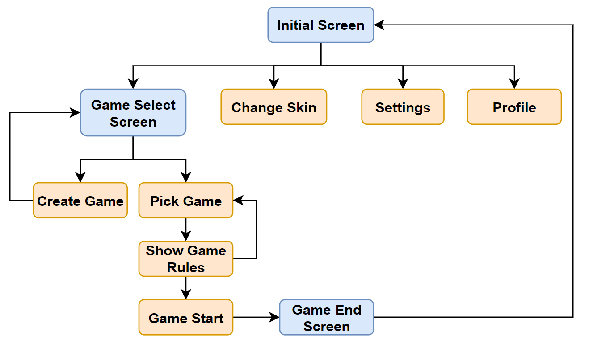

### Initial Screen

<insert picture of Screen here>

### Change Skin

<insert picture of Screen here>

### Settings

<insert picture of Screen here>

### Profile

<insert picture of Screen here>

### Create Game

<insert picture of Screen here>

### Game Rules

<insert picture of Screen here>

### Game End Screen

<insert picture of Screen here>

## **Game Mechanics**

### Setup

* The Tableau: Seven piles that make up the main table.
* The Foundations: Four piles on which a whole suit or sequence must be built up. In most Solitaire games, the four aces are the bottom card or base of the foundations. The foundation piles are hearts, diamonds, spades, and clubs.
* The Stock (or “Hand”) Pile: If the entire pack is not laid out in a tableau at the beginning of a game, the remaining cards form the Stock pile from which additional cards are brought into play according to the rules.
* The Talon (or “Waste”) Pile: Cards from the Stock pile that have no place in the tableau or on foundations are laid face up in the waste pile.

### Progression of play

* List down game flow from start of game to the middle of game and game resolution

### Resolution

* Pop-up window appears with Game summary containing the ff info:
  + Total Score earned (Can be + or negative)
  + Total Duration of finished Game
  + Total # of Moves done
* Player has the ff. options after viewing the Game Summary:
  + Restart Game - Starts the game again with the same shuffled deck
  + New Deal - Starts the game with a newly shuffled deck
  + Back to main menu - Returns the player to the Main Menu

# **Audio** **Breakdown**

<Insert Screenshot of Audio Asset Master List>

# **Technical Requirements**

* Tools/Software & Engine used

# **Art Bible**

* Color Palette/UI/Card Designs/In Game Photos/Scenes

# **About the Dev**

* Name of Organization and about the developer