**Lucrarea de laborator nr. 3**

Executat: Mihai SMOLEAC

Grupa: IS21Z

Varianta: XVIII

**Elemente și funcții logice elementare**

**Scopul lucrării:**

1 Obţinerea deprinderilor de minimizare a funcţiilor logice.

2 Obţinerea deprinderilor de construire a schemelor electrice principiale.

**Experimentul nr. 1 Proiectarea schemei electrice numerice principiale**

1. De completat tabelul de adevăr şi de minimizat (prin metoda Karnough) funcţiile logice

prezentate în următorul tabel:

|  |  |
| --- | --- |
| Nr. d/o | Functia logica |
| 18 | |  | | --- | | f(a,b,c,d,e,f) = Σ(8, 9, 10, 11, 12, 13, 14, 15, 16, 17, 18, 19, 21, 22, 23, 24, 25, 26, 27, 28, 29, 30, 32, 33, 34, 35, 36, 37, 38, 39, 40, 41, 42, 43, 44, 45, 46, 48, 49, 50, 51, 52, 53, 55) | |

|  |  |  |  |  |  |  |  |
| --- | --- | --- | --- | --- | --- | --- | --- |
| **Nr/index** | **a** | **b** | **c** | **d** | **e** | **f** | **F(a,b,c,d,e,f)** |
| 0 | 0 | 0 | 0 | 0 | 0 | 0 | 0 |
| 1 | 0 | 0 | 0 | 0 | 0 | 1 | 0 |
| 2 | 0 | 0 | 0 | 0 | 1 | 0 | 0 |
| 3 | 0 | 0 | 0 | 0 | 1 | 1 | 0 |
| 4 | 0 | 0 | 0 | 1 | 0 | 0 | 0 |
| 5 | 0 | 0 | 0 | 1 | 0 | 1 | 0 |
| 6 | 0 | 0 | 0 | 1 | 1 | 0 | 0 |
| 7 | 0 | 0 | 0 | 1 | 1 | 1 | 0 |
| 8 | 0 | 0 | 1 | 0 | 0 | 0 | 1 |
| 9 | 0 | 0 | 1 | 0 | 0 | 1 | 1 |
| 10 | 0 | 0 | 1 | 0 | 1 | 0 | 1 |
| 11 | 0 | 0 | 1 | 0 | 1 | 1 | 1 |
| 12 | 0 | 0 | 1 | 1 | 0 | 0 | 1 |
| 13 | 0 | 0 | 1 | 1 | 0 | 1 | 1 |
| 14 | 0 | 0 | 1 | 1 | 1 | 0 | 1 |
| 15 | 0 | 0 | 1 | 1 | 1 | 1 | 1 |
| 16 | 0 | 1 | 0 | 0 | 0 | 0 | 1 |
| 17 | 0 | 1 | 0 | 0 | 0 | 1 | 1 |
| 18 | 0 | 1 | 0 | 0 | 1 | 0 | 1 |
| 19 | 0 | 1 | 0 | 0 | 1 | 1 | 1 |
| 20 | 0 | 1 | 0 | 1 | 0 | 0 | 0 |
| 21 | 0 | 1 | 0 | 1 | 0 | 1 | 1 |
| 22 | 0 | 1 | 0 | 1 | 1 | 0 | 1 |
| 23 | 0 | 1 | 0 | 1 | 1 | 1 | 1 |
| 24 | 0 | 1 | 1 | 0 | 0 | 0 | 1 |
| 25 | 0 | 1 | 1 | 0 | 0 | 1 | 1 |
| 26 | 0 | 1 | 1 | 0 | 1 | 0 | 1 |
| 27 | 0 | 1 | 1 | 0 | 1 | 1 | 1 |
| 28 | 0 | 1 | 1 | 1 | 0 | 0 | 1 |
| 29 | 0 | 1 | 1 | 1 | 0 | 1 | 1 |
| 30 | 0 | 1 | 1 | 1 | 1 | 0 | 1 |
| 31 | 0 | 1 | 1 | 1 | 1 | 1 | 0 |
| 32 | 1 | 0 | 0 | 0 | 0 | 0 | 1 |
| 33 | 1 | 0 | 0 | 0 | 0 | 1 | 1 |
| 34 | 1 | 0 | 0 | 0 | 1 | 0 | 1 |
| 35 | 1 | 0 | 0 | 0 | 1 | 1 | 1 |
| 36 | 1 | 0 | 0 | 1 | 0 | 0 | 1 |
| 37 | 1 | 0 | 0 | 1 | 0 | 1 | 1 |
| 38 | 1 | 0 | 0 | 1 | 1 | 0 | 1 |
| 39 | 1 | 0 | 0 | 1 | 1 | 1 | 1 |
| 40 | 1 | 0 | 1 | 0 | 0 | 0 | 1 |
| 41 | 1 | 0 | 1 | 0 | 0 | 1 | 1 |
| 42 | 1 | 0 | 1 | 0 | 1 | 0 | 1 |
| 43 | 1 | 0 | 1 | 0 | 1 | 1 | 1 |
| 44 | 1 | 0 | 1 | 1 | 0 | 0 | 1 |
| 45 | 1 | 0 | 1 | 1 | 0 | 1 | 1 |
| 46 | 1 | 0 | 1 | 1 | 1 | 0 | 1 |
| 47 | 1 | 0 | 1 | 1 | 1 | 1 | 0 |
| 48 | 1 | 1 | 0 | 0 | 0 | 0 | 1 |
| 49 | 1 | 1 | 0 | 0 | 0 | 1 | 1 |
| 50 | 1 | 1 | 0 | 0 | 1 | 0 | 1 |
| 51 | 1 | 1 | 0 | 0 | 1 | 1 | 1 |
| 52 | 1 | 1 | 0 | 1 | 0 | 0 | 1 |
| 53 | 1 | 1 | 0 | 1 | 0 | 1 | 1 |
| 54 | 1 | 1 | 0 | 1 | 1 | 0 | 0 |
| 55 | 1 | 1 | 0 | 1 | 1 | 1 | 1 |
| 56 | 1 | 1 | 1 | 0 | 0 | 0 | 0 |
| 57 | 1 | 1 | 1 | 0 | 0 | 1 | 0 |
| 58 | 1 | 1 | 1 | 0 | 1 | 0 | 0 |
| 59 | 1 | 1 | 1 | 0 | 1 | 1 | 0 |
| 60 | 1 | 1 | 1 | 1 | 0 | 0 | 0 |
| 61 | 1 | 1 | 1 | 1 | 0 | 1 | 0 |
| 62 | 1 | 1 | 1 | 1 | 1 | 0 | 0 |
| 63 | 1 | 1 | 1 | 1 | 1 | 1 | 0 |

|  |  |  |  |  |  |  |  |  |
| --- | --- | --- | --- | --- | --- | --- | --- | --- |
| ***abc***  ***def*** | ***000*** | ***001*** | ***011*** | ***010*** | ***110*** | ***111*** | ***101*** | ***100*** |
| ***000*** | 0 | 1 | 1 | 1 | 1 | 0 | 1 | 1 |
| ***001*** | 0 | 1 | 1 | 1 | 1 | 0 | 1 | 1 |
| ***011*** | 0 | 1 | 1 | 1 | 1 | 0 | 1 | 1 |
| ***010*** | 0 | 1 | 1 | 1 | 1 | 0 | 1 | 1 |
| ***110*** | 0 | 1 | 1 | 1 | 0 | 0 | 1 | 1 |
| ***111*** | 0 | 1 | 0 | 1 | 1 | 0 | 0 | 1 |
| ***101*** | 0 | 1 | 1 | 1 | 1 | 0 | 1 | 1 |
| ***100*** | 0 | 1 | 1 | 0 | 1 | 0 | 1 | 1 |

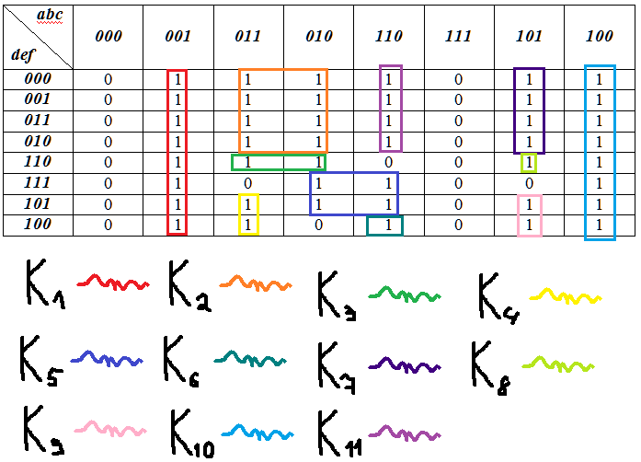

K1­­ = K­2 = K3 = K4 = K5 = K6 = K7 = ; K8 = ;

K9 = K10 = K11 =

F(a,b,c,d,e,f) =

Conform formulei schema electrica contine 6 elemente NU, 11 elemente ȘI, 1 element SAU.