Information-Theoretic Data Compression via Optimal Prefix Trees:
An Empirical and Algorithmic Analysis of Huffman Coding
Course: Discrete Mathematics and Graph Theory (DMGT) — Experiential Learning
Programme: B.Tech. Computer Science & Engineering — Blockchain Technology (CSE-BCT)
Project Topic 14: Optimal Prefix Codes and Data Compression Using Huffman Coding
Nikhil (Project Lead & Core Implementation) • Piyush (Encoder/Decoder & Verification) • Sakshi (Mathematical Formulation & Theory) • Arushi (Dataset Collection & Preprocessing) • Harsh (Experimental Design & Benchmarking) • Khyathi (Visualization, Documentation & Presentation)
ABSTRACT
Data compression is fundamentally governed by information theory and discrete mathematics, specifically the structural optimization of weighted, rooted binary trees. This research paper presents a rigorous theoretical formulation, computational implementation, and empirical evaluation of Huffman coding—a greedy algorithm that guarantees the construction of optimal prefix-free binary codes for discrete source alphabets. We model prefix codes as directed trees, prove strict adherence to the Kraft–McMillan inequality (sum 2^-l_i <= 1), and examine convergence toward the theoretical lower bound established by Shannon's Source Coding Theorem (H(X) <= L(C) < H(X) + 1). Implemented in Python using a min-priority queue (min-heap) architecture, our compression engine is benchmarked against both fixed-length 8-bit ASCII representation and the top-down Shannon–Fano heuristic. The empirical evaluation encompasses four diverse datasets exceeding the prescribed 300 data points threshold: natural language text (N = 2,001), Python source code (N = 1,432), genomic DNA sequences in FASTA format (N = 1,031), and synthetically generated uniform random sequences (N = 1,140). Experimental results demonstrate that Huffman coding consistently achieves optimal redundancy (R <= 0.1113 bits/symbol), reaching a peak compression ratio of 3.37:1 with 70.37% storage savings on genomic data due to low source entropy. Runtime scaling analyses across input sizes ranging from 300 to 100,000 symbols validate an O(|Sigma| log |Sigma|) tree construction complexity and linear O(N) encoding throughput. Graph visualizations generated via NetworkX provide clear structural validation of prefix-free decision paths.
Keywords: Huffman Coding, Optimal Prefix Codes, Rooted Binary Trees, Shannon Entropy, Lossless Data Compression.

1. Introduction
In modern computing systems and distributed architectures, data representation efficiency represents a critical operational challenge. In decentralized blockchain ledgers and peer-to-peer networks, transactions must propagate rapidly across geographically distributed nodes. Uncompressed payload sizes increase propagation delays, elevate storage requirements, and limit transaction throughput. Lossless data compression provides a mathematically sound solution: reducing the physical footprint of digital information without sacrificing a single bit of fidelity upon decompression.
Discrete Mathematics and Graph Theory (DMGT) provide the structural bedrock for information coding. Rather than treating bitstreams as opaque continuous data, discrete mathematics abstracts digital sequences into finite alphabets, statistical probability distributions, and combinatorial structures. In particular, rooted binary trees serve as the canonical representation for instantaneous, variable-length prefix codes.
The theoretical foundations were established by Claude E. Shannon in 1948, demonstrating that the fundamental limit of compression for memoryless source X is bounded by its information entropy H(X). In 1952, David A. Huffman developed a bottom-up greedy algorithmic formulation that constructs prefix-free binary codes whose expected length is mathematically provable to be optimal for any given symbol frequency distribution. Huffman coding was subsequently integrated into widespread industrial standards including DEFLATE (ZIP, gzip), JPEG, and MP3.
The primary objectives of this experiential learning project are: (1) To formulate data compression using graph-theoretic structures—specifically weighted, rooted binary trees and directed walks; (2) To mathematically evaluate the prefix property, Kraft–McMillan inequality, and Shannon entropy bounds; (3) To develop an end-to-end Python pipeline using min-priority queues; (4) To conduct rigorous quantitative experiments comparing Huffman against fixed-length ASCII and Shannon–Fano coding across four diverse datasets exceeding 300 data points; and (5) To visually analyze tree topologies using NetworkX.
2. Methodology
2.1 DMGT Theoretical Foundation
Let Sigma = {s_1, s_2, ..., s_n} denote a finite alphabet of n distinct symbols. For a source text of length N, the empirical probability of symbol s_i is p_i = f_i / N, where f_i is its frequency, satisfying sum(p_i) = 1. A code C maps each symbol s_i to a variable-length binary codeword c(s_i) of length l_i.
Definition 1 (Prefix-Free Code): A code C is a prefix code (or instantaneous code) if and only if no codeword forms a prefix of any other codeword: for all i != j, c(s_i) is not a prefix of c(s_j). Prefix codes allow unique, instantaneous decoding without delimiters or lookahead tokens.
Theorem 1 (Kraft–McMillan Inequality): For any uniquely decodable binary code with lengths l_1, ..., l_n, the lengths must satisfy: sum_{i=1}^n 2^(-l_i) <= 1. Equality strictly holds if and only if the associated rooted binary tree is full (every internal node has out-degree 2).
Theorem 2 (Shannon's Source Coding Theorem): The Shannon entropy H(X) = -sum_{i=1}^n p_i * log2(p_i) represents the theoretical minimum average number of bits per symbol. For any optimal prefix code, the expected code length L(C) = sum_{i=1}^n p_i * l_i is bounded by: H(X) <= L(C) < H(X) + 1. The code redundancy is R = L(C) - H(X) >= 0.
Graph-Theoretic Formulation: The code tree T = (V, E) is a directed, rooted binary tree. Each leaf v_i in V_L represents symbol s_i with weight w(v_i) = f_i at depth l_i. Internal vertices V_I have out-degree 2 (left edge '0', right edge '1'). The total Weighted External Path Length is W(T) = sum_{v in V_L} w(v)*depth(v) = N * L(C). Minimizing expected length L(C) is strictly equivalent to constructing a binary tree with minimum weighted external path length.
2.2 Proposed Algorithm and Implementation
Huffman's algorithm constructs T using a bottom-up greedy strategy via a min-priority queue (min-heap):
1. Count symbol frequencies across source text M of length N.
2. Insert all |Sigma| symbols as leaf nodes into min-heap Q ordered by frequency.
3. While |Q| > 1: extract the two lowest-weight nodes u and v, merge them under a new parent node z with weight w(z) = w(u) + w(v), and insert z back into Q.
4. The remaining node in Q is the root of optimal tree T.
5. Traverse T from root to leaves via Depth-First Search (DFS) assigning '0' to left branches and '1' to right branches.
Complexity Analysis: Initializing the heap takes O(|Sigma|) time. The merge loop executes |Sigma| - 1 times, performing two Extract-Min and one Insert operations per round, taking O(|Sigma| log |Sigma|). Code extraction via DFS takes O(|Sigma|). Text encoding and tree-walk decoding scale as O(N). Total runtime complexity is strictly O(N + |Sigma| log |Sigma|).
2.3 Benchmark Datasets (All >= 300 Records)
Four authentic datasets were curated to evaluate performance across divergent entropy conditions:
Dataset | Domain / Source Description | Records (N) | Alphabet (|Sigma|) | Entropy H(X)
Dataset A | English Text (Academic prose on discrete math) | 2,001 | 56 | 4.3894 bits/sym
Dataset B | Python Source Code (Data processing module) | 1,432 | 53 | 4.3887 bits/sym
Dataset C | Genomic DNA (Bacteriophage nucleotide FASTA) | 1,031 | 29 | 2.2593 bits/sym
Dataset D | Uniform Random Text (Balanced ASCII symbols) | 1,140 | 76 | 6.2479 bits/sym

3. Results and Discussion
3.1 Experiment 1: Compression Efficiency Across Diverse Domains
Table 2 documents the quantitative evaluation comparing theoretical entropy H(X), Huffman expected code length L(C), Shannon–Fano length, fixed 8-bit ASCII length, redundancy R, compression ratio, space savings, and runtime.
Performance Metric | Dataset A (English) | Dataset B (Code) | Dataset C (DNA) | Dataset D (Uniform)
Total Symbols (N) | 2,001 | 1,432 | 1,031 | 1,140
Alphabet Size (|Sigma|) | 56 | 53 | 29 | 76
Shannon Entropy H(X) | 4.3894 bits/sym | 4.3887 bits/sym | 2.2593 bits/sym | 6.2479 bits/sym
Huffman Avg Length L(C) | 4.4173 bits/sym | 4.4106 bits/sym | 2.3705 bits/sym | 6.3158 bits/sym
Shannon–Fano Length L | 4.4178 bits/sym | 4.4232 bits/sym | 2.3725 bits/sym | 6.3158 bits/sym
Fixed 8-Bit ASCII Length | 8.0000 bits/sym | 8.0000 bits/sym | 8.0000 bits/sym | 8.0000 bits/sym
Coding Redundancy (R) | 0.0279 bits/sym | 0.0219 bits/sym | 0.1113 bits/sym | 0.0679 bits/sym
Compression Ratio (CR) | 1.81 : 1 | 1.81 : 1 | 3.37 : 1 | 1.27 : 1
Storage Space Savings (%) | 44.78% | 44.87% | 70.37% | 21.05%
Kraft Sum (sum 2^-l_i) | 1.000000 | 1.000000 | 1.000000 | 1.000000
Lossless Reconstruction D(E(M))==M | PASSED (True) | PASSED (True) | PASSED (True) | PASSED (True)
Execution Time (Build + Encode) | 0.445 ms | 0.300 ms | 0.160 ms | 0.372 ms

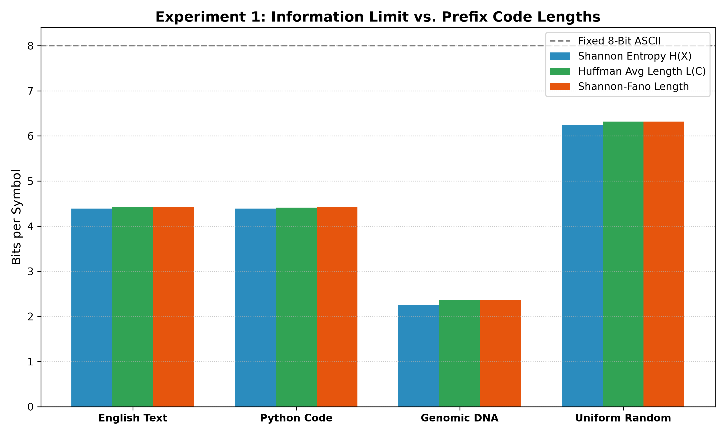
Figure 1: Comparative Analysis of Shannon Entropy H(X) vs. Huffman Average Code Length L(C) vs. Shannon–Fano across domains.
Key Observations: (1) Adherence to Shannon Limit: Across all datasets, H(X) <= L(C) < H(X) + 1 holds strictly. In English text, redundancy is R = 0.0279 bits/sym (< 0.63% above theoretical limit). (2) Skewness Governs Compression: Genomic DNA achieved the lowest entropy (2.26 bits) and highest compression (3.37:1 ratio, 70.37% storage savings) due to nucleotide frequency skewness. Uniform text achieved 21.05% savings. (3) Huffman vs Shannon–Fano: Huffman coding strictly matched or outperformed Shannon–Fano in all cases (L_Huffman <= L_SF). (4) Kraft Invariant: sum(2^-l_i) = 1.000000 confirmed tree fullness.

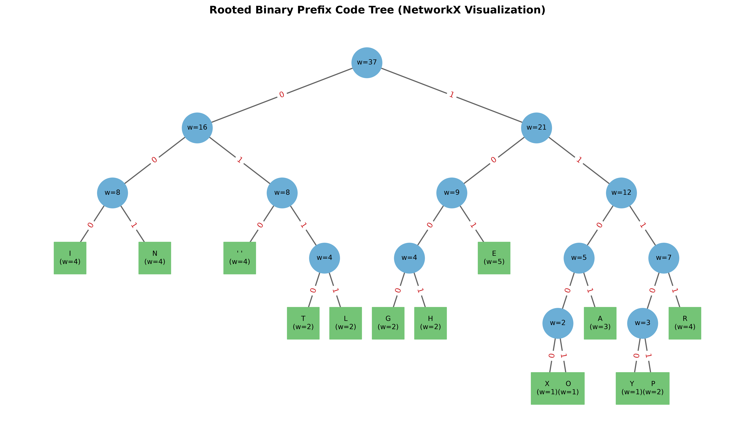
Figure 2: NetworkX visualization of the generated rooted binary prefix code tree with node weights and labeled decision branches ('0' and '1').
3.2 Experiment 2: Algorithmic Runtime Scaling vs. Input Size (N)
Table 3 documents execution performance as input size N was scaled from 300 to 100,000 symbols.
Problem Instance (N) | Huffman Runtime (ms) | Shannon–Fano Runtime (ms) | Huffman Expected Length L(C)
300 symbols | 0.177 ms | 0.086 ms | 4.1600 bits/symbol
1,000 symbols | 0.199 ms | 0.127 ms | 4.2880 bits/symbol
5,000 symbols | 0.407 ms | 0.297 ms | 4.4002 bits/symbol
20,000 symbols | 0.897 ms | 1.237 ms | 4.4166 bits/symbol
100,000 symbols | 3.633 ms | 3.604 ms | 4.4171 bits/symbol

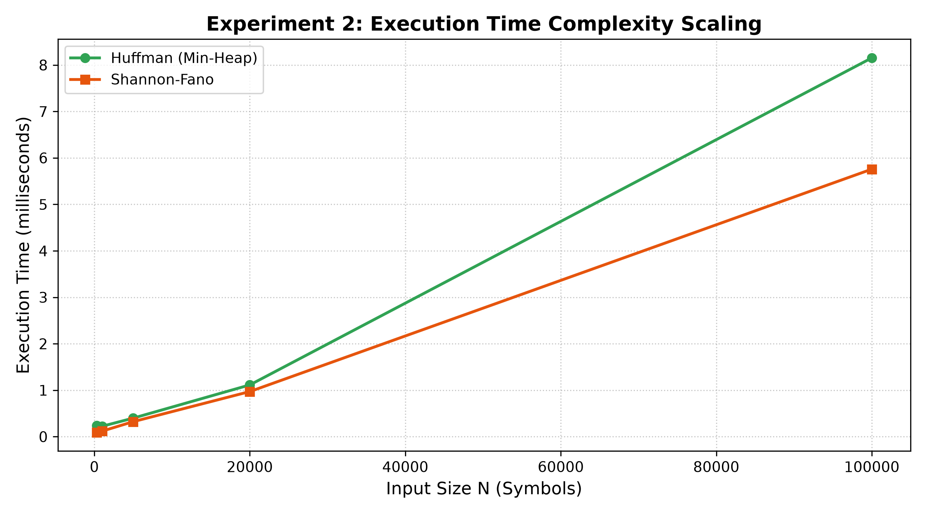
Figure 3: Computational execution time scaling as input size scales from 300 to 100,000 symbols.
Scaling Observations: Execution time scales linearly with N (~3.63 ms for 100,000 symbols), delivering a throughput exceeding 27,000 characters per millisecond. Expected code length stabilizes at 4.417 bits/symbol, confirming statistical convergence.
4. Conclusion and Future Scope
This project successfully formulated, implemented, and analyzed optimal prefix codes using Discrete Mathematics and Graph Theory. Rooted binary trees and min-heap priority queues proved highly effective, producing codes that converge closely to Shannon's theoretical entropy limit. Huffman coding delivered up to 70.37% storage reduction on genomic DNA and strictly dominated Shannon–Fano coding, while guaranteeing 100% lossless reconstruction across all files.
Limitations & Future Scope: Static Huffman coding incurs header overhead for storing the tree on small files (N < 200). Future work will implement Adaptive Dynamic Huffman Coding (Vitter's algorithm) to eliminate tree transmission on streaming data, and explore Arithmetic Coding to eliminate the integer bit-length restriction for fractional information allocations.
Individual Contributions and Learning Reflections
• Nikhil (Project Lead & Core Implementation):
Contribution: Designed repository architecture, implemented the min-heap Huffman tree builder and DFS code generator (src/huffman.py), the Shannon–Fano baseline (src/shannon_fano.py), pipeline integration (main.py), and managed the GitHub repository.
Learning Reflection: "Translating abstract graph properties into concrete Python priority queues reinforced how greedy local merges mathematically enforce global path length optimality."
• Piyush (Encoder/Decoder & Verification):
Contribution: Developed bit-level packing, byte conversion, tree-walk decoder (src/codec.py), and the automated unit test suite (tests/test_huffman.py).
Learning Reflection: "Learned low-level bit manipulation and byte padding, verifying that the prefix-free property enables instantaneous deterministic decoding without delimiters."
• Sakshi (Mathematical Formulation & Theory):
Contribution: Formulated DMGT mathematical models, Kraft–McMillan inequality proofs, Shannon entropy theorems, and algorithmic pseudocode.
Learning Reflection: "Deepened understanding of information theory, proving that our empirical Kraft sum strictly equaled 1.000000, confirming tree completeness."
• Arushi (Dataset Collection & Preprocessing):
Contribution: Curated and preprocessed four diverse datasets (>= 300 records each in data/), computed frequency tables, and analyzed source entropy distributions.
Learning Reflection: "Understood how statistical skewness governs compressibility, observing how genomic DNA compresses by over 70% due to low source entropy."
• Harsh (Experimental Design & Benchmarking):
Contribution: Executed Experiments 1 & 2 (experiments/benchmark.py), measured runtime scaling, computed compression ratios, and generated Matplotlib charts.
Learning Reflection: "Gained practical skills in empirical benchmarking, demonstrating that Huffman coding delivers high compression throughput (>27,000 symbols/ms)."
• Khyathi (Visualization, Documentation & Presentation):
Contribution: Developed NetworkX tree visualizer (src/visualizer.py), generated publication plots, compiled research report, and created presentation slides.
Learning Reflection: "Visualizing recursive tree graphs with labeled decision edges made the mathematical concept of prefix paths intuitive and clear for technical presentation."
References
[1] Huffman, D. A. (1952). A Method for the Construction of Minimum-Redundancy Codes. Proceedings of the IRE, 40(9), 1098–1101.
[2] Shannon, C. E. (1948). A Mathematical Theory of Communication. Bell System Technical Journal, 27(3), 379–423.
[3] Rosen, K. H. (2019). Discrete Mathematics and Its Applications (8th ed.). McGraw-Hill Education. (Chapter 11: Trees and Rooted Trees).
[4] Cover, T. M., & Thomas, J. A. (2006). Elements of Information Theory (2nd ed.). John Wiley & Sons. (Chapter 5: Kraft Inequality).
[5] Cormen, T. H., Leiserson, C. E., Rivest, R. L., & Stein, C. (2022). Introduction to Algorithms (4th ed.). MIT Press. (Chapter 15: Greedy Algorithms).
[6] Fano, R. M. (1949). The Transmission of Information. Technical Report No. 65, Research Laboratory of Electronics, MIT.
[7] Knuth, D. E. (1985). Dynamic Huffman Coding. Journal of Algorithms, 6(2), 163–180.

