Predicting “White Elephant” Outcomes for Olympic and World Cup Venues
S5 Baseline Models Report, Team Gamma
Jonathan Layne (Team Lead) · Martin Gotora (Documentation Lead) · Brian Wrenn (Communication Lead)
DSE6311 Data Science Capstone
Repository: https://github.com/Smoothspinner/sports-urbanism-capstone

Background and Question (Recap)
Cities that host the Olympics or the World Cup build venues that get used heavily for a few weeks and then have to justify themselves for decades. Some manage it. Others sit empty while the host city keeps paying for them.
Our research question hasn’t changed. We’re still asking whether information available before a venue is built (design purpose, capacity, event type, host-country income and corruption, newly built status, and distance from the host city center) can predict whether that venue stays in active use or becomes a white elephant.
What has changed since Sprint 4 is the outcome itself, and it’s a definition rather than a revision. Our earlier reports counted any venue recorded as not in use as a failure, which came to 106 Olympic venues. We finished the review we flagged last sprint and separated genuine abandonment from closures with other causes. Of those 106, urban redevelopment accounts for 69, replacement by a successor stadium for 6, and war for 5. None of those three are failures of the kind we set out to study, since a stadium torn down because the land became valuable is a success story for the city. That leaves 26 venues recorded as abandoned before demolition, and those 26 are now the target. Against the 875 rows in our modeling table the failure rate is 3.0%. Those rows cover 850 distinct venues, since a venue that hosted two Games appears once for each.
Our hypothesis needed a second look this sprint, and the reason is the change in the target rather than a change of mind. We had expected newly built, single-purpose venues far from the city center to fail more often, on the reasoning that long-term use was never the point of building them. Our Sprint 3 EDA appeared to contradict that, since on the broader definition of failure we were using then, existing Olympic venues came out not in use more often than newly built ones. That comparison does not survive the change in target, because the closures we have since separated out are concentrated in exactly the venues it was counting.
On the frozen target the Olympic direction reverses. Newly built venues fail at 3.8% (15 of 394) against 2.3% for existing ones (11 of 470), which is the direction we originally predicted. The World Cup arm still runs the other way, with 0 of 94 purpose-built stadiums failing against 4 of 167 existing ones. We are not treating either arm as settled. The counts are small on both sides, and newly built venues are also younger and have had less time to fail, so age and build status are tangled together in these rates.
Our hypothesis and prediction therefore stand as written, with one caveat added: build status on its own separates the two groups weakly at best, and design purpose, the other predictor our hypothesis names, is still unmeasured on the Olympic side.

Methods
We fit two baseline models on the Olympic data: logistic regression and LDA. The outcome is white_elephant, which is rare, 26 failures out of the 875 rows in our modeling table, about 3%. Logistic regression was our first choice because the outcome is yes/no and its coefficients are easy to interpret. We added LDA as a second baseline because it makes different assumptions about the data, which gives us a useful comparison.
Our plan going into this sprint was to fit these two on the feature set we engineered in Sprint 4, using the coverage picture our Sprint 3 EDA had already given us to decide what was safe to include. That plan survived contact with the data in outline and not in detail, as the predictor change below shows.
We chose predictors in two passes. Our first set was capacity, GDP percentile rank, venue age, and new-build status. We kept that set small on purpose. Only 17 failures appear in the training data, roughly 4 for every predictor, well under the 10 per predictor usually treated as a floor. A model given more than that to fit against 17 cases will start describing noise instead of venues.
Before finalizing, we ran a check on every predictor we impute. Capacity is missing for 84% of training rows, venue age for 81%, and GDP percentile rank for 39%, so all three are largely filled in with the training median. We wanted to know whether being missing was itself linked to failure. If it were, then the filled-in values wouldn’t reflect the venue at all. They would reflect whether Wikidata happened to have a record for it.
We tested each variable’s missing-flag against the outcome using Fisher’s exact test, which asks whether two yes/no variables occur together more often than chance would explain. Capacity came back clean: no relationship between missingness and failure (p = 1.00, odds ratio 1.47). GDP percentile rank came back clean on the same test (p = 1.00, odds ratio 1.10). Venue age did not. All 17 training failures had a missing venue age. None of the 110 training rows with a known venue age failed (p = 0.054). In other words, every failure carried the same placeholder value. The model would have been learning “Wikidata has no record of this venue,” not “this venue is old.”
We dropped venue age and replaced it with host-city population percentile rank. That variable has much better coverage, and we rank it against the full UN city population panel, the same method we use for GDP, so it isn’t affected by the same problem. We ran the same test on it once it was in the model, and it came back clean too, at 12.5% missing and p = 0.709.
Predictor | % Missing (training) | Fisher’s p-value | Verdict
Capacity | 84% | 1.00 | Missingness unrelated to outcome, kept
GDP percentile rank | 39% | 1.00 | Missingness unrelated to outcome, kept
Host-city population | 12.5% | 0.709 | Missingness unrelated to outcome, kept
Venue age | 81% | 0.054 | All 17 failures had missing venue age, dropped
Table 1. Missingness tested against the outcome for every predictor we impute. Venue age is the only one showing a pattern, and that pattern is why we dropped it instead of imputing it.
Final predictors: log-capacity, GDP percentile rank, host-city population percentile rank, and new-build status.
For validation we used 5-fold cross-validation, repeated 10 times, and scored mainly on AUC. AUC measures how well a model ranks failures above non-failures, where 0.5 is no better than guessing and 1.0 is perfect. We report AUC first because it doesn’t depend on picking a cutoff. At a 3% failure rate, the usual 0.5 cutoff simply predicts “no failure” for nearly everything, which tells us nothing. So we also report results at the cutoff that best balances catching failures against raising false alarms.
Both models carry assumptions, and one of them we were able to test directly with the missingness check above. We set all of them out, tested and untested, alongside the results in the next section.

Results
Fitted model: logistic regression averaged an AUC of 0.586 across the 50 folds, ranging from 0.292 to 0.861. LDA averaged 0.597, ranging from 0.422 to 0.828. Both models land only slightly better than guessing, so our predictors carry some signal but not much.
Our AUCs are nearly identical to what we got with the original predictor set that included venue age (0.588 and 0.592), which tells us something useful: venue age was never adding real predictive value. Removing it cost us nothing.
Model | AUC (mean, range) | Sensitivity | Specificity | Balanced Accuracy
Logistic Regression | 0.586 (0.292 to 0.861) | 97.1% | 24.5% | 60.8%
LDA | 0.597 (0.422 to 0.828) | 98.2% | 24.0% | 61.1%
Table 2. Baseline performance on the Olympic data. Sensitivity and specificity are taken at each model’s balanced cutoff, where the two models come out close to indistinguishable.
At that balanced cutoff, logistic regression reached 97.1% sensitivity and 24.5% specificity (balanced accuracy 60.8%); LDA reached 98.2% and 24.0% (balanced accuracy 61.1%). The two models behave almost identically: both catch nearly every real failure, but only by flagging roughly three-quarters of all venue-rows as “at risk,” a direct consequence of how weak the underlying signal currently is.
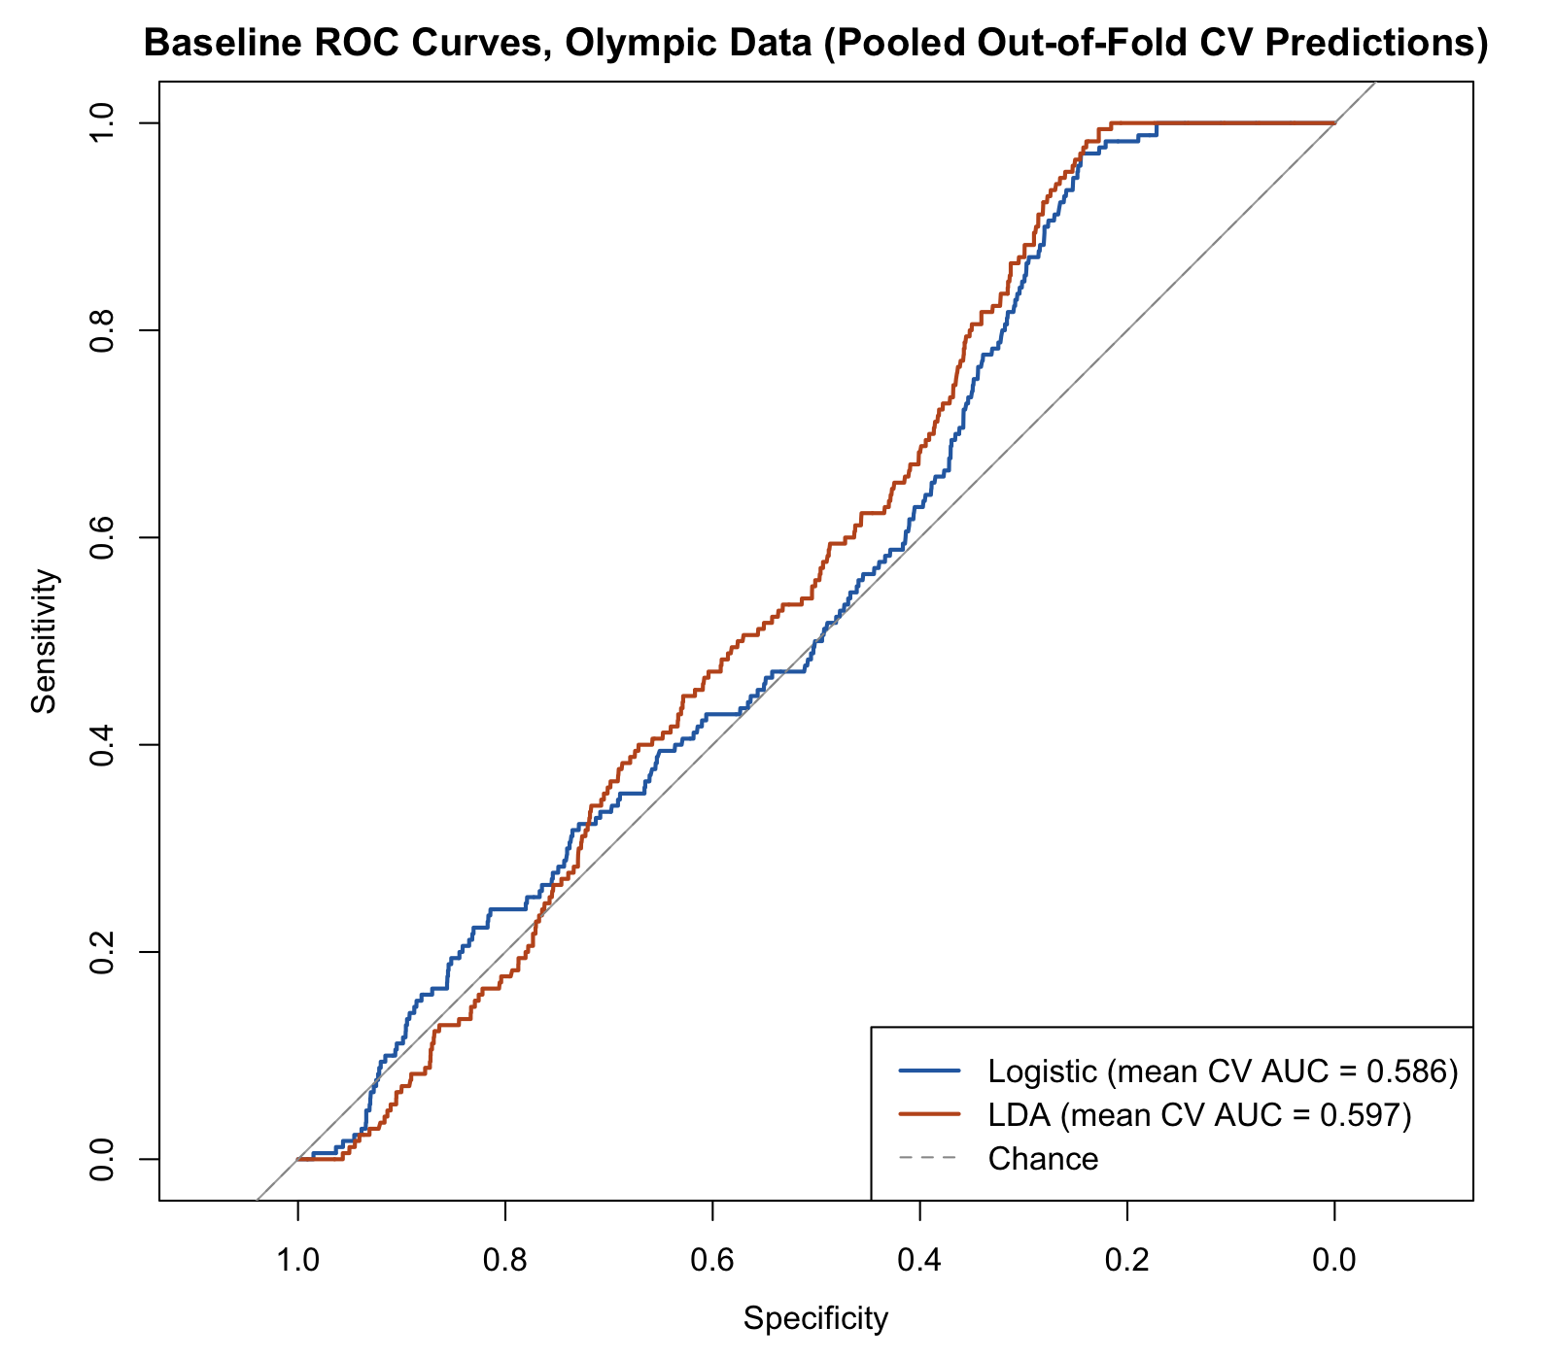
Figure 1. ROC curves for both baselines on the Olympic data, drawn from the pooled out-of-fold cross-validation predictions. The legend gives each model’s mean AUC across the 50 folds, matching Table 2, rather than the AUC of the pooled curve itself. Both curves stay close to the chance diagonal.
Assumptions:
- Our observations are not independent. GDP and city population are identical for every venue at the same Games, so venues cluster by Games edition rather than varying one by one. Athens 2004 alone accounts for 9 of our 26 failures. We have not corrected for this and are flagging it as a limitation to handle during tuning.
- With 17 training failures against 4 predictors we are at roughly 4 failures per predictor, below the usual floor of 10. This is why we kept the model small rather than adding every variable we have.
- Median imputation assumes a value is missing for reasons unrelated to the outcome. We tested that directly for every predictor we impute rather than assuming it, and venue age was the only one to fail the test (Table 1), which is why it is out of the model.
- Logistic regression and LDA both assume no two predictors carry the same information twice. Our Sprint 3 EDA ran that check on the World Cup numeric predictors and found no pair correlated above 0.7 (Table 5 of that report). We have not run it on the Olympic side, and with four predictors in the model redundancy is not what we think is holding the baseline back.
- LDA additionally assumes equal covariance across the two groups and roughly normal predictors. We did not test either. With 17 failures there is not enough data on the failure side to test them meaningfully, and we would rather say that than report a diagnostic we don’t trust. If covariance looks unequal once we have more predictors, QDA is the comparison to run.
One further note on the World Cup side, which is why we do not score it as a classifier: no purpose-built World Cup stadium has ever failed, 0 of 94, against 4 of 167 existing ones. With only 4 World Cup failures in total, the model separates the two groups perfectly: the new-build coefficient comes back with a standard error in the thousands, and R warns that the fitted probabilities hit 0 or 1. That is a property of the sample size rather than a finding about stadiums.
Overfitting: cross-validation was our main control this round, along with keeping the predictor count low. Testing and removing venue age also counts as overfitting control, since it stopped the model from exploiting a pattern that came from our data collection rather than from the venues themselves. Regularization and formal feature selection come next week.

Discussion and Next Steps

What the baseline tells us
Neither baseline can answer our research question yet. Logistic regression scored a cross-validated AUC of 0.586 and LDA 0.597, against 0.5 for guessing (Table 2). Read as a comparator, that’s a weak first pass. Read as a diagnostic, which is the more useful reading this early, it’s informative about exactly where the project is stuck.
The averages hide the more important number. Across the 50 folds, logistic AUC ranged from 0.292 to 0.861 and LDA from 0.422 to 0.828. Several folds performed worse than chance, and that spread isn’t noise to be averaged away; it follows directly from having 17 failures in the training set, which leaves roughly three positive cases in any given validation fold. A single fold’s AUC is close to meaningless at that count, and reporting one train/test number would have hidden this completely.
Threshold behavior tells the same story from another angle. At the default 0.5 cutoff the model labels every venue “no” and specificity is exactly zero, which is the expected result at a 3% base rate rather than a defect. Re-cutting the pooled out-of-fold probabilities at the point that balances sensitivity and specificity catches nearly every real failure, sensitivity 0.97 for logistic and 0.98 for LDA, but only by flagging roughly 76% of all venue-rows as at risk in both cases. A screening tool that warns about three venues in four isn’t giving a host city anything it can act on.

The constraint is our data, not our model class
Working through the diagnostic surfaced something we’d underweighted. Coverage across the four predictors is very uneven. Out of 567 training rows, capacity is missing for 475, so the imputed capacity column sits at one median value for 84% of rows and carries only 78 distinct values in total. GDP percentile rank is missing for 221, and since the training median coincides with a value already present, 246 rows end up sharing a single number. Host city population is the exception at 71 rows missing, or 12.5%. Counts here are rows rather than distinct venues, since 14 venues hosted two Games and the 567 rows cover 553 venues. The models fit on 561 of those rows, the other six having no new-build status recorded.
So capacity is close to a constant, and GDP is coarse by construction: it takes only 27 distinct values across the training set, because it is a country-year figure shared by every venue at the same Games. Host city population and new-build status carry most of the variation the baseline actually has to work with.
That reframes what a more flexible model could buy us. LASSO, random forests and boosting all change how predictors get combined, and none of them recover capacity figures that were never in the source. Our expectation going into Sprint 6 is therefore that the model ladder will be informative about functional form and largely unable to lift performance on its own.

Why we won’t use the missingness itself as a predictor
Our methods above report the test that took venue age out of the model: every failure in the training set had a missing venue age, and none of the rows with a recorded one failed (Table 1). That leaves an obvious temptation open. Our preprocessing script already builds a missing-data indicator alongside each imputed column, so the very pattern that disqualified venue age could be handed to the model as a predictor in its own right. We’re not taking it.
Our reason for refusing it isn’t statistical. Our research question asks what information available before construction predicts failure, and whether Wikidata records an opening year isn’t a fact about the venue at all. Most of the Beijing 2022 sites are missing that field, and they are four years old and thoroughly documented. Across the full table, 665 of the 707 rows missing it still carry a Wikidata record, so the gap sits in one database property rather than in the historical record. A column tracking it would be a column about Wikidata’s completeness in 2026, which nobody planning a venue could have consulted. Testing the indicators and declining to keep them is the honest use of a baseline as a diagnostic.

Revisions to the Analysis Plan
Five changes, with reasons.
- The World Cup arm drops out of scored modeling and becomes descriptive. Under the frozen target the World Cup data holds 4 failures across 3 distinct stadiums. Our splitting script groups on stadium ID to keep the same venue out of both sides, so three groups can’t produce a usable test fold at any seed. Describing it is the only honest option, and we report it that way above.
- Changing the predictor set moves ahead of model complexity, and half of it is already done. Venue age is out and host city population is in as of this sprint. Capacity is still in and still imputed for four rows in five, so it is the next to come out. Region has no missing values at all and has never been in the set. Swapping predictors is a larger expected gain than any algorithm on our ladder, and it costs a rerun rather than a new data source.
- Every new predictor now gets a missingness check before it goes in. Venue age looked acceptable on coverage alone and still had to come out once we tested it. From here, any candidate gets its missing-flag tested against the outcome the way venue age was (Table 1) before it joins the model. Imputation on its own does not make a mostly-missing variable safe to use.
- Random forest and gradient boosting stay on the plan, with revised expectations. Both remain worth fitting because they relax the straight-line assumption our baselines carry, and a tree-based model handles the missingness structure differently than an imputed linear model does. We’re no longer expecting them to be the thing that makes the model work.
- Design purpose is still unresolved on the Olympic side. It is one of the two predictors our hypothesis names, and at present we can only measure it on the World Cup arm, which is the arm we’ve just stopped scoring. Settling how to derive it for Olympic venues is now on the critical path for testing the hypothesis as written, not a refinement.
We’re also carrying forward the question raised in Sprint 4 about whether this is better framed as time-to-event than as binary classification, since a venue can only fail after it’s built and older venues have had longer to do so. That is the same confound sitting underneath our build-status finding, and it is a larger change than the remaining sprints comfortably allow, so we’re recording it as a limitation rather than adopting it.

Next steps: tuning and model evaluation
The coverage question is settled and the answer is no. Our Wikidata pull already carries a fallback for the opening year, and for much of the older Olympic roster the value simply isn’t recorded there. Our earlier review of the IOC workbook found four columns per venue table with no opening or construction field, which rules that source out as well. Olympedia may hold more, but adopting a new source is a larger build than the remaining sprints allow.
Sprint 6 therefore changes the predictor set rather than the model class, and part of that change is already in. Venue age has come out and host city population has gone in, since Table 2 of our Sprint 4 preprocessing report shows it missing for only 13.5% of Olympic rows. Capacity is the remaining candidate to drop, because a column imputed for four rows in five can’t carry a relationship. Distance is not a replacement: the same table shows it missing for 77.4% of Olympic rows, close to the 84.5% and 80.8% of the columns we’re dropping. Era and region are available, but each becomes several indicator columns, and with as few failures as the training set holds we’ll keep the total small rather than adding every categorical we have.
Additional models, and how we’ll validate them: regularized logistic regression comes first once the predictor set is settled, then random forest, then gradient boosting. We start with a penalty because of how few failures we have rather than because our predictors overlap. Shrinking weak coefficients toward zero is what lets us test more candidates than 17 failures would otherwise support. All three get scored the way the baselines were, on repeated 5-fold cross-validation with the same seed, so the numbers stay comparable across the ladder. Any tuning happens inside the resampling rather than against a score we then report.
Hyperparameter tuning needed: regularized regression needs the penalty strength, and the lasso-versus-ridge balance, chosen by cross-validation. Random forest needs the number of predictors tried at each split, and a floor on how small a branch can get. Gradient boosting needs the learning rate, the number of trees and how many splits each tree is allowed, which have to be set together because they trade against each other. Threshold selection gets reported as a range across plausible operating points rather than a single cutoff, since the cost of a missed white elephant and the cost of a false alarm aren’t symmetric for a host city. Resampling for the class imbalance is worth trying but isn’t our main lever, since AUC is computed across all thresholds at once and synthetic oversampling would be interpolating between the 17 real failures we have.

Appendix
Data Dictionary / Codebook: maintained in the team repository and current as of this submission: https://github.com/Smoothspinner/sports-urbanism-capstone/blob/main/reports/cleaning_preprocessing/data_dictionary.md
It documents every column in both modeling tables (olympic_model_split.csv and worldcup_model_split.csv), including the imputed columns and their missing-data indicator flags, and the frozen definition of the white_elephant outcome we use throughout.

