Predicting White Elephant Risk in Olympic and World Cup Venues Using Machine Learning
Exploratory Data Analysis Report. DSE 6311 Capstone.
Team Gamma
- Brian Wrenn (Team Lead)
- Martin Gotora (Communications)
- Jonathan Layne (Documentation)
GitHub repository: https://github.com/Smoothspinner/sports-urbanism-capstone

Background and Question
Some Olympic and World Cup venues go unused after the event: “white elephants.” Prior work explains them after the fact, but we could not find anyone who predicts them before the venue is built. That is our gap. Hosting is expensive and the budget record is poor, and a venue that falls out of use keeps costing the host city money long after the closing ceremony. Our question is whether information a city has at the planning stage, before anything is built (design, capacity, event type, host-country income and corruption, whether the venue is newly built, and how far it sits from the city center), can predict whether a venue stays active or becomes a white elephant. Our hypothesis is that venues that are newly built, single-purpose, and far from the city center become white elephants more often, because long-term use was never the point of building them. The stakeholder is a host-city bid committee: politically accountable, mostly non-technical, and in need of a model whose reasons they can read and defend. This report is a first look at the data behind that model. It is not the modeling itself, and we have not cleaned the data fully yet on purpose; the point here is to learn what the data looks like so we know what cleaning it will need.

Methods

Datasets
We are building one venue table from two main sources. The World Cup side comes from the Fjelstul World Cup Database, a clean CSV on GitHub. It does not record what became of each stadium, so we labeled that ourselves from each stadium’s Wikipedia article, which gave us 265 rows, one per stadium per tournament appearance across all 30 men’s and women’s tournaments. The Olympic side comes from the IOC’s own report on post-Games venue use, a 316-page PDF that we extracted into a spreadsheet; it covers 983 venue rows and, unlike the World Cup source, already records each venue’s current use. On top of both we joined host-country income (World Bank GDP per capita), host-country corruption (Transparency International’s Corruption Perceptions Index), and host-city population (UN data), all measured at the year the event was awarded rather than the year it was held, so we only use numbers the bid committee could have had at the time. The IOC assessed venue use as of 2024 and checked it against published sources and site visits, so we treat that side as a solid third-party record; the World Cup labels are ours, built from secondary sources and cross-checked against a separate source (a Wikidata pull), so we hold them to more scrutiny.

EDA Methods
Before looking at anything we did a small amount of cleaning, and only what was needed to count the data. The Olympic status text was not consistent. The same three states (in use, not in use, dismantled) showed up under several different spellings and with some stray formatting, so we standardized the wording into those three categories for counting, while keeping the original status text so we do not lose the detail it carries (such as rebuilt or demolished). We did the same for the New, Existing, and Temporary classification. We added a region for each host country and an era for each edition (pre-WWII, postwar, and recent) so we could compare across place and time. We did not touch missing values, since the assignment asks us to hold off on that until we understand the data. For the numbers themselves we used standard summary statistics, and checked each distribution’s shape by comparing the mean to the median (a large gap signals skew), along with counts of how often each category occurs and a correlation check to see whether any two of the factors the model uses (its predictors) move together so closely that we would not want both in the model.

Results
Descriptive statistics: The number-valued predictors (the continuous ones) are strongly right-skewed. World Cup stadium capacity averages about 47,900 seats but has a median of 44,000, and the mean sitting well above the median signals a long tail of very large stadiums (Table 1, Figure 3). Host GDP per capita and city population show the same pattern. This tells us those variables will probably need a transformation (such as a log scale) before modeling, so a handful of extreme values do not dominate. For the categories (Table 2), the World Cup venues split 171 Existing to 94 New and almost evenly between multi-purpose (137) and single-purpose (128). The Olympic venues run 473 Existing, 388 New, and 113 Temporary.
Two tables: Table 1 reports the summary statistics for the continuous variables on each side. Table 2 reports the counts and proportions for the category variables (the categorical ones).
Table 1. Descriptive statistics for the continuous variables, World Cup and Olympic venues.
Variable | Dataset | N | Mean | Median | SD | Min | Max
stadium_capacity | World Cup | 265 | 47,883 | 44,000 | 24,656 | 5,000 | 200,000
gdp_per_capita | World Cup | 216 | 18,272 | 10,675 | 18,991 | 284 | 77,387
city_pop_thousands | World Cup | 256 | 2,692 | 919 | 4,520 | 50 | 29,438
opened_year | World Cup | 264 | 1,963 | 1,961 | 36 | 1,892 | 2,022
tournament_year | World Cup | 265 | 1,989 | 1,994 | 25 | 1,930 | 2,022
gdp_per_capita | Olympic | 607 | 14,624 | 10,565 | 13,241 | 420 | 42,240
city_pop_thousands | Olympic | 853 | 6,600 | 3,026 | 8,154 | 56 | 32,886
games_year | Olympic | 983 | 1,976 | 1,984 | 33 | 1,896 | 2,022

Table 2. Frequencies and proportions for the main categorical variables.
Variable | Category | Count | Percent
World Cup, newly built | Existing | 171 | 64.5
World Cup, newly built | New | 94 | 35.5
World Cup, design purpose | Multi-purpose | 137 | 51.7
World Cup, design purpose | Single-purpose | 128 | 48.3
World Cup, current status | In use | 238 | 89.8
World Cup, current status | Not in use | 27 | 10.2
Olympic, classification | Existing | 473 | 48.1
Olympic, classification | New | 388 | 39.5
Olympic, classification | Temporary | 113 | 11.5
Olympic, classification | Mixed | 9 | 0.9
Olympic, current status | In use | 757 | 77.0
Olympic, current status | Not in use | 123 | 12.5
Olympic, current status | Dismantled | 103 | 10.5
Figures: Figure 1 shows how the venues spread across regions, and Figure 2 shows the same by era. Both make the same point: the data is uneven. Most venues sit in Western Europe and in the postwar era, and some region-and-era combinations have almost nothing in them. That matters because we plan to test the model separately by region and era, and a group with only a few venues cannot tell us much. Figure 3 shows the capacity distribution and its right-skew directly. Figure 4 compares host GDP per capita for the two events on a log scale.
Figure 5 is the one we did not expect. It compares whether a venue was newly built against whether it is still in use, and the raw pattern runs the opposite way from our hypothesis: existing World Cup venues are out of use more often (about 15%) than newly built ones (about 2%). The reason is in the detail. Most of the “not in use” World Cup venues (17 of 27) were simply replaced by a newer stadium, and those are mostly old existing grounds that aged out, not new stadiums that never worked. Only a few venues (about three) are actual abandonment, which is the failure our project is really about. This is the clearest lesson of this first look: raw “not in use” is not the same as being a white elephant, and we have to build the thing we are trying to predict (our target) from the reason a venue closed, not just from its status. Table 3 is the correlation check. No two numeric predictors are strongly correlated (nothing above 0.7), so we do not have a redundancy problem to fix. The two notable pairs are GDP and event year (0.61) and opening year and event year (0.64), and the first of those is partly a misleading effect, not a real relationship, which we describe below.
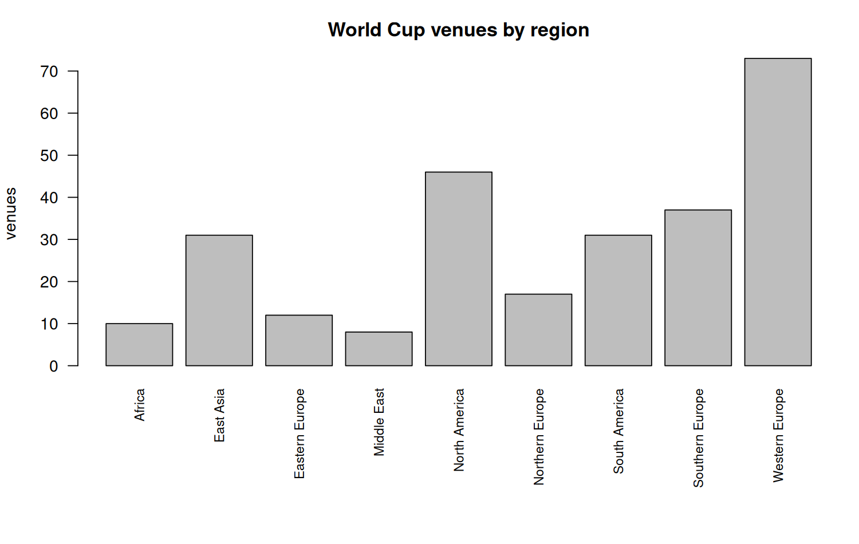
Figure 1. World Cup venue counts by region.
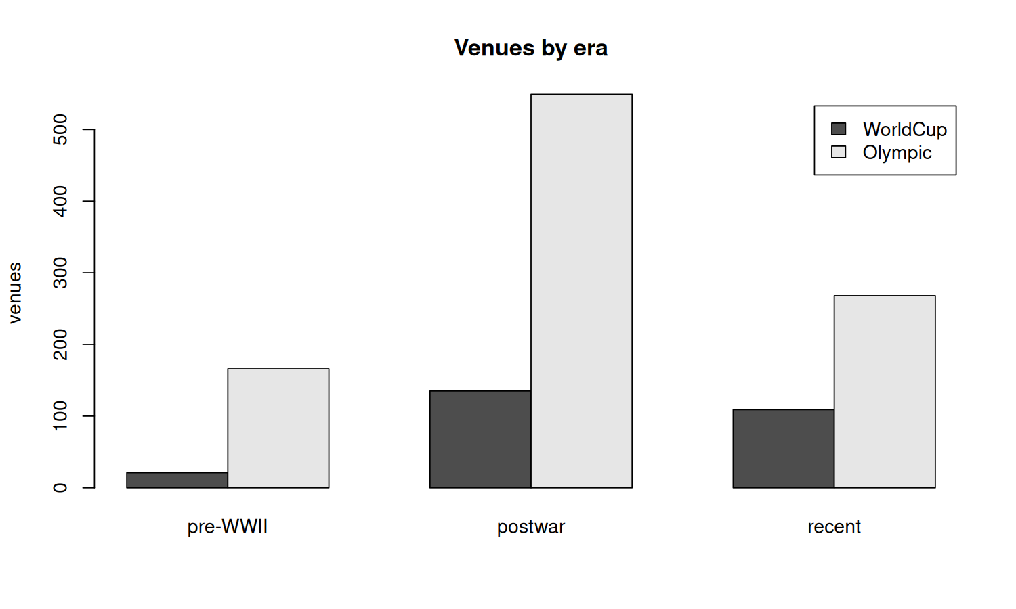
Figure 2. Venue counts by era (event year), World Cup and Olympic.
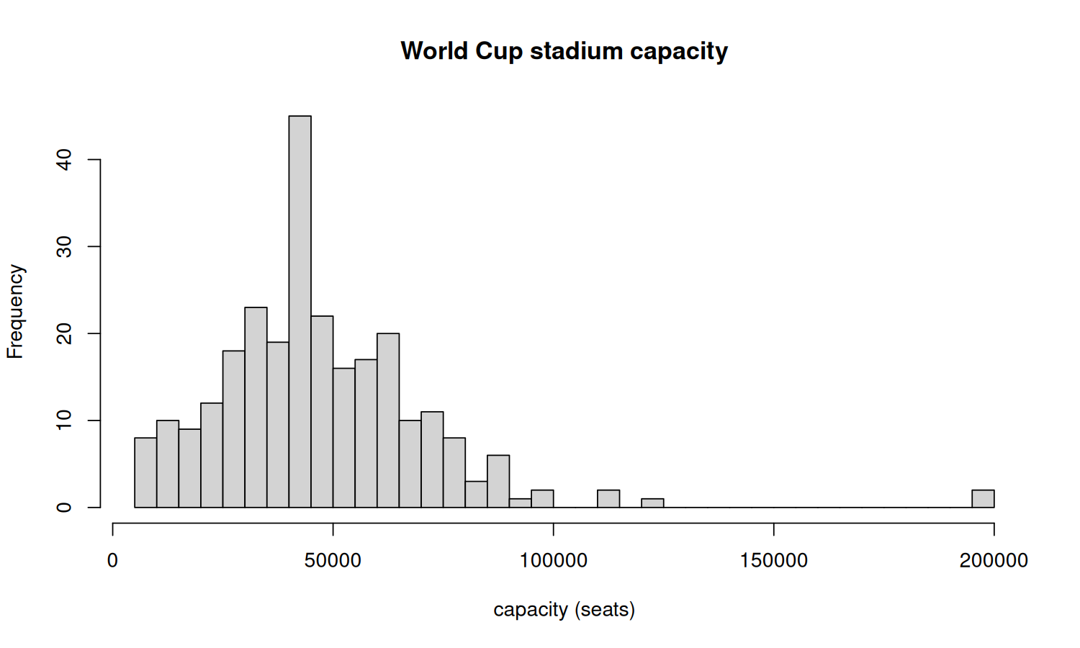
Figure 3. Distribution of World Cup stadium capacity.
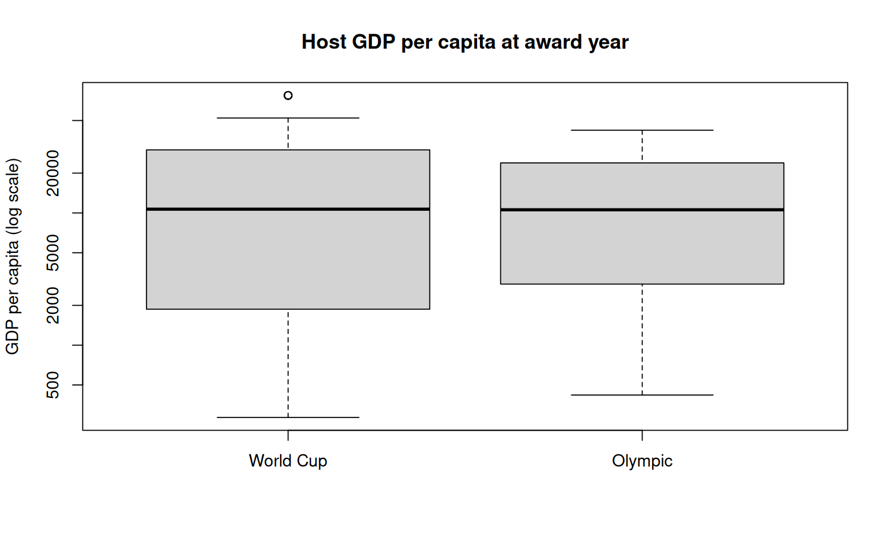
Figure 4. Host GDP per capita at award year, by event, on a log scale.
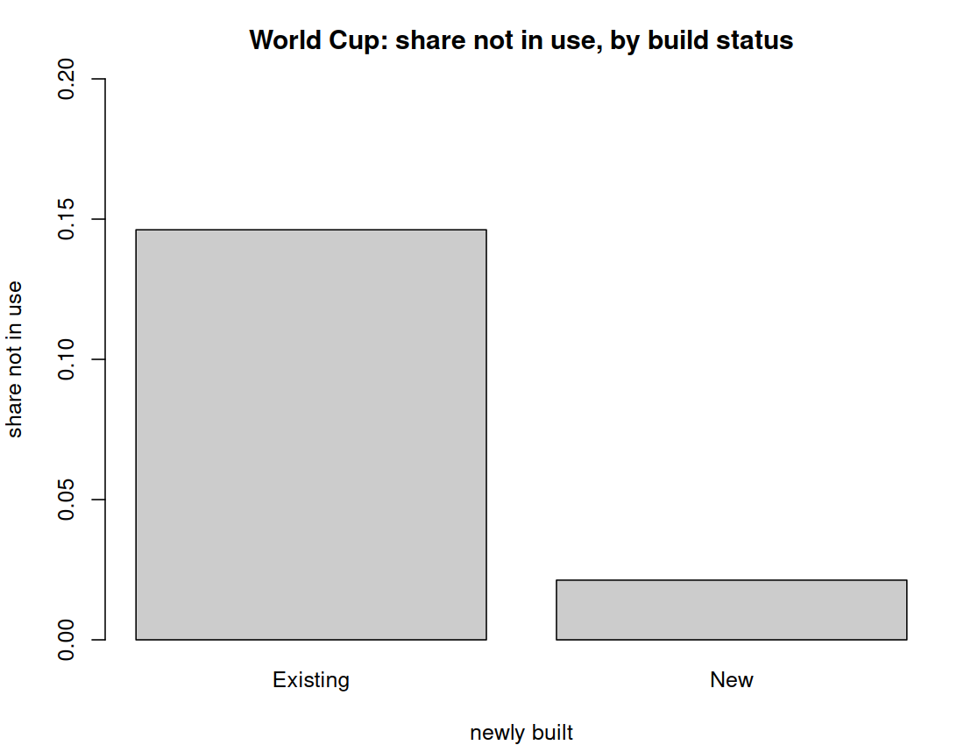
Figure 5. World Cup venues: share not in use, by build status.
Table 3. Correlation matrix of the World Cup numeric predictors.
 | stadium_capacity | gdp_per_capita | city_pop_thousands | opened_year | tournament_year
stadium_capacity | 1.00 | -0.09 | 0.32 | 0.07 | 0.10
gdp_per_capita | -0.09 | 1.00 | 0.00 | 0.28 | 0.61
city_pop_thousands | 0.32 | 0.00 | 1.00 | 0.16 | 0.13
opened_year | 0.07 | 0.28 | 0.16 | 1.00 | 0.64
tournament_year | 0.10 | 0.61 | 0.13 | 0.64 | 1.00

Discussion and Next Steps
Key takeaways: The headline is how rare the failures are, a problem called class imbalance: on the World Cup side only about three venues out of 238 are true failures, roughly 1.5%. On the Olympic side 123 of 983 venues are “not in use” (12.5%), but that count is not the same thing, because we have not yet separated the real failures from war losses, redevelopment, and normal end-of-life replacement the way we did for the World Cup side. So the two numbers are not comparable yet, and we should not combine them into one rate. This rarity is exactly why we already decided not to judge the model on plain accuracy, and the data confirms the concern is real rather than theoretical. Second, Figure 5 shows why our target has to come from the reason a venue closed, not just its status. Third, the GDP figure is nominal (current dollars), so the same country shows a much higher number in a later year (Mexico is about $481 in 1964 and $2,170 in 1983), which is mostly inflation, not real growth; some of the GDP-to-year correlation is just that. Fourth, corruption scores are almost entirely missing (about 94% to 97%), because that data only starts in 2012, so corruption can only be a predictor on recent editions, if we keep it at all.
Data cleaning and preprocessing plan: Nothing in this pass changes the overall plan, but it sharpens a few steps. We will bring the Olympic status data up to the structure we already use on the World Cup side, which keeps three things apart: the plain status (in use or not in use), a short detail note (such as rebuilt or demolished), and the reason a venue closed (replaced by a newer stadium, urban redevelopment, war, or genuine abandonment). The Olympic side currently packs the status and the detail into one text field and has no reason recorded, so we will split the detail out and hand-code the reason, just as we did for the World Cup venues, so that both halves count a real failure the same way. We are keeping those detail notes rather than dropping them, because whether a venue was demolished or only closed, and whether it was temporary, both matter for deciding what counts as a real white elephant. We will decide on a transformation for the skewed predictors (capacity, GDP, population). We will settle whether to use GDP as-is or adjust it so eras compare fairly. We will widen the region and era buckets where they are too thin to split on. And we still need to build the distance-to-city-center predictor from coordinates, which is our next piece of real work: the World Cup coordinates are already pulled, but the Olympic venues have none yet, and we have no city-center coordinates for either side, so that step needs its own source.

Appendix: Data Dictionary
We keep the data dictionary as a Markdown file in our GitHub repo, next to the data it describes, so it stays current as the tables change:
https://github.com/Smoothspinner/sports-urbanism-capstone/blob/main/reports/EDA/data_dictionary.md
It lists every column in the two joined tables (worldcup_stadiums_joined.csv and olympic_venues_joined.csv) with its type and a short note, and ends with the gaps we still have at this stage.

