1. **Please mention group members names and UFID. Also write the steps to run your code.**

Name: Smrati Pandey

UFID: ********

Nidhi Sharma

UFID: ********

Download the file

Run the command: **mix run proj1.exs 100000 200000**

1. **The number of worker actors that you created.**

The number of workers will vary according to the range given.

For example, if the range is 1000 to 2000

Total number to be run by the system = 2000-1000 = 1000, this will be divided in chunks of 10 and total number of workers created = (1000/10) = 100

Total number of workers created for this scenario is 100.

1. **Size of the work unit of each worker actor that you determined results in best performance for your implementation and an explanation on how you determined it. Size of the work unit refers to the number of sub-problems that a worker gets in a single request from the boss.**

The size of the worker was determined on the bases of best distribution in the cores.

The best performance obtained (user+sys)/real. If the distribution is high then accordingly, we select the unit of worker module.

1. **The result of running your program for: mix run proj1.exs 100000 200000**

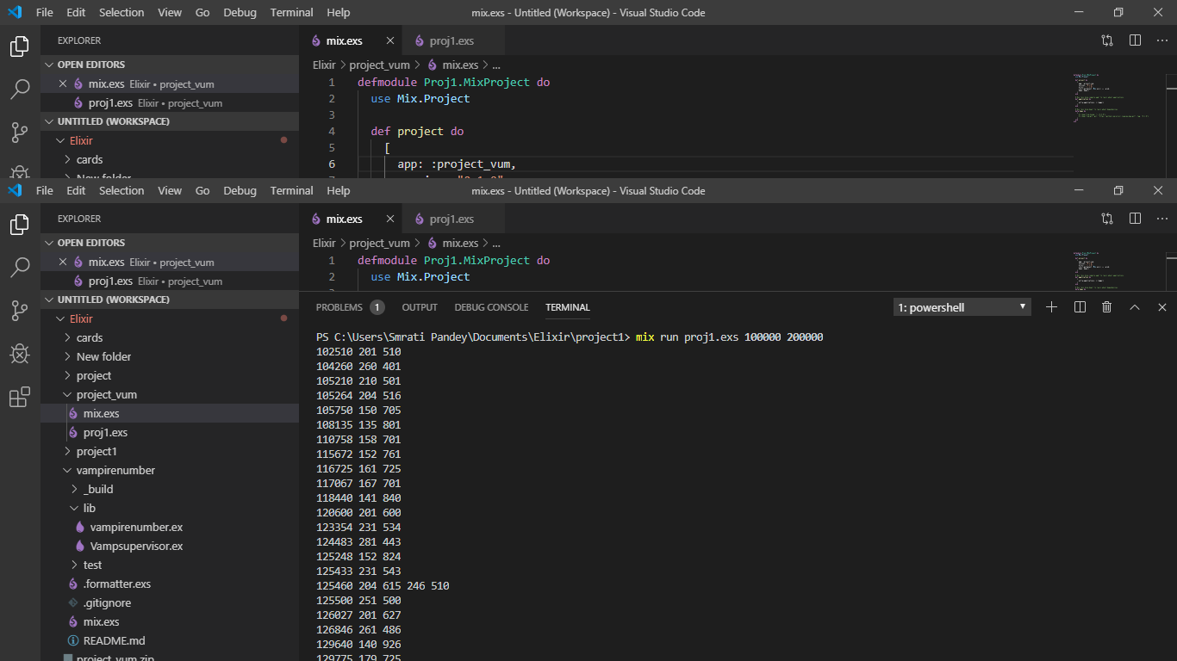

Result:102510 201 510

104260 260 401

105210 210 501

105264 204 516

105750 150 705

108135 135 801

110758 158 701

115672 152 761

116725 161 725

117067 167 701

118440 141 840

120600 201 600

123354 231 534

124483 281 443

125248 152 824

125433 231 543

125460 204 615 246 510

125500 251 500

126027 201 627

126846 261 486

129640 140 926

129775 179 725

131242 311 422

132430 323 410

133245 315 423

134725 317 425

135828 231 588

135837 351 387

136525 215 635

136948 146 938

140350 350 401

145314 351 414

146137 317 461

146952 156 942

150300 300 501

152608 251 608

152685 261 585

153436 356 431

156240 240 651

156289 269 581

156915 165 951

162976 176 926

163944 396 414

172822 221 782

173250 231 750

174370 371 470

175329 231 759

180225 225 801

180297 201 897

182250 225 810

182650 281 650

186624 216 864

190260 210 906

192150 210 915

193257 327 591

193945 395 491

197725 275 719

1. **Report the running time for the above problem (4). The ratio of CPU time to REAL TIME tells you how many cores were effectively used in the computation. If you are close to 1 you have almost no parallelism (points will be subtracted).**

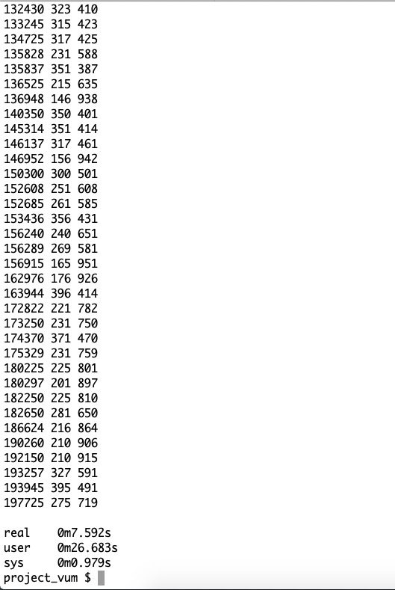

**Running time = (26.683+.979)/7.592 = 3.6436 approx.**

1. **The largest problem you managed to solve (For example You can try finding out bigger vampire numbers than 200000).**

The highest range achieved by the program is around 500000