10 Appendix

Appendix A: Project Timeline (Gantt Chart)
The planned 14-week project timeline is shown below.
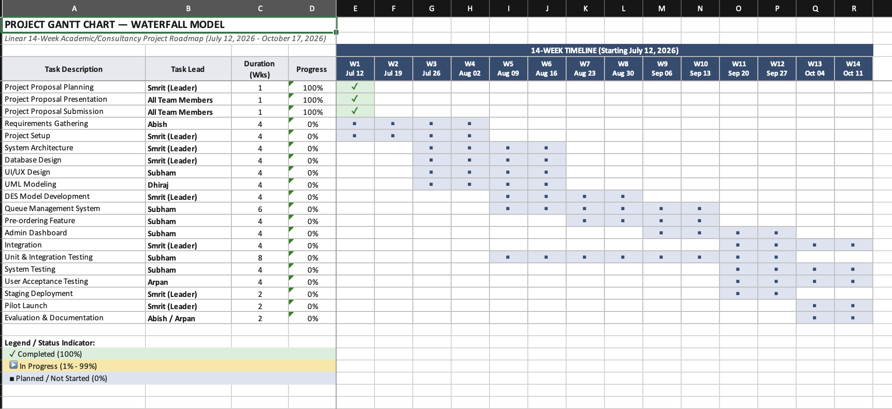
This Gantt chart illustrates a linear 14-week academic/consultancy project timeline spanning from July 12, 2026 to October 17, 2026. The chart displays 18 key project tasks with their assigned task leads, duration in weeks, and progress status. Tasks are sequenced across 14 weeks (W1 through W14), with initial tasks like Project Proposal Planning, Presentation, and Submission marked as 100% complete. Subsequent phases including Requirements Gathering, Project Setup, System Architecture, Database Design, UI/UX Design, and UML Modeling are planned for execution, followed by DES Model Development, Queue Management System, integration, testing phases, and finally Staging Deployment, Pilot Launch, and Evaluation & Documentation toward the end of the timeline.

Appendix B: Use Case Diagram

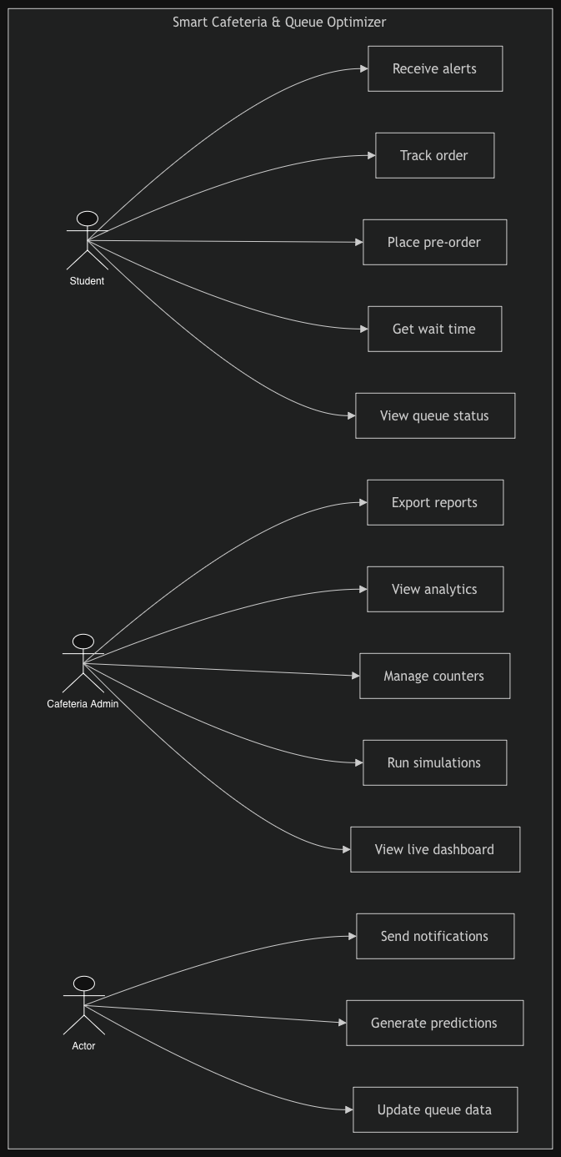

This use case diagram depicts the Smart Cafeteria & Queue Optimizer system with three primary actors: Student, Cafeteria Admin, and Actor. The Student can perform six main functions: Receive alerts, Track order, Place pre-order, Get wait time, View queue status, and Export reports. The Cafeteria Admin has access to eight use cases: View analytics, Manage counters, Run simulations, View live dashboard, Send notifications, and associated functions. The Actor role can Generate predictions and Update queue data. All interactions are represented through connecting lines showing the relationships between actors and their respective system functions.

Appendix C: System Architecture Diagram

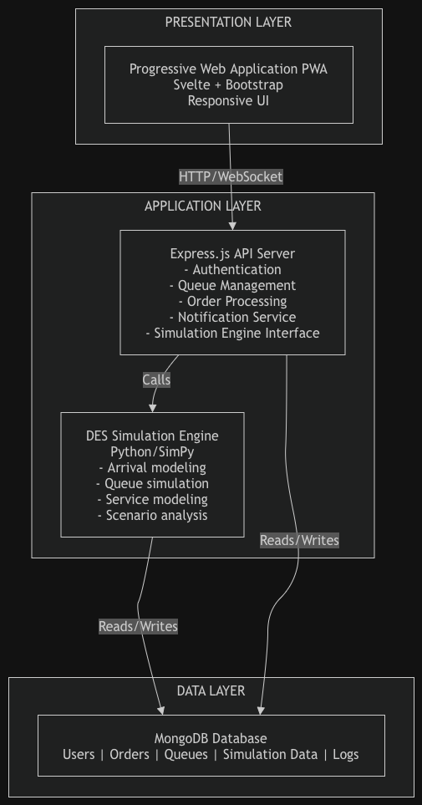

This three-layer system architecture diagram shows the technical structure of the Smart Cafeteria system. The Presentation Layer contains a Progressive Web Application built with Svelte, Bootstrap, and a responsive UI. The Application Layer features an Express.js API Server handling Authentication, Queue Management, Order Processing, Notification Service, and Simulation Engine Interface, connected via HTTP/WebSocket protocol. The DES Simulation Engine uses Python/SimPy for Arrival modeling, Queue simulation, Service modeling, and Scenario analysis. Finally, the Data Layer comprises a MongoDB Database storing Users, Orders, Queues, Simulation Data, and Logs, with read/write connections from both the Application and Simulation layers.

