Smart Cafeteria & Resource Queue Optimizer

Discrete Event Simulation + Live Management System
Group The OG
Smrit Chaulagain (Lead) | Subham Khadka | Abish Aryal | Arpan Somnath Adhikari | Dhirendra Singh Khadka

Project Overview
This Progressive Web Application (PWA) combines Discrete Event Simulation (DES) with live queue management to optimize cafeteria operations at NAMI College. During peak hours (9-10 AM), students currently wait 10-15 minutes. Our system aims to reduce wait times by 50% and increase pre-order adoption to 40% within 14 weeks.

Key Features:
• Real-time queue visualization with live wait-time predictions
• Student pre-ordering system to reduce physical queues
• Admin "what-if" simulation tools for staffing decisions
• Comprehensive analytics and historical reporting

1. Project Timeline (14 Weeks, 5 Sprints)
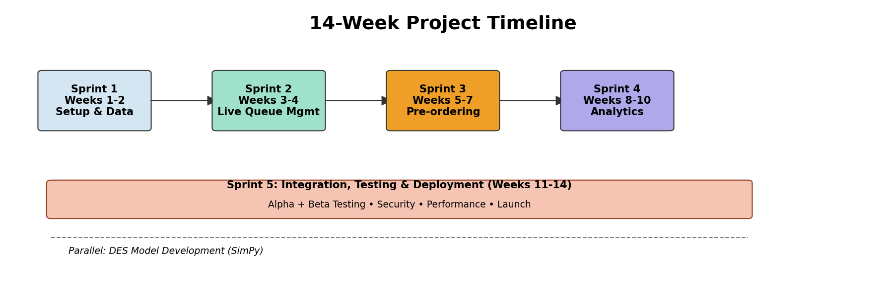
The project is divided into 5 sprints over 14 weeks, with the DES model development running in parallel across all sprints. Sprint 1 focuses on foundation and data collection, Sprint 2 on core queue management, Sprint 3 on pre-ordering capabilities, Sprint 4 on simulation and analytics, and Sprint 5 on integration, testing, and deployment.

2. System Architecture (3-Layer Design)
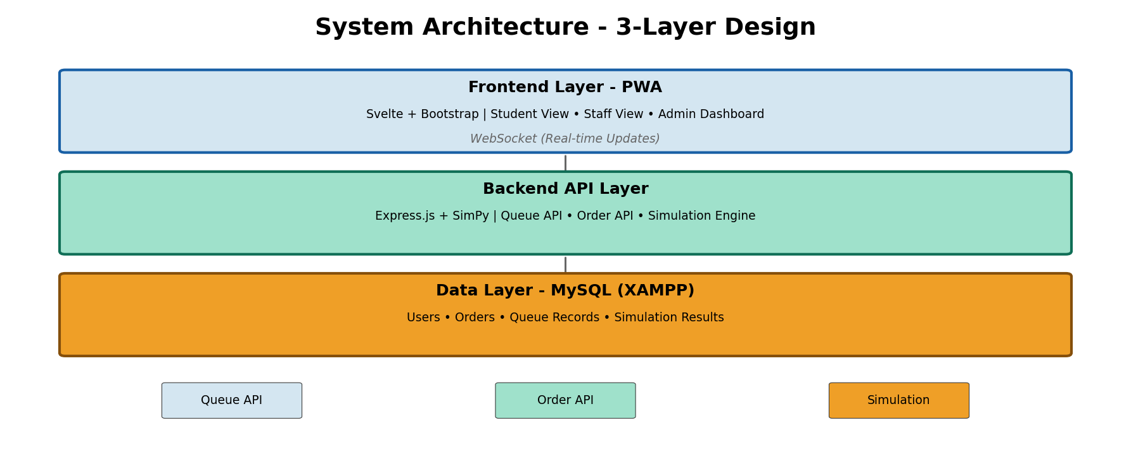
Layer 1 - Frontend (PWA): Built with Svelte and Bootstrap, providing responsive, mobile-friendly interfaces for students, staff, and admins with real-time WebSocket updates.
Layer 2 - Backend API: Express.js server running on Node.js, integrating SimPy for simulation, managing queue operations, orders, and analytics.
Layer 3 - Database: MySQL database running on XAMPP, storing user profiles, orders, queue records, and simulation results.

3. Success Metrics & Goals
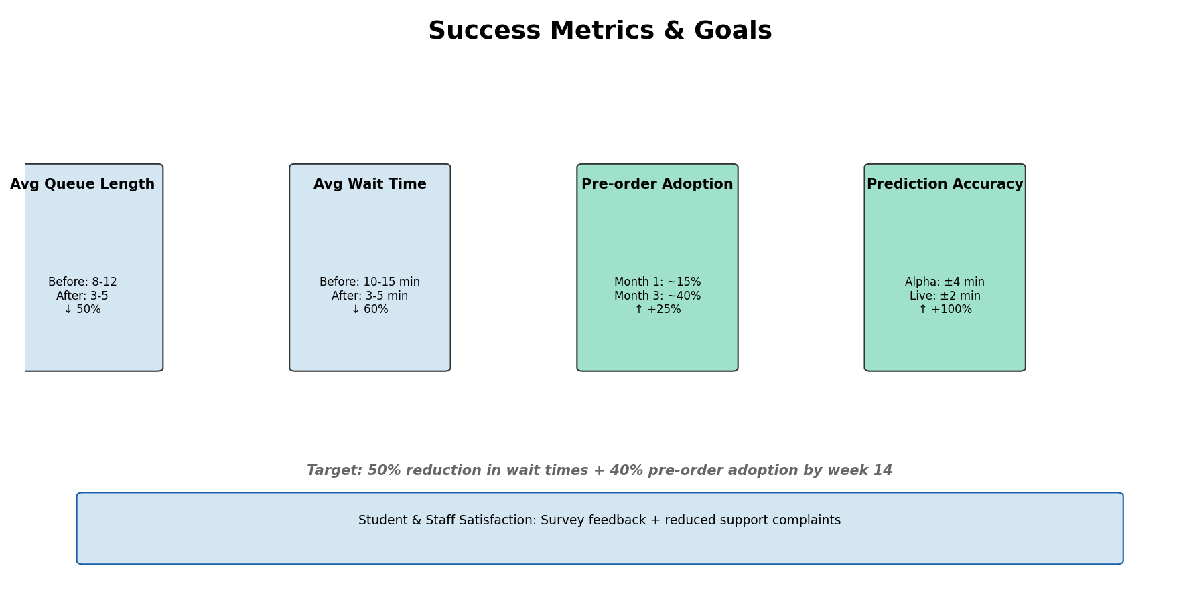
Metric | Current State | Target State | Improvement
Avg Queue Length | 8-12 students | 3-5 students | ↓ 50%
Avg Wait Time | 10-15 minutes | 3-5 minutes | ↓ 60%
Pre-order Adoption | ~0% (baseline) | ~40% by week 14 | ↑ 40%
Prediction Accuracy | N/A (new system) | ±2 min margin | < 10% error
Target Achievement: 50% reduction in wait times + 40% pre-order adoption by week 14

4. User Roles & Feature Access
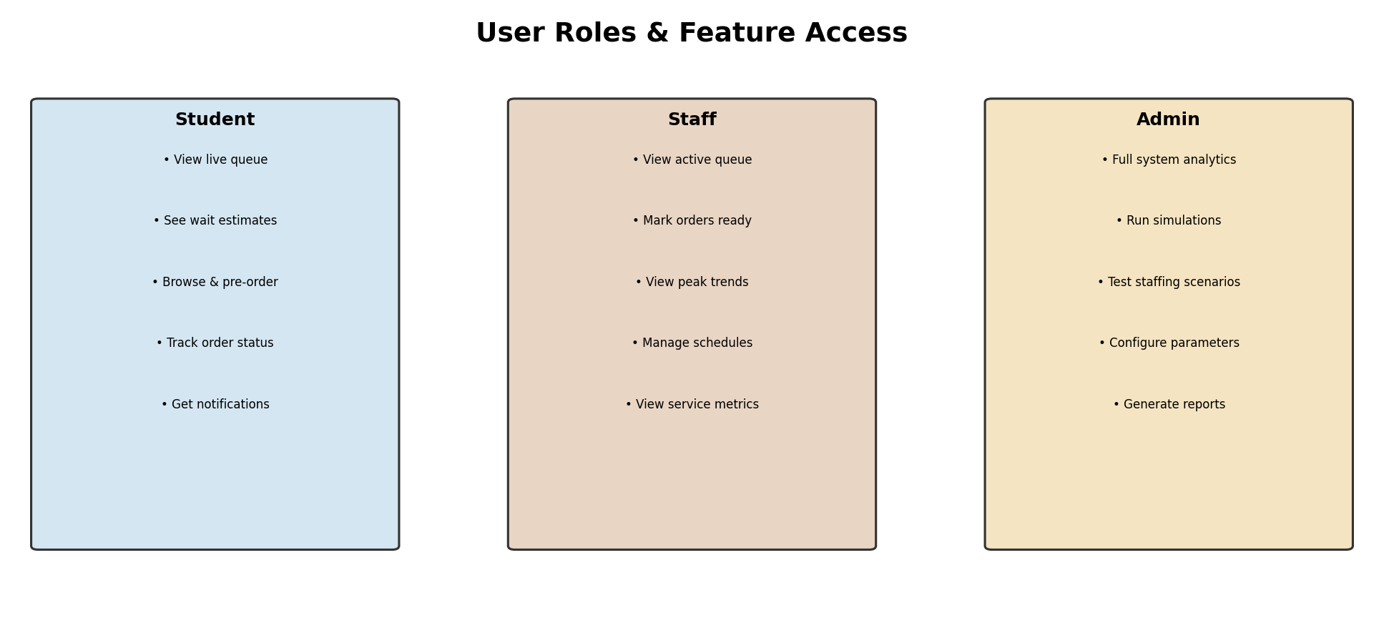
Student | Staff | Admin
• View live queue | • View active queue | • Full system analytics
• See wait estimates | • Mark orders ready | • Run simulations
• Browse & pre-order | • View peak trends | • Test staffing scenarios
• Track order status | • Manage schedules | • Configure parameters
• Get notifications | • View service metrics | • Generate reports

5. Technology Stack
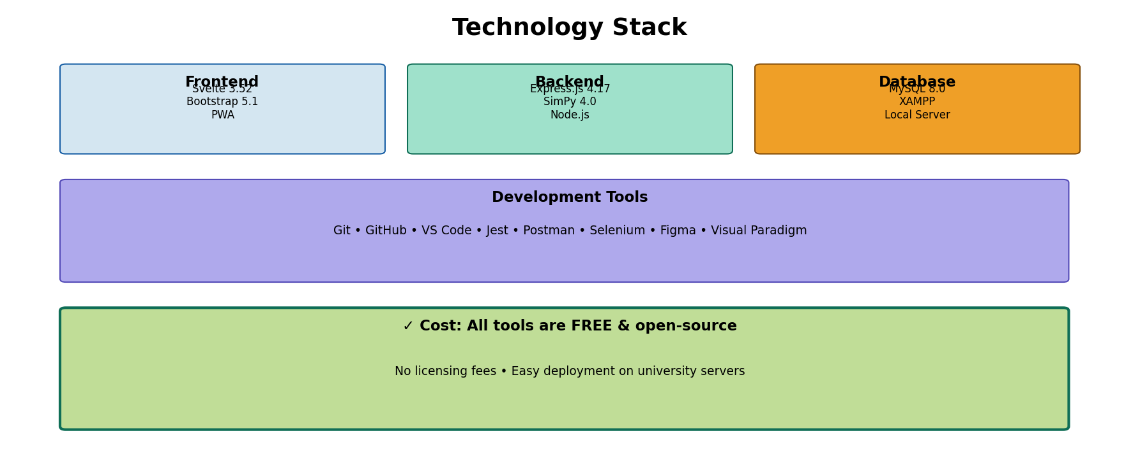
Layer | Technology | Version | Purpose
Frontend | Svelte | 3.52.0 | Reactive UI framework
 | Bootstrap | 5.1.x | Responsive design
Backend | Express.js | 4.17.x | API server
 | SimPy | 4.0.x | Discrete event simulation
Database | MySQL (XAMPP) | 8.0.x | Data storage
Dev Tools | Git / GitHub | 2.34.x | Version control
 | VS Code | 1.63+ | Code editor
 | Jest / Postman | Various | Testing framework
✓ Key Advantage: All tools are FREE and open-source. No licensing fees or vendor lock-in.

6. Student Journey - Peak Hour Flow
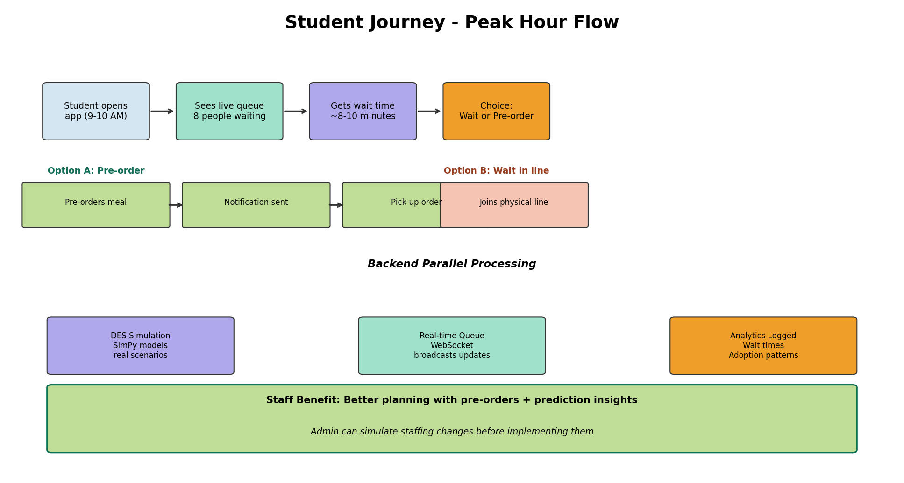
During lunch rush (9-10 AM), students open the app and see the live queue length with an estimated wait time. They then decide to either pre-order (getting a notification when ready) or join the physical line (with real-time updates). The backend simultaneously runs DES simulations and logs analytics for continuous improvement.

Testing & Evaluation Strategy

Alpha Testing (Internal):
• Unit and integration tests throughout development
• DES model validation against real cafeteria data
• Performance and API reliability testing

Beta Testing (User Acceptance):
• Selected student and staff testers
• Controlled functionality tests with observations
• Free-form exploration and feedback collection

Key Evaluation Metrics:
• Queue Reduction: Measurable drop in length and wait time
• Pre-order Adoption: % of students using the feature
• Prediction Accuracy: How close estimates match actual times
• User Satisfaction: Surveys from students and staff

Project Implications & Impact

Social Impact:
Students get more time for studying and rest. Fair access to pre-orders prevents line-cutting.

Economic Impact:
Better staffing and resource use reduces operational costs. Higher throughput during peaks may increase revenue. Free software stack means near-zero licensing expense.

Ethical & Legal:
• Data Privacy: Only required data collected; anonymized analytics
• Accessibility: App follows WCAG guidelines for all users
• Transparency: Wait-time predictions clearly marked as estimates

Professional Standards:
✓ User-first design principles
✓ Transparent data practices
✓ Licensed and free software only
✓ Full responsibility for outcomes

