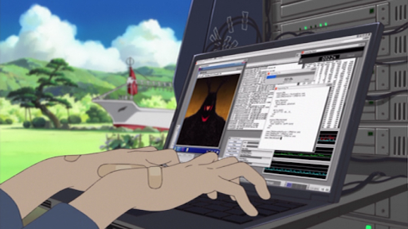
Title: Children and Cyber security
Introduction:
A large part of the Internet consumer is the young generation, not older than sixteen-seventeen-year-olds who are innocent and naive, making them the easiest targets for cyber crimes and cyberbullying. These children have grown up with technology and are so used to being around and about the internet that they do not even register it as a potential threat. They are unaware of the consequences that the internet possesses and might end up getting involved in heinous crimes that can ruin their whole life. Truly, it is indeed very easy to tip the balance of life when they are at such a tender age. Often, a small incident can shape their personality for better or for worse. They need to be made aware of such things in a subtle manner because due to their difficult age because it's very hard to teach them something without offending them or making them raise their defenses. After all, they do not want to be lectured. I propose the idea of making a web series about cybercrime and teaching intelligent methods/techniques to keep safe while on the internet through the show's characters and plotline. Making the series animated would appeal more to children and it would be easier to express the important points through animation by emphasizing those points. The narrative can depict difficult topics such as cyberbullying which are usually underrated and are taken as a joke by those who have never experienced it. It is easy to underestimate the things that children go through because being an adult makes it seem harmless to adults.
The problem:
Children are easy prey on the internet as shown by studies and statistics. According to the University of New Hampshire’s Youth Internet Safety Study (YISS), “As of 2010 only 9 percent of kids who use the internet received an unwanted sexual solicitation”(CNN) Examples of these incidents. There needs to be a way to teach them about ways to prevent such crimes. Workshops and lessons can teach them the methods but they might not be affected by such lectures and take it for granted. They might feel uninvolved with such things because according to them they are just using the internet to have fun and are safe. After all, they are not involved in criminal activities. They think that things said in the workshops do not concern them. They will be more receptive if emotions/pathos is involved like in the form of a story.

Solution:
Children are more receptive to pathos than logos so teaching them through a story is more fruitful than using facts and boring lectures. The method that can be adopted to spread awareness about cyber security is creating an animated series where the main character is a normal teenager, who encounters many cyber crimes and goes through a series of adventures to secure themselves and their friends and ultimately save the world. The heroics of the teenager can be shown through animation and details of the security measures can be creatively incorporated into the story so that the children/teenagers watching can follow the same steps to secure themselves. The emotions and relatability of the characters can show how the crimes can affect anybody and so foster a feeling of attentiveness when using the internet. Different cybercrimes, such as malware attacks or social engineering attacks can be shown in each episode and the way to prevent as well deal with such attacks can be shown by the main character's actions.

Goals/Objectives:
My solution is to create an animated web series that tackle the different issues with cyber security. The goal of this project is as follows:
- The goal is to teach children about cyber security measures and the ill effects of using the internet carelessly.
- To achieve this, I propose that an animated series be made that integrates the measure and issues of cyber security in its storyline and expand on them in a thrilling/adventurous theme to make it enjoyable and educational at the same time.
- The theme will be teenage protagonist helps her friend to tackle cyberbullying and realizes that she wants to help people with similar problems due to lack of cyber-security. She has always been good at computers but didn’t think that she could use that to help others.
- Another objective is to spread awareness about significant issues regarding vulnerability on the internet as well as mass surveillance and privacy invasion by the government.
- This can also be achieved through the storyline where the villain could be the one misusing these vulnerabilities. The villain might not necessarily be from the government but just a person doing evil deeds for themselves and personal grudges.
- There will be several different villains with different cyber attacks for the protagonist to overcome their schemes and give the audience an accurate method that they can use in their daily life. For example, a marketing company uses targeted advertisements to manipulate internet users and what a person can do to surf the internet as safely as possible.
- Make the next generation safe and more aware of cyber security in a subtle manner so as to prevent the feeling of being lectured.
- Rather than a workshop or a mandatory class, teaching things through media has become more successful. Media has the power to target pathos and make the audience more invested in a topic than when they learn it in school. Using this nature, making a series would be the better way to get the point of cyber security through to the children.
- In recent years, animated series have become popular not only among kids but also mature audiences. This means that an animated series’ target demographic includes people of all ages. An animated series is useful in expressing things that cannot be easily explained to the younger audience. For example, the characters can go into cyberspace and a fictional depiction of such an action might help them understand more about the technology that they are so used to.
- Make the animated series famous so as to spread the story as far as possible.
- To make the series famous, using famous platforms such as Youtube and Instagram, would help spread the series faster. There needs to be a campaign where the artists involved with series who are influential and famous, hold online events and collaborate with youtube channels to advertise and give interviews.
- The series can also be advertised during DEF CONs where the people in the cybersecurity industry can help further spread the word. The plan is to not only advertise but also attract sponsors who might be interested in sponsoring the web series.
- Once the series is found well received by people, it must be dubbed in other languages around the world to make it more influential.
- This is to increase its popularity and further spread the awareness to other countries and cultures.
- The goal of this project is to target people from all over the world because this problem concerns every person on the internet directly or indirectly.

Cost/Timeline/Schedule:
Since this is a big project, it will take a lot of time and money to make this plan a reality. An estimate of 2 years or more can go into the production of the series and a full staff of animators, writers, designers, producers, and directors as well as a few sponsors will be necessary. The initial step will be to gather sponsors and funds for the project. After finalizing a story and characters, the project proposal will be presented to not only major but also up-and-coming animation studios. DefCon is a place where cyber security experts gather, so we can present the proposal there to look for interested sponsors. The timeline will expanse over a two-year-long production time so the salaries for animators and staff need to be sufficient for such a timeline. For the series to succeed, there need to be good voice actors and reputable figures to promote the series. Interviews and collaborations with famous personalities and youtubers will help spread the word at an exponential rate. The trailer must be released within a year from the start of production so that the promotion can be done successfully.
Gantt Chart of the production schedule:
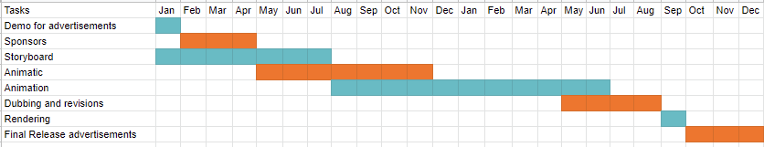
Cost estimate
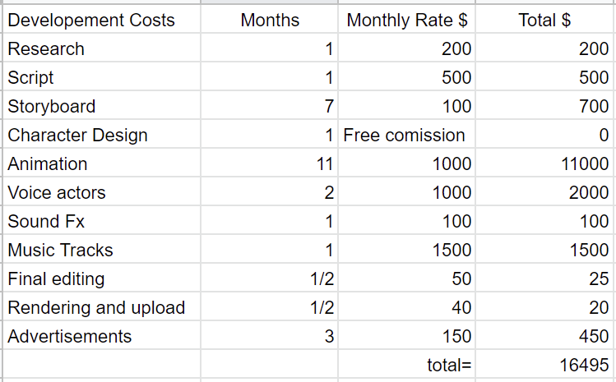
From the above table, it is evident that creating an animated series requires a lot of funds but if sponsors are found, the project might not be as difficult as it sounds. The research is an important part of the project because we need data and authentic information on how to safekeep oneself when surfing the internet. The script needs to be exciting and relevant to the target audience, that is, teenagers. The script must have the slangs and trends followed by kids. The storyboard is the main process where the actual animation starts to set its fundation. The storyboard must be complete in time so that the whole project stays on track because a the next steps depend upon the storyboard. Good character design will help increase the quality of the series to be considered a serious web series, on the level of something created by disney or any other popular production company. Any student at ASU can volunteer to create a nice character design. Animating the series will take a long time and might have to be revised again and again to perfect the scenes according to what the director wants, to ensure the good quality of animation. It will cost a lot of time as well as money, so it takes up the largest percentage of resources to make it a success. I would like to request youtubers and other voice actors to volunteer for this project in order to cut the cost of expensive voice actors. The money for voice acting is basically for the studio rental and syncing the voices with the characters. Sound effects cast a lot of money but can be really helpful in expressing the emotions in a scene. Asking a student to volunteer would help a lot. Music tracks must be really good for the opening of the series so that it interests the audience more, therefore it has a lot of funds but less time. Final editing will help revise all of the small mistakes in the animation and will keep in mind what is appropriate for a teenager watching the show. The last part about rendering is an important part of the project and without the series being rendered with care, it won’t be aired on time. Adverting on free platforms will be great but we need to present this idea on as many places as possible to gain potential sponsors and volunteers. This part has been given a low budget even though it requires a lot more because we are low on funds. Once the funds increase, a new budget will be created.
Conclusion:
The project is going to be a very huge production plan requiring a lot of revenue so the proposal needs to be successful in appealing to sponsors. To spread awareness about cyber security, an animated series might be one of the best methods to appeal to the target audience. All teenagers. A youtube channel called “Common Sense Education” has a few videos educating teens about digital footprint. A digital footprint is the information a person leaves behind on the internet. In the video about oversharing, they explain how a person can overshare without notice and not think too much about the consequences just for the sake of ‘posting to be posting’.(YouTube) Using teen voices to educate other teens, specially with real life examples, successfully spread the lesson they wanted to teach. However, the video is not popular and a teen rarely comes across it. People can ignore the video completely and just carry on with their lives. Therefore, creating a web series might reach the teens and can subtly teach them about such things without invoking the feeling of being forced with an idea. Just telling the teenagers might only help a little but, if a longlasting effect is desired, showing them through media and realistic examples might be better. In conclusion, the proposal to create a web series is a huge task and requires lots of funds but it will all be worth it if it succeeds. All of the cost and budgeting really depends on the first phase of the project, that is, gaining sponsors and volunteer staff to make this project happen.

Works cited
Beens, R. (2021, December 10). Council post: The State of Mass Surveillance. Retrieved November 10, 2021, from https://www.forbes.com/sites/forbestechcouncil/2020/09/25/the-state-of-mass-surveillance/?sh=6582e4c7b62d
Cortes, J. (2020, April 19). What is an animation production pipeline? Retrieved November 15, 2021, from https://usv.edu/blog/what-is-an-animation-production-pipeline/
Edgar, T. H. (2017). Beyond snowden : Privacy, mass surveillance, and the struggle to reform the nsa. Brookings Institution Press. Retrieved November 2, 2021, from https://ebookcentral-proquest-com.ezproxy1.lib.asu.edu/lib/asulib-ebooks/reader.action?docID=5179961
Edward Snowden: Leaks that exposed US spy programme. (2014, January 17). Retrieved November 2, 2021, from https://www.bbc.com/news/world-us-canada-23123964
Elgersma, C. (2017, August 3). Parents, here’s the truth about online predators. Retrieved November 9, 2021, from https://www.cnn.com/2017/08/03/health/online-predators-parents-partner/index.html
Feldstein, S. (2020, August). State surveillance and implications for children - unicef.org. Retrieved November 2, 2021, from https://www.unicef.org/globalinsight/media/1101/file/UNICEF-Global-Insight-data-governance-surveillance-issue-brief-2020.pdf
Hawk, S. T., Keijsers, L., Frijns, T., Hale,William W., I.,II, Branje, S., & Meeus, W. (2013). “I still haven’t found what I’m looking for”: Parental privacy invasion predicts reduced parental knowledge. Developmental Psychology, 49(7), 1286-1298. doi:http://dx.doi.org/10.1037/a0029484
Madden, M., Lenhart, A., Cortesi, S., Gasser, U., Duggan, M., Smith, A., & Beaton, M. (2020, August 17). Teens, social media, and privacy. Retrieved November 2, 2021, from https://www.pewresearch.org/internet/2013/05/21/teens-social-media-and-privacy/
Teen voices: Oversharing and your Digital Footprint - YouTube. (2019, January 11). Retrieved November 9, 2021, from https://www.youtube.com/watch?v=ottnH427Fr8

