**Exercise 1: Configuring a Basic Spring Application**

1. **Set Up a Spring Project:**
   * Create a Maven project named **LibraryManagement**.

* + Add Spring Core dependencies in the **pom.xml** file.

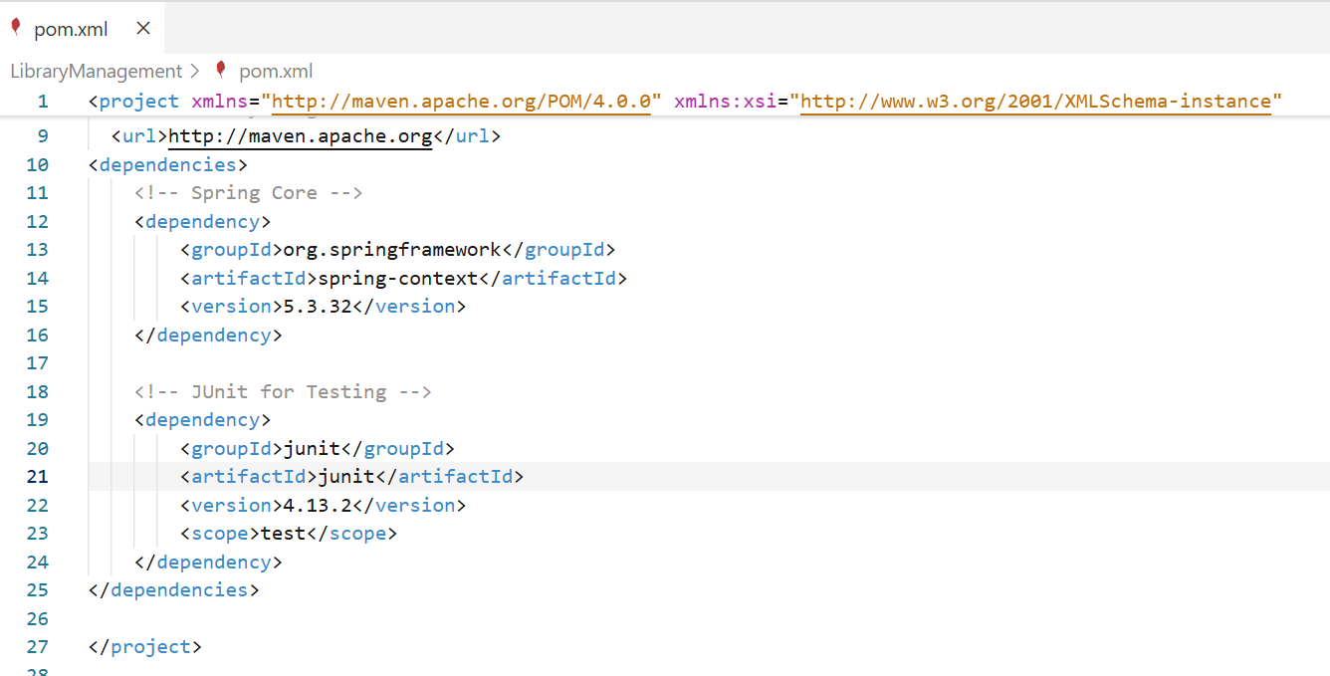

ApplicationContext.xml

Bookservice.java

Bookrepository.java

LibraryManagementApplication.java

Result:

**Exercise 2: Implementing Dependency Injection**

**Applicationcontext.xml:**

<?xml version="1.0" encoding="UTF-8"?>

<beans xmlns="http://www.springframework.org/schema/beans"

       xmlns:xsi="http://www.w3.org/2001/XMLSchema-instance"

       xsi:schemaLocation="

          http://www.springframework.org/schema/beans

          http://www.springframework.org/schema/beans/spring-beans.xsd">

    <!-- Define BookRepository Bean -->

    <bean id="bookRepository" class="com.library.repository.BookRepository" />

    <!-- Define BookService Bean and inject BookRepository -->

    <bean id="bookService" class="com.library.service.BookService">

        <property name="bookRepository" ref="bookRepository" />

    </bean>

</beans>

**Bookservice.java:**

package com.library.service;

import com.library.repository.BookRepository;

public class BookService {

    private BookRepository bookRepository;

    // Setter for Dependency Injection

    public void setBookRepository(BookRepository bookRepository) {

        this.bookRepository = bookRepository;

    }

    public void printService() {

        System.out.println("BookService: Performing service task...");

        bookRepository.printRepo();  // call method in injected repository

    }

}

**LibraryManagementApplication.java**

package com.library;

import com.library.service.BookService;

// import org.springframework.context.ApplicationContext;

import org.springframework.context.support.ClassPathXmlApplicationContext;

public class LibraryManagementApplication {

    public static void main(String[] args) {

        // Load Spring context from applicationContext.xml

        try (ClassPathXmlApplicationContext context = new ClassPathXmlApplicationContext("applicationContext.xml")) {

            // Get BookService bean

            BookService service = (BookService) context.getBean("bookService");

            // Verify the dependency was injected and working

            service.printService();

        }

    }

}

Result:

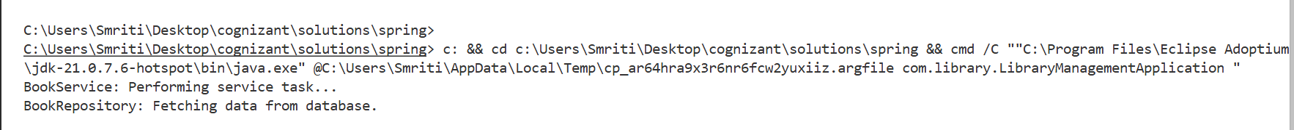

**Exercise 4: Creating and Configuring a Maven Project**

**Pom.xml**

<project xmlns="http://maven.apache.org/POM/4.0.0"

         xmlns:xsi="http://www.w3.org/2001/XMLSchema-instance"

         xsi:schemaLocation="http://maven.apache.org/POM/4.0.0

                             http://maven.apache.org/xsd/maven-4.0.0.xsd">

    <modelVersion>4.0.0</modelVersion>

    <groupId>com.library</groupId>

    <artifactId>LibraryManagement</artifactId>

    <version>1.0-SNAPSHOT</version>

    <properties>

        <maven.compiler.source>1.8</maven.compiler.source>

        <maven.compiler.target>1.8</maven.compiler.target>

    </properties>

    <dependencies>

        <!-- Spring Context -->

        <dependency>

            <groupId>org.springframework</groupId>

            <artifactId>spring-context</artifactId>

            <version>5.3.32</version>

        </dependency>

        <!-- Spring AOP -->

        <dependency>

            <groupId>org.springframework</groupId>

            <artifactId>spring-aop</artifactId>

            <version>5.3.32</version>

        </dependency>

        <!-- Spring Web MVC -->

        <dependency>

            <groupId>org.springframework</groupId>

            <artifactId>spring-webmvc</artifactId>

            <version>5.3.32</version>

        </dependency>

    </dependencies>

    <build>

        <plugins>

            <!-- Maven Compiler Plugin -->

            <plugin>

                <artifactId>maven-compiler-plugin</artifactId>

                <version>3.10.1</version>

                <configuration>

                    <source>1.8</source>

                    <target>1.8</target>

                </configuration>

            </plugin>

        </plugins>

    </build>

</project>

**Build result:**

