Part I- Executive Summary
- Project purpose
The project forecasts weekly and annual passenger volumes for the bus terminal and identifies the key operational, calendar, weather, and carrier-specific drivers of demand for 2026–2030. It translates these statistical results into capacity, scheduling, and carrier-planning insights for terminal management.
- Data and methods
- Historical passenger volumes are combined with service data such as trips operated and capacity.
- Additional inputs include weather conditions, calendar effects (holidays, seasons, weekdays/weekends), and carrier-specific activity.
- Time-series models are used to generate weekly and annual passenger forecasts over the 2026–2030 horizon.
- Correlation analysis and statistical significance testing identify which factors are most strongly associated with passenger volumes.
- Forecast uncertainty is measured using confidence intervals around the projected values.
- Carrier-level projections are created to show how each operator’s passenger volume and market share are expected to change over time.
- Key findings
- Passenger numbers are forecasted to continue growing through 2030, eventually surpassing pre-2019 levels before stabilizing at a new, higher baseline.
- Demand shows strong seasonal patterns, with noticeable peaks during summer months, holiday weeks, and consistent differences between weekdays and weekends.
- The number of bus trips, available seat capacity, and calendar events like holidays and snow weeks have the strongest and most reliable connections to passenger volumes.
- Weather factors such as temperature and precipitation show weaker or less consistent relationships with ridership.
- A small number of large carriers account for the majority of passengers and market share throughout the forecast period.
- Several smaller carriers are projected to grow at faster rates, though they start from a much lower passenger base.
- Overall market concentration remains high, with one or two dominant operators continuing to shape terminal capacity and scheduling needs.
- Methodology Summary
- SARIMAX time series forecasting model
- Data warehouse architecture with ETL pipelines
- Power BI dashboard for interactive analytics
- Correlation and regression analysis for factor importance
- Tools and Technologies Used
- Data Consolidation and Preparation: Microsoft Excel, Python
- ETL and DataWarehouse: SSIS, SSMS, Microsoft SQL Server
- Forecasting and Analytics: Python time-series libraires, Statistical method including correlation analysis
- Reporting and Visualization: Microsoft Power BI, PowerBI DAX

Team Contributions
Team member | Primary Responsibility
Smriti Maharjan | Data consolidation, Data Cleaning, ETL, Warehouse,
Harichandana
Devi
Sandeep
Emanuel

Data consolidation
The project began with several separate files provided by the company, including historical terminal records, post-2023 updates, and carrier-specific spreadsheets, along with external weather and calendar datasets. These sources used different structures, column names, and time definitions, so they could not be analyzed directly.
- Time fields (Week_Date, Year, Month, Week_of_Year, Season, Fiscal_Year) organized the data on a consistent weekly calendar for forecasting.
- Core metrics (Bus_Departures, Passenger_Departures, Passengers_Per_Bus, recovery and moving-average fields) captured how much service was run, how many passengers traveled, and how this compared with 2019 and recent weeks.
- Carrier identifiers (Carrier_Name, Carrier_Full_Name, Service_Type) allowed analysis and forecasting by individual operator and service type.
- COVID and economic flags, along with Days_Since_Pandemic_Start, tracked structural shifts such as the pandemic and high-inflation periods.
- Weather and event indicators (temperature, precipitation, snow, severe weather, holidays, NYC events, tourism peaks) described external conditions that could explain spikes or drops in weekly passengers.
ETL Layer
The ETL layer was implemented as two SSIS packages that together automate how data flows from files into analytics tables.
- The first package (01_LoadDataWarehouse) loads the cleaned Excel/CSV data into a SQL Server star schema, populating the date, carrier, weather, event, service-type, and COVID status dimensions, and then the Fact_Passenger_Departures table. This gives the company a consistent, governed warehouse that all reporting and modeling can rely on .
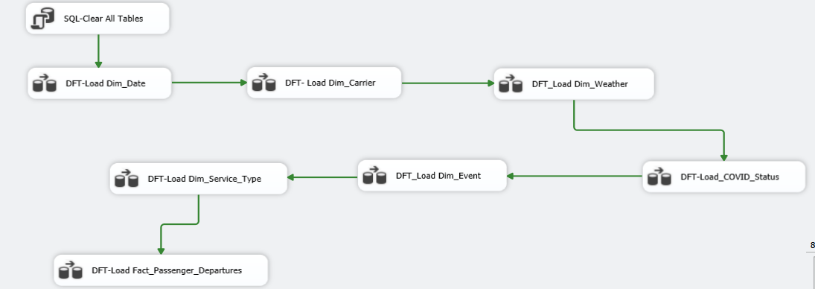
- The second package (02_Load_Analytical_Aggregates) reads from that fact table and creates four ready-to-use summary tables: monthly carrier performance, quarterly trends, COVID-impact metrics, and overall carrier KPIs. These aggregates are what the Power BI dashboards primarily use, so reports run quickly and align directly with management questions .
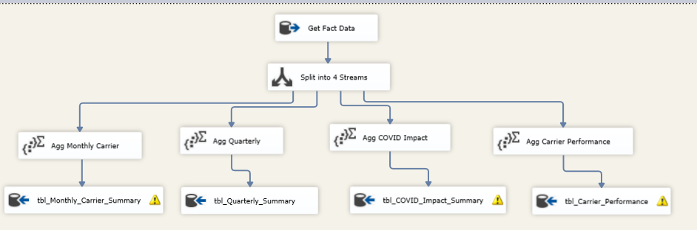
DataWarehouse
The data warehouse step turned the consolidated files into a structured star schema that is easy to query and use for reporting.​
What was done
- Designed and implemented a star schema centered on the Fact_Passenger_Departures table, linked to five dimensions: Dim_Date, Dim_Carrier, Dim_Service_Type, Dim_Weather, and Dim_Event, plus a Dim_COVID_Status table for pandemic and economic phases.​
- Loaded this schema in SQL Server using the SSIS package 01_LoadDataWarehouse, which moves the cleaned FinalDataset and reference tables into the fact and dimension tables with consistent keys and data types .
Why it was done
- The star schema gives the company a single source of truth for passenger, service, weather, and event data, structured specifically for analytics rather than day-to-day operations .
- It supports fast, flexible slicing of results by time, carrier, service type, COVID period, weather, and events, which is critical for forecasting, recovery analysis, and carrier performance reporting .
How it is queried
- All analytical SQL was developed and tested in SQL Server Management Studio (SSMS) against this warehouse
