**WT ASSIGNMENT-1(LAB-1)**

1. **Write html code for text formatting as per display below.**

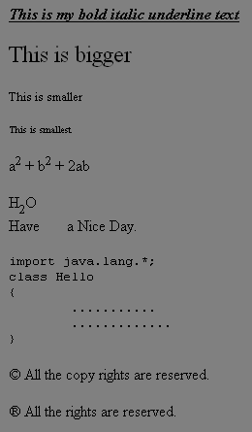

1. **Write html code for internal and external linking. Check the following link target attribute how they navigate one page to another page.**

_**blank**

**_self**

**_parent**

**_top**

1. **Write the html code using the image in three ways.**

**i. Display image in the web page**

**ii Using image as linking page**

**iii Using image as background color.**

1. **Write the code of listing as output given below**.

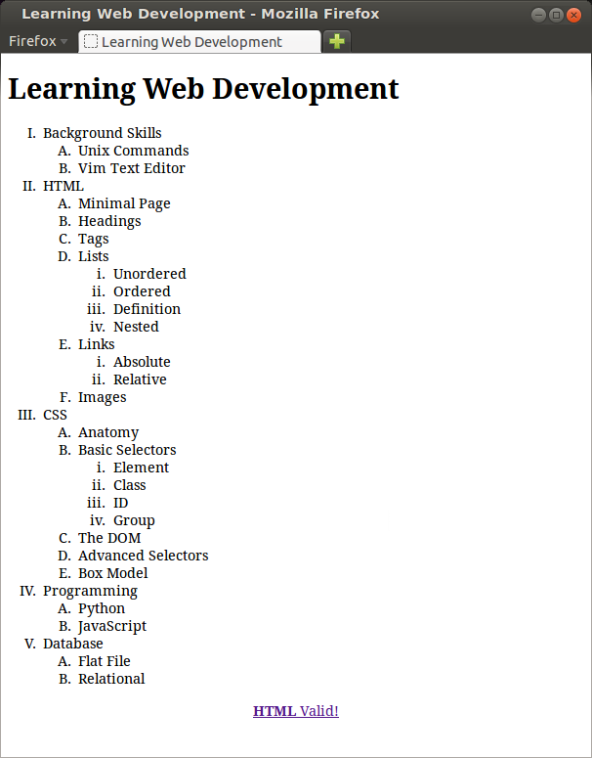

1. **Write html code for the following Table.**

