**WT ASSIGNMENT-2**

1. **Write html code for Frames and Hyper Links.**

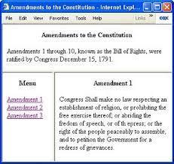

1. **Write html code for form.**

