**Title**

**Digital Menu Cards for Restaurants and Ordering System Using QR Code Scanning.**

**Abstract**

QR codes were first used in 1994 in the automotive industry in Japan. Since then and today the technology of QR code has come a long way and is now a household name. QR code scanning has found usage in many fields and industries over the years. One of the latest and more exciting usage of QR code was found in the restaurant business. The methodology is simple, customers scan a QR code provided to them with their smartphones, a menu shows up, they place orders via an website on the smartphone. In today’s world where social distancing is so necessary because of the pandemic, this process can prove to be the saving grace of the restaurant industry.

**Introduction**

A QR code menu is a computerized menu that is open for suppers and consumers on their cell phones in the wake of filtering a QR code. All clients need to do is point their cell phone and output the QR code (which practically everything cell phones can do) and they're quickly taken to a touchless menu. This replaces the requirement for actual menus meaning a more secure encounter for all interested parties. It is a completely new framework to deal with the requesting frameworks inside an inn or cafés. This task offers a proficient requesting framework for the lodgings and eateries. This Online Restaurants Menu Card System assists you with Streamlining your activities to meet client’s assumptions. An adaptable café the board framework which assists you with being more methodical and speedier in your administrations to clients. Its quick and time usage framework for clients and as well as the inn administrations.

**Background**

Diverse sources contain varying details on the term "menu's" etymology. These days, companies frequently use experiential marketing strategies to differentiate themselves from the competition. According to Pine and Gilmore (2001), experiential marketing is a single event or series of connected events designed to simulate a real-world experience in which the consumer actively participates, acquires, and consumes. Whatever the experience's design, marketing efforts focus on people's senses while taking into account customer needs like enjoyment, forewarning, emotional impact, and education. Due to the growing use of technological processes and the development of information technology, the food and beverage industries have begun to explore for alternative methods to influence the customers. Restaurants have been one of the application areas for experiential marketing. Experiential marketing is exemplified at this moment by digital menu systems that are visually appealing but also immerse the customer in the process. A digital menu is how a restaurant presents its menus and presents information about its cuisine and drinks on an electronic display (Sahin, 2019). The literature analysis and on-the-ground inspections have shown that several forms of digital menus are used by enterprises. The following categories can be used to classify various digital menu types.

**Non-Touchscreen Digital Menu Systems**

Non-touchscreen digital menu systems are digital boards that show visual details about the company's items and need a customer-facing staff member to take their order. They are simple to use both inside and outside. By connecting to a private network, LCD, LED, OLED, or plasma displays are used for product advertising. These digital menu boards are typically found at fastfood establishments. Static and dynamic digital menu boards are the two categories used to categorize non-touchscreen digital menu boards. Large screens called static digital menu boards (SDMB) provide for the presentation of the menu items' appealing aesthetics and prices in a location where customers can easily view them and use them to make decisions (ahin, 2019). These screens have the advantage that the graphics don't change all the time and stay static. On the same panel, two images are occasionally changed. They resemble billboards in appearance.

**Touchscreen Digital Menu Systems**

Digital touchscreen menu systems give customers the option of self-service. With the use of selfservice technologies, customers can make any purchase without assistance from customer care personnel (Cho & Fiorito, 2010). Tablets (such as the iPad or Samsung Galaxy), tabletop touchscreens, PDAs (Personal Digital Assistants), websites on cellphones, and kiosks are the most frequently used SSTs. After receiving the order from the customer, the service personnel frequently uses PDAs to deliver it to the kitchen. Mobile apps won't be discussed in this study because they operate on the same principles as tablet-based website. Kiosks and tablet-based digital menus are the two most popular ways used in restaurants to let consumers place an order without the assistance of a server. Digital menu systems that enable a business's menu to be shown and ordered on tablet computers are known as tablet-based digital menus.

**Background of QR**

AQR (Quick Response) code is a scannable code encoded with information. For the situation of QR codes, data (of different structures) is changed over into an extraordinary two-layered game plan of squares. At the point when a QR code scanner is put over those squares, it disentangles their marshaling back into that information's unique structure.

**Components of a QR code Following are some important components of QR code**

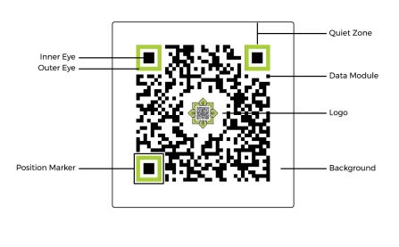

**T FigT1:TMechanismTforTQRTScanning**

**Problem Statement**

The major issue is that customers have to stand in a big line and wait too long to place an order. Some of the stalls require a lot of time for each consumer to enter and inquire about their order. The issue causes customers to become dissatisfied and waste time waiting for their turn to place an order. Lack of managed ordering services might negatively impact the store's customer service. This will have an impact on how satisfied customers are with their food purchases. The second issue is the menu display's poor visibility. Some of the stall operators did not make it apparent what was in the dish and how the menu was displayed. Most stall owners merely use bunting, laminated paper, or chalkboards to list the name of the meal, its price, and other details. Poor visibility makes it less likely that a client will act on their behavioral intentions to buy the food. One of the issues that customers who choose cashless solutions have is that there are no modest changes available. A cashless approach often involves an electronic payment made online between two parties. Customers believe that using a cashless payment system saves them from having to wait around for workers to exchange money. Technology for cashless payments can also aid in lowering the high risk of financial loss. With technology developments in service improvement and controlling food purchasing systems in restaurants, this research will learn more about results and ways to improve customer experience. This is required in order to offer a diversity of services and satisfy different client expectations. As a result, in order to improve consumer satisfaction, operators must devise new solutions for their booths and services.

**Aims**

Customers can look at menu and can place the order without any contact with a server or a reusable a menu on paper that has been handled by several individuals. It promotes minimal contact and maintains social problem distance. Time and money can be saved by using a digital menu. It will assist in lowering the expense of printing new menus each time a small update is required. Additionally, any modifications made using the software for digital signage can update the menus throughout the whole restaurant. These digital menu systems may be modified, and real-time adjustments can be made to things like design, price, available meals, special deals, etc. Additionally, the wait time is decreased by automatically placing the order from our devices. Additionally, the restaurant employees served the dinners more quickly. Additionally, it facilitates restaurants' order processing system. Restaurants can share more information with their customers thanks to digital signage, which could result in more sales and higher profit margins. Since there is no restriction on the amount of information you can post online, restaurants can market, advertise, and distribute personalized menus and details about their meals using digital menus. Restaurants can promote interesting discounts and deals by using digital menu cards. They can also show enticing, exquisite photographs of bizarre foods and meals to entice customers to place further food orders. This will encourage clients to eat more food than they had originally planned to and to try a wider variety of foods. Restaurants will get a competitive edge in the market by choosing AI-based menu cards. With eye-catching culinary photographs and videos that can be updated frequently, digital menu cards can help entice visitors to a restaurant. Restaurants can fully remove the hassle of reprinting every time we modify the menu or if they spoil by switching to digital-menu-cards.

Today's trend in restaurants is an eco-friendly setting. Customers are appreciative of how green the restaurant business is getting on a daily basis. If the company has several branches, it can use this to keep a consistent voice. Digital menu cards remove any errors because every instruction is recorded, improving the quality of service at the restaurant. Digital menu boards are more practical and beneficial for both customers and eateries. These cutting-edge AI menus can modify pictures, update advertising, and show videos on demand in comparison to conventional menu cards. Restaurants can program the menu to vary automatically depending on the time, day, and audience, and they can also promote the daily special. Customers will feel a little more at ease because to the appealing visuals they may view on their own devices, especially during COVID. It's entertaining, and a new fad makes everyone's life simpler without breaking the bank. Nowadays, more and more restaurants prefer digital menu cards to printed ones since they offer greater operational efficiency and more sales. It's time for restaurant operators to raise their digital menu game and stop losing consumers.

**Objectives**

It should reflect the character of the restaurant, concentrate overall operations, encourage profitability, set a budget, and keep the brand top-of-mind with customers. It gives customers a more accurate idea of what to expect from your food, providing you the chance to pique their interest and whet their appetite. Customers have a more positive experience while using digital menus. Customers are entertained by your digital menus. A menu inside a glass frame is less likely to attract in a passerby than a digital display outside your restaurant. You have the chance to make the menu more engaging by using a digital menu board. It includes everything the information you want your clients to know, including tempting images, educational films, lists of discounts, and more, in addition to just displaying the options for purchase. Our restaurant can be found outside thanks to a digital menu. In addition, guests can bid the host farewell while she hands menus to diners outside the establishment. Because digital signage software is adaptable, you can reach your target audience when and when they need to hear your message. Restaurants with digital menus do not have a budget line item that restaurants without digital menus do. You no longer need to send routine advertising and menu changes to your printers after making an investment in digital signage. Old poster boards won't need to be taken down and replaced by your front-line workers. Simply reduce labor costs and the number of individuals involved. Use digital signage software to set up a nighttime schedule that is suited to any night owls who may be passing by and displays the benefits of returning during regular business hours. Show a magic-making head chef in a video, post pictures of satisfied customers eating their meals, and offer these consumers a special deal. They'll return. Keep your business open all the time.

**Justification**

Traditional menu ordering and catering methods like those discussed above take time and are prone to human errors that can be minimized but not eliminated. The self service ordering system has a disadvantage because self service restaurants are more common in big cities. Therefore, there aren't many options for self-service restaurants in smaller cities. These self-service technologies frequently cause unreasonable delays in the delivery of the order. The recently created zigbee based technology has a problem with its high cost and constrained range. Our goal is to create a system that is affordable and usable in small restaurants that are unwilling to commit a significant amount of money in these systems. The novel proposed system places a strong emphasis on improving user friendliness, straightforward navigation, low cost, expanding the service range of wireless communication used, and speeding up order processing. Utilizing the GLCD, Touchscreen, GSM Module, and Microcontroller effectively allows for this. The meal items and associated pricing are displayed on the menu card system in restaurants. The customer may see how the food is made in addition to seeing the pricing of the dish. Customers can view not just the costs but also information on how each food item is prepared. Besides these advantages, we also offer an ordering system.

**Scope**

Because automation is becoming more and more vital in every industry, restaurants must provide customers with cutting-edge experiences that are satisfying. Many restaurants in the modern formal dining environment provide static menus, or paper menu cards, to communicate the available meal items. Waiters then deliver orders to the kitchen personnel. The visual experience can be greatly improved by using an electronic menu card instead of a paper one. Wireless communication can take the place of waiters manually delivering orders to the kitchen to prevent order delays. People are currently more interested in the newest technologies and willing to automate their normal jobs as a result of improved literacy and public awareness of advanced technology. Therefore, integrating new approaches and technologies into the current meal ordering system will enhance consumer satisfaction by automating repetitive operations. Therefore, integrating new technologies and methods into the current system for ordering food will improve the consumer experience.

**CHAPTER 2: INFORMATION GATHERING**

**2.1 LITERATURE REVIEW**

Here, a device for automating the assimilation of restaurant meal ordering systems is seen. The Ordering System in the restaurant, the Billing System, and the Customer Relationship Management System (CRM) are only a few of the digital menu structures that are assimilated into digital hotel management. This integrated explanation can expand or list hotel software systems in environments with any size hotel chains. The structure improves service effectiveness and efficiency. This building additionally increases the place's allurement to a wide spectrum of customers. Enforcing this framework allows you a cost-effective way to give your customers a personalized service experience where they can choose what they want, however they want it - from dining to ordering to paying and leaving comments. The proposal is comprehensive in its discussion of the Wireless Ordering System's (WOS) specialized operation, including the system's design, purpose, limitations, and recommendations. It is anticipated that as handheld devices, such as PDAs, are more widely used in restaurants, omnipresent websites will become an important tool for improving management. By utilizing PDAs to complement food ordering, it is thought that restaurants and caterers will benefit sufficiently by saving time, reducing human error, and offering higher-quality customer service. It is clear from the combination of this system's straightforward architecture and swiftly accessible turn-up communications technologies that it is an enticing solution for the hospitality sector.

**PROPOSED SYSTEM**

In this system, customers place meal orders using a touchpad that is powered by Android. The service area, the restaurant owner's desk (or cashier table), and the kitchen are the three key components of the system architecture shown in Figure. Customers order food on the touchpad by selecting different food combinations. The order is then taken to the kitchen for fulfillment and is then passed to each customer's tablet for invoicing.

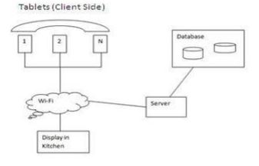

**Figure 1: Proposed System Architecture**

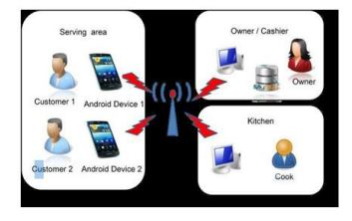

**Figure 2: Working of Proposed System**

1. **Tablet / Smartphone on Table**

Each table will have a tablet or smartphone. Customers will be able to browse the food products as often as they like thanks to this. Customers can browse the system-generated suggestions for a certain menu item. When paying a bill, the customer can enter his or her information. This enables the restaurant owner to evaluate the level of service and to send messages or emails to customers informing them of various offers.

1. **Suggestions for Customer**

The restaurant manager can post numerous menu item consolidations on a tablet. By doing so, the customer will be able to put the best order and increase sales.

1. **Attractive Presentation**

The Menu is set up in a pleasing manner. Every food item is photographed so that clients can see more clearly what the food will look like after delivery. The usage of diverse themes and color palettes is appealing.

1. **Modifiable Menu**

The admin manager has the ability to change the menu. Menu items can be added, updated, or removed by the admin manager.

1. **Market basket analysis for a restaurant.**

This information can be utilized to promote other non-frequent items by creating frequent item sets from previously placed orders and suggesting their combinations to clients.

1. **Customer relationship management**

Customers receive relevant text messages offering them enticing discounts and other acceptable deals based on the classification in k-means.

**Research Methods**

As explained in above section of requirement gathering is considered to be the most important process in the overall development process so, various information and deep researches is carried out for the completion of this project. These studies demonstrate that customer happiness is significantly influenced by service quality. Additionally, research have shown that the most important elements in determining consumer happiness are service quality, meal quality, and perceived value then, with relation to the impact of behavioral intentions. In this study's research paradigm, customer satisfaction is determined by factors like service quality, meal quality, and perceived value, with behavioural intentions acting as its outcomes.

Collection of Data:

The data required for the research was collected using the following techniques:

* **Personal Interviews:**

To gain insight into the issue at hand, the researcher conducted in-person interviews with staff members and human resource managers of well-known hotel companies.

* **Questionnaire:**

To get the sample's replies, a questionnaire with simple and pertinent questions was created and distributed to them.

**3. Synthesis**

**a) Use Case diagram**

* Use case diagram are utilized to gather the requirements of a system including inner and outside impacts. The requirements are generally plan requirements. Hence, when a system is examined to gather its functionalities, use cases are readied and actor characters are identified. The main purpose of this use case diagram is to catch the dynamic part of a system. In my system there are three actors: Customers, Admin Manager and manager with their own tasks.

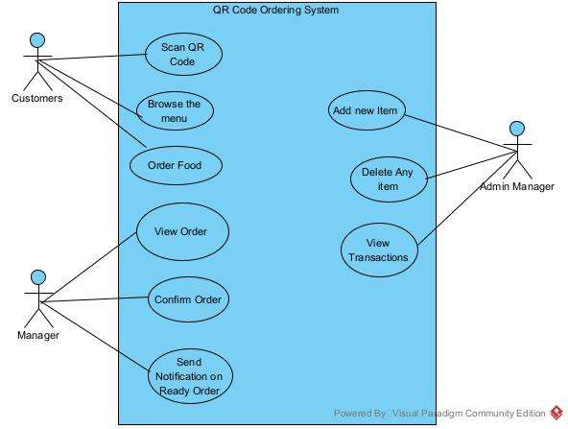

**Fig: use-Case Diagram**

**b) Data Flow Diagram**

* A dataflow diagram (DFD) maps the flow of data for any procedure or system. It utilizes characterized images like square shapes, circles and arrow, in addition to short content names, to show information inputs, storage point and the routes between every goal.

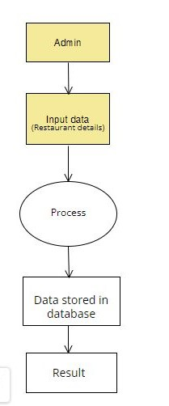

**Fig: Data Flow Diagram**

**c) Class Diagram**

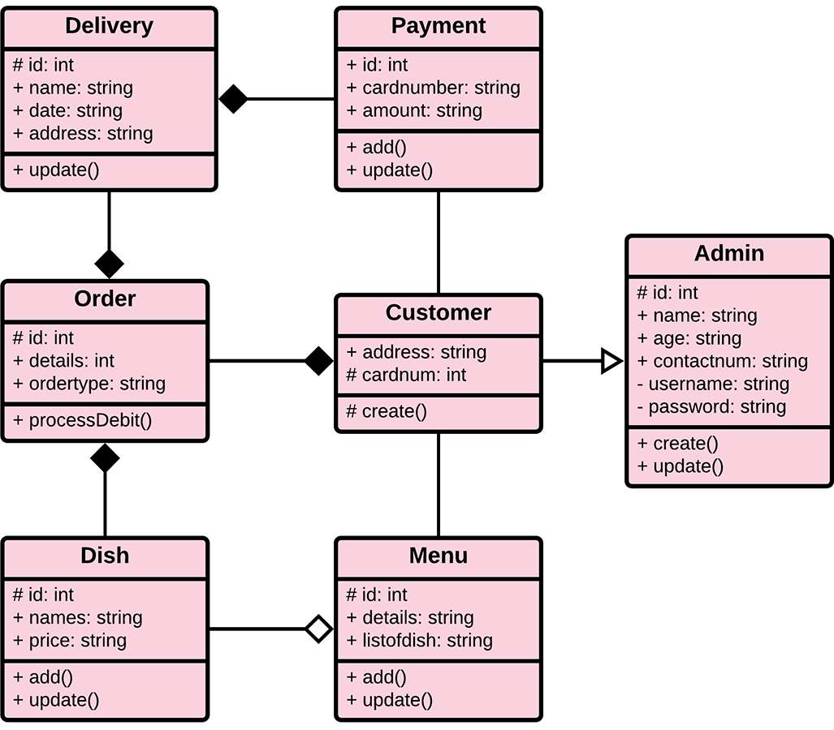

**Fig: Class Diagram**

**d) E-R Diagram**

* E-R diagram means Entity Relation Diagram. An ER diagram shows the relationship among element sets. An entity set is a gathering of comparable elements and these elements can have properties. Regarding DBMS, an element is a table or characteristics of a table in database, so by demonstrating relationship among tables and their qualities, ER chart shows the total consistent structure of a database.

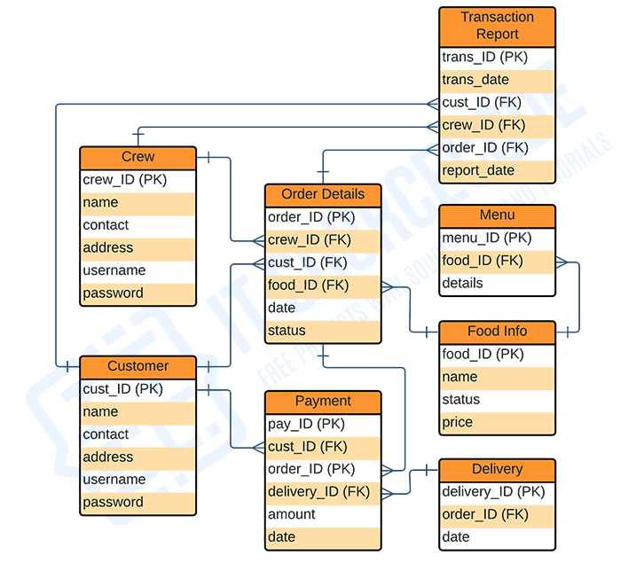

Fig: E-R Diagram

e) Sequence Diagram

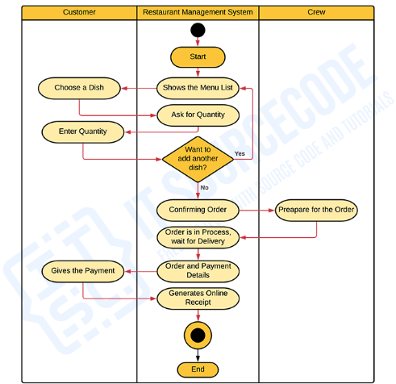

Fig: Sequence Diagram

f) Activity Diagram

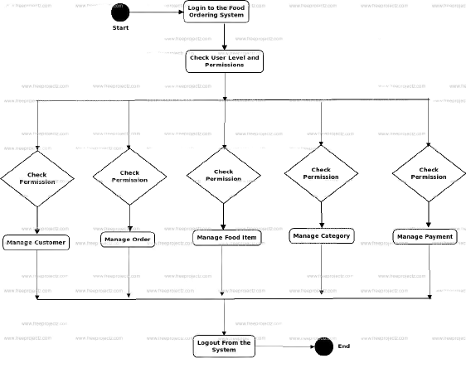

Fig: Activity Diagram