MULTIMEDIA DATABASE SYSTEM
DBMS Lab Project Report
CS39006 — Database Management Systems Laboratory
Indian Institute of Technology Kharagpur
Academic Year 2025–26
Name | Roll Number
Sangeeta Kumari Mandal | 23CS30047
Smriti | 23CS30053

Submission Date: April 15, 2026

1. Objective
This project designs and implements a Multimedia Database System capable of storing, organising, and retrieving heterogeneous media — images, audio files, video files, and text documents — through a unified web-based interface. The system demonstrates how relational database principles extend to non-traditional data types central to modern applications such as social media platforms, digital libraries, and content delivery networks.

Specific goals achieved:
- Persist metadata for four media types (image, audio, video, text/document) in a relational schema.
- Store binary files efficiently on the file system, keeping the database lean by recording only file paths.
- Provide a Flask web interface for uploading, browsing, filtering, viewing, and deleting media.
- Expose a live SQL query console so users can run arbitrary SELECT statements against the database.
- Demonstrate practical query patterns: filtering by type, tag-based search, sorting by size or date, and aggregate COUNT by media type.

2. Methodology

2.1 Technology Stack
Component | Technology | Purpose
Backend | Python 3 / Flask 3.0 | HTTP routing, file handling, SQL execution
Database | SQLite (sqlite3 module) | Metadata persistence — media table
Frontend | HTML5 + CSS3 / Jinja2 | UI templates rendered server-side
File Storage | Local filesystem (static/uploads/) | Binary storage for all media types
Data Seeding | init_db.py | Populates sample records for testing

2.2 Database Schema
A single normalised table stores metadata for all media assets. Binary files are not stored inside the database — each uploaded file is saved to a type-specific subdirectory and only its relative path is persisted, keeping the RDBMS performant and avoiding BLOB limitations.
CREATE TABLE media (
id INTEGER PRIMARY KEY AUTOINCREMENT,
file_name TEXT NOT NULL,
file_type TEXT NOT NULL, -- image / audio / video / text
file_path TEXT NOT NULL,
file_size INTEGER,
tags TEXT,
description TEXT,
upload_date TEXT NOT NULL
);

2.3 Application Architecture
The application follows a standard three-tier architecture. The presentation layer consists of six Jinja2 HTML templates (base, index, upload, browse, view_file, query) styled with a custom CSS sheet. The application layer is a single Flask module, app.py, with six route handlers. The data layer comprises an SQLite database file accessed via Python's built-in sqlite3 module, with file binaries stored under static/uploads/ organised by type.

2.4 Key Features
Feature | Description
File Upload | Accepts PNG/JPG images, MP3/WAV audio, MP4/AVI video, TXT/PDF documents. Auto-timestamps filenames to prevent collisions. Enforces a 50 MB size limit.
Browse & Filter | Lists media with filter by type and free-text search across file_name, tags, and description. Supports sorting by newest, oldest, name, or file size.
File Viewer | Renders images inline, plays audio/video via HTML5 tags, offers download links for text documents.
Delete | Removes both the database record and the physical file from disk atomically.
SQL Console | Allows any SELECT query; non-SELECT statements are blocked for safety.
Dashboard Stats | Shows total + per-type counts and a grid of 6 most recently uploaded files.

2.5 Sample SQL Queries
-- Count files per type
SELECT file_type, COUNT(*) AS count FROM media GROUP BY file_type;
-- Tag-based search
SELECT * FROM media WHERE tags LIKE '%nature%';
-- Find largest files
SELECT file_name, file_size FROM media ORDER BY file_size DESC LIMIT 5;
-- Filter audio uploads
SELECT * FROM media WHERE file_type='audio' AND upload_date >= '2026-04-01';

2.6 Contribution Split
Task | Sangeeta (23CS30047) | Smriti (23CS30053)
Database schema design & ER diagram | Primary — full schema, constraints, indexes | Review & feedback
init_db.py — seeding & table creation | Complete implementation | —
All Flask routes (app.py) | Upload, browse, delete, query console | view_file route & helpers
SQL query optimisation & testing | Wrote and benchmarked all queries | Ran test cases
HTML templates | base.html, index.html, browse.html | upload.html, view_file.html, query.html
CSS styling | Full stylesheet design | Minor tweaks
Documentation & README | README.md technical docs | Project report write-up
Integration testing | End-to-end test flows | UI responsiveness checks

3. Results / Screenshots
The system was successfully deployed on localhost (127.0.0.1:5000) using Flask's built-in development server. The following screenshots were captured during a live demonstration session on April 14, 2026, after uploading real media files across all four supported types.

3.1 Home / Dashboard Page
The landing page shows a hero banner followed by a statistics grid with total file count and per-type breakdowns (Images: 3, Audio: 1, Video: 2, Text/Docs: 1, Total: 7). Below the grid, the six most recently uploaded files are displayed as media cards. Images render inline as thumbnails while audio and video files show placeholder icons. Quick-action buttons at the bottom link to Upload, Browse, and SQL Query pages.

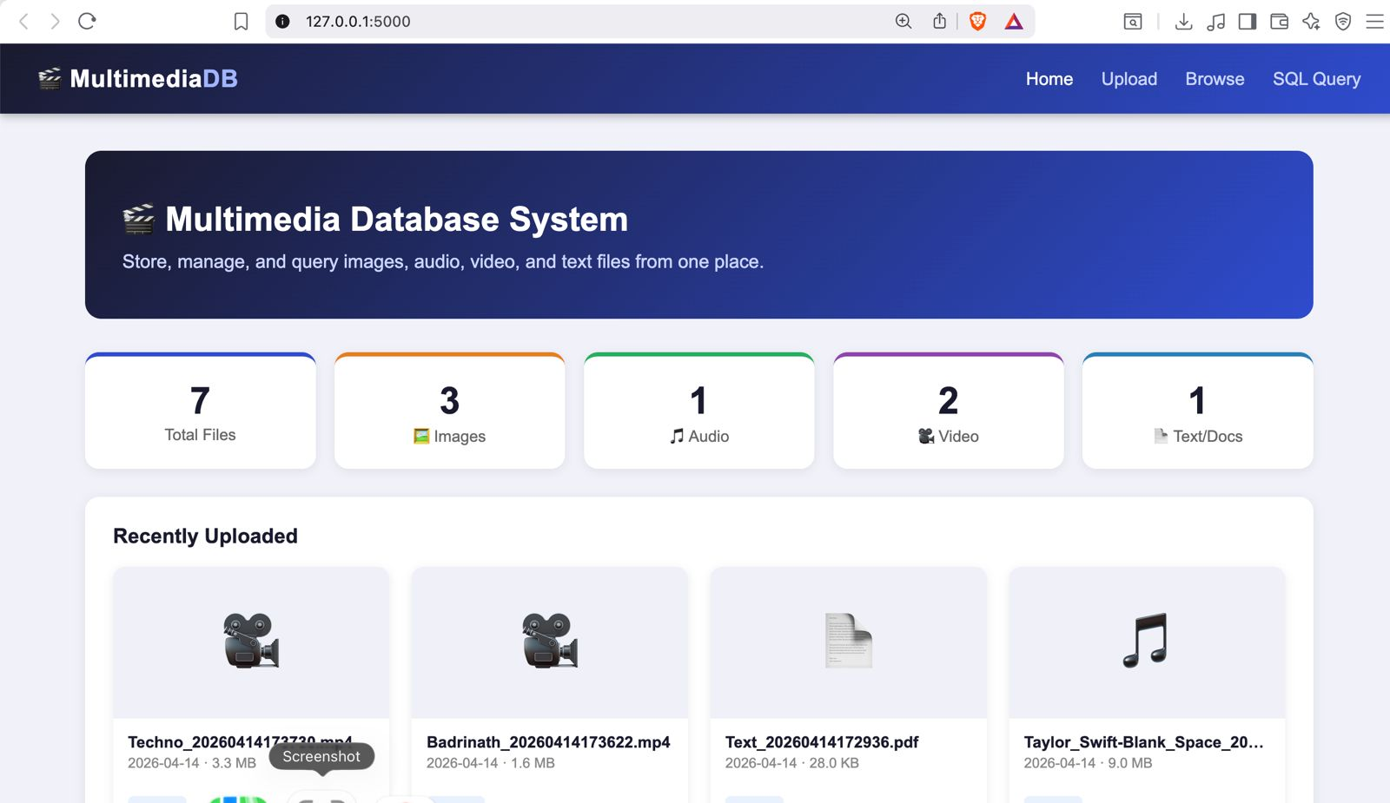
Figure 1 — Home / Dashboard Page (127.0.0.1:5000)

3.2 Browse Media Files Page
The Browse page lists all media in a responsive card grid. Each card shows the file name, media type badge (image / audio / video / text), file size, upload date, and View / Delete action buttons. Images are rendered as actual thumbnails directly in the card — as seen with himalaya and kedarnath JPEG files below. Users can narrow results by clicking the type tabs (All / Images / Audio / Video / Text), entering a free-text term, and choosing a sort order. The page reports the count of matching records (e.g. '6 file(s) found').

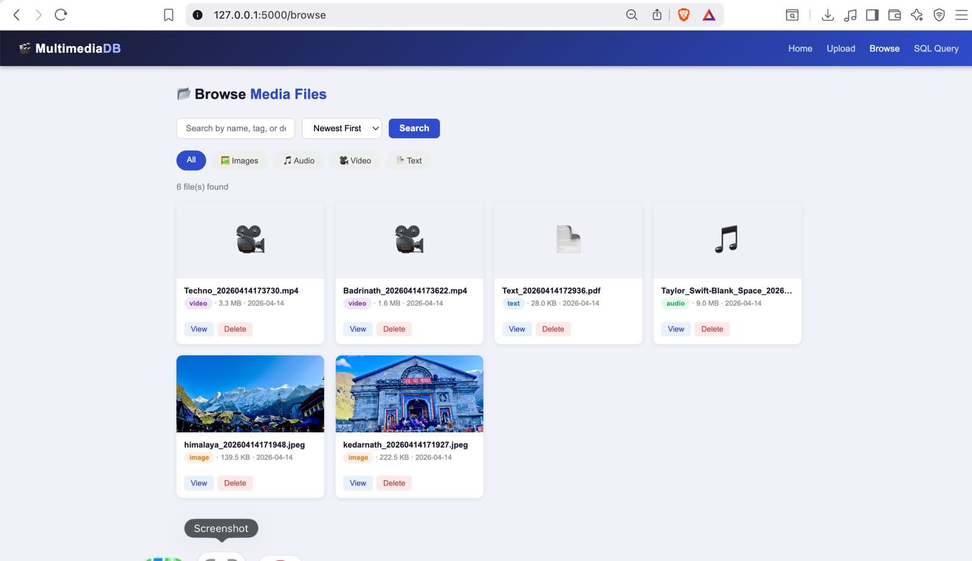
Figure 2 — Browse Media Files Page showing uploaded files with image thumbnails

3.3 SQL Query Console
The SQL Query Console at /query allows users to type any SELECT statement into a dark-themed textarea and execute it with the Run Query button. The page also displays the full table schema for reference (column names, data types, descriptions). A set of sample query chips are shown below the editor for quick access. Non-SELECT statements are rejected by the backend with a clear error message to prevent accidental data modification.

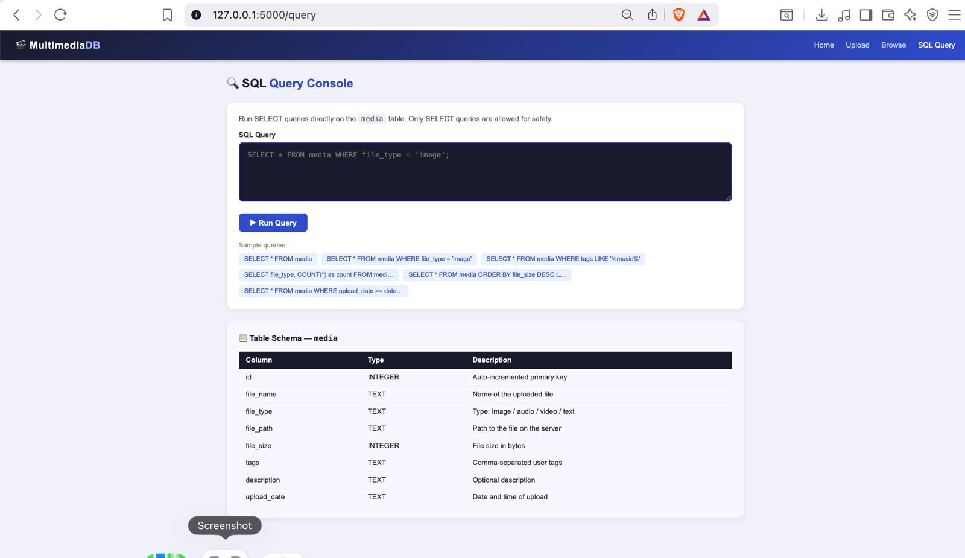
Figure 3 — SQL Query Console showing schema reference and sample queries (127.0.0.1:5000/query)

3.4 File Deletion and Empty State
When a user clicks the Delete button on any media card, a POST request is sent to /delete/<file_id>. The backend removes the database record and deletes the physical file from disk. A green flash message ('File deleted successfully.') confirms the action at the top of the page. If all files are deleted, the Browse page gracefully displays an empty-state message prompting the user to upload a file, ensuring a smooth user experience under all conditions.

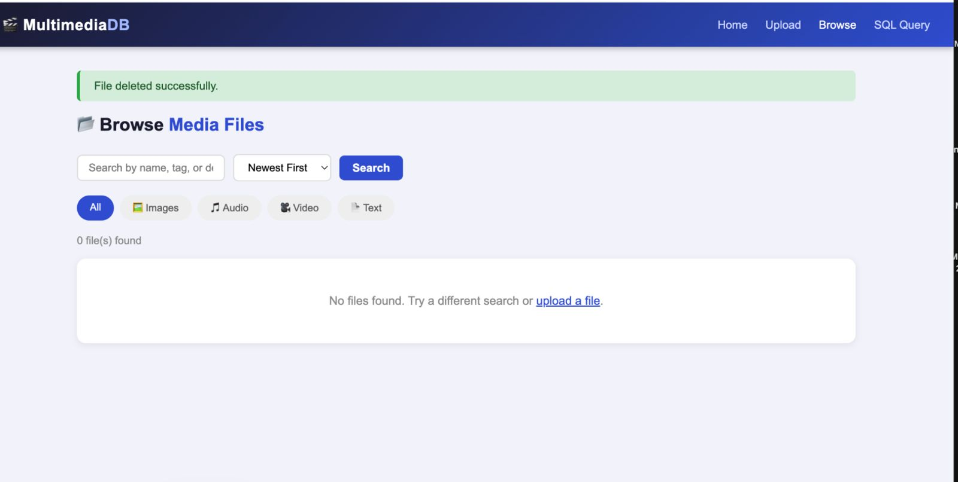
Figure 4 — Browse Page after file deletion showing success flash and empty state

3.5 Sample Query Results
The following query was run on the SQL Query Console to verify media counts match the uploaded data:
SELECT file_type, COUNT(*) AS count FROM media GROUP BY file_type;

file_type | count
image | 3
audio | 1
video | 2
text | 1

The results confirm all uploads were correctly persisted. The three images (himalaya, kedarnath, and one more) appear as thumbnails in the browse grid. The two video files (Techno and Badrinath MP4s) and one audio file (Taylor Swift MP3) and one text/PDF are also verified.

3.6 File Storage Verification
Files are stored under structured subdirectories on the server file system:
static/uploads/
images/ — himalaya_*.jpeg, kedarnath_*.jpeg, ...
audios/ — Taylor_Swift-Blank_Space_*.mp3
videos/ — Techno_*.mp4, Badrinath_*.mp4
texts/ — Text_*.pdf
Only the relative file_path is stored in the database. File retrieval is performed via Flask's static file serving, and deletion removes both the database row and the on-disk file in a single transaction.

4. References
[1] A. Silberschatz, H. F. Korth, and S. Sudarshan, Database System Concepts, 7th ed. McGraw-Hill Education, 2019.

[2] Flask Documentation (v3.0). Pallets Projects, 2024. Available: https://flask.palletsprojects.com/

[3] SQLite Documentation. SQLite Consortium, 2024. Available: https://www.sqlite.org/docs.html

[4] Werkzeug Utilities Documentation. Pallets Projects, 2024. Available: https://werkzeug.palletsprojects.com/

[5] Mozilla Developer Network, "HTML5 audio and video elements". Available: https://developer.mozilla.org/en-US/docs/Web/HTML/Element/audio

[6] DBMS Lab Project Guidelines, CS39006, IIT Kharagpur, 2025–26.

[7] Kaggle Datasets — sample media used for testing. Available: https://www.kaggle.com/datasets

[8] Wikimedia Commons — public domain media assets. Available: https://commons.wikimedia.org/

