**APPENDIX 1**

##### **BANK AUTOMATION SYSTEM**

##### **A PROJECT REPORT**

***In partial fulfilment for the award of the degree of***

**DIPLOMA**

**IN**

# **COMPUTER SCIENCE AND ENGINEERING**

# **INFORMATION TECHNOLOGY**



**Under the guidance of Submitted by**

**MRS.ASHU SINGLA ANJALI (SL/15/0294) (ASSISTANT PROFESSOR) SMRITI RANI (SL/15/0274)**

**(CSE Department) DIKSHITA GARG(SL/15/0271)**

**SANT LONGOWAL INSTITUTE OF ENGINEERING AND TECHNOLOGY LONGOWAL - 148106**

**DISTRICT- SANGRUR, PUNJAB, INDIA**

##### **MAY 2018**

##### **APPENDIX 2**

**CERTIFICATE**

Certified that this project report” BANK AUTOMATION SYSTEM” submitted by ” ANJALI , SMRITI RANI ,DIKSHITA GARG” in the partial fulfillment of the requirement for the award of degree of diploma.

This report has not been submitted to any other university or institution for the award of any degree.

ANJALI (SL/15/0294)

SMRITI RANI (SL/15/0274)

DIKSHITA GARG(SL/15/0271)

Signature of the Supervisor

(ASHU SINGLA)

Assistant Professor

**ACKNOWLEDGEMENT**

While working on this project we had an interaction with our teachers, friends and well-wishers. It is not possible to name all of them and therefore we would like to take this opportunity to thank all of them whole-heartedly.

However we offer our special thanks to Mrs. Ashu Singla for not only for the idea but also for the encouragement and generous support throughout the project and also for providing infrastructure necessary for development of project and the entire staff members who helped us during the time of our project work.

**ABSTRACT**

Software may be applied in any situation for which pre- specified set of steps has been defined. It is a means for optimal utilization of time, space and above all there is more of customer’s satisfaction. The efficiency and arithmetical accuracy of the system is increased and hence less errors. Banking in general plays a vital role in day to day life of human. Before the usage of computers in the banking sector, maintaining the records of customers was a time consuming task and there was a risk of manipulation of records. From the advent of computers into the banking sector, it has become an easy task to maintain the records and day to day transaction of the banks. Software is used to maintain the functional areas, which are well defined and may be applied in any situation. The project is being developed by keeping in mind the requirements of the bank, the type of transactions. This project up to certain extent provides the functions that are performed in a bank. The automation of bank i.e. proposed system plays the vital role in the development of the country’s economy.

I have considered the following functions:

* Add record
* Show/List data
* Search record
* Edit record
* Delete record

**TABLE OF CONTENT**

Certificate…………………………………………………………………………..................

Acknowledgement………………………………………………………………....................

Abstract……………………………………………………………………………………….

**CHAPTER 1: INTRODUCTION**…………………………………………………………1-3

Purpose………………………………………………………………………………………..

Objective……………………………………………………………………………………….

**CHAPTER 2: FEASIBILITY STUDY**………………………………………………..….4-5

Economic feasibility…………………………………………………………………………….

Technical Feasibility…………………………………………………………………………….

Operational Feasibility…………………………………………………………………………..

**CHAPTER 3: PROBLEM DEFINITION**……………………………………………………6

Drawback of existing System…………………………………………………………………….

**CHAPTER 4: REQUIREMENT OF CURRENT SYSTEM**...............................................7-8

Advantage of Proposed System…………………………………………………………………..

**CHAPTER 5: TOOLS/PLATFORM USED**……………………………………………....9-10

Choice of Language………………………………………………………………………………

**CHAPTER 6: FEATURES**…………………………………………………………………..11

**CHAPTER 7**: **LIST OF FIGURES**……………………………………………………….12-21

Coding……………………………………………………………………………………………

Output Screen…………………………………………………………………………………….

**CHAPTER 8: PROGRAM TESTING AND LIMITATION**…………………………..22-23

**CHAPTER 9: CONCLUSION AND REFERENCES**………………………….……….24-25

**CHAPTER-1**

**INTRODUCTION**

A bank is an organization used to deal with money. Bank draws surplus money from the people who are using at the time and lend to those who are in a position to use it for productive purpose. Banks are extremely useful banks play a vital role in economics developments of under developed economics.

This banking record system project in C++ is a simple console application developed without the use of graphics component. It is more of a database project in C++, and is built using the language’s file handling mechanism. It is suitable for beginners who want to learn how to add, edit, search, delete or modify records in a file, and how to use file as database overall.The source code for this project is short – just over 150 lines. The coding has been presented in a very understandable manner. The source code needs to be compiled in Code::Blocks IDE using GCC compiler. You can download the source code plus the executable file for banking record system project in C++ from the link below.

**PURPOSE**

Earlier many Commercial Organizations keep their records manually. It is very difficult for a man to keep all records correctly. It is very tedious and time consuming process. Though a man has a very intelligent mind, he can’t solve heavy Calculations fast and accurately if so he makes errors.

Business Organizations can be kept inside one Computer .It processes automatically all Organizations transaction without time taking & errors. This process gives accurate result with 100% accuracy than manual system.

Computer professionals have developed many Computer languages and packages .A man who has a good practice of language and software can develop Computer programs. Once a program is fed a man who not knows anything about Computer can operate very well.

**OBJECTIVE**

The proposed system is fully computerized. It avoids errors, wastage of time and bulk of paper work. The process of the banking system by using the computerized is the one of the best solution for avoiding the lots of overheads. So we are organizing the present system in the computerized form.

* Less management problem
* Accurate information
* Easy to manage
* Reduce time
* Simple input giving procedures
* Easy modification, addition and deletion thus easy updating.
* Computerized system of record keeping.
* Data in a computerized file system is more secure.
* User friendly and easy to use.
* There is always scope for further enhancement of the system to yield more fruitful result.
* The whole process of the proposed system is more efficient.

**CHAPTER-2**

**FEASIBILITY STUDY**

Feasibility study is conducted after finding out the system objective.

The following feasibilities are considered for the project in order to ensure that the project is visible and does not have major obstructions. The feasibility of a computer based system can be studies in three major areas.

* Economic Feasibility
* Technical Feasibility
* Operational Feasibility

**ECONOMIC FEASIBILITY**

In our project system for the development of the system, we have to spend the computer resources, like the required software and hardware that supports the computer system in an effective manner and the money to be paid to the developer. But the comparing the costs spend on project system with the future benefits the amount spends is negligible.

Because once we have create software then, if any are changes are required then they can be done with small modifications. Since all the information is available within a few seconds the system performance will be substantially increased.

This System is economically feasible because

1. It is of low cost as it does not require any extra software and hardware.
2. This system is handled by single user because it provides the entire database in one place from which we can get all information.
3. Hence it does not require more man power and it saves money.

**TECHNICAL FEASIBILITY**

Technical feasibility is just the technical aspect of project. In this we have to find out various Hardware and Software requirements for the project. Computer system basically is a mixture of hardware and software and it is necessary to find out, to what extends it can support the proposed edition. We have developed the Banking System by using very basic concept of object oriented language, C++ and graphics concept from C. This project has been developed using the high level language C++. Because of the object oriented features supported by the C++. It becomes quite easy and simple to develop the project.

The file system of the C++ helps us to store large amount of data about the employees and retrieve it whenever enquired very easily. All the output is generated on the CRT screens.

**OPERATIONAL FEASIBILITY**

The operational feasibility mostly looks to the part that how easily project can put into the action. It looks over that, is there any difficulty on loading of this project This project is operationally feasible because once the user enters and follows all the rules he/she will be provided by the Banking application. Due to the simple interface the project is very user-friendly because it provides all the options on the form itself. Our project easily understands by user, because user cannot require extra technical knowledge to handle this project

**CHAPTER -3**

**PROBLEM DEFINITION**

**DRAWBACK OF EXISTING SYSTEM**

1. **It is very time consuming** - In the Manual system, the performance measuring of an employee is a tiresome job to do and also time consuming.
2. Less Data security is there.
3. **Lot of the paper work** - existing system involves a lot of repetitive paper work including different records of the poles.
4. More paper works are to be done.
5. **No alarming facility** - In the Manual system it doesn’t checks for the performance of an employee, hence this causes irregularity in the matter of promotion.
6. **No query generation facility** - In the manual system doesn’t support, the organization does not get the actual idea of the employees performance.
7. **Wastage of resources** - A major portion of the total space is occupied in keeping manually maintained files including records. No query processing systems - There are time consuming provisions for solution to different queries .If at all a record is to be searched then the entire files are to be sorted from beginning to end.

**CHAPTER -4**

**REQUIREMENT OF CURRENT SYSTEM**

As in today’s world everyone is in a hurry because time is very precious and it is very important for everyone. As the project tells the idea of banking, it is used in every Banking Organization which are basically running on profit making.

It is very tedious and time-consuming job to maintain a registers manually. For maintaining on this manually it is very lengthy and also requires lot of manpower to handle this work and can also make a lot of mistakes, which can effect on profit and the Organizations image. In this Project basically I have dealt with the Add record, Show/List record, Delete record, Search record

Edit record.

This Project is very easy to manage banking transactions. It stores information about new account holder, in addition into old account; list of accounts, individual account, daily transactions, monthly report, and edit account etc. Which is common for any bank.

It handless huge data very efficiently with 100% accuracy and saves time .This Project maintains large day-to-day transaction which a person finds it difficult to do manually.

The main-menu is displayed on the screen. Select item from that list and enter the required information . So, application of this project is most applicable for useful purpose.

**ADVANTAGE OF PROPOSED SYSTEM**

1. **It fully user friendly -** The system is fully user friendly since it is developed in windows based with c++, which is having very easy understandable facilities.
2. **It does not require expert hand -** The data entry can be done by any body. Since it handles. Any error may be handle by a readable message.
3. **Paper work is reduced -** Since there is no unnecessary printing, Photo coping of the Document for the individual customer.
4. **Timely alerting -** The system alerts the user about the customer that when the period of deposit is over and the customer closes his account or continue his account.
5. **Faster access of information -** The system will accessed the data fastly and since the system will in on LAN. Then the retrievals can be round the clock.
6. **Efficient tractability -** Whatever the number of employee the tracing of particular customer information will be very easy.
7. **Query can be done easily -** Query will make easy to get the information about a particular customer.

1. **Report generation can be done easily -** As after the automation of the system report about an customer can be done easily.

**CHAPTER -5**

###### Tools/Platforms, language to be used :-

# **Software Requirement**

Operating System Microsoft Windows 10

Tools Code Block

Front End OOPS concept (C++)

Back End Text, Data file of C++

# **Hardware Requirement**

Primary Memory 16 MB SDRAM and more

Microprocessor Intel Pentium Processor (100 MHZ)

Secondary Memory 10 GB Hard disk

Monitor Plug and Play Monitor

Keyboard Keyboard P/S2 keyboard

Mouse PS/2 Mouse

**CHOICE OF LANGUAGE**

C++ is an Object Oriented Programming Language that provides a way of modularizing programs by creating partition memory area for data and function. C++ is versatile for handling very large programs. It is suitable for virtually and programming task including database, communication system and complex real life application.

C++ programs are easily maintainable and expandable when a new feature needs to be implemented ;it is very easy to add to existing structure of an object. In C++ we can create variables at any place of programs.

It provides the concept like inheritance and polymorphism.

File handling in C++ is very easy to implement database. Use of graphics can be done very easily as per as formatting is concern. That is why I have selected C++ Programming Language for my Project.

**CHAPTER -6**

**FEAUTURES**

* **Add Record**

For this feature void read_data() function has been used to add banking record into the file. It asks for information such as account number, first name, last name and balance to be entered.

* **Show/ListData**  
  With the information provided in add record, the void show_data() function in this banking record system project in C++ show the record corresponding to a particular account number, first name and last name. Current balance of the account holder is displayed.
* **SearchRecord**  
  When the function for this feature is first executed, it shows the total records in the file, and the user can then search by record number. If the record searched for is not found, the banking record system project in C++ displays the message – “Error in opening! File Not Found.
* **EditRecord**  
  This works in similar manner to the Search feature. When the function for Edit Record is first executed, it shows the total records in the file, and the user can edit the information by providing record number. Then, the C++ project shows all the data in that record, and the user can enter any data to modify. If the record to be edited for is not found, it displays the message – “Error in opening! File Not Found!!”
* **DeleteRecord**

First of all, when the function of this feature is executed, it shows all the records in the file, and the user can enter the record number to delete. If the record was not found, this banking record system project in C++ displays the message – “Error in opening! File Not Found!!

**CODING**

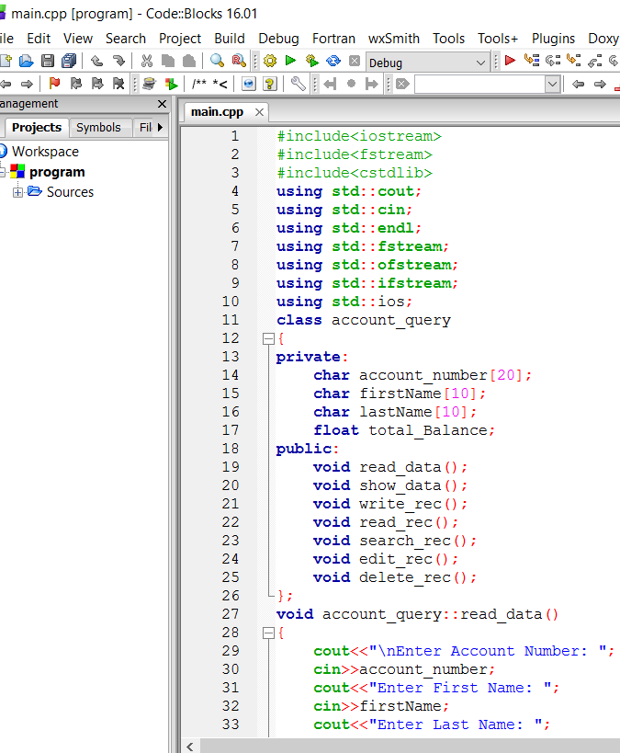

Fig: 1.1

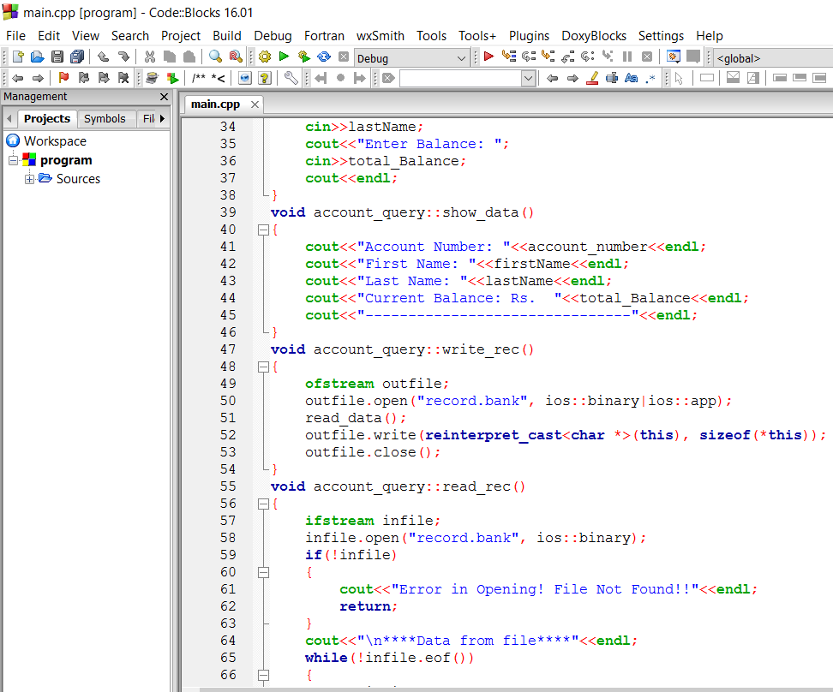

Fig: 1.2

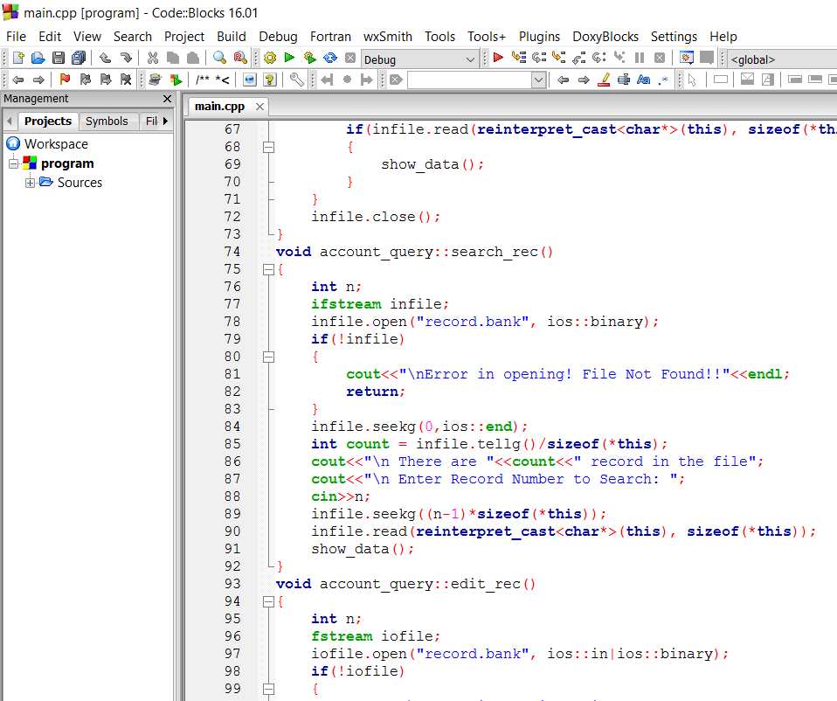

Fig: 1.3

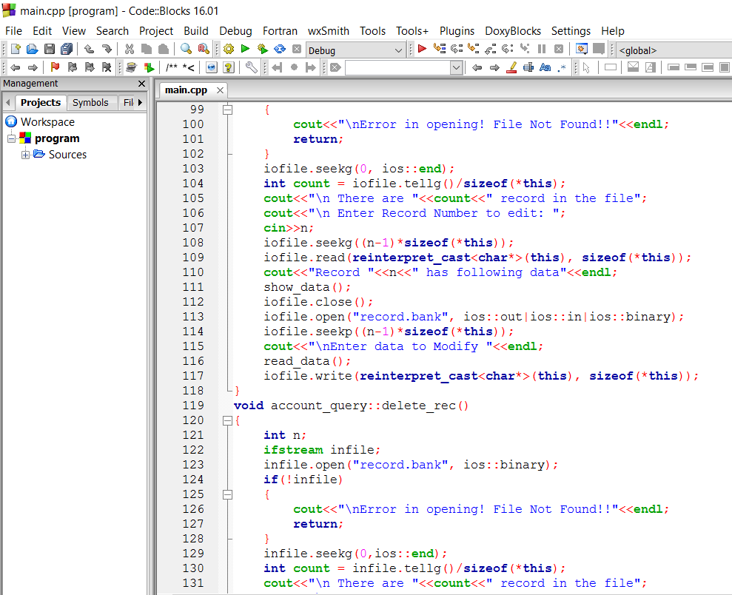

Fig: 1.4

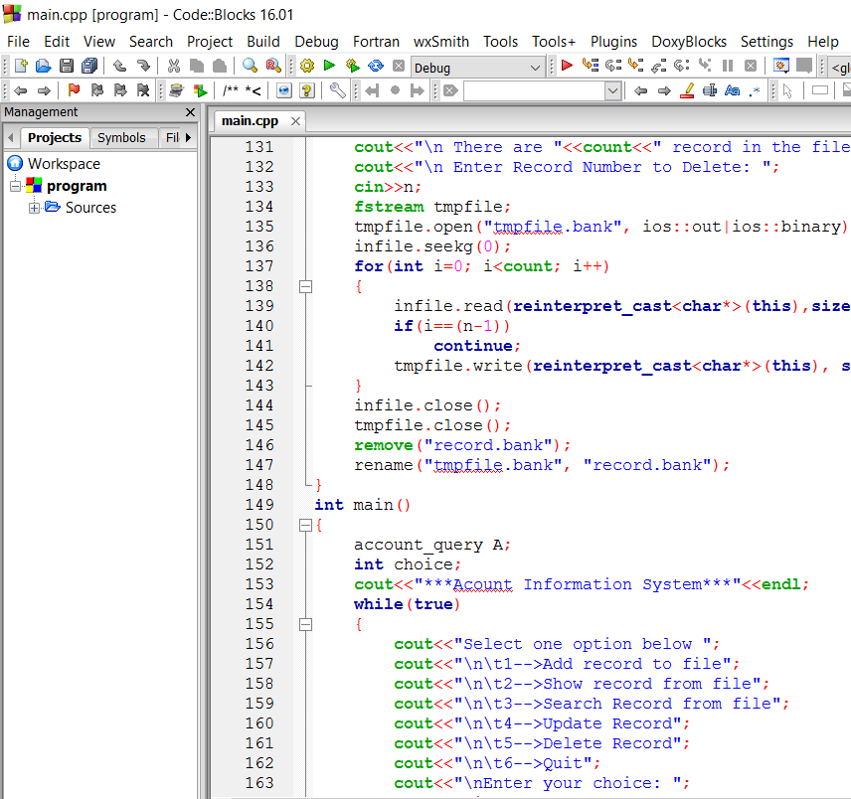

Fig: 1.5

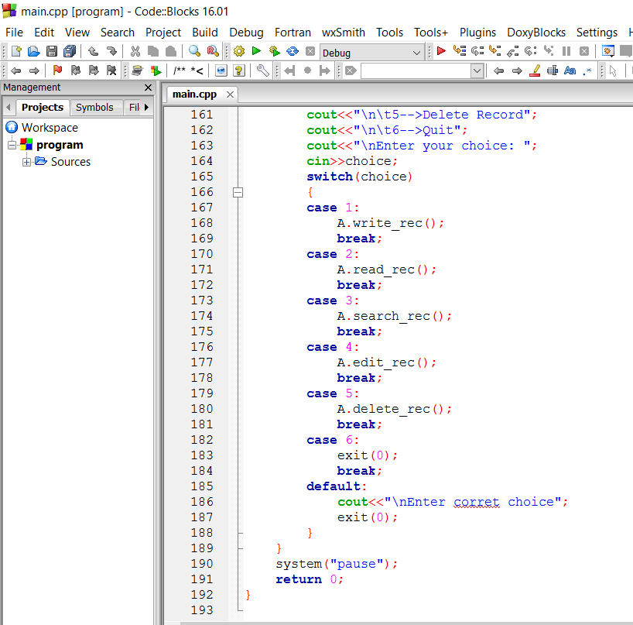

Fig :1.6

**OUTPUT SCREEN**

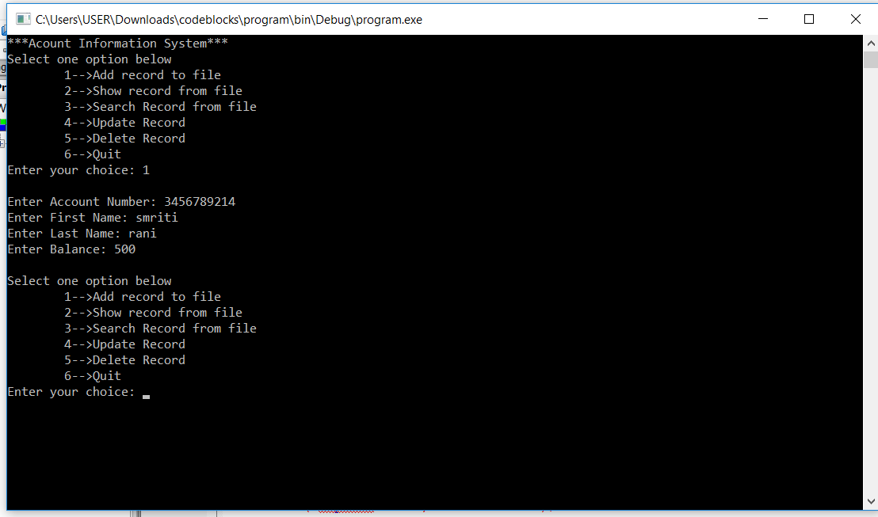

Fig: 2.1

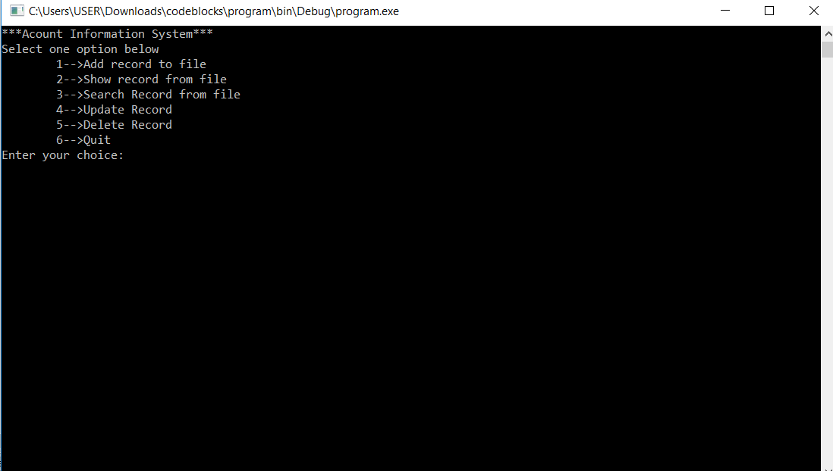

Fig:2.2

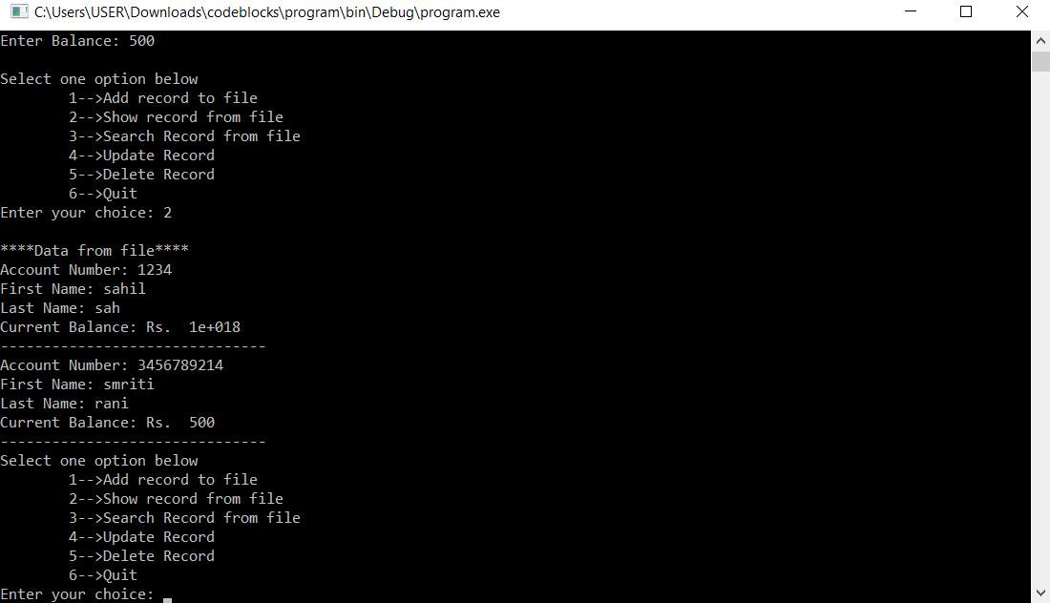

Fig: 2.3

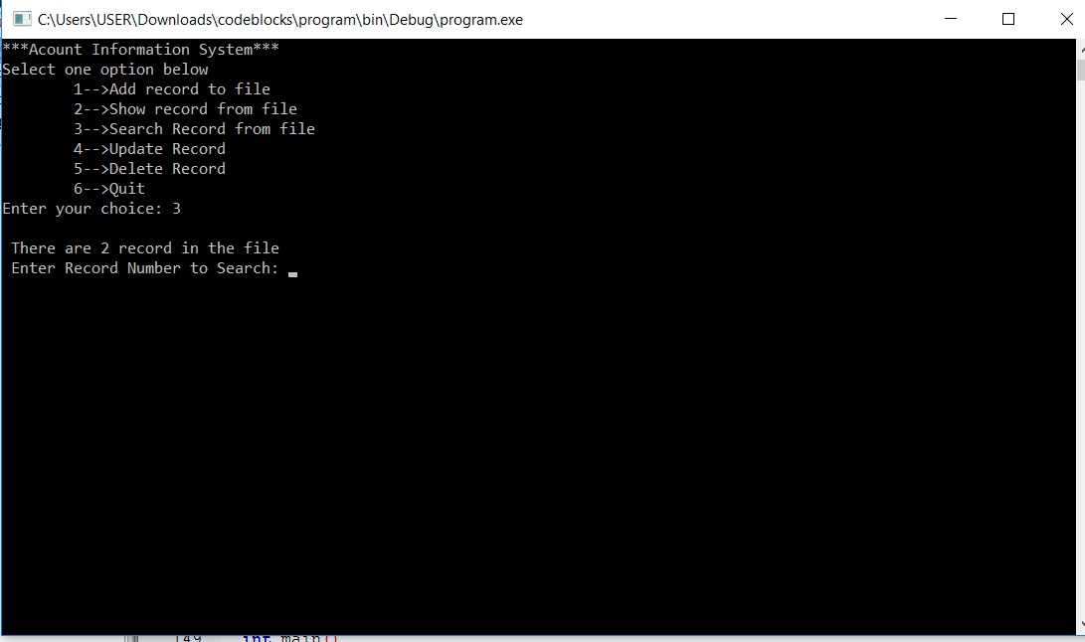

Fig: 2.4

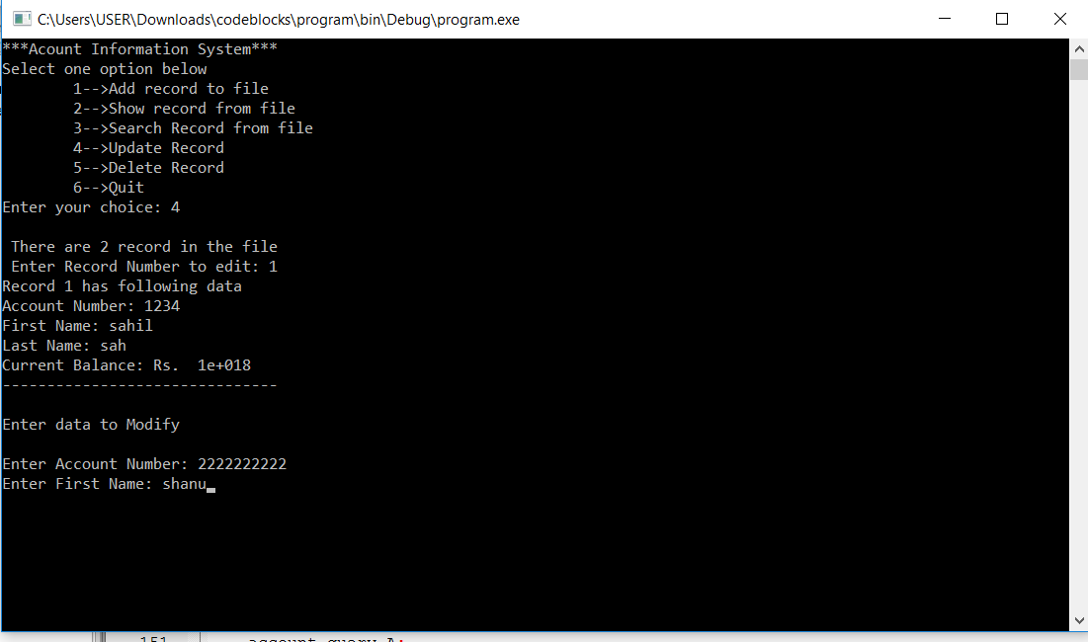

Fig: 2.5

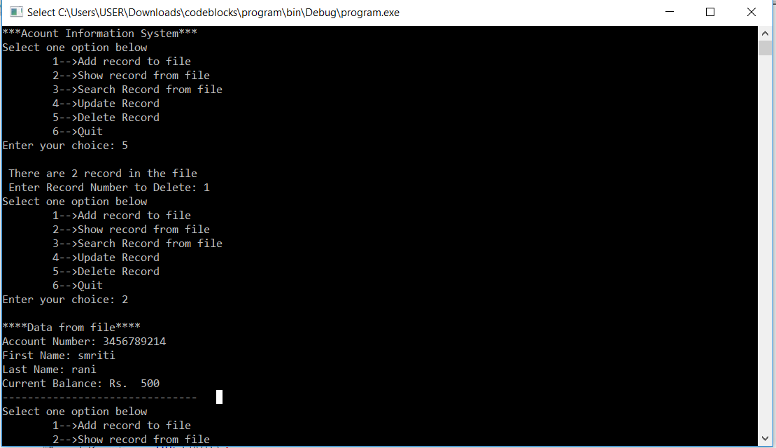

Fig:2.6

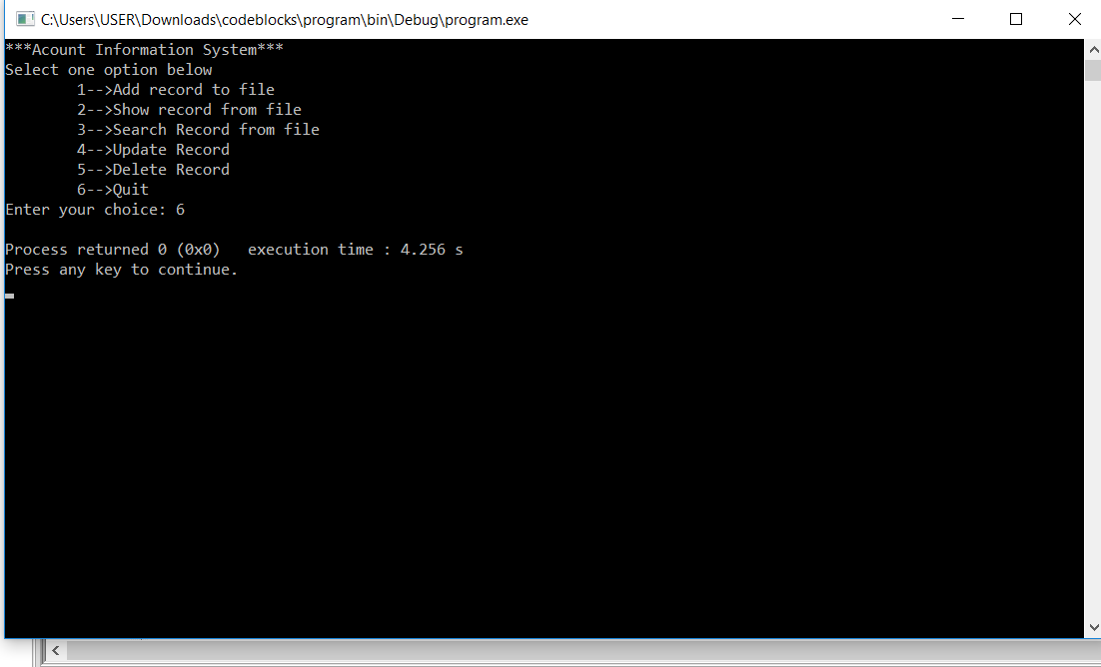

Fig: 2.7

**CHAPTER – 7**

**PROGRAM TESTING**

A program represents the logical elements of a system. For a program to run satisfactorily, it must compile data and test data correctly and tie it properly with other programs. Achieving errors free programs is the responsibility of the programmer. Program testing checks for two types of errors . Syntax and Logical error.

A syntax error is a program statement violates on or more rules of the language in which it is written. A logical error, on the hand deals with incorrect data fields, out of the range items, and invalid combinations. Since diagnostics do not detect logical errors, the programmer must examine the output carefully for them. While testing the program, we compared the actual output with the expected output. On finding a discrepancy, we traced the sequence of instruction to determine the problem.

**LIMITATION**

The present System is based on certain limits and conditions.

1. This project is also application for the “Banks.”
2. The main drawback is that in this System the customer doesn’t have the facility for the recurring deposit, or fixed deposit schemes.
3. There is no facility for the issue of loans!
4. This System requires many types of databases, but C++ does not support database system fully.

The concept of the banking is common in all the banks worldwide, so this will be applicable in each and every bank. But due to time limitation and other difficulties each and every point cannot achieve. But minor changes in my above listed facilities can be made available to user.

**CHAPTER -8**

**CONCLUSION**

In today’s world corporate sector needs the comprehensive application programs and software. Hence this system helps us to complete the need of user and maintaining the portability of the program. Our program is giving the facility for searching the appropriate records, creating the new records etc. This is just an attempt to provide the user with all facilities of bank system. However there are some aspects which are not able to achieve in our project due to time constraints.

In future we look forward to complete all the aimed tasks. At this level we make the system simple and user friendly.

**REFERENCES**

https://en.m.wikipedia.org>wiki>Link

Tutorial points

Free engineering classes (You tube)