clc;

clear all;

close all;

coin=imread('final.jpg');

figure(1);

subplot(2,2,1);

imshow(coin),title('Original Image');

BW_im = im2bw(coin);

subplot(2,2,2);

imshow(BW_im),title('Thresholded Image/ B/W Image');

BW_out = ~BW_im;

subplot(2,2,3);

imshow(BW_out),title('Complemented Image');

BW_output = imfill(BW_out,'holes');

BW = bwpropfilt(BW_out, 'Area', [70000, 110443]);

subplot(2,2,4);

imshow(BW),title('Filled Image');

[L Ne]=bwlabel(BW);

pt=regionprops(L,'Area','Centroid');

total=0;

hold on;

for n=1:size(pt,1)

rup=pt(n).Centroid;

X=rup(1);

Y=rup(2);

if (pt(n).Area < 90000)

text(X-10,Y,'1');

total=total+1;

else

text(X-10,Y,'2');

total=total+2;

end

end

number=n;

rupees=total;

hold on;

title(['Rupees : Rs.', num2str(rupees), ' ', 'Number of coins:', num2str(n)]);

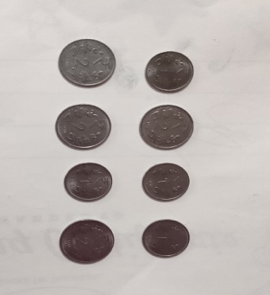

clc;

clear all;

close all;

coin=imread('fin.jpg');

figure(1);

subplot(2,2,1);

imshow(coin),title('Original Image');

BW_im = im2bw(coin);

subplot(2,2,2);

imshow(BW_im),title('Thresholded Image/ B/W Image');

BW_out = ~BW_im;

subplot(2,2,3);

imshow(BW_out),title('Complemented Image');

BW_output = imfill(BW_out,'holes');

BW = bwpropfilt(BW_out, 'Area', [70000, 110443]);

subplot(2,2,4);

imshow(BW);

[L Ne]=bwlabel(BW);

pt=regionprops(L,'Area','Centroid');

total=0;

hold on;

for n=1:size(pt,1)

rup=pt(n).Centroid;

X=rup(1);

Y=rup(2);

if (pt(n).Area < 90000)

text(X-10,Y,'2');

total=total+1;

else

text(X-10,Y,'1');

total=total+1;

end

end

number=n;

rupees=total;

hold on;

title(['Rupees : Rs.', num2str(rupees), ' ', 'Number of coins:', num2str(n)]);

