WAD-Assignment 6.
Create a Node.JS Application which serves a static website.
Steps :
mkdir node-static-app
cd node-static-app
npm init -y
npm install express
node-static-app/
│
├── server.js
└── public/
├── index.html
├── style.css
└── script.js

Server.js :
const express = require('express');
const path = require('path');

const app = express();

// Serve static files from 'public' folder
app.use(express.static(path.join(__dirname, 'public')));

// Start server
const PORT = 3000;
app.listen(PORT, () => {
console.log(`Server running at http://localhost:${PORT}`);
});
To run app ;
node server.js
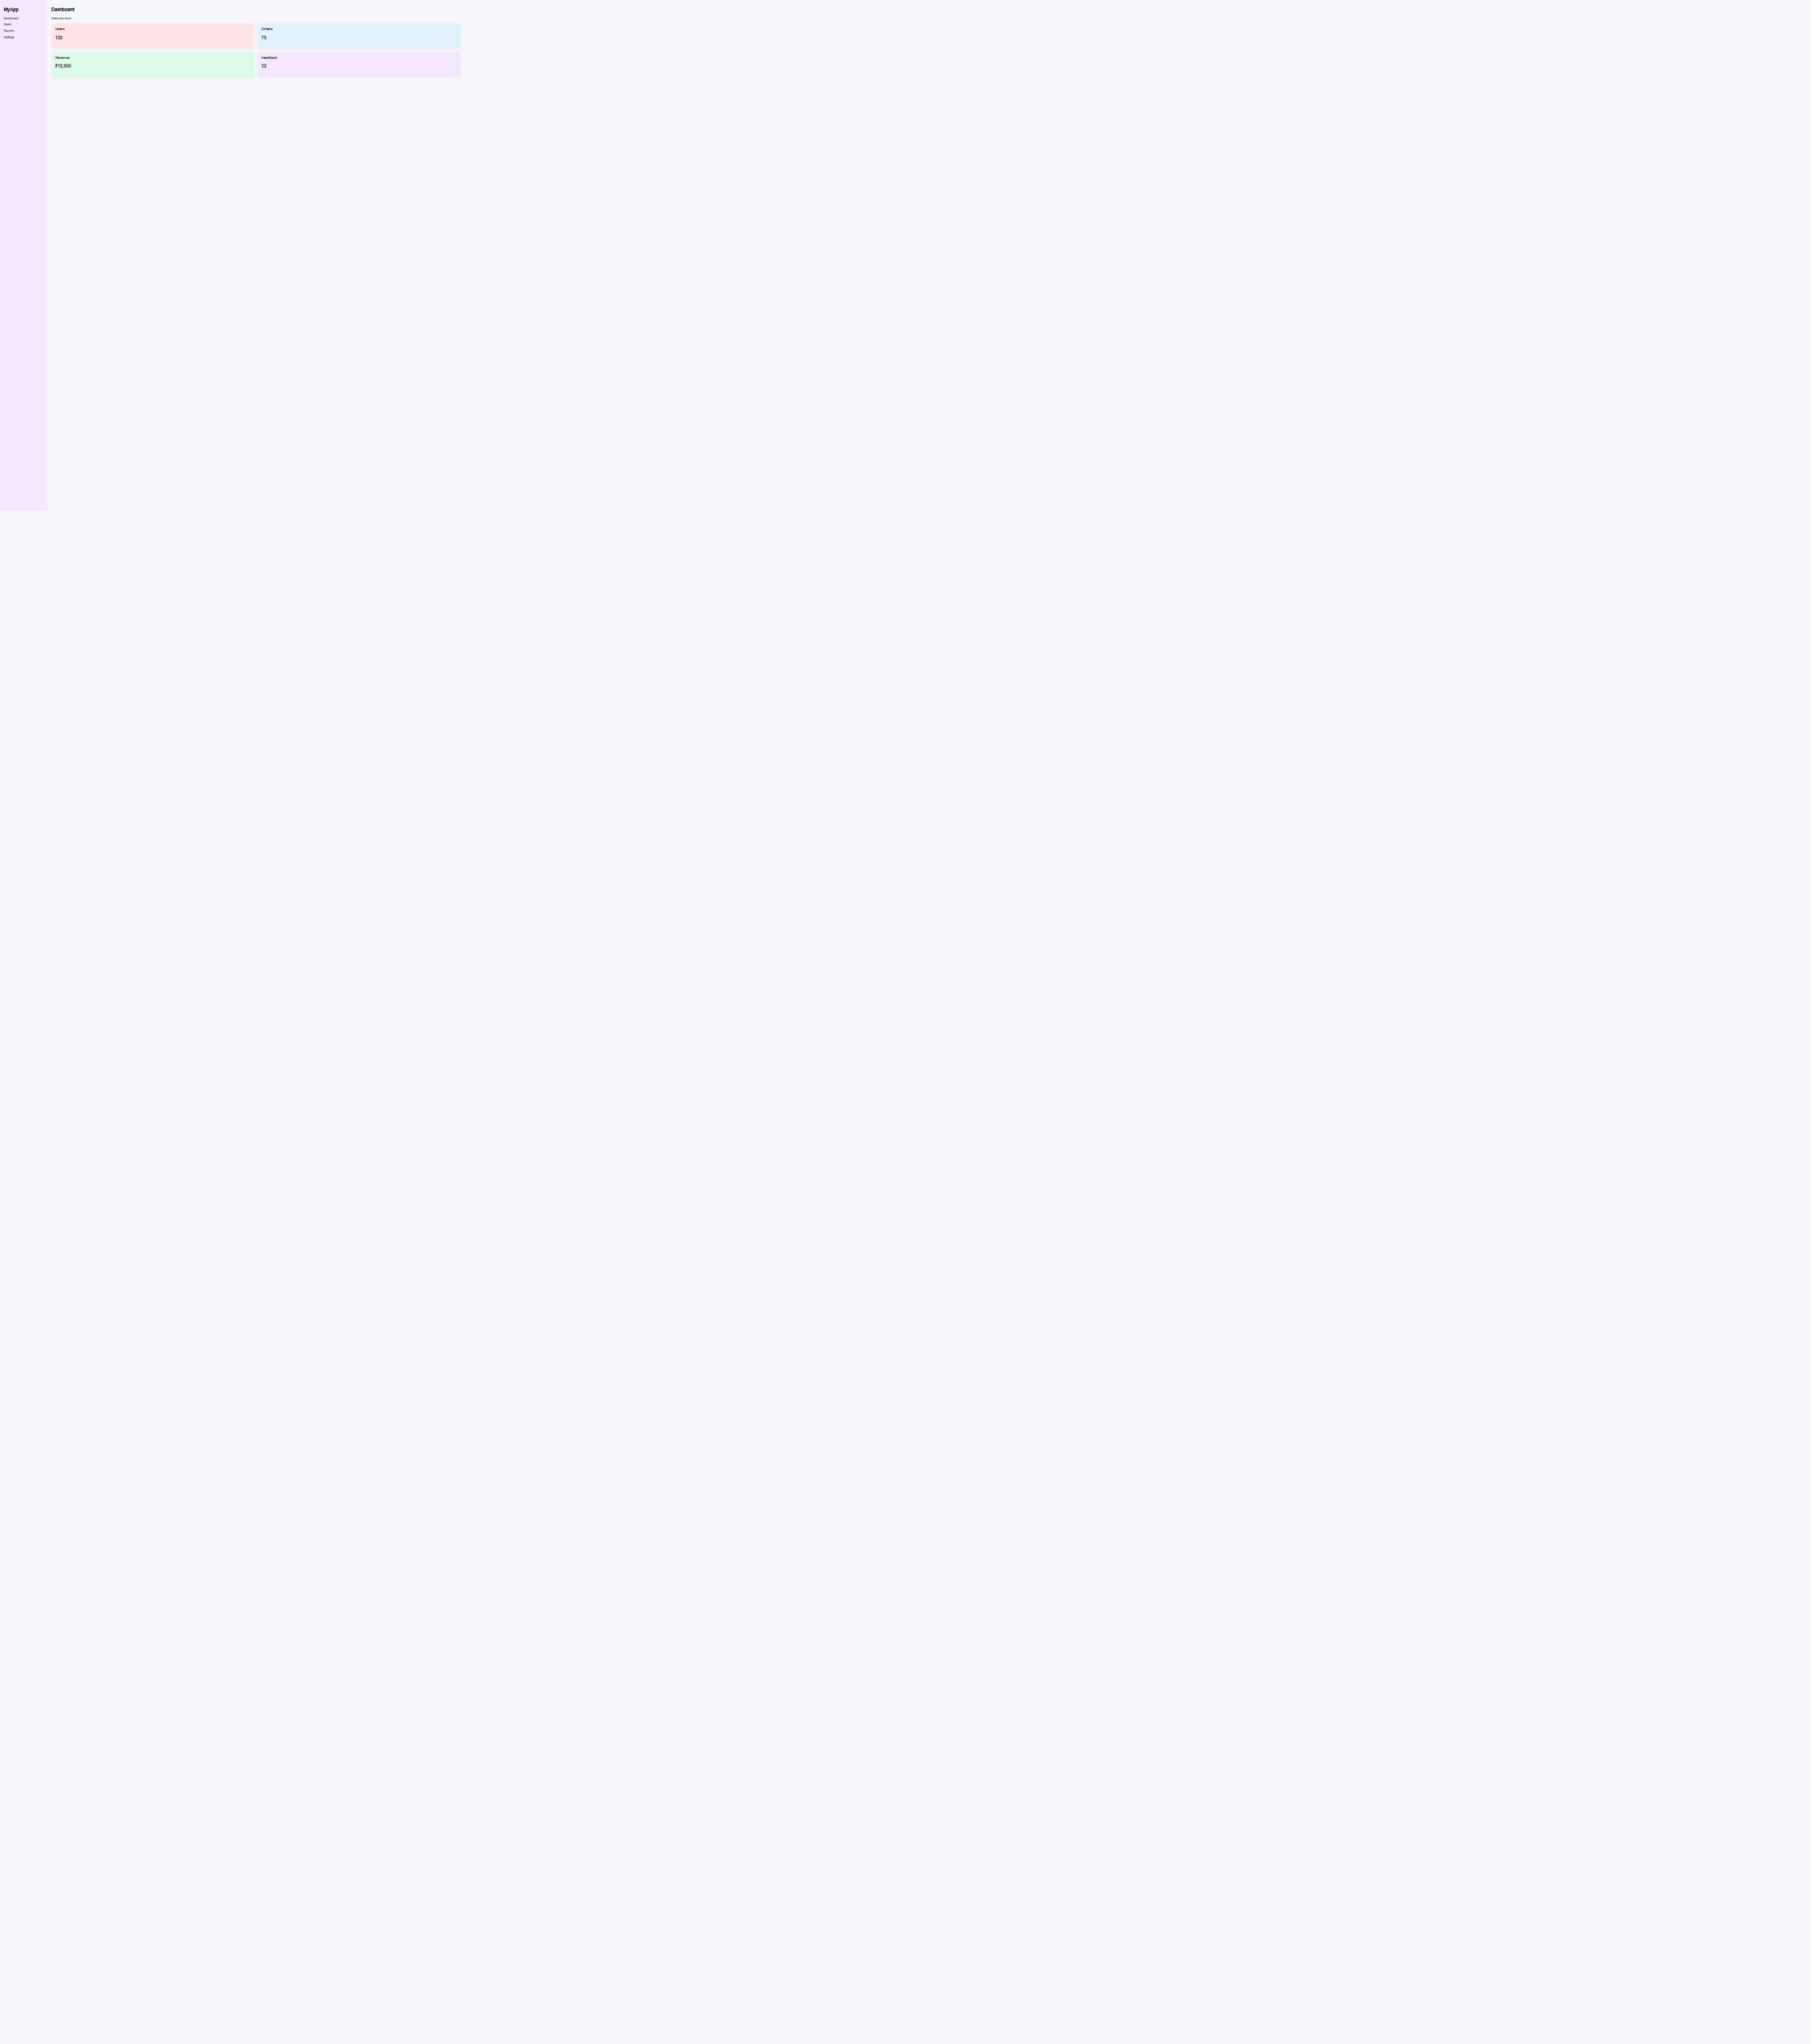
Output :

