WAD -Assignment 8
Create a simple Mobile Website using jQuery Mobile.
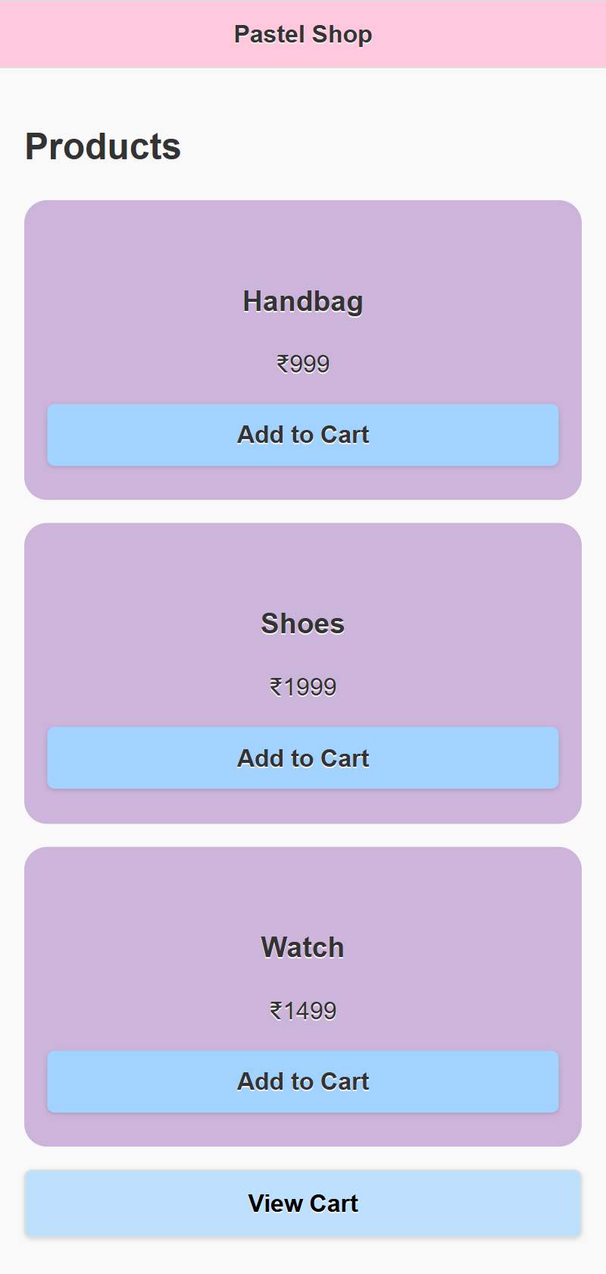
Output :
