WAD – Assignment 1b.
Write a JavaScript Program to get the user registration data and push to array/local storage with AJAX POST method and data list in new page.
Screenshots :
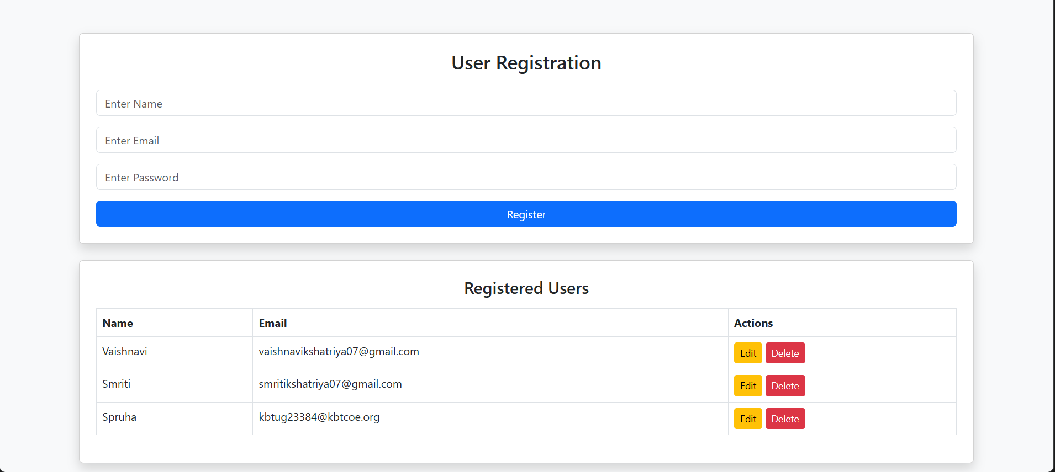

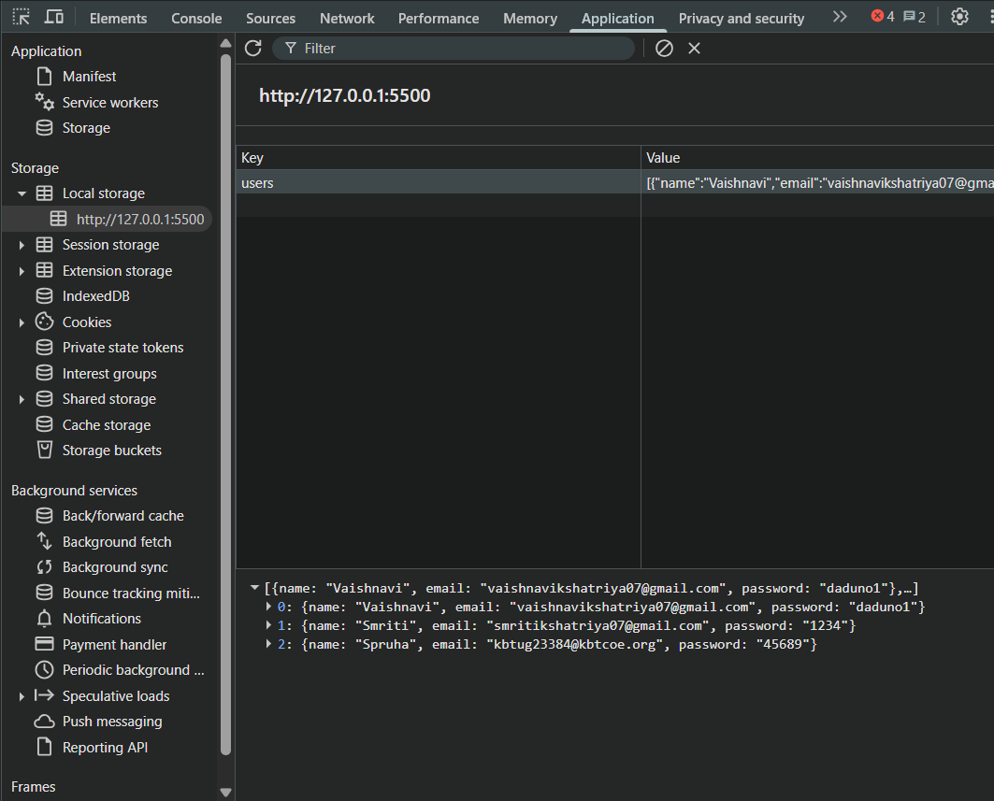

Ctrl+Shift+I -> Inspect
Ctrl+Shift+P-> Applications
Local Storage -> session

