The British College

COMPONENT 1

Advance Web Engineering

Student Name: Smriti Manandhar

Student id: C7202783

CONTENTS

* Configuration of Development Tools
* Debugging Tools
* OOP PHP

1. **Configuration Development Environment**

***XAMPP***

Start your browser and enter this url – <https://www.apachefriends.org/index.html>. Different versions of XAMPP are available. Locate the version you want to download and click on the download button. The download process will start immediately. Once the download process is complete, open the downloaded file which will be an executable file. Opening the executable file will start the installation process.

A setup wizard will appear automatically once you start running the executable file. On “Welcome to XAMPP” setup window click on next. On “Select Components” windows, you can check the components you want to install and uncheck the components you don’t want to install. Then, click next. Select the folder where you want the application files to be stored. Then, click next. The installation process in carried on and it may take few minutes to be completed. After the installation is complete, all the checked components will be unpacked into the selected folder. Then, by clicking on “Finish”, XAMPP will be successfully installed. At the end of the installation process, if you’ve clicked on “Do you want to start the Control Panel now?” then automatically XAMPP Control Panel will appear. If not, you can go to start menu, enter “Xampp Control Panel” and double click on it.

. 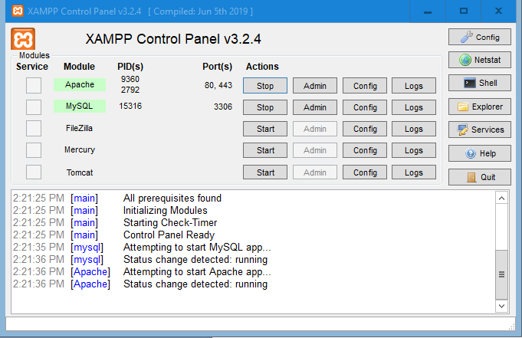

After starting Apache server and running localhost on your browser, the browser will display a page like this:

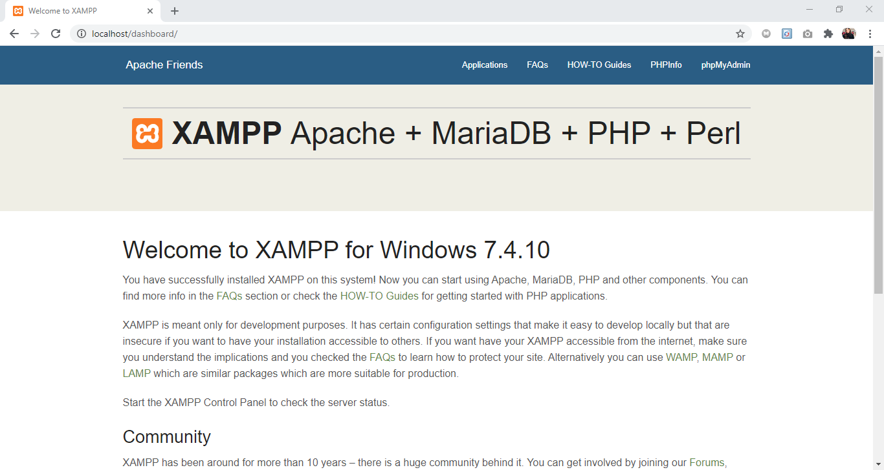

***VISUAL STUDIO CODE***

Download the Visual Studio Code for Windows OS from URL <https://code.visualstudio.com/download>. Once downloaded, open VSCodeUserSetup-{version}.exe and start the installation process. A desktop icon will be created if you’ve selected to do so during the installation process. After successfully installing the VS Code, click on the VS Code icon located in the desktop. Then, an interface like this will be displayed and you’re ready to start coding.

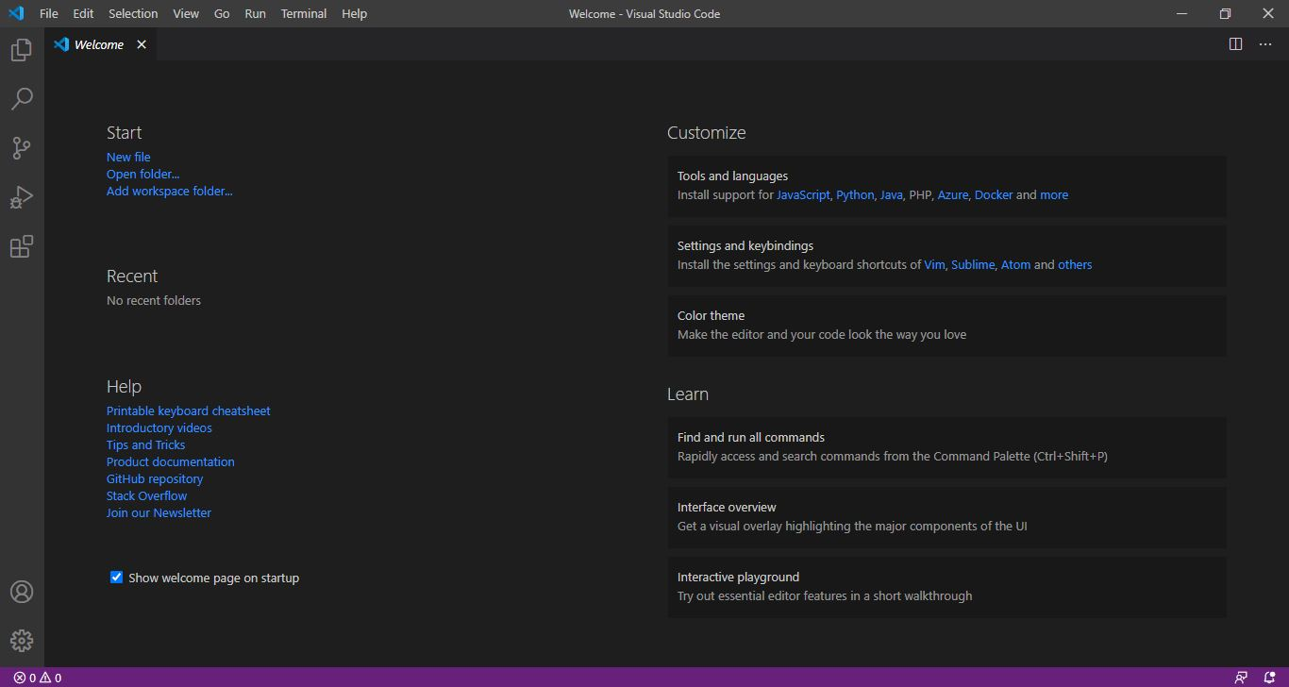

1. **Debugging tools**

***XDEBUG***

First, download Xdebug according to your specific PHP version. Then, place the downloaded dll file inside C:\xampp\php\ext. If you have Xampp installed in other drive then place the file in that specific location. Open your php.ini file located in C:\xampp\php\php.ini with any text editor. Once php.ini file is opened, first disable output_buffering (output_buffering: Off;). Then, create another section [XDebug] and add the following lines:

zend_extension= "c:\xampp\php\ext\php_xdebug-2.9.7-7.4-vc15-x86_64.dll"

xdebug.remote_autostart = 1

xdebug.remote_enable = 1

xdebug.remote_port = 9000

Restart Apache and open your PHPInfo page which will look something like this if you have successfully installed XDebug:

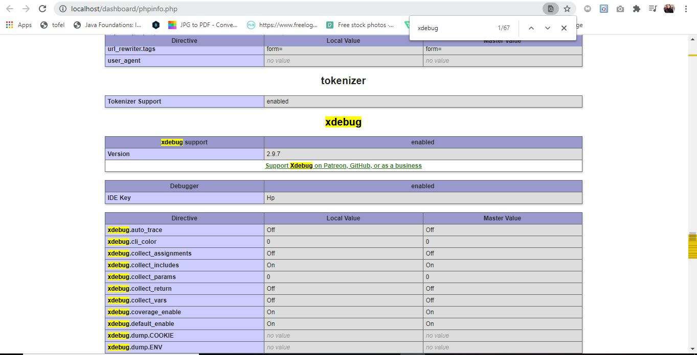

***XDebug for VSCode***

In order to debug PHP, you need to configure XDebug. First, install the extension “PHP Debug” by searching for it in the extension window. Once installed, reload the VSCode. Now click on Run tab and select add configuration. You should select the environment PHP. Once selected, VSCode will automatically add a launch.json file in the root directory. Add a line “runtimeExecutable”: “C:\\xampp\\php\\php.exe” after port. The path may vary if you have xampp installed in another drive. Then, launch.json file will look something like this:

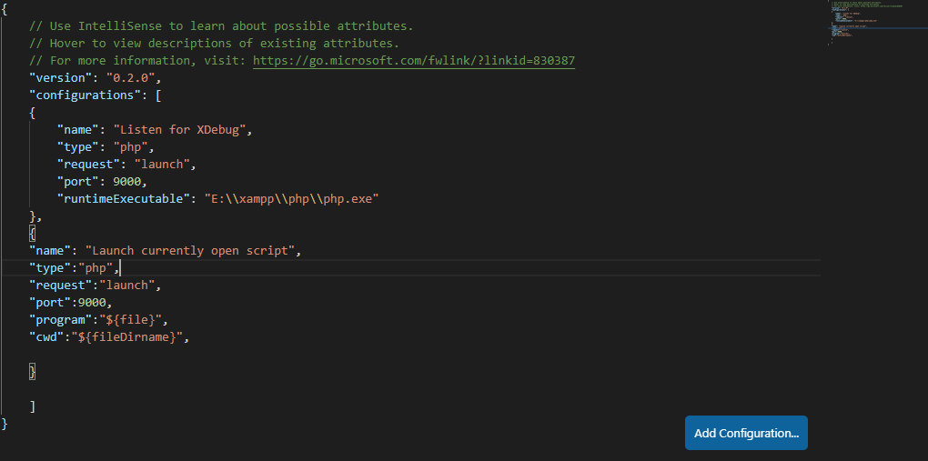

Now, open a file and click on the debug mode tab. Click on the green debug button. This will start the debugging.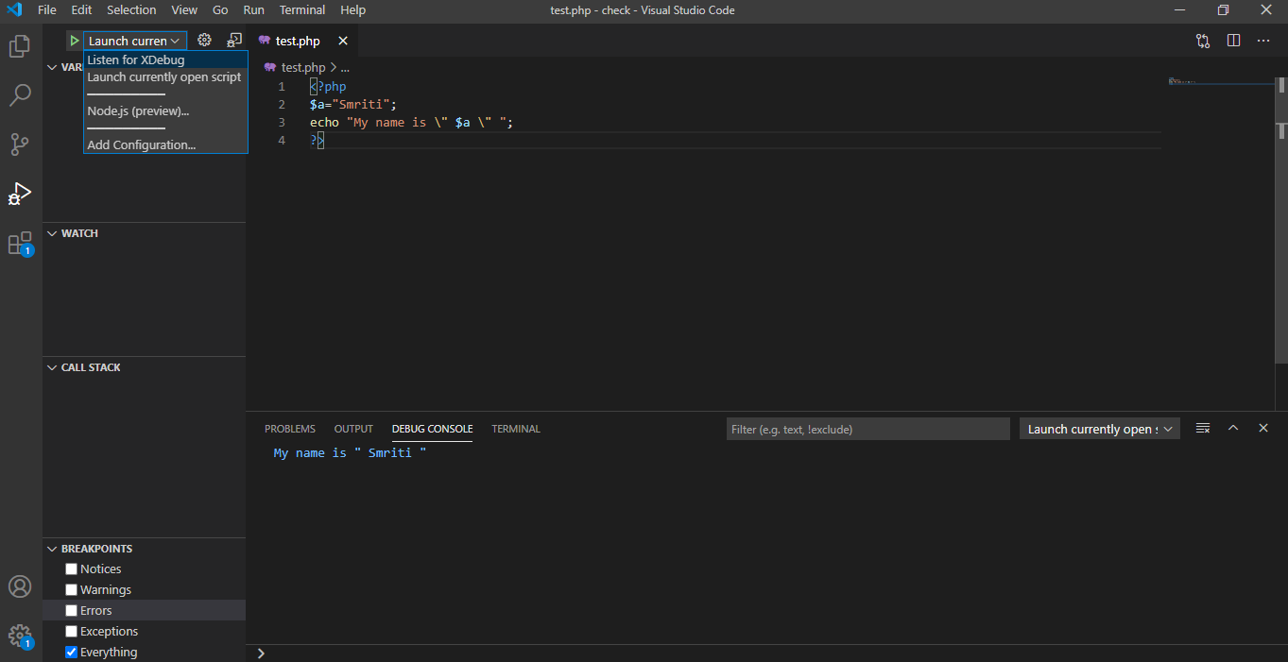

1. **OOP PHP**

The final output of the given exercise:

