ACD_BDD2_Session_11_Assignment_1

1. Created flumetwitter.conf and store it under /usr/local/acadgild/conf

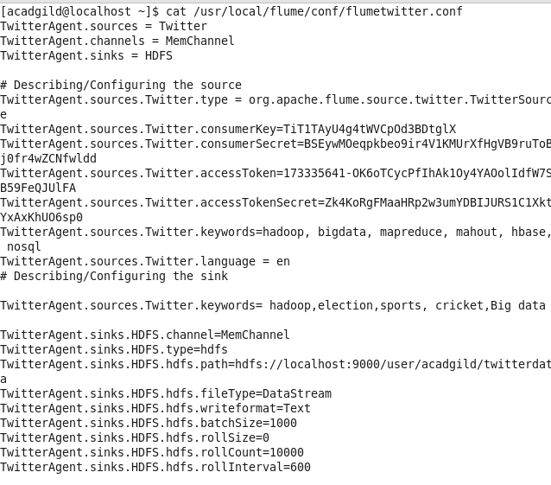

1. Configured flume conf file with consumer key and access token.



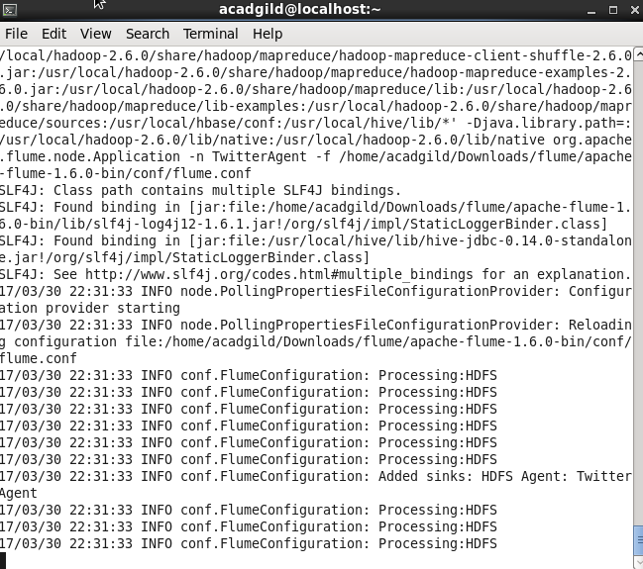

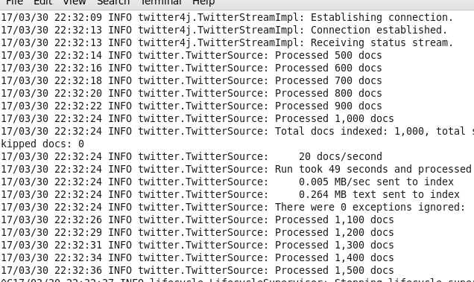

1. File created:

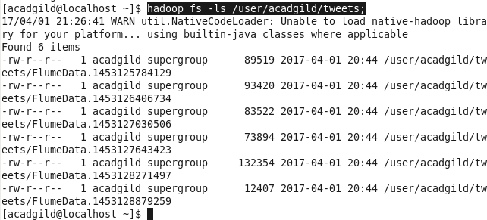

1. Inside file twitter data are present:

