ACD_BDD2_Session_14_Assignment_1

1st started hive and created database ‘custom’:

hive> create database custom;

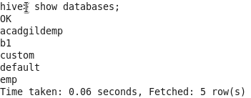

hive>use custom;  
hive>set.hive.cli.print.current.db=true;

Created Table ‘temp_data’:

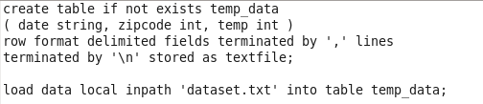

Output:

