ACD_BDD2_Session_14_Assignment_2

Now using the old dataset i.e.

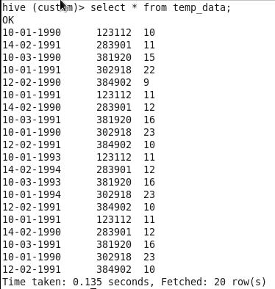

We will solve the 2nd assignment:

1. Fetch date and temperature from temp_data where zip code is greater than 300000 and less than 399999.

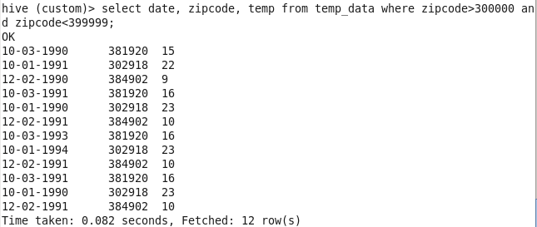

1. Calculate maximum temperature corresponding to every year from temp_data table.



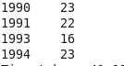

1. Calculate maximum temperature from temp_data table corresponding to those years which have at least 2 entries in the table.



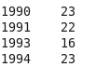

1. Create a view on the top of last query, name it temp_data_vw.

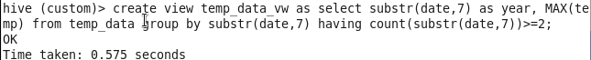

1. Export contents from temp_data_vw to a file in local file system, such that each file is '|' delimited.



