ACD_BDD2_Session_15_Assignment_2

1st created a table named ‘Olympics’ and loaded the data from ‘olympix_data.csv’ into this table:

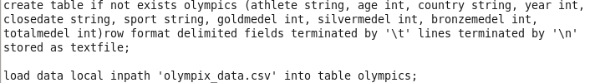

1) Write a Hive program to find the number of medals won by each country in swimming.



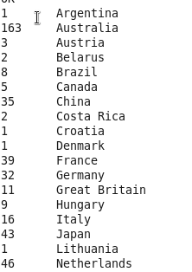 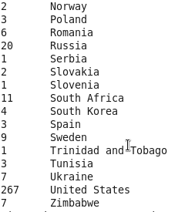

2) Write a Hive program to find the number of medals that India won year wise.



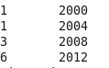

3) Write a Hive Program to find the total number of medals each country won.



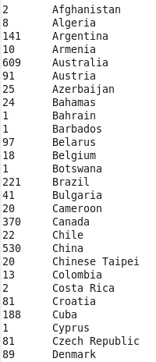 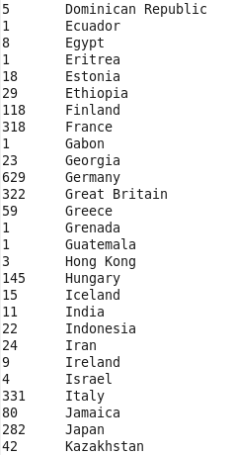

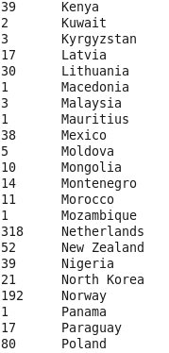 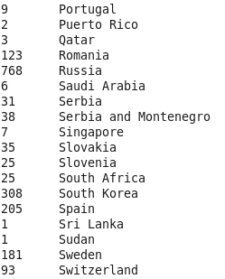 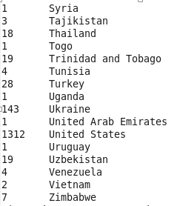

4) Write a Hive program to find the number of gold medals each country won.



