ACD_BDD2_Session_20_Assignment_1

Created Dataset “x.txt”

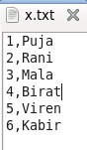

Load it to HDFS:

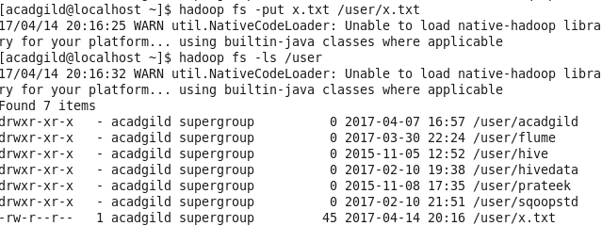

Now loading the data into mysql using sqoop:

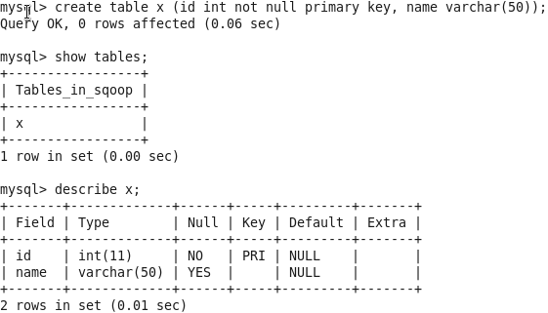



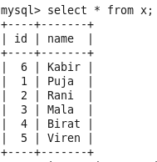

Now performing UPSERT:

2 new data inserted into the old file:

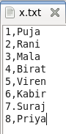

Shift it to HDFS:

