ACD_BDD2_Session_20_Assignment_2

Created table “company” in MySQL and inserted data into it:

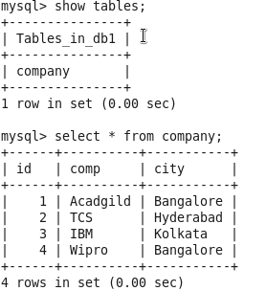

Now tried to import it on hive:



But after discussion with support team of acadgild:

My VM is not supporting or missing configuration issue with this thus this database not visible at hive table, Instead it is imported to hadoop:

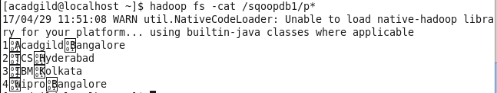

So I tried incremental import on it:

1st I inserted one more input into the table :

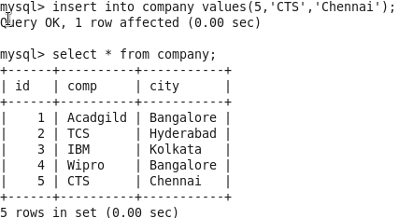

Then used incremental sqoop import:



But this new data not being retrieved:

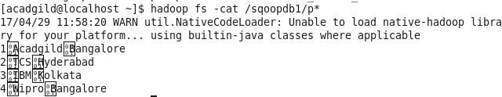

After checking with support team…there is issue with my VM, thus incremental load not happening.   
Even they have verified with the same code to other VM at their end…Cloudera, Hortonworks that works there too..just not in my VM.

So they gave confirmation that I’m good to submit this assignment in this way, as my codes are correct.