ACD_BDD2_Session_3_Assignment_1_Main

**Task 1:**

Write a Java program, to take an HDFS Path as input and display all the files and sub-directories in that HDFS path.

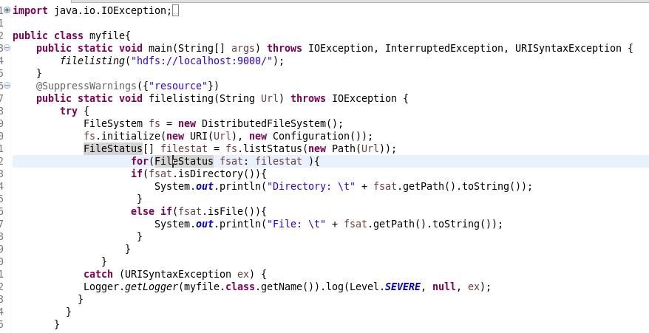

Output:

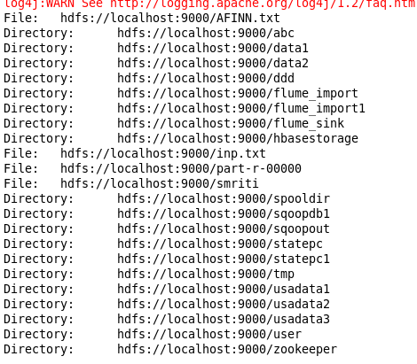

**Task 2:**

Modify the previous program to list all the files and sub-directories in the HDFS path recursively.

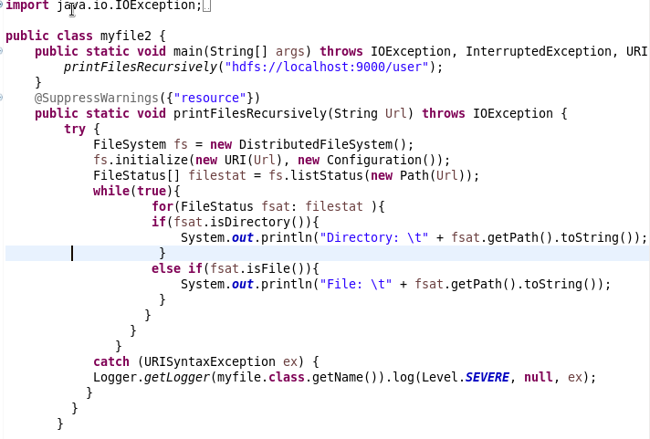

Output**:**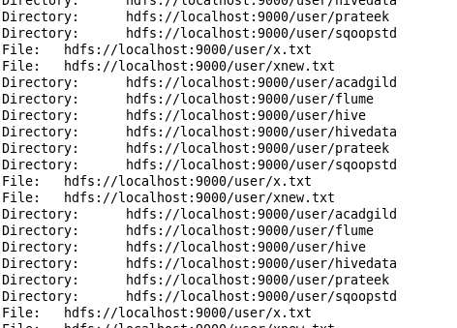

**Task 3:**

Modify the previous program to take multiple HDFS paths (separated by space) and list all the files and sub-directories in those HDFS paths recursively.

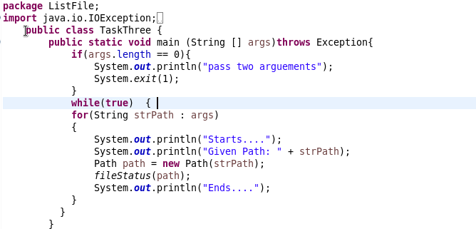

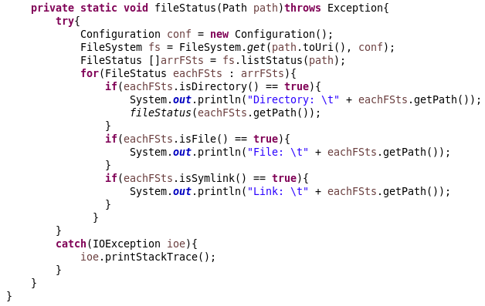

Output**:**

