ACD_BDD2_Session_3_Assignment_1_Main

**Task 4:   
Write a java program to list down all the files inside a directory and its sub-directories who have last modified timestamp between the start_ts and end_ts passed as an argument. The default value of start_ts is 0 and for end_ts is infinite.**

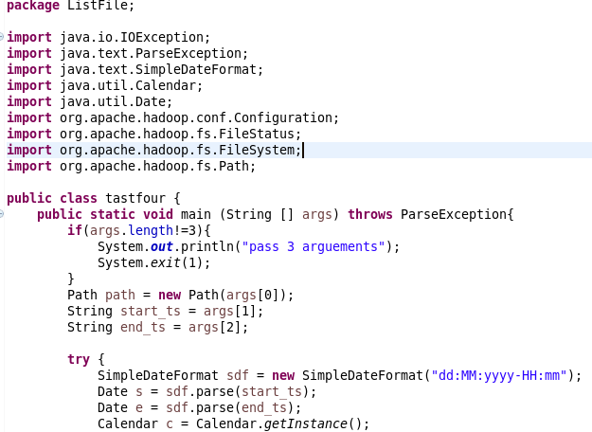

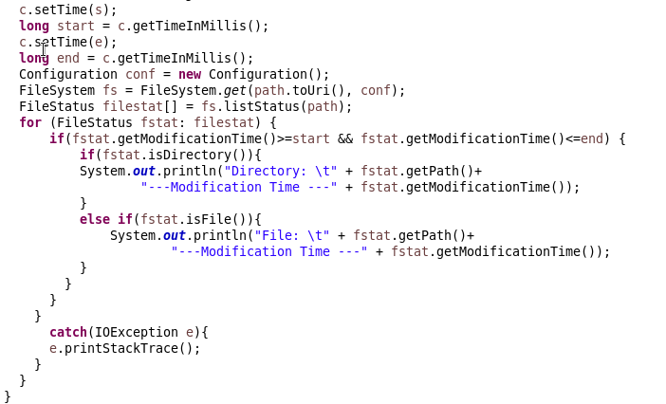

**Output:**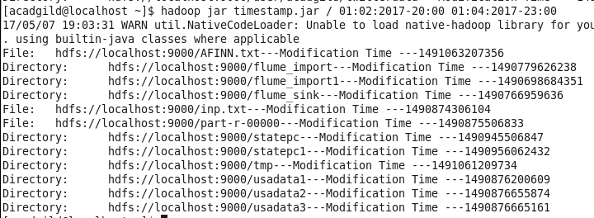

**Task 5:  
Write a Java program to display the content of a file in HDFS on screen.**

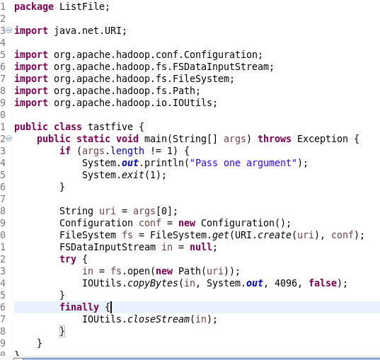

**Output:**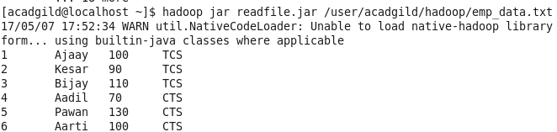

**Task 6:  
Write a Java program to copy a file from local filesystem to HDFS**.

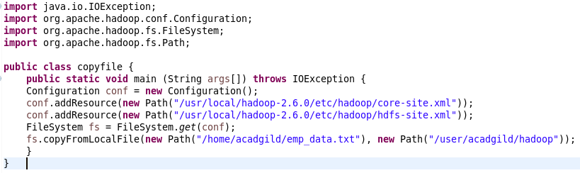

**Output:**