ACD_BDD2_Session_4_Assignment_1

**Task 1:**

**1. Write a Map Reduce program to filter out the invalid records.**

**The output of this program will act as input for subsequent tasks.**

**Map only job will fit for this context.**

**Mapper class:**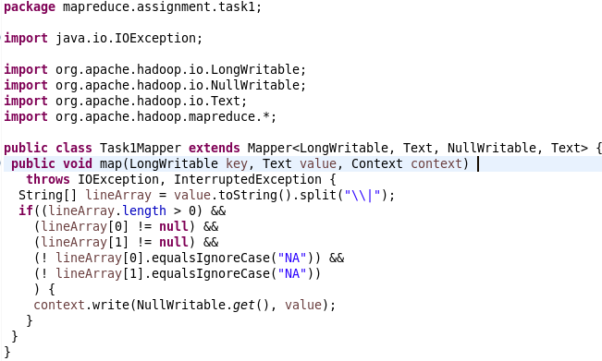

**Driver Class:**  
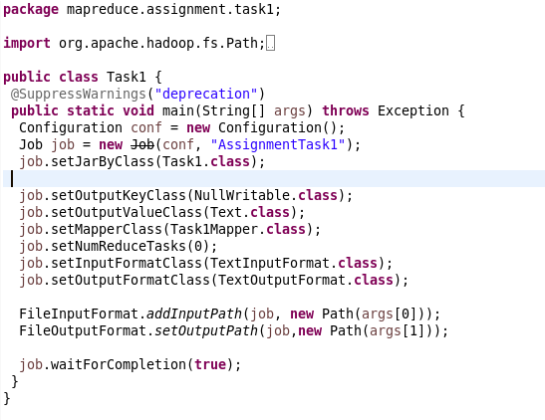

**Output:**