ACD_BDD2_Session_4_Assignment_2

**Task 2 & 3:   
i)Write a Map Reduce program to calculate the total units sold for each Company.  
ii)Write a Map Reduce program to calculate the total units sold in each state for Onida company.  
  
Driver Class:**  
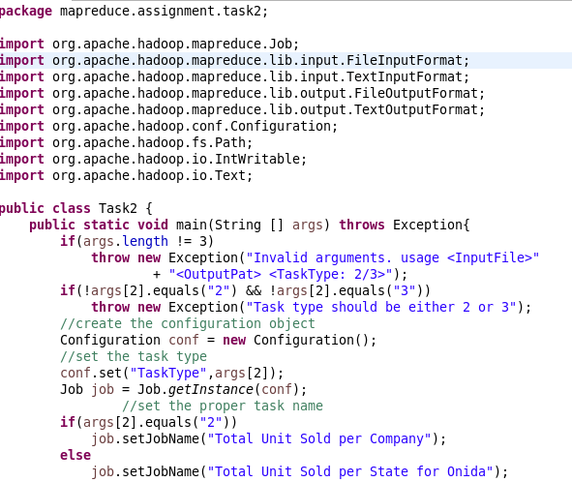  
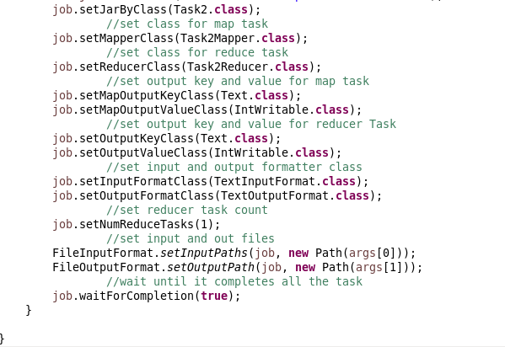

**Mapper Class:**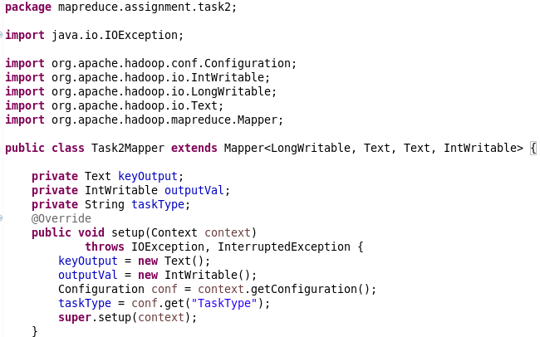  
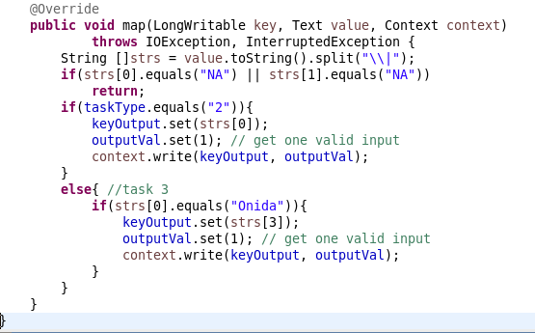

**Reducer Class:**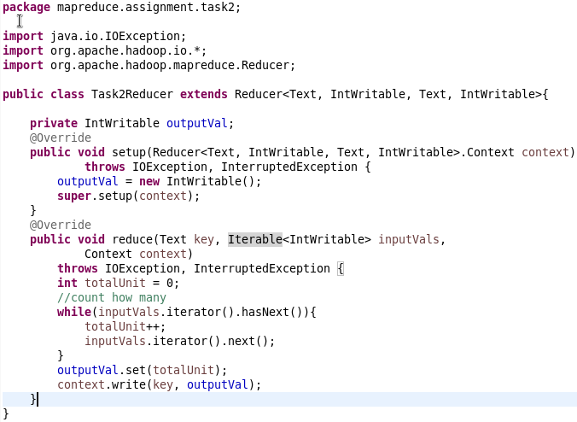  
  
**Output for Task 2:**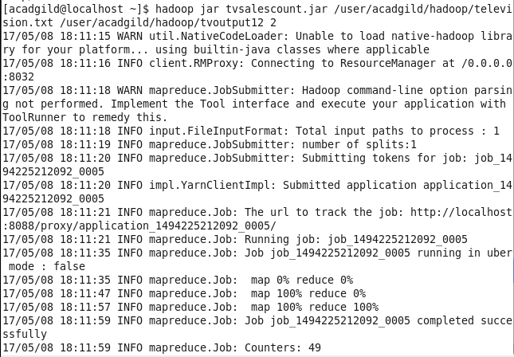

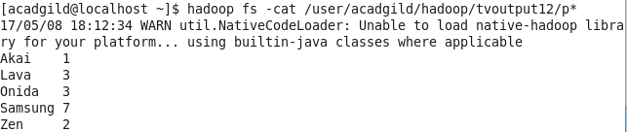

**Output for Task 3:**