ACD_BDD2_Session_9_Assignment_1_Main
- What is the total amount of petrol in volume sold by every distributer?

Output:
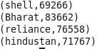

- Which are the top 10 distributers ID's for selling petrol? Also display the amount of petrol sold in volume.
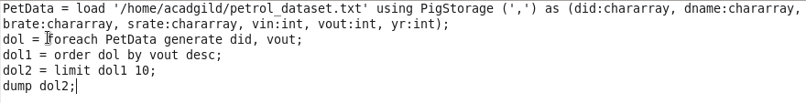

Output:
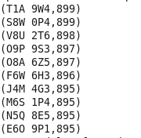

- List 10 years where consumption of petrol is more with the distributer id who sold it.
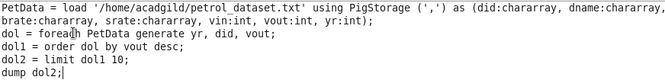

Output:
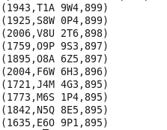

- Find the distributer name who sold petrol in least amount
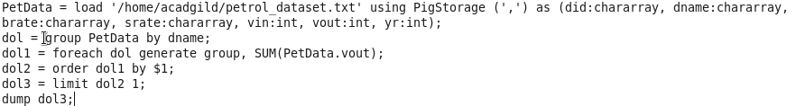

Output:

