ACD_BDD2_Session_9_Assignment_2_Main

1. **Find the number of students who scored less than 5(50%).**

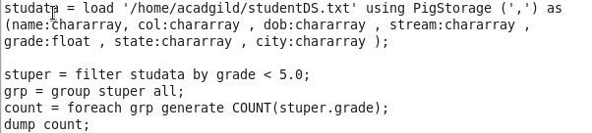

1. **List the name of students who are from Alaska.**

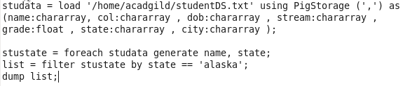

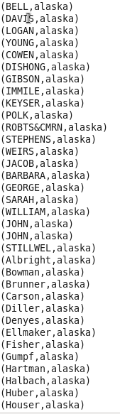 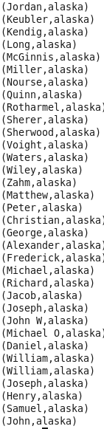

1. **How many government collages are there in Alabama?**

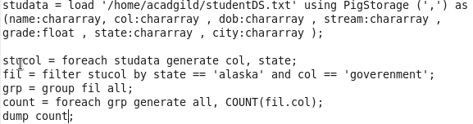

1. **List the name of students who are from Oregon and persuing BE.**

