ACD_BDD_Session_18_Assignment_1_Main

**Create a HBase table 'customer' with one column family 'details'.**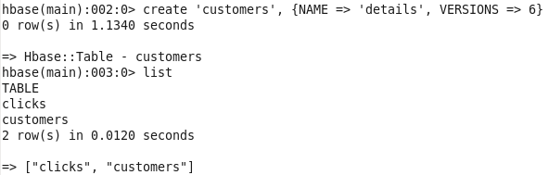

**Write a shells script that loads the content of the file customers.dat in the HBase table.**

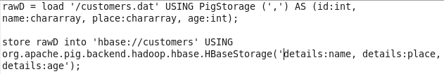

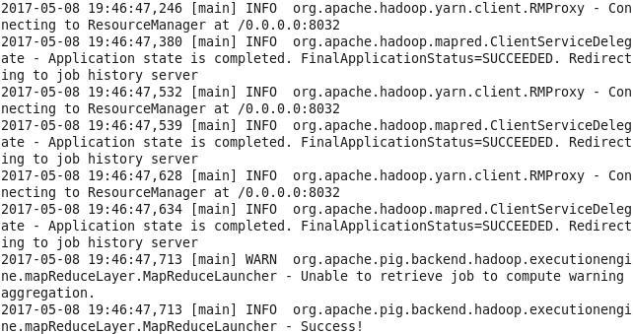

**Output (The structure of file looks like: id, name, location, age):**