ACD_BDD_Session_19_Assignment_1_Main

**1. Create a customer_hive table on the top of 'customer' table created in the last session.  
 Calculate the maximum and minimum age of customer from the table.  
  
Hbase table ‘customers’:**  
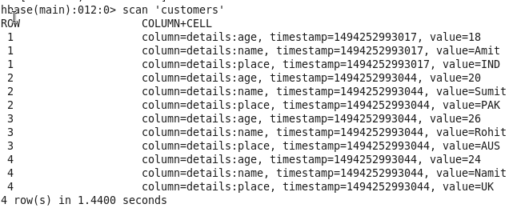

**Creating Hive external table using HiveQL by fetching data from Hbase:**  
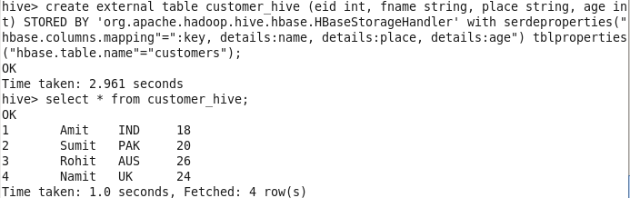  
  
**Max age:**  
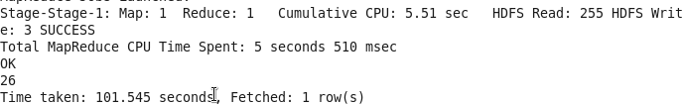  
  
**Min age:**  
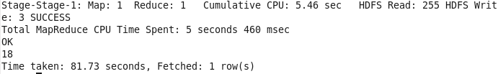

**2. Access the customer hbase table from pig and compute the maximum and minimum age**

**among all the customers along with their corresponding name and id.**  
**Hbase table ‘customers’:**  
  
  
**Creating ‘customers’ table in Grunt shell in Pig fetching from Hbase:**  
  
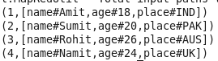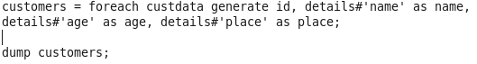  
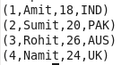  
  
**Max age:**  
  
  
**Min age:**  
  
