LEAN SIX SIGMA GREEN BELT PROJECT
Title: Reducing pH Variability in a Neutralization Process Using Lean Six Sigma

Project Overview:
This project applies the Lean Six Sigma DMAIC framework to reduce outlet pH variability in a continuous acid–base neutralization process operated in a stirred tank reactor. pH neutralization is a common yet challenging unit operation due to its nonlinear behavior near neutrality, where small disturbances can lead to significant deviations in the output pH. The objective of this study is to identify the key drivers of pH variability, improve process capability relative to customer-defined specifications, and establish control mechanisms to sustain the gains. The project is conducted as a Green Belt–level, data-driven study using simulated data and literature-supported operating ranges to demonstrate methodology rather than full-scale industrial implementation.

- DEFINE PHASE

  - Background & Motivation
pH neutralization is a fundamental unit operation widely used in chemical manufacturing, pharmaceutical production, and wastewater treatment to ensure compliance with quality and environmental requirements. This operation is commonly carried out in continuous stirred tank reactors (CSTRs), where acidic and basic streams are mixed to achieve a target pH near neutrality. Although the underlying chemistry is straightforward, pH control near the neutral point is inherently challenging due to the highly nonlinear nature of the titration curve, where small disturbances in flow rate, reagent concentration, or mixing intensity can cause large deviations in outlet pH. In industrial practice, such variability can result in off-specification batches, increased chemical consumption, greater operator intervention, and potential environmental non-compliance. From a quality and process-performance perspective, this variability represents a significant source of defects and waste. Consequently, applying a Lean Six Sigma framework provides a structured, data-driven approach to quantify process variation, identify key contributors to pH fluctuations, and improve process capability, making pH neutralization an ideal candidate for a Green Belt–level improvement project.

  - Voice of Customer (VoC)
The primary customers of the acid–base neutralization process include internal operations and quality teams, as well as external environmental and regulatory stakeholders responsible for ensuring compliant discharge conditions. From the customer perspective, the process is expected to consistently deliver an outlet pH close to neutrality with minimal variability and minimal need for manual intervention. Deviations from acceptable pH limits are undesirable because they lead to off-spec material, increased chemical usage for rework, greater operator involvement, and potential environmental non-compliance. Consequently, consistency and reliability of outlet pH are critical customer requirements, making variability reduction a key priority for process improvement.

  - Critical-to-Quality (CTQ) Characteristic
Based on the Voice of the Customer analysis, outlet pH was identified as the Critical-to-Quality (CTQ) characteristic for this project. The target outlet pH was defined as 7.0, corresponding to neutral conditions. In accordance with typical industrial and regulatory expectations, acceptable specification limits were established at 6.7 (LSL) and 7.3 (USL). Process performance is therefore evaluated based on its ability to consistently operate within this specification range while maintaining minimal variability around the target value.

  - Problem Statement
The current neutralization process exhibits excessive variability in outlet pH relative to the defined specification limits of 6.7 to 7.3. Although the process mean is approximately centered near the target pH of 7.0, the observed spread of the data results in a significant number of off-specification observations. This variability leads to inconsistent process performance, increased chemical consumption, and the need for frequent operator intervention. Before this project, the extent and drivers of pH variability had not been quantitatively assessed, limiting the ability to systematically improve process capability.

  - Process Overview & SIPOC
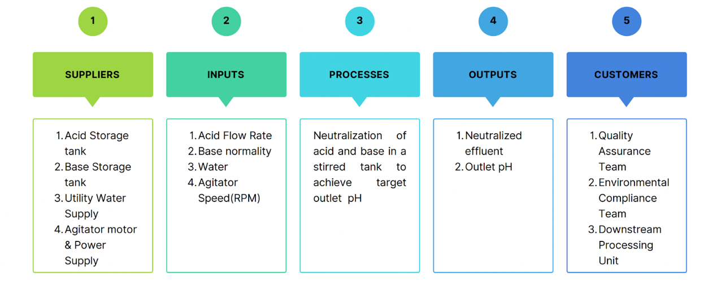
The process under study is a continuous acid–base neutralization system operated in a stirred tank reactor. An acidic feed stream and a basic feed stream are introduced into the reactor, where agitation promotes mixing and reaction to produce an outlet stream with a pH near neutrality. A SIPOC (Suppliers, Inputs, Process, Outputs, Customers) diagram was developed to provide a high-level overview of the process and to clearly define process boundaries. The SIPOC identifies acid and base feed streams as key inputs, reactor mixing and residence time as core process elements, and outlet pH as the primary output delivered to internal and external customers. This high-level mapping supports alignment between customer requirements and the process variables evaluated in subsequent phases.
Fig 1: SIPOC Diagram of the Acid–Base Neutralization Process

  - Project Scope & Constraints
The scope of this project is limited to reducing outlet pH variability in a laboratory-scale continuous neutralization process through the application of Lean Six Sigma tools. The analysis focuses on three controllable process variables: acid flow rate, base normality, and agitator speed. Steady-state operation is assumed throughout the study, and improvements are evaluated using statistical analysis and confirmation runs. Measurement system variability associated with the pH probe is assumed to be negligible relative to process variation. Advanced controller tuning, equipment redesign, sensor hardware modification, and scale-up considerations are outside the scope of this project. The study is intended to demonstrate Lean Six Sigma methodology using representative, literature-supported operating ranges rather than real-time industrial plant data.

- MEASURE PHASE

  - Baseline Operating Conditions
To quantify current process performance, baseline data were collected under steady-state operating conditions representative of normal operation. The acid flow rate was maintained at 6.0 L/min, base normality at 0.75 N, and agitator speed at 300 RPM. These mid-range operating conditions were selected to reflect typical neutralization operation without intentional optimization, providing a realistic reference point for assessing process variability before improvement efforts.

  - Data Collection and Measurement Approach
A total of 30 individual outlet pH measurements were collected under baseline conditions to characterize process performance and enable statistical analysis. Outlet pH was selected as the response variable due to its identification as the Critical-to-Quality (CTQ) characteristic in the Define phase. Measurements were recorded after the system reached steady-state to minimize transient effects and ensure consistency across observations.
The pH measurement system was assumed to be sufficiently accurate and precise relative to the process variation and specification width. Given the high resolution and common industrial use of laboratory pH probes, measurement system variability was considered negligible for this study. Therefore, a formal measurement system analysis (MSA) was not conducted.

  - Baseline Data Summary & Distribution Assessment
Descriptive statistics were generated to summarize baseline outlet pH performance. The baseline data exhibited a mean outlet pH of approximately 6.98, which is close to the target value of 7.0, indicating acceptable centering of the process. However, the standard deviation of approximately 0.315 suggested substantial variability relative to the allowable specification range.
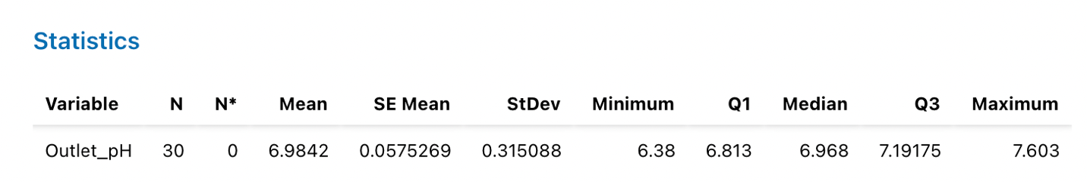
Fig 2: Descriptive Statistics of the baseline outlet pH

Normality of the baseline data was evaluated using graphical methods and the Anderson–Darling test. The resulting p-value exceeded the standard significance level of 0.05, indicating that the outlet pH data could reasonably be modeled using a normal distribution. This validation supported the use of parametric statistical tools such as capability analysis and control charts in subsequent analysis.
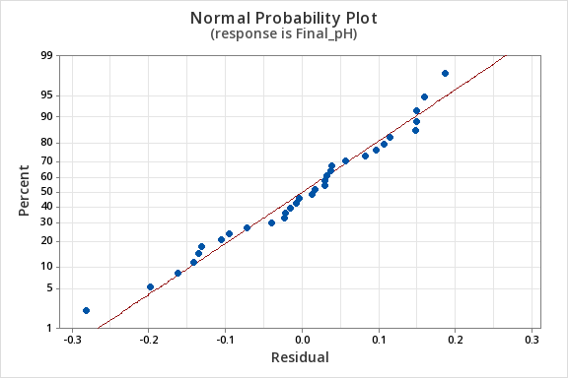

Fig 3: Normal probability plot for baseline outlet pH

  - Baseline Process Capability Analysis
Process capability analysis was conducted using the defined specification limits of 6.7 (LSL) and 7.3 (USL) to assess the ability of the baseline process to meet customer requirements. The resulting Cp and Cpk values were significantly below 1.0, indicating that the process was not capable of consistently operating within specifications. Although the process mean was near the target value, excessive variability resulted in a high proportion of observations outside the acceptable range.
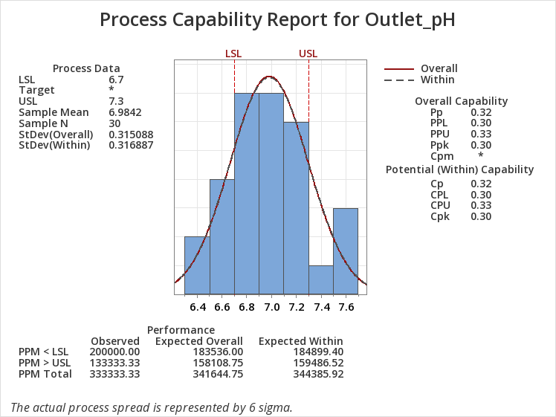

Fig 4: Baseline Process Capability Analysis
These results confirm that variability, rather than mean offset, is the primary contributor to poor process performance and reinforce the need for focused improvement efforts.

  - Baseline Process Stability Assessment
An Individuals–Moving Range (I–MR) control chart was constructed to evaluate baseline process stability over time. While no extreme out-of-control signals were observed, the magnitude of variation within the control limits was large, consistent with the low capability indices. The control chart results indicate that although the process may be statistically stable, it is operating with excessive common-cause variation that prevents consistent specification compliance.
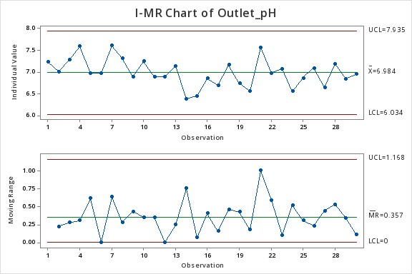

Fig 5: I–MR Control Chart for Baseline Outlet pH

  - Key Findings
The Measure phase established a quantitative baseline for outlet pH performance and confirmed that the process is centered near the target but exhibits unacceptable variability. Capability analysis demonstrated that the process is not capable of meeting customer specifications under current operating conditions. These findings provided a clear, data-driven justification for advancing to the Analyze phase to identify the root causes of pH variability.

- ANALYZE PHASE

  - Objective of Analyze Phase
The objective of the Analyze phase is to identify and quantify the key process variables responsible for outlet pH variability and to distinguish statistically significant factors from those with negligible impact. Building on the baseline variability established in the Measure phase, this phase applies structured root cause analysis and statistical experimentation to isolate the dominant drivers of pH fluctuations and understand their interactions.

  - Cause-and-Effect Analysis
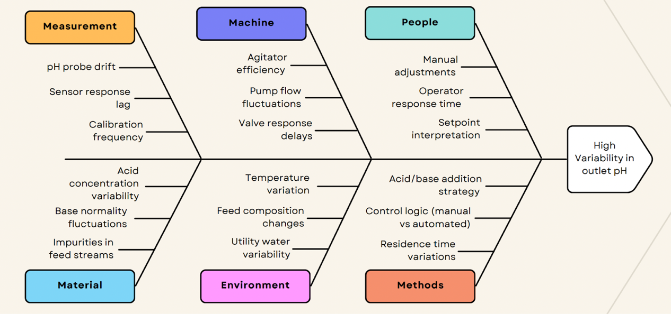
A cause-and-effect (fishbone) diagram was developed to systematically identify potential sources of outlet pH variability. Causes were grouped into six major categories: Measurement, Machine, Material, Methods, Environment, and People. Potential contributors included acid flow rate fluctuations, base normality variability, agitator efficiency, residence time variation, sensor response lag, and operator interventions.

Fig 6: Cause-and-Effect (Fishbone) Diagram for pH Variability

This qualitative analysis highlighted acid flow rate, base normality, and mixing intensity (agitator speed) as the most plausible controllable factors influencing pH variability. These factors were selected for further quantitative evaluation using a designed experiment.

  - Design of Experiments (DoE) Strategy
A full factorial design of experiments was conducted to statistically evaluate the effects of key process variables on outlet pH. Three controllable factors were selected based on the cause-and-effect analysis:
Acid flow rate (A): 5 and 7 L/min
Base normality (B): 0.6 and 0.9 N
Agitator speed (C): 200 and 400 RPM

A 2³ full factorial design was implemented with multiple replicates and randomized run order to minimize bias and satisfy ANOVA assumptions. Outlet pH was recorded as the response variable. Replication enabled estimation of experimental error and improved confidence in effect significance.

  - Analysis of Variance (ANOVA)
Analysis of variance was performed to determine the statistical significance of main effects and interactions.
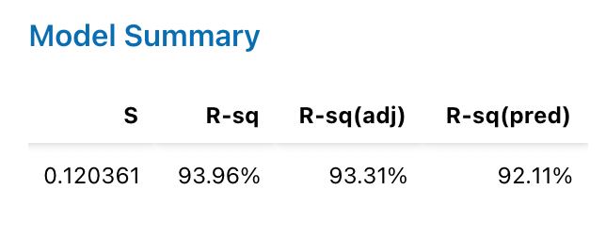
Fig 7: Model Summary for DOE Regression
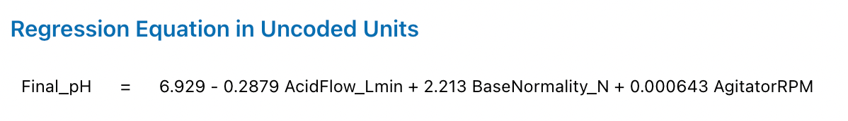
Fig 8: DOE Regression Equation

The overall regression model was highly significant (p < 0.001), with an R² value of approximately 94%, indicating that the selected factors explain most of the observed pH variability.

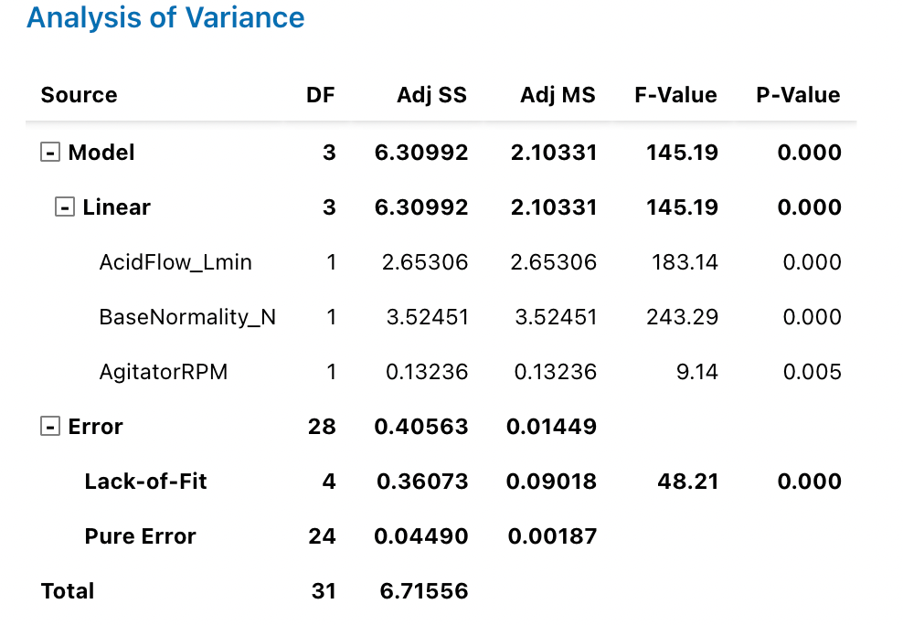

Fig 9: ANOVA Table for Full Factorial Design

The ANOVA results revealed that:
- Base normality (B) was the most significant factor influencing outlet pH (p < 0.001).
- Acid flow rate (A) also had a strong and statistically significant effect (p < 0.001).
- Agitator speed (C) had a statistically significant but comparatively smaller effect (p ≈ 0.005).
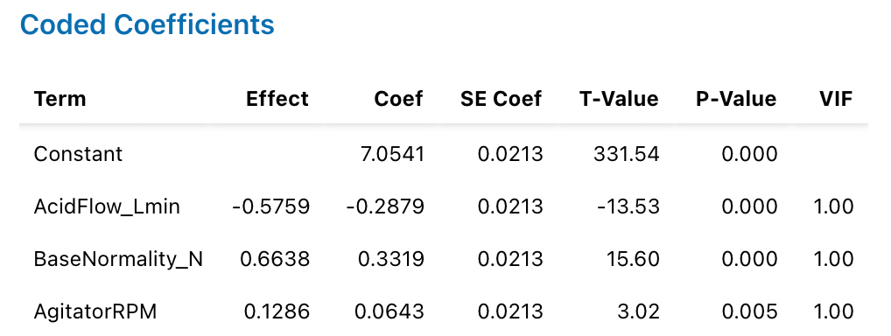

Fig 10: Variance Inflation Factors (VIF)

Variance inflation factors (VIF ≈ 1) confirmed the absence of multicollinearity among the factors, validating the reliability of the regression coefficients.
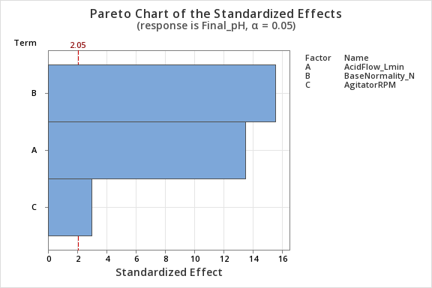

Fig 11: Pareto Chart of Standardized Effects

The Pareto chart indicates that base normality and acid flow rate are the most statistically significant factors influencing outlet pH, with standardized effects exceeding the significance threshold at α = 0.05. In contrast, agitator speed exhibits a comparatively smaller effect, confirming its secondary role in pH variability relative to reagent flow and concentration.

  - Main Effect and Effect Direction
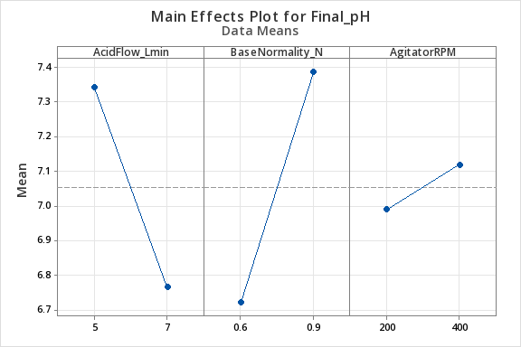

Fig 12: Main Effects Plot for Outlet pH

Main effects analysis indicated clear and interpretable trends:
- Increasing base normality increased outlet pH.
- Increasing acid flow rate decreased outlet pH.
- Increasing agitator speed slightly improved pH consistency, likely due to enhanced mixing and reduced local concentration gradients.

The direction and magnitude of these effects are consistent with the underlying acid–base neutralization chemistry and reactor hydrodynamics.

  - Interaction Effects
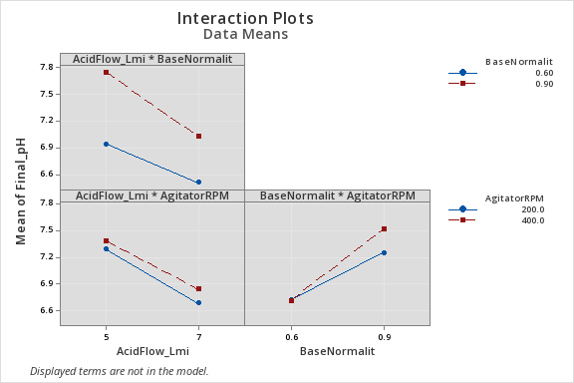

Fig 13: Interaction Plots for Outlet pH

Interaction plots revealed a significant interaction between acid flow rate and base normality (A×B). The non-parallel nature of the interaction lines indicates that the effect of acid flow rate on outlet pH depends strongly on the base normality level. This interaction explains why simple one-factor-at-a-time adjustments are insufficient to control pH variability near the neutral point.

Interactions involving agitator speed were comparatively weak, suggesting that while mixing affects consistency, it does not dominate pH behavior relative to reagent flow and concentration.

  - Key Findings
The Analyze phase conclusively demonstrated that outlet pH variability is primarily driven by acid flow rate and base normality, with a statistically significant interaction between the two. Agitator speed plays a secondary role by influencing mixing quality rather than directly shifting pH.

These findings confirm that variability in chemical addition, rather than measurement noise or operator behavior, is the dominant source of pH fluctuations. The results provide a clear, data-driven basis for selecting improved operating conditions in the Improve phase to reduce variability and enhance process capability.

- IMPROVE PHASE

  - Objective of Improve Phase
The objective of the Improve phase is to determine and validate operating conditions that reduce outlet pH variability and improve process capability while maintaining the target pH near neutrality. Using the statistically significant factors identified in the Analyze phase, optimal factor settings were selected to minimize variability and ensure consistent, specification-compliant performance. The effectiveness of these improvements was verified through confirmation runs and comparative statistical analysis.

  - Selection of Optimal Operating Conditions
Based on the Analyze phase results, acid flow rate and base normality were identified as the dominant factors influencing outlet pH, with a statistically significant interaction between the two, while agitator speed exhibited a secondary effect associated with mixing consistency. Using the main effects and interaction plots, an operating region was selected to stabilize the outlet pH near the target value of 7.0 while minimizing variability. This region corresponds to a moderate acid flow rate within the tested range, a balanced base normality that offsets acid addition without overshooting, and a higher agitator speed to ensure uniform mixing. These operating conditions were chosen to reduce the process sensitivity to small disturbances in reagent flow and concentration, thereby promoting robust neutralization behavior and consistent pH control rather than merely shifting the process mean.

  - Confirmation Run and Process Performance Validation
A confirmation run was conducted at the selected operating conditions to validate the improvements predicted during the Analyze phase. Multiple outlet pH observations were collected under steady-state operation to assess process performance after implementation of the selected factor settings.

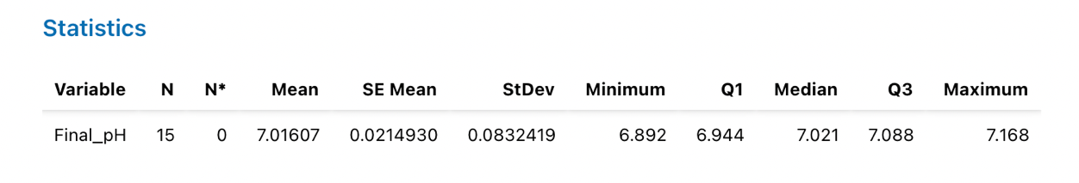
Fig 14: Descriptive Statistics for Confirmation Run

Descriptive statistics from the confirmation run showed that the mean outlet pH shifted closer to the target value of 7.0, while the standard deviation was substantially reduced compared to the baseline process. In addition, the overall spread of the data narrowed, with fewer extreme values observed. When compared against baseline performance, the improved process demonstrated enhanced consistency, reduced sensitivity to disturbances, and a lower likelihood of off-specification observations.

These results confirm that the selected operating conditions effectively reduced outlet pH variability and improved overall process capability, thereby validating the effectiveness of the improvement actions implemented in this phase.

  - Process Capability Improvement (Cp and Cpk)
Process capability analysis was performed for the improved process using specification limits of 6.7 (LSL) and 7.3 (USL).
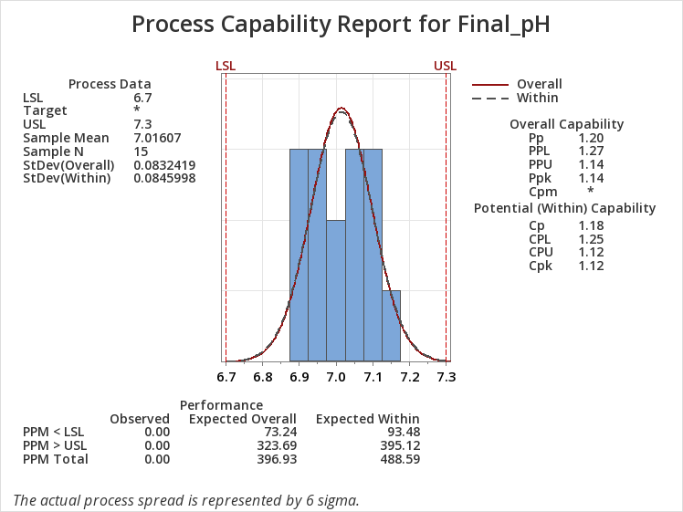

Fig 15: Process Capability Analysis for Improved Process

The improved process exhibited:
Cp ≈ 1.18
Cpk ≈ 1.12
Compared to the baseline condition, both Cp and Cpk showed clear improvement, indicating a more capable and centered process. The Cpk value greater than 1 confirms that the improved process consistently operates within specification limits with reduced risk of out-of-specification output.

  - Control Chart Verification
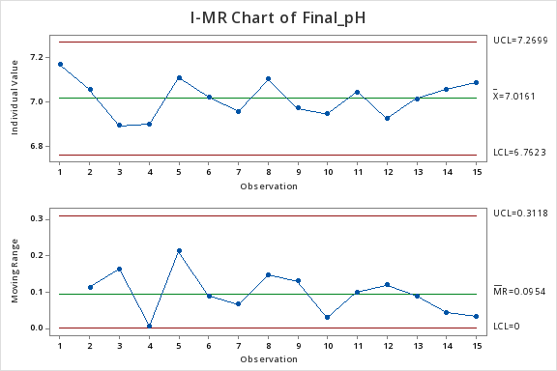
An Individuals–Moving Range (I–MR) control chart was developed for the improved process to assess statistical stability. All observations fell within control limits, and no trends or out-of-control signals were observed in either the Individuals or Moving Range charts.

Fig 16: Control Chart Verification for Improved Process
This confirms that the improved process is statistically stable and that the observed reduction in variability is sustainable under the selected operating conditions.

  - Summary
Metric | Baseline | Improved
Mean pH | 6.984 | 7.016
Std Dev (σ) | 0.315 | 0.083
Cp | 0.32 | 1.18
Cpk | 0.30 | 1.12
OOS Observations | Present | 0

The Improve phase successfully translated Analyze phase insights into actionable process improvements. By selecting optimal operating conditions for acid flow rate, base normality, and agitator speed, outlet pH variability was significantly reduced, process capability was improved, and stable operation near the target pH was achieved. These results provide a strong foundation for implementing long-term control strategies in the Control phase.

- CONTROL PHASE

  - Objective
The Control phase focuses on sustaining the improvements achieved during the Improve phase and ensuring long-term stability of the outlet pH within the specified limits. Based on the optimized operating conditions identified earlier, control mechanisms were established to prevent regression and to enable early detection of process deviations.

  - Standardized Operating Conditions
The optimized operating region identified in the Improve phase was formalized as the new standard operating condition for the neutralization process. Acid flow rate, base normality, and agitator speed were fixed at the selected levels that demonstrated reduced variability and improved process capability. These setpoints are intended to maintain the outlet pH close to the target value of 7.0 while minimizing sensitivity to small disturbances in reagent flow and concentration.

  - Statistical Process Control (SPC)
An Individuals–Moving Range (I–MR) control chart was developed for the improved process using the confirmation-run data. The I-chart showed that all observations remained within the upper and lower control limits with no out-of-control signals, indicating a stable process mean. The MR-chart similarly confirmed reduced short-term variability, with moving ranges well within control limits. Together, these charts demonstrate that the improved process is statistically stable and operating under control.

  - Process Capability Monitoring
Process capability analysis of the improved data indicated a substantial improvement in both Cp and Cpk values compared to the baseline process. The increased capability indices confirm that the process is now capable of consistently meeting the specification limits (LSL = 6.7, USL = 7.3) with a significantly lower probability of out-of-specification observations. Ongoing capability analysis is recommended as part of routine process monitoring to ensure sustained performance.

  - Control Plan & SOP
A control plan was established to ensure continued adherence to the optimized conditions. Key elements include:
- Routine monitoring of outlet pH using calibrated pH probes
- Periodic review of I–MR control charts to detect special-cause variation
- Defined response actions for operators in the event of control limit violations
- Scheduled verification of reagent concentrations and flow rates

These actions are documented in a standard operating procedure (SOP) to promote consistency and reduce operator-dependent variability.

  - Long term Sustainibility
By combining optimized operating conditions with SPC-based monitoring and a formal control plan, the neutralization process is positioned for long-term stability. The Control phase ensures that the gains achieved through Lean Six Sigma are maintained over time, thereby reducing defects, minimizing rework, and supporting consistent, specification-compliant operation.

All statistical analyses, graphical summaries, control charts, process capability studies, and design of experiments presented in this project were performed using Minitab® Statistical Software. The use of Minitab ensured consistent application of industry-standard Lean Six Sigma tools and validated the statistical rigor of the results.

References
- Box, G. E., Hunter, J. S., & Hunter, W. G. (2005). Statistics for experimenters: design, innovation, and discovery. John Wiley & Sons.
- George, M. L., Maxey, J., Rowlands, D. T., Upton, M., & David. (2004). Lean six sigma pocket toolbook (p. 282). New York, NY, USA: McGraw-Hill Professional Publishing.
- Montgomery, D. C. (2020). Introduction to statistical quality control. John wiley & sons.
- Montgomery, D. C. (2017). Design and analysis of experiments. John wiley & sons.
- Seborg, D. E., Edgar, T. F., Mellichamp, D. A., & Doyle III, F. J. (2016). Process dynamics and control. John Wiley & Sons.

