DevOps Assignment No. 1

Perform following operations on Git and GitHub.

1. Create a Repository
2. Create Branches
3. Perform Commit, Push, Pull
4. Compare and Pull request
5. Merge and Rebase
6. Squashing Commits
7. Delete branches
8. Fork a project, Open and merge Pull request
9. **Create a Repository - DO**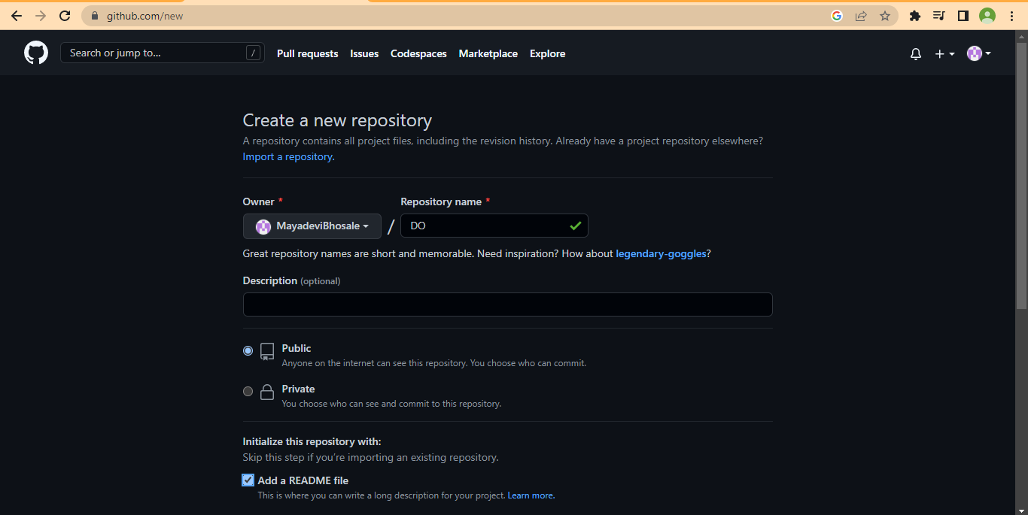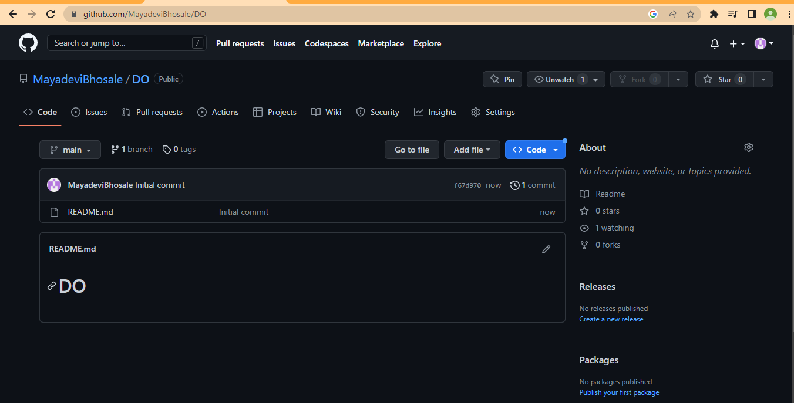

Add local files to remote repository -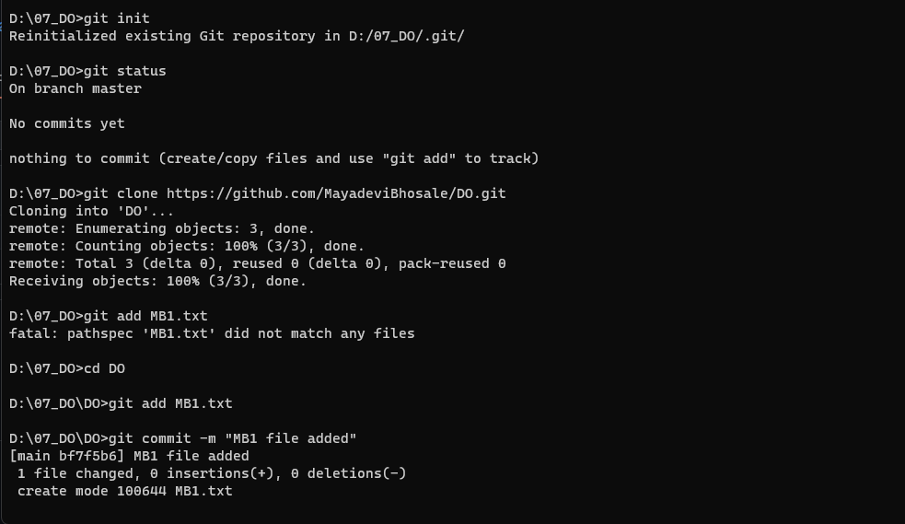

Push to github :

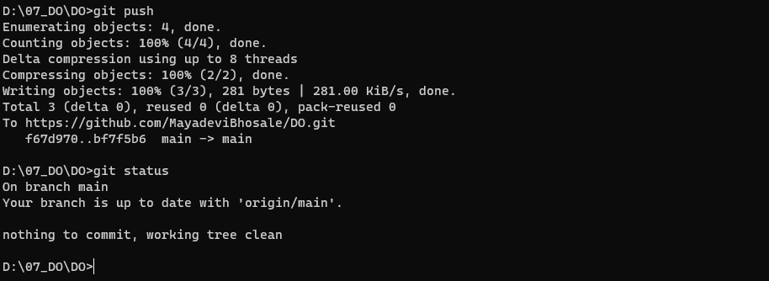

On GitHub MB1 File is Added :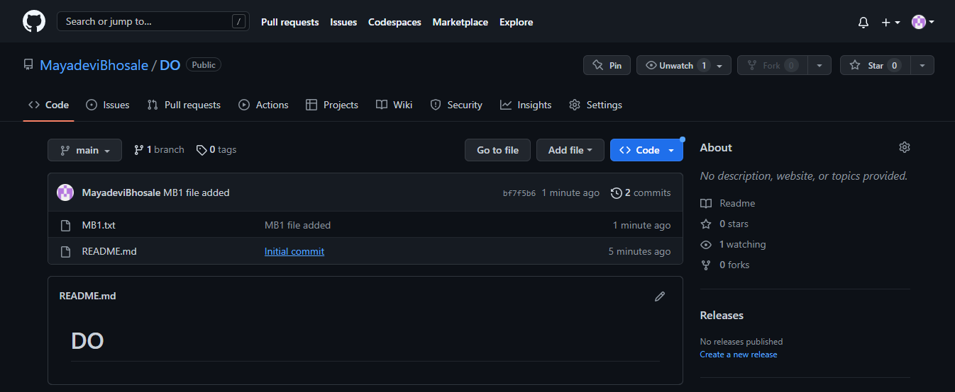

Add one more file MB2 in main branch and push on remote repository :

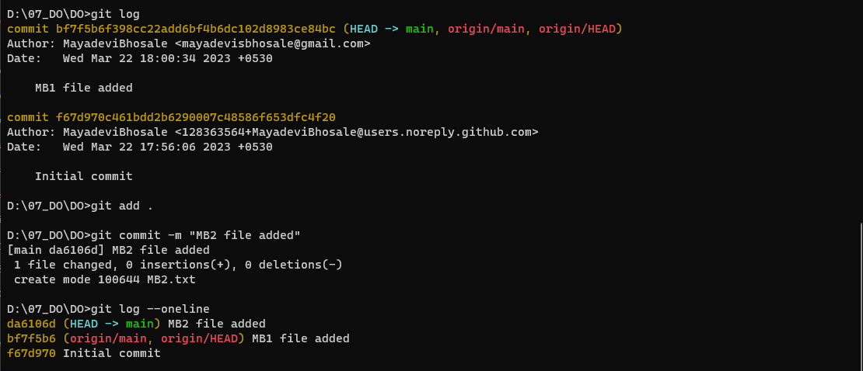

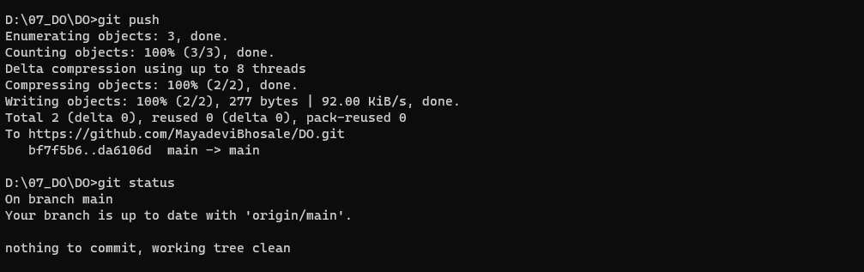

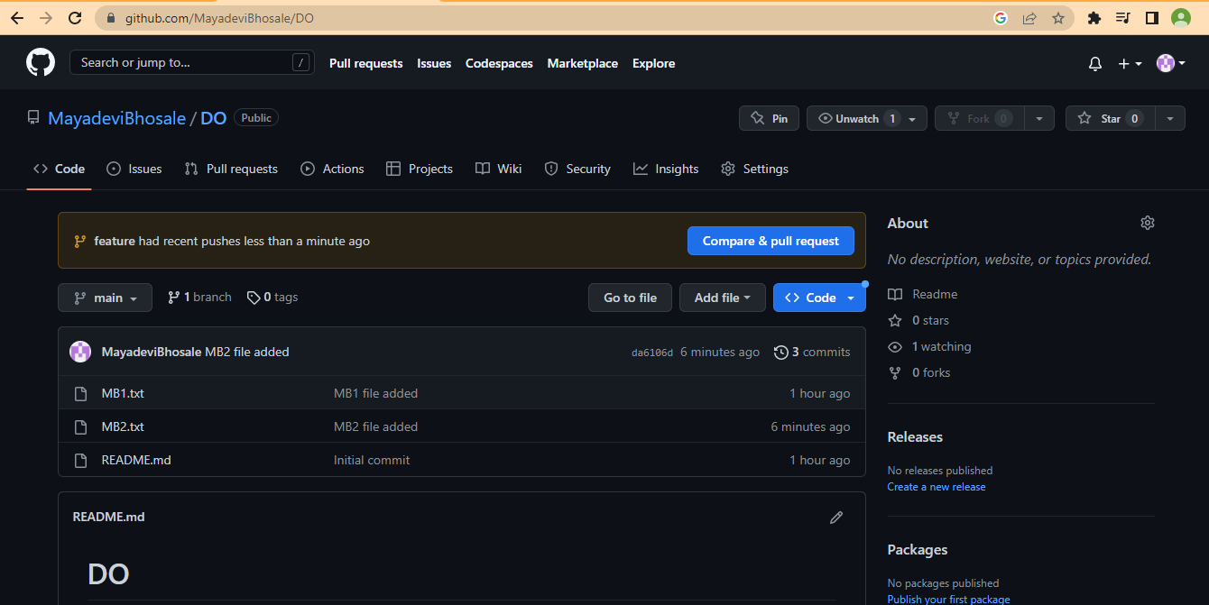

1. **Create a new branch** - feature and Added new file MB3.txt

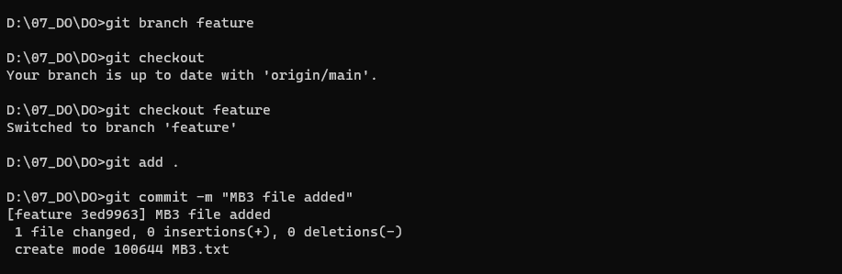

Feature branch on GitHub :

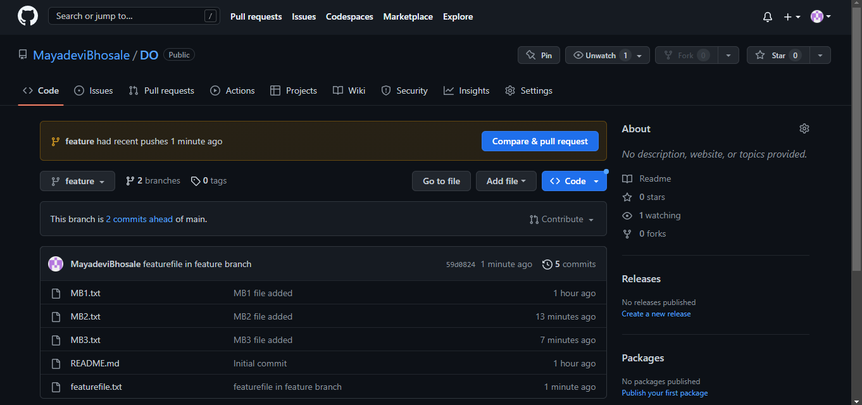

New file created in feature branch as featurefile.txt :



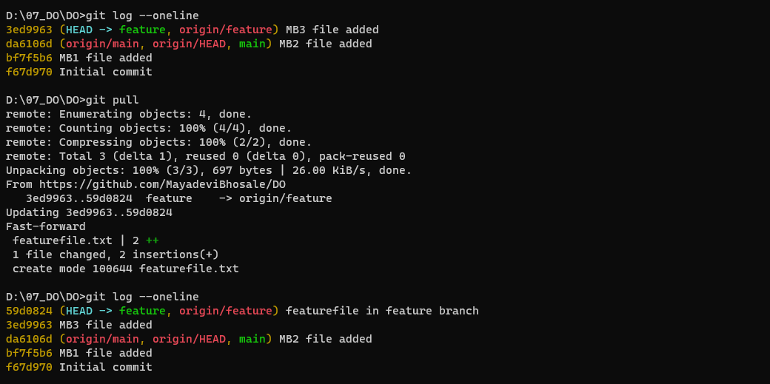

1. **Compare and Pull Request**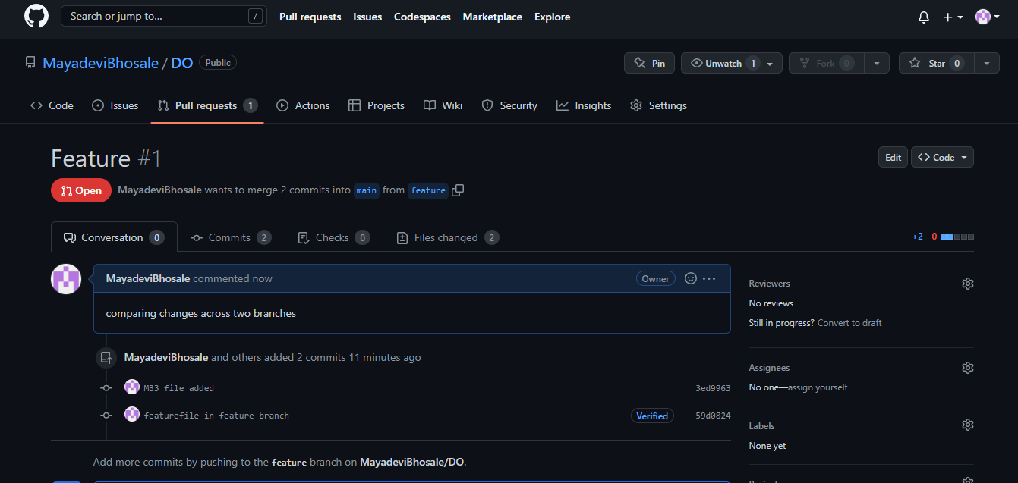
2. **Merge feature branch to main**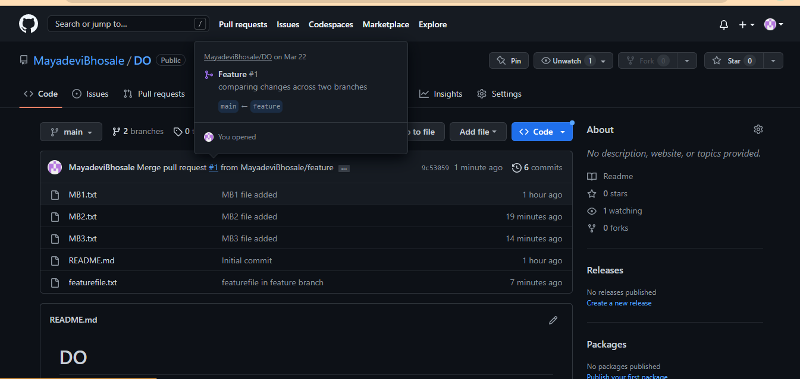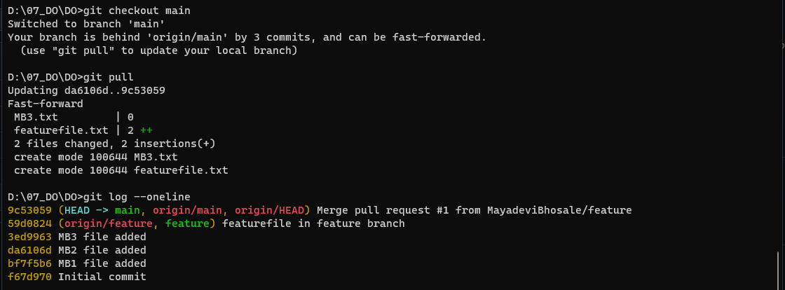

After Merge :

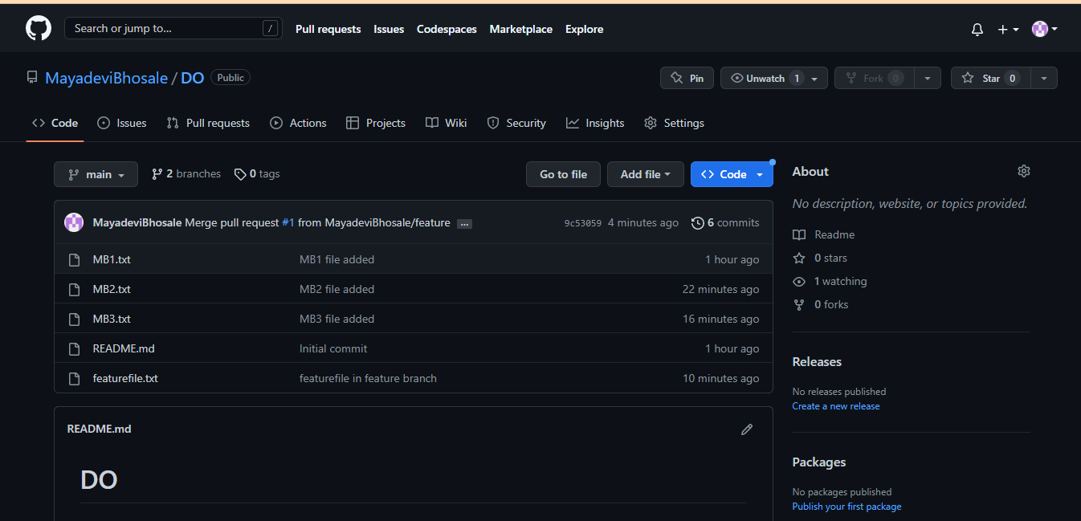

1. **Create a new file in feature branch as MB4.txt and Rebase the branch**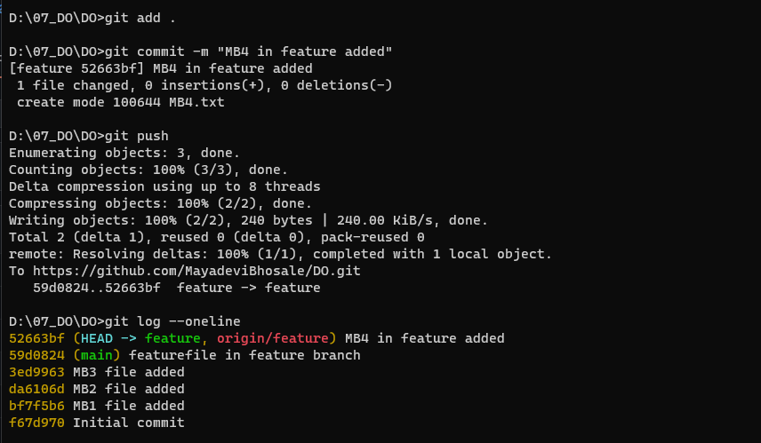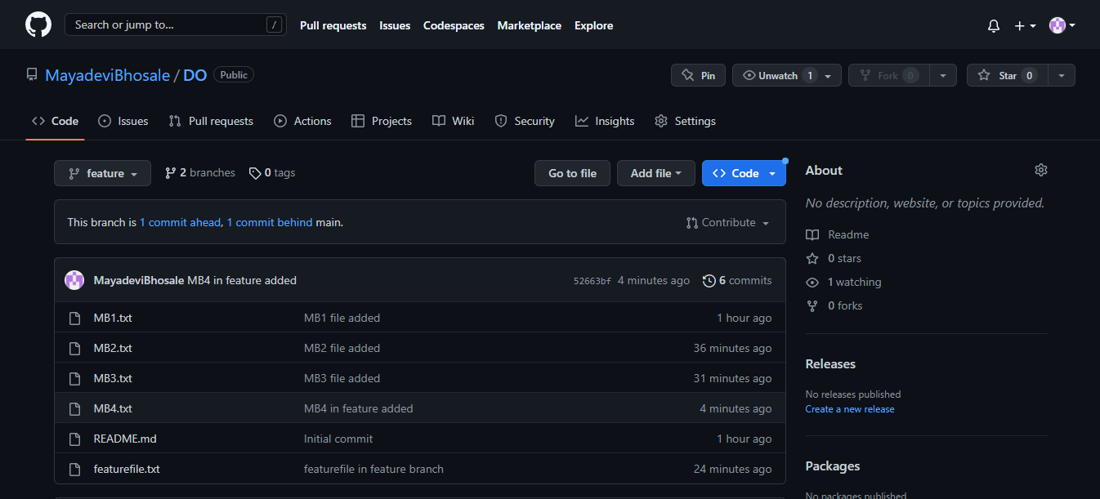

Rebase the main branch in feature : 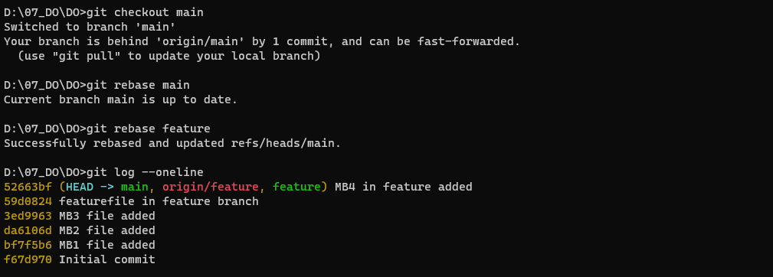

In github :



1. **Squashing the commits from MyDO Repository**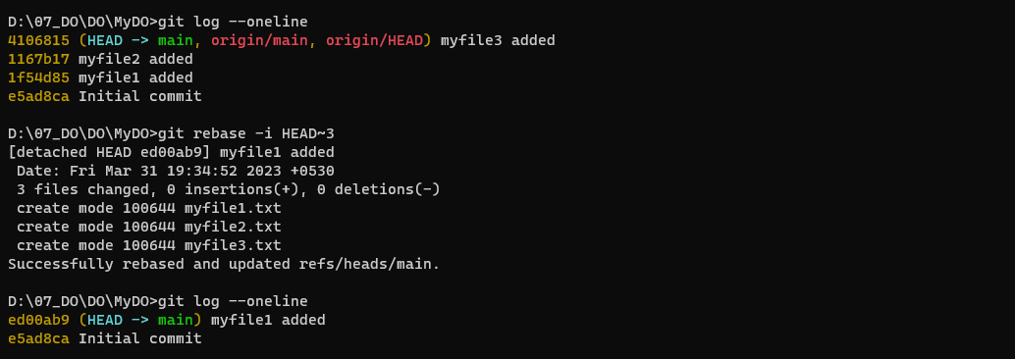

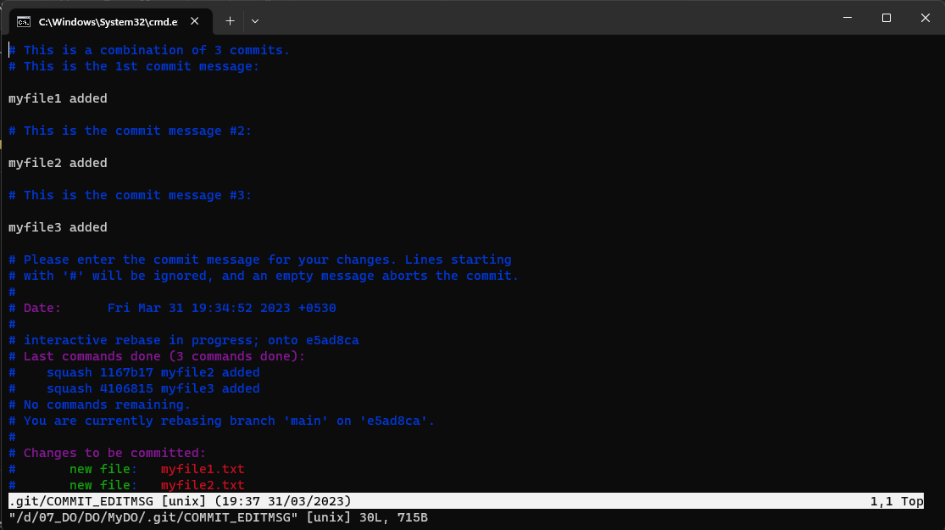

1. **Delete Branch :**

Before Delete :

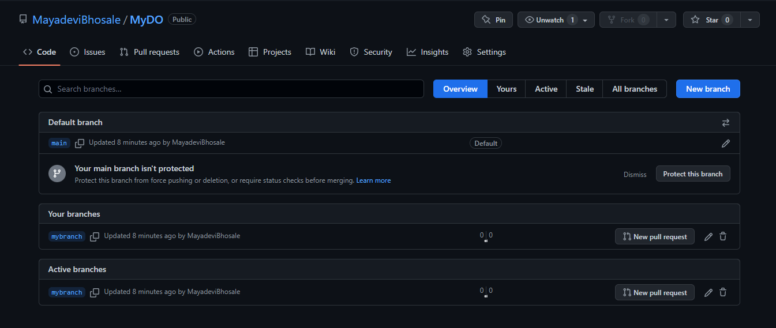

Delete Branch : From local Repository

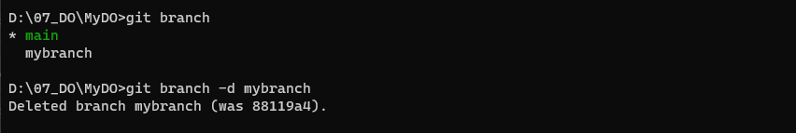

Delete Branch : From Remote Repository



After Deleting the “mybranch” Branch in GitHub : 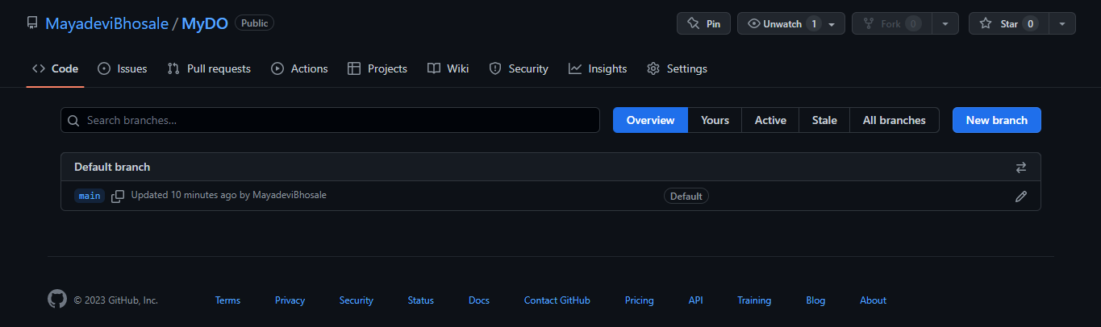

1. **Fork a project, Open and merge Pull request**

Fork the Spoon-Knife repository to your own repository :

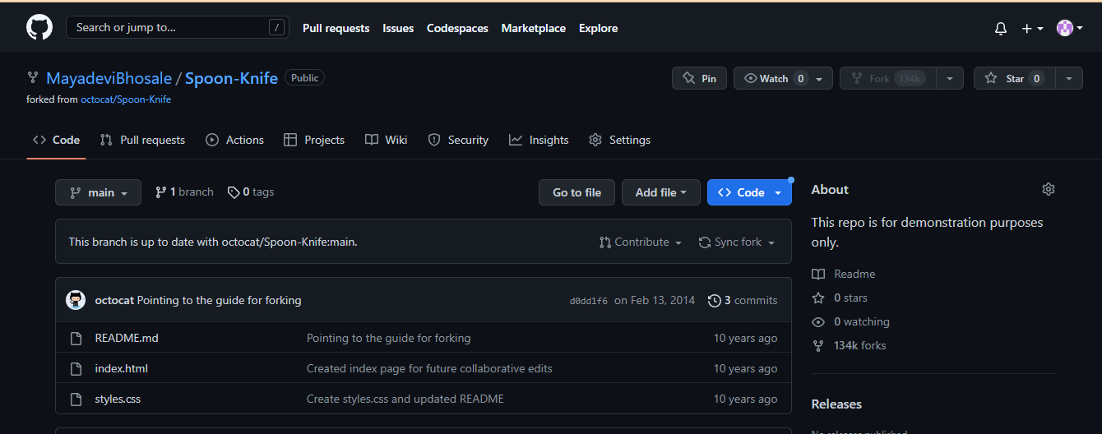

Clone the remote Spoon-Knife repository to local :

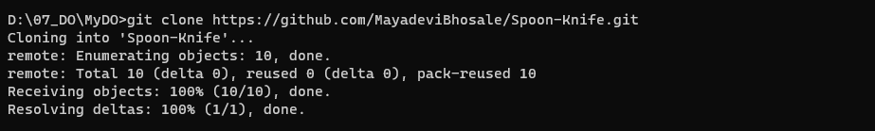

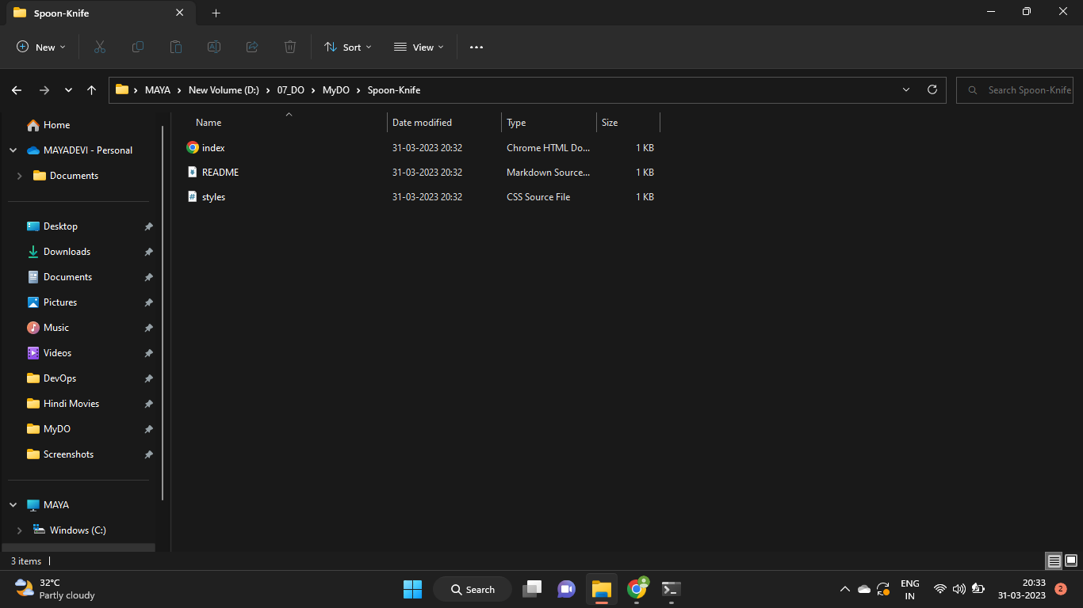

Configuring Git to sync your fork with the upstream repository:

